Software Requirements Specification
for
<Café Mini>
Version 1.0 approved
Prepared by Muhammad Hamza Khan
Department Of Computer Science, University of Karachi
19/Feb/2018
Table of Contents
Table of Contents ii
Revision History ii
1. Introduction 1
1.1 Purpose 1
1.2 Document Conventions 1
1.3 Intended Audience and Reading Suggestions 1
1.4 Product Scope 1
1.5 References 1
2. Overall Description 2
2.1 Product Perspective 2
2.2 Product Functions 2
2.3 User Classes and Characteristics 2
2.4 Operating Environment 2
2.5 Design and Implementation Constraints 2
2.6 Assumptions and Dependencies 3
3. External Interface Requirements 3
3.1 User Interfaces 3
3.2 Hardware Interfaces 3
3.3 Software Interfaces 3
3.4 Communications Interfaces 3
4. System Features 4
4.1 System Feature 1 4
4.2 System Feature 2 (and so on) 4
5. Functional Requirements 4
6. Other Nonfunctional Requirements 4
5.1 Performance Requirements 4
5.2 Safety Requirements 5
5.3 Security Requirements 5
5.4 Software Quality Attributes 5
5.5 Business Rules 5
7. Other Requirements 5
Appendix A: Glossary 5
Appendix B: Analysis Models 5
Appendix C: To Be Determined List 6

Revision History
Name | Date | Reason For Changes | Version

Introduction

Purpose
This document is intended to provide a detailed description of the project Café Mini. It will illustrate the purpose, interfaces, features and other requirements for the software as well as the constraints of the system. This document is intended to propose to customer and development team as a reference guide for development.

Intended Audience and Reading Suggestions
This document is made to be read by customer for the software ,development team and marketing staff.

Product Scope
The “Café Mini” is a GPS-based mobile application which helps people to find the closest branch of the business based on the user’s current position and other specification. The application should be free to download from either a mobile phone application store or similar services.

Café owners can provide their menu and other information via their module of the application. This information will act as the bases for the search results displayed to the user. Owners also uses the admin panel in order to administer the system and keep the information accurate. The administrator can, for instance, verify or update the prices of any item in the menu.

Furthermore, the software needs both Internet and GPS connection to fetch and display results. All system information is maintained in a database, which is located on a web-server. The software also interacts with the GPS-Navigator software which is required to be an already installed application on the user’s mobile phone. By using the GPS-Navigator, users can view desired branch on a map and be navigated to them.

References
-Business Requirement Document
-Use case diagram

Terms and their definition

TERM | DEFINITION
User | Someone who interacts with the mobile phone application
Admin/Owner | App administration who have specific permissions to modify the data
GPS | Global Positioning System

Overall Description

Product Perspective
This system will consist of two parts: one mobile application for users and one application for owner. The mobile application will be used to find branches, view information and place orders about them while the owner application will be used for managing the information about the menu and branches and the system as a whole.

The system will need to communicate to a GPS application within the mobile phone, which in turn communicates with a physical GPS device to find the location of the user. The GPS will provide the mobile application with locations of both the user and the branches and the distance between them, but it will also provide maps and the functionality to display the application’s data on the map. The functionality provided by the GPS will be embedded into the application in order for the user to be able to use the functions in the application in a seamlessly manner.

A database will be used. Both the mobile applications will communicate with the database, however in slightly different ways. The mobile application for users will only use the database to get data while the admin app will also add and modify data. All of the database communication will go over the Internet

Product Functions
Feature | Description
Select order | This process will allow the user to select any food or drink and specific details about them and place the order.
Search Branch | For dine-in purpose user can search the branch based on their location via GPS
Manage System | Admin application will be able to add, delete or update branch, menu item, price etc.

User Classes and Characteristics

There are two types of users that interact with the system: users of the mobile application administrators/owner. Each of these two types of users has different use of the system so each of them has their own requirements.

The mobile application users can only use the application to find a branch and place order. This means that the user have to be able to search for branches, choose a branch from that search and then navigate to it.

The restaurant owner will use the mobile application. There they will manage the information about their restaurant, for example a description of the restaurant, contact information and their menu.

Operating Environment

Application Server:
All the data of the system will be stored on a web-server.

Client System
An android phone with GPS enabled services.

Design and Implementation Constraints
The mobile application is constrained by the system interface to the GPS navigation system within the mobile phone. Since there are multiple system and multiple GPS manufacturers, the interface will most likely not be the same for every one of them. Also, there may be a difference between what navigation features each of them provide.

The Internet connection is also a constraint for the application. Since the application fetches data from the database over the Internet, it is crucial that there is an Internet connection for the application to function.

Both the mobile applications will be constrained by the capacity of the database. Since the database is shared between both application it may be forced to queue incoming requests and therefore increase the time it takes to fetch data

Orders can only be placed within the timings of the branch other times the option will be disabled.

Assumptions and Dependencies
One assumption about the product is that it will always be used on mobile phones that have enough performance. If the phone does not have enough hardware resources available for the application, for example the users might have allocated them with other applications, there may be scenarios where the application does not work as intended or even at all.

Another assumption is that the GPS components in all phones work in the same way. If the phones have different interfaces to the GPS, the application need to be specifically adjusted to each interface would mean the integration with the GPS would have different requirements than what is stated in this specification.

External Interface Requirements

User Interfaces

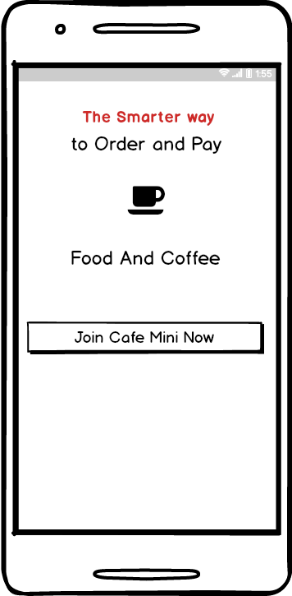
Join Café Mini/Sign-up

Home Screen

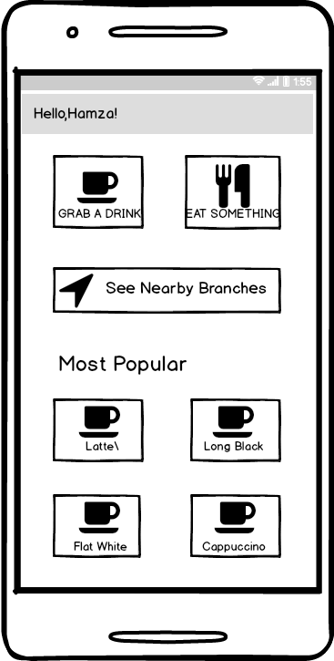

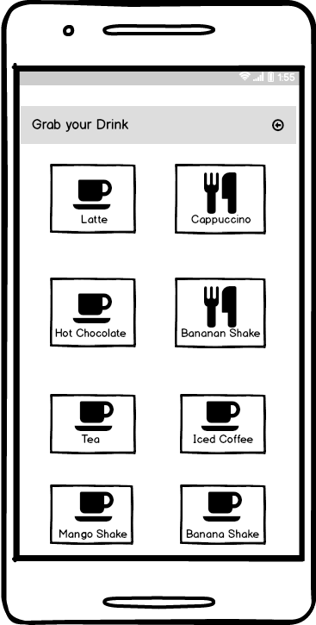
Menu Screen (Drinks)

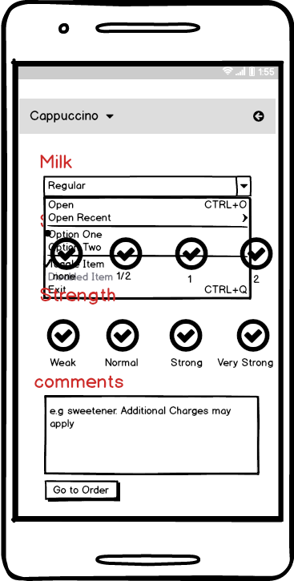
Item Detail Screen

Order Details
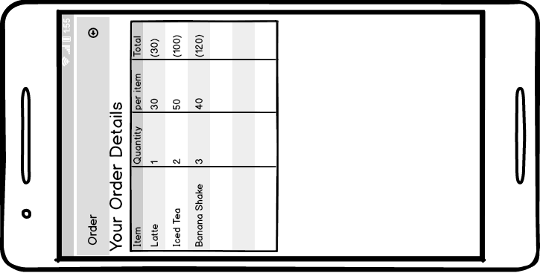

Hardware Interfaces
Since neither the mobile application nor the web server have any designated hardware, it does not have any direct hardware interfaces. The physical GPS is managed by the GPS application in the mobile phone and the hardware connection to the database server is managed by the underlying operating system on the mobile phone and the web server.

Software Interfaces
The mobile application communicates with the GPS application in order to get geographical information about where the user is located and the visual representation of it, and with the database in order to get the information about the branches. The communication between the database and the application of admin consists of operation concerning both reading and modifying the data, while the communication between the database and the mobile application consists of only reading operations.

Communications Interfaces
The communication between the different parts of the system is important since they depend on each other. However, in what way the communication is achieved is not important for the system and is therefore handled by the underlying operating systems for both the mobile applications.

System Features
This system elaborates major features of the product along with its functional requirement

Login
4.1.1 Description and Priority
The process will provide the user ability to log-in via their profiles in system database.
Priority: high
4.1.3 Functional Requirements
FR-1: System shall provide forgot password module to retrieve user password
FR-2: System shall provide sign-up module to register user before login.

Sign-up
4.1.1 Description and Priority
The process will provide the user ability to signup and register themselves in the system database.

Priority: high
4.1.3 Functional Requirements
FR-1: System shall provide forgot password module to retrieve user password
FR-2: System shall provide login module to use sign up credentials.

Select order
4.1.1 Description and Priority
The process will provide the user ability create custom orders
Priority: high
4.1.3 Functional Requirements
N/A

Search for a branch
4.1.1 Description and Priority
The process will provide the user ability search for nearest branch based on their location

Priority: high
4.1.3 Functional Requirements
N/A

Functional Requirements

Update and release
ID: FR2
TITLE: Download and notify users of new releases
DESC: When a new/updated version or release of the software is released, the user should check for these manually. The download of the new release should be done through the mobile phone in the same way as downloading the mobile application.
RAT: In order for a user to download a new/updated release.
DEP: FR1

User registration
ID: FR3
TITLE: User registration - Mobile application
DESC: Given that a user has downloaded the mobile application, then the user should be able to register through the mobile application. The user must provide user-name, password and e-mail address. The user can choose to provide a regularly used phone number.
RAT: In order for a user to register on the mobile application.
DEP: FR1

User login
ID: FR4
TITLE: User log-in - Mobile application
DESC: Given that a user has registered, then the user should be able to log in to the mobile application. The log-in information will be stored on the phone and in the future the user should be logged in automatically.
RAT: In order for a user to register on the mobile application.
DEP: FR1, FR3

Search
ID: FR6 TITLE:
Mobile application - Search
DESC: Given that a user is logged in to the mobile application, then the first page that is shown should be the home page. The user should be able to search for a branch, according to his location from this page.
RAT: In order for a user to search for a branch.
DEP: FR4

So on…

Other Nonfunctional Requirements

Performance Requirements
5.1.1 Usage of the result in the list view

ID: QR3
TITLE: Usage of the result in the list view
DESC: The results displayed in the list view should be user friendly and easy to understand. Selecting an element in the result list should only take one click.
RAT: In order to for a user to use the list view easily.
DEP: none

5.1.2 Response Time

ID: QR6
TAG: ResponseTime
GIST: The fastness of the search
SCALE: The response time of a search
METER: Measurements obtained from 1000 searches during testing.
MUST: No more than 2 seconds 100% of the time.
WISH: No more than 1 second 100% of the time.

Safety Requirements
N/A

Security Requirements
5.3.1 Communication Security

ID: QR12
TAG: Communication Security
GIST: Security of the communication between the system and server.
SCALE: The messages should be encrypted for log-in communications, so others cannot get user-name and password from those messages.
METER: Attempts to get user-name and password through obtained messages on 1000 log-in session during testing.
MUST: 100% of the Communication Messages in the communication of a log-in session should be encrypted. Communication Messages:
Defined: Every exchanged of information between client and server.

Software Quality Attributes
- Downtime is limited to weekends.
- Support 1000 concurrent logins
- User interface non-functional requirements

Other Requirements
<N/A>
Appendix A: Glossary
<Define all the terms necessary to properly interpret the SRS, including acronyms and abbreviations. You may wish to build a separate glossary that spans multiple projects or the entire organization, and just include terms specific to a single project in each SRS.>
Appendix B: Analysis Models
<Optionally, include any pertinent analysis models, such as data flow diagrams, class diagrams, state-transition diagrams, or entity-relationship diagrams.>
Appendix C: To Be Determined List
<Collect a numbered list of the TBD (to be determined) references that remain in the SRS so they can be tracked to closure.>

