       Machine Learning

Assignment Report (1A)

Team members:

Nipun Wahi         Hrithik Kulkarni     Mir Ameen Mohideen

2018A7PS0966H     2018A7PS0278H     2018A7PS0487H

Fischer’s LDA  
Data pre-processing:

Reading the data as a pandas data frame was followed by separating the rows based on the target variable and storing those indices in a NumPy array.

Model and Implementation details:

First, we found the means of the two classes of data and then used it to calculate the covariance matrix Sw by summing up the two covariances matrices of the corresponding classes.

The vector w was found using the equation w= Sw -1 .(M1-M0)

3-D plot of the dataset

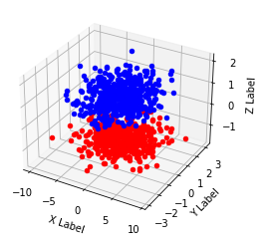

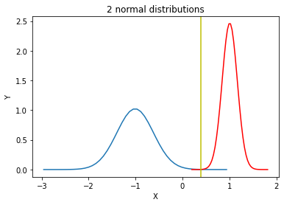

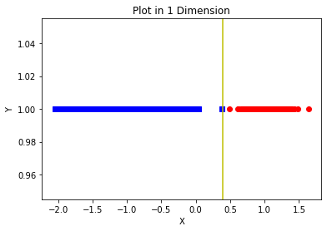

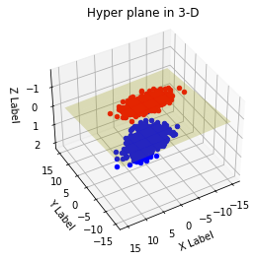

# Results:

Intersection point in 1-D = 0.389

W = [[0.00655686][ 0.01823739][-0.99981218]]

The equation of plane in 3-D is given by:

0.0065x+0.0182y-0.999z=0.389 where x,y and z are the three features in the given dataset

The accuracy of Fischer’s Linear Discriminant is 100% i.e. no points are misclassified.