**Senior Project Proposal**

**Department of Computer Science**

**Calvin University**

**Title**: Cognitive model of Introverted Students in class

**Author(s)**: Daniel Kwon, Jaden Brookens

**Date**: 11-3-2024

**Advisor**: Eric Araújo

## Background and Problem

Our project seeks to tackle the significant issue of untapped potential in classroom discussions caused by the hesitation of introverted students to participate using a computational modeling strategy. Introversion, while a natural personality trait, can lead to a loss of valuable insights and perspectives that would otherwise contribute to a richer learning environment. By examining why introverts tend to shy away from answering questions and how this impacts overall classroom dynamics, we aim to understand the root causes of their reluctance.

Failing to hear from half the class limits the diversity of thought, which negatively affects the quality of education for everyone. Our goal is to identify strategies to encourage introverts to share their thoughts more freely, recognizing that their unique viewpoints are crucial for well-rounded discussions. By understanding the interaction patterns of introverted students, we can develop solutions to help them engage more effectively, thus unlocking the full potential of every student and enhancing the collective learning experience.

## Brief Description of Solution Being Provided

Agent-based Modeling is a framework where autonomous agents are developed aiming to understand their interaction with other agents and their environment. By creating an Agent-based Model of introverted students in classroom, we intend to examine how they behave and think while receiving information and observing their colleagues and teachers in their environment. Our cognitive model will be based on new discoveries in education, psychology and social neuroscience studies.

Agent based Models are composed of agents/nodes that have properties that will impact the next node it points to, until it reaches a result. Each node and hyperparameter of prototype will be fine-tuned using gradient descending using loss function from the theoretical data set we generated. As the creators of this model, we are the ones tuning the agents through research. This fine-tuned model will provide us with the cognitive process of introverted students.

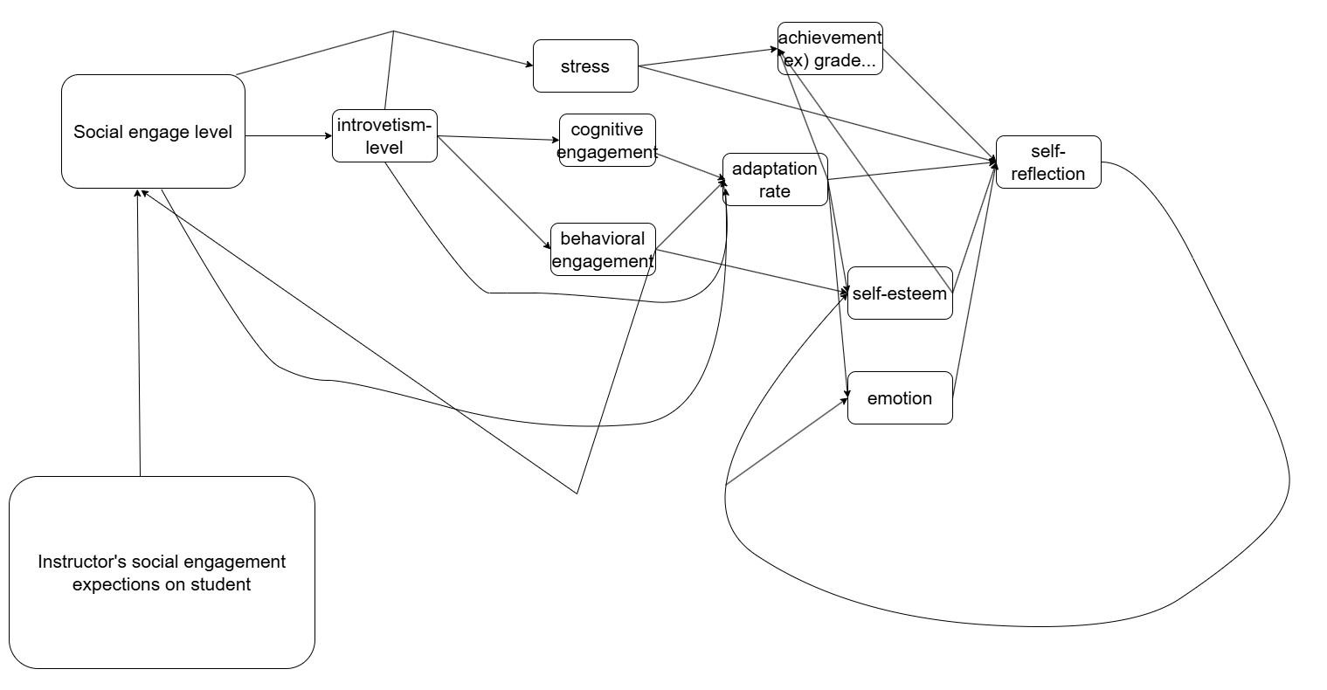

<https://drive.google.com/file/d/1OicDiXEe5nmCIOlwgnjMq8rUdtxDUDFy/view?usp=sharing>

This is an example of our agent-based model prototype. This is modeling the mind of a student. Starting from the left side of the image, the instructor’s social engagement is the one thing we will have outside of the student’s control. Each node represents key features of this specific situation. And each node represents the influence and direction of one node to the other.

For example,

**I** (introvertism level) * weight = **CE** (frequency of cognitive engagement)

Are represented by:

I

CE

Our final result of this project is something as below.

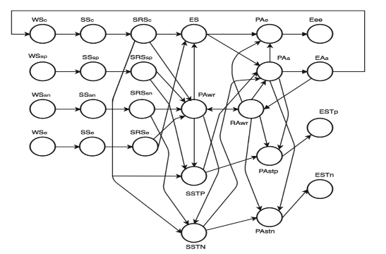

[978-3-319-67077-5_37.pdf](https://calvincollege.sharepoint.com/:b:/r/sites/2024seniorprojectteam/Shared%20Documents/General/978-3-319-67077-5_37.pdf?csf=1&web=1&e=xfXxDh)

This is an example of an agent-based model Prof. Araujo created that shows the spread of information by individuals in a disaster. The left most W-start node represents the states of world. S-nodes represent the sense of a person receiving information from the world. And the other nodes represent how that information processed and generated outcomes.

We will be creating a similar model for our own case. Each node will be based on findings from research papers on the cognitive processes of students. We will gather the key features in a classroom situation and observe the relationships between them. These relationships will form a mathematical model to calculate the outcome we aim to observe.

The features and relationships will be visualized as nodes and arrows.

We use customized nodes because we want to observe the process of cognition. If our goal were simply to predict outcomes from certain inputs, we might rely on hidden layers, as in other major machine learning models. However, hidden layers within such models are not interpretable by humans. Therefore, we use agent-based modeling to build a relationship layer that allows us to directly observe cognitive processes within the model.

By simulating the cognitive process of introverts, we will generate refinement for classroom activities. We will use Net Logo to simulate a virtual classroom based on the generated model.

# *Research or Development Objective*

This is primarily a research project, but it contains development process also. We will research valid theory and data that explains introverted students' behavior. Using the research results, we will make cognitive models of those students.

The current schedule of this project is:

* October 2024:

Do a literature review of relevant work on student introversion.

* November 2024:

Generates the first draft model that explains the cognitive process from collected papers.

* December 2024:

Make a presentation on our halfway point that we will share during the cs seminar.

* January 2025:

Finalize the model structure.

* February 2025:

Use collected data to fine tune the weights in the model.

* March 2025:

Analyze the cognitive model and its conclusions. Use the model and

Net Logo to develop refinements for classroom activities.

* April 2025:

Make a final presentation.

## Interest and Qualifications

The project is based on the agent modeling process and requires the following skills and knowledge:

An interest in and understanding of psychology domain knowledge, agent-based modeling, and network modeling skills. Agent-based modeling will also require machine learning techniques. Additionally, an understanding of Python is essential for coding and fine-tuning the agent-based model.

Heonjae Kwon, Bachelor of Computer Science (BCS) senior at Calvin university

CS 106: Introduction to Scientific Computation (Python)

CS 300: Agent base Modeling

CS 344: Machine Learning

PSYC 151: Introductory Psychology: Perspectives on The Self

PSYC 201: Developmental Psychology: Lifespan

Jaden Brookens, Computer Science Plus (BS)

CS 108: Introduction to Computing (python)

CS 300b: Agent Based Modeling

## Collaboration with Advisor, Outside Experts and Users

We will have a regular meeting with Professor Eric Araújo on Thursday at 5PM

## Resources Required

This project currently does not require any financial resources. While there may be a slight possibility of deployment costs in the future, the likelihood remains low.

## Sources

Hassan, A. (2019). *The effects of the introversion on educational attainment: A cross-sectional study*. International Journal of Scientific & Engineering Research. Retrieved from <https://www.ijser.org/researchpaper/The-Effects-of-the-Introversion-on-Educational-Attainment-A-Cross-Sectional-Study.pdf>

Harrington, J. R. (2016). *Introversion, extraversion, and the academic achievement of college students: A longitudinal study* (ED573764). ERIC. Retrieved from <https://eric.ed.gov/?id=ED573764>

Christov-Moore, L., & Iacoboni, M. (2021). *The empathy paradox: Increasing disconnection in the age of increasing connection.* PLOS ONE, 16(5), e0251097. <https://doi.org/10.1371/journal.pone.0251097>

Sticca, F., Goetz, T., Nett, U. E., Hubbard, K., & Haag, L. (2014). S*hort- and long-term effects of over-reporting of grades in a high-stakes context. Teaching and Learning in Medicine*, 26(4), 336–348. <https://doi.org/10.1080/10401334.2014.979183>

Di Domenico, S. I., & Ryan, R. M. (2020). *The emerging neuroscience of intrinsic motivation: A new frontier in self-determination research*. Frontiers in Psychology, 11, 590748. <https://doi.org/10.3389/fpsyg.2020.590748>

Qualter, P., & Munn, P. (2019). *Introverted but socially engaged in school learning: The interaction between introversion and social engagement and its role in well-being*. ResearchGate. <https://www.researchgate.net/publication/336021685>

Amalia, R., & Kurniawati, N. (2020). *The role of introversion and extroversion in improving students’ academic performance*. Plus Minus: Jurnal Pendidikan Matematika, 1(1), 52-64. Retrieved from <https://journal.institutpendidikan.ac.id/index.php/plusminus/article/view/1082>

Costa, P. T., & McCrae, R. R. (1982). *An approach to the measurement of introversion and extraversion*. Journal of Research in Personality, 16(4), 494-505. <https://doi.org/10.1016/0092-6566(82)90070-8>

Johnson, D. (2018). *The effects of introversion on learning engagement in college settings (Doctoral dissertation).* ProQuest Dissertations Publishing. Retrieved from <https://www.proquest.com/openview/b26a9f6d46e2d94385d8e5dfb4e1576e/1?pq-origsite=gscholar&cbl=18750&diss=y>

Smith, K. (2019). *Examining introverted students’ engagement in active learning environments.* Taylor University Master of Arts in Higher Education (MAHE) Theses, (78). Retrieved from <https://pillars.taylor.edu/mahe/78/>

Tuovinen, Sanna, et al. “Introversion and Social Engagement: Scale Validation, Their Interaction, and Positive Association with Self-Esteem.” Frontiers in Psychology, U.S. National Library of Medicine, 30 Nov. 2020, www.ncbi.nlm.nih.gov/pmc/articles/PMC7734327/.