e-project: Imperial

Imperial

User Guide

|  |  |  |
| --- | --- | --- |
| Supervisor | Sir Najam | |
| Batch | PR-2022-06G1 | |
| Serial No | Enrollment Number | Student Name |
| 1. | 1391924 | Hassan Ahmed Khan |
| 2. |  | Anas |
| 3. |  | Shahab Wali Khan |



e-project: Imperial

**USER GUIDE**

*1. Welcome (**0.Welcome.html**)*

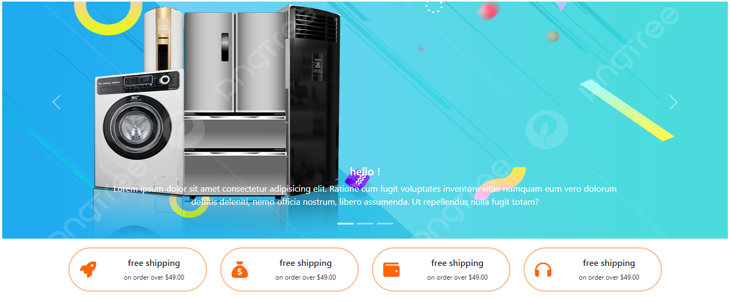

*Figure 1: Welcome Page To Imperial*

***Used to select the language displayed on the website:***

* When the user selects the American flag icon, the link to the Web page displays the English language.
* When the user selects the Vietnamese flag icon, the link to the Web page displays the Vietnamese language.
* 2. ***Header***



*Figure 2: Header*

2.1. ***Menu Bar***

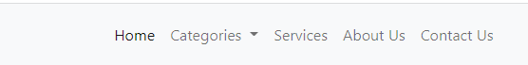

*Figure 3: Menu Bar*

***Used to load the remaining pages. The following is a list of those pages:***

* Home Page (1.Index.html)
* Categories Page (2. Categories)
* Man’s Fashion (2.1 Man’s Fashion)
* Inverter & AC (2.2 Inverter/AC)
* TV & LCD (2.3 TV/LCD)
* Sport & Outdoor (2.4 Sport & Outdoor)
* Motor & Bikes (2.5 Motor & Bikes)
* Services Page (3. Services)
* About US Page (4. About US)
* Contact US Page (5. Contact US)

*Top Best Item Sold Out This Month*

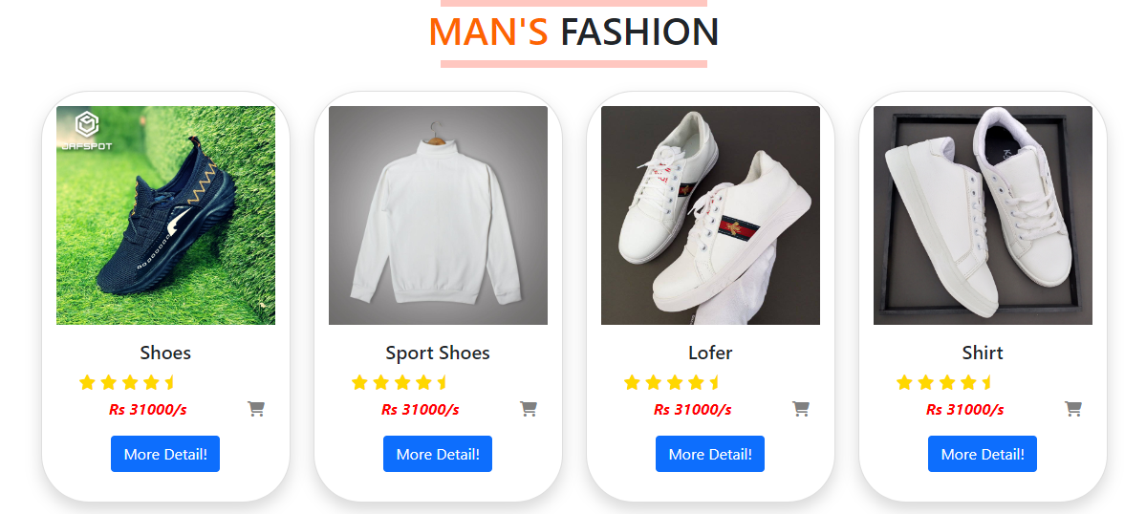3.***Man’s Fashion***

4. ***AC & Inverter***



5. ***TV & LCD***

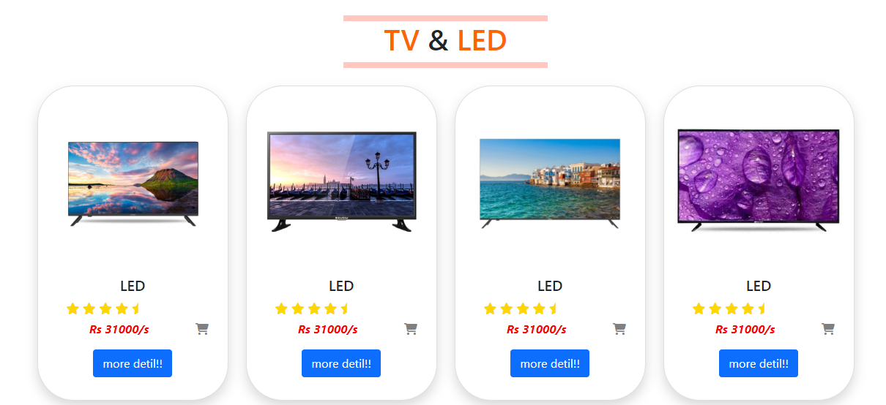

6. ***Sport & Outdoor***

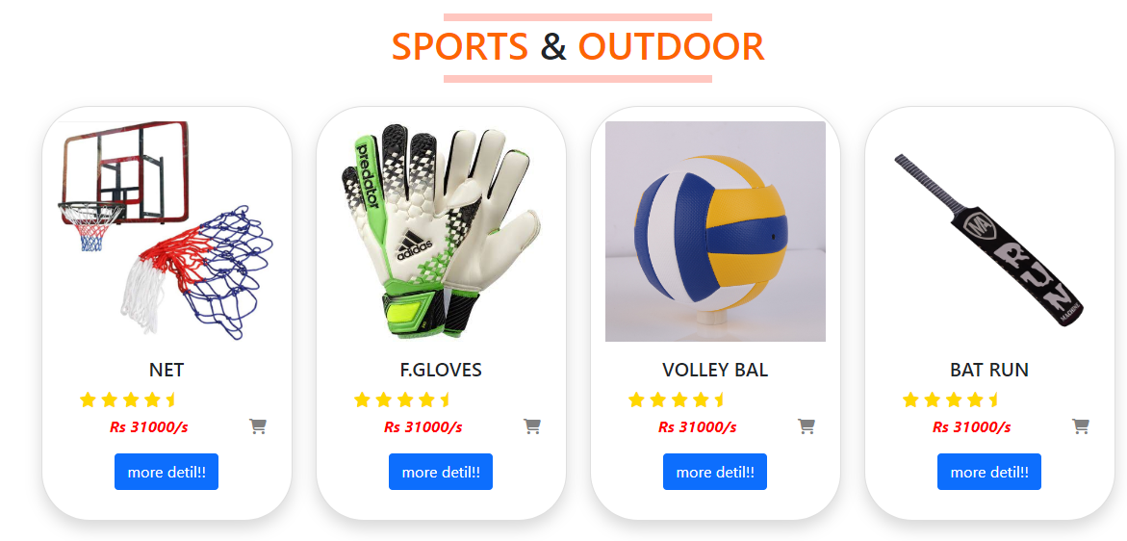

7. ***Bike & Motor***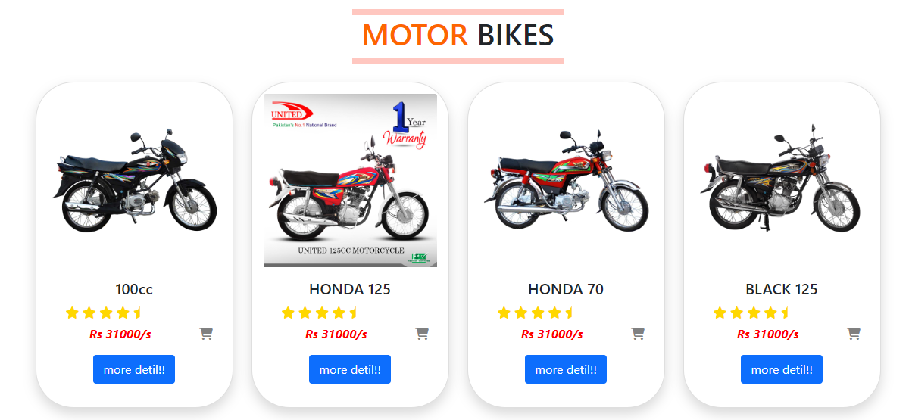

8. ***Banner***

9. ***Brand***



10. ***About US***

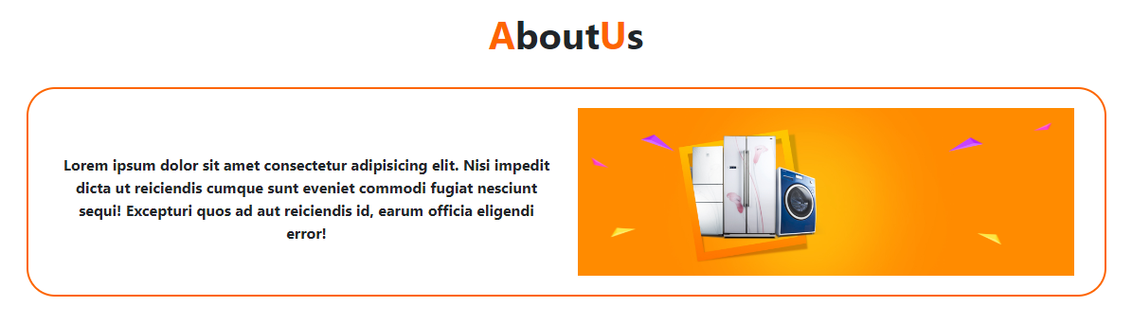

11. ***Email***

