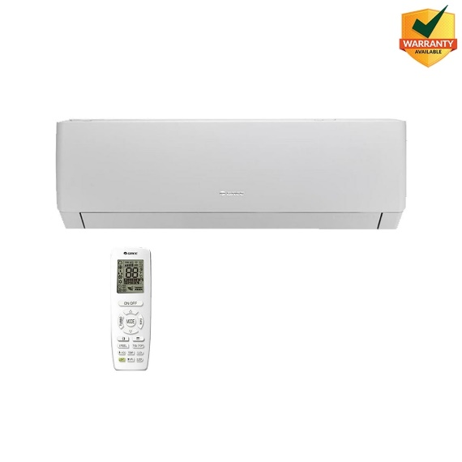

GS-18PITH11W Gree Pular 1.5Ton Inverter Split AC Heat & Cool

Product details of GS-18PITH11W Gree Pular 1.5Ton Inverter Split AC Heat & Cool

* GS-18PITH2W Gree Pular 1.5Ton Inverter Split AC Heat & Cool
* PULAR Inverter is a new addition to the inverter family. Capacity is available in 12K, 18K & 24K BTU’s.
* Elegant White color with Matt Finish.
* Both Vertical & Horizontal Airflow
* Seamless Design with double air deflector. Which can provide air even at 90° direction
* Seven Fan Speed
* Single Panel Easy Clean Filters
* Health Filters
* European Complaint Heat & Cool AC
* Low Noise Operation
* Powerful G-10 AC
* Energy Efficiency Class A+ (Upto 60% Energy Saving)
* Low Voltage Startup – 150V
* Ultra-Low Frequency Torque Control
* State-of-the-art DSP Chip
* Precise Temperature Control
* Hidden LED Display
* Cold Plasma Generator
* I-Feel
* Ceiling Cooling & Floor Heating System
* Power Factor Correction Technology Upto 99%
* Turbo Mode
* Sleep Mode
* Timer
* Auto Restart
* Child Lock