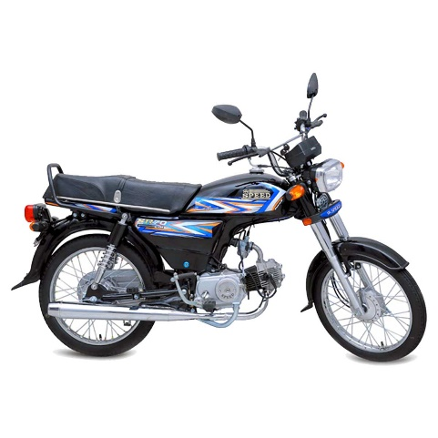

HI-SPEED SR70 BLACK MODEL 2022

Product details of HI-SPEED SR70 BLACK MODEL 2022

* This item is only for Karachi Customers
* Self-Pickup from Brand Premises : F-460, Metroville, S.I.T.E. Karachi.
* Technical Assistance: 021-111-132-729 (Mon - Fri; 10AM - 7PM)

Bike Description 70cc Chinese  
ENGINE: 4-Stroke OHC, Air Cold Single Cylinder  
Displacement: 78cm3  
Bore&Stroke: 47.0x41.4mm  
Compression: 8.8:1  
Extreme Horse Power: 7.0ps/8500RPM  
Extreme Torque: 0.55lg-m/6500RPM  
Transmission: 4SpeedRarelyMesh  
Ignition System: CDI Electronic Control System  
Clutch: Wet Plate Type  
Frame: Back Bone Type Strong Body  
Size: 1885x760x990mm  
Ground Clearance: 35mm  
Petrol Tank Capacity: 10.0Litre  
Front Wheel: 2.25-174PR  
Back Wheel: 2.50-176PR  
Dry Weight: 82kg  
Petrol Expense: 1Litre 70KM

Specifications of HI-SPEED SR70 BLACK MODEL 2022

* Brand

Hi Speed Infinity

* SKU

269964581_PK-1483700086

* Engine displacement (cc)

70 CC

* Location

Karachi

* Number of Cylinders

1

* Number of Gears

4

* Model Year

2021