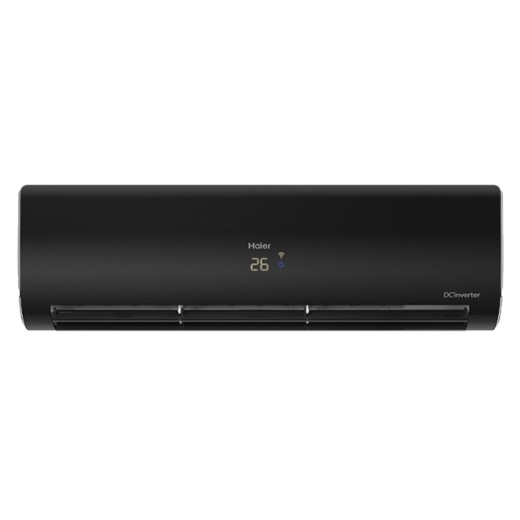

Haier (Pearl Inverter Series) 1 Ton DC Inverter UPS Enabled - Self Cleaning - WiFi Enabled-Turbo Cooling-Black Colour AC - HSU-12HFPCA(B)/10 Years Warranty/Air Conditioner/Haier Free Installation’

Product details of Haier (Pearl Inverter Series) 1 Ton DC Inverter UPS Enabled - Self Cleaning - WiFi Enabled-Turbo Cooling-Black Colour AC - HSU-12HFPCA(B)/10 Years Warranty/Air Conditioner/Haier Free Installation

* Just Call HAIER UAN 042-111-142-437 to avail free installation.
* Brand Warranty
* 10 Years Compressor Warranty
* R32 Refrigerant
* Voltage 150-260v
* Running Current (A) 2.6-6.6
* Indoor Dimensions W\*D\*H : 850\*295\*210
* Outdoor Dimensions W\*D\*H : 700\*245\*535
* Elegant Coloured Indoor Panel
* Concealed LED
* Bigger Indoor
* Turbo cool
* Self Cleaning
* Strong Airflow
* Exquisite Dust Filter
* UPS enabled with device
* Sleep Mode
* Powerful Cooling & Heating
* Easy Operation of Controller
* Black Body Colour
* Super Quiet
* Anti - Corrosion