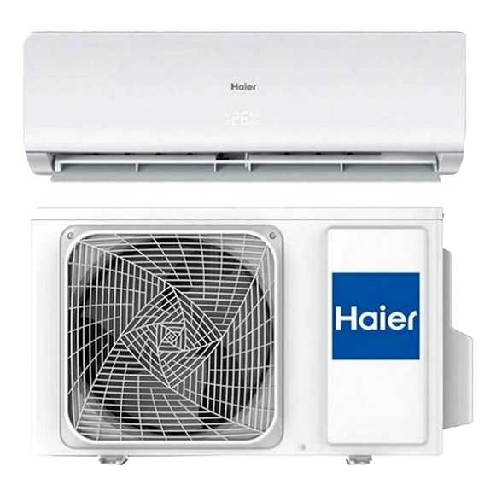

Haier (Turbo Cool Series) 1 Ton-Turbo Cooling - Wide Voltage- Full BTU-White Colour AC - HSU-12CFCM/10 Years Warranty/Air Conditioner/Haier Free Installation

Product details of Haier (Turbo Cool Series) 1 Ton-Turbo Cooling - Wide Voltage- Full BTU-White Colour AC - HSU-12CFCM/10 Years Warranty/Air Conditioner/Haier Free Installation

* Free Installation by Haier Company100 % CopperLong Air ThrowHidden LEDSleep ModeLow Voltage OperationLow NoiseEnvironment FriendlyVoltage StabilizerTurbo Cooling1 Ton CapacityWall Mounted Split Air ConditionerCool OnlyCooling Capacity (BTU): 12000R410a Refrigerant

A highly affordable series of air conditioners which stands out in a minimalistic white design, capable of delivering excellent cooling performance. This Air Conditioner will make this summer cooler than ever with its instant cooling and amazing efficiency. This AC is certainly the right choice, is a reliable choice and the right pick for anyone who wants the best for their household. ￼ 20% Power Saving Series Haier air conditioner can give more power cooling for fast air conditioning of entire room within 1 minute. ￼ Turbo Cooling Instant cooling just a push away, press" turbo" button on your remote controller and enjoy instant cooling. Healthy ionizer Enjoy the feeling of a forest at homeJust press the health button,your room if filled with refreshing ions.

Specifications of Haier (Turbo Cool Series) 1 Ton-Turbo Cooling - Wide Voltage- Full BTU-White Colour AC - HSU-12CFCM/10 Years Warranty/Air Conditioner/Haier Free Installation

* Brand

Haier

* SKU

135974324_PK-1885436778

* Kit Included

Yes

* Connecting Wire

Yes

* Cooling Liquid

R32

* Inverter

No

* Air Conditioner Rated Capacity (BTUs)

1 Ton / 12000 BTU

* Air Conditioner Features

Fast Cooling

* Room Size

130 SqFt