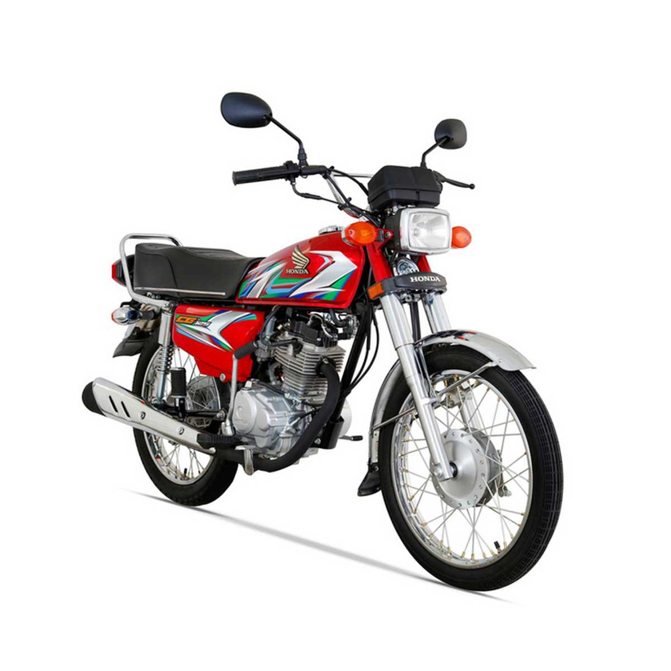

Honda - CG125 - (Red Colour) For Lahore only

Product details of Honda - CG125 - (Red Colour) For Lahore only

* Engine 4-Stroke OHV Cooled by Air
* Bore & Stroke 56.5 x 49.5 mm
* Starting Kick Start
* Final Drive Roller Chain
* Transmission Continuous 4 Speed Mesh
* Dimension(LxWxH) 1911 x 732 x 1016 mm
* Seat Height 771 mm
* Ground Clearance 140 mm
* Petrol Capacity 9.2 Liters (Reserve 2 Liters)
* Wheel Base 1201 mm
* Tire at Front 2.50 Ã¢ÂÂ 18 (4 PR)
* Tire at Back 3.00 Ã¢ÂÂ 17 (6 PR)
* Suspension Front Telescopic Fork 103 mm Travel
* Suspension Back Swing Arm 68 mm Travel
* Dry Weight 99kg
* 3 Year Engine Brand Warranty

Specifications of Honda - CG125 - (Red Colour) For Lahore only

* Brand

Atlas Honda

* SKU

102006669_PK-1247720732

* Engine displacement (cc)

125 CC

* Location

Lahore

* location_city

Honda - CG125 - (Red Colour) For Lahore only

* Number of Gears

4

* Number of Cylinders

1

* Model Year

Model Year- 2022

* Model

Honda CG 125

What’s in the box

1 x Honda CG 125 Red