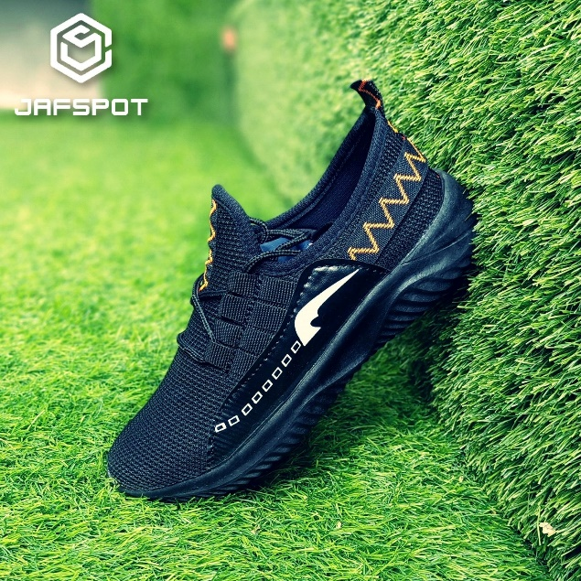

Men's Running Shoes Men's Slip-on Shoes Tennis Walking Casual Shoes Black Gym Breathable Rubber Work Shoes fashin shoes

Product details of Men's Running Shoes Men's Slip-on Shoes Tennis Walking Casual Shoes Black Gym Breathable Rubber Work Shoes fashin shoes

* Men's Running Shoes
* Men's Slip-on Shoes
* Tennis Walking Casual Shoes
* Black Gym Breathable
* Rubber Work Shoes
* fashin shoes