ABSTRACT
First, the conversation data itself lacks of sufficient contextual information for accurately understanding users’ preference. Second, there is a semantic gap between natural language expression and item-level user preference.
we incorporate both word-oriented and entity-oriented knowledge graphs (KG) to enhance the data representations , and adopt Mutual Information Maximization to align the word-level and entity-level semantic spaces. Based on the aligned semantic representations, we further develop a KGenhanced recommender component for making accurate recommendations, and a KG-enhanced dialog component that can generate informative keywords or entities in the response text.

Introduction:
Previous solutions, like the belief tracker and switching decoder, have improved CRS performance, but there are still two main issues: the limited contextual information available in conversations, and the semantic gap between natural language and user preference reflected in items/entities.

The authors propose a new CRS approach utilizing a word-oriented Knowledge Graph (KG), ConceptNet, and an item-oriented KG, DBpedia, to enhance the semantics of words and items respectively, and unify their representation spaces. Graph neural networks are used to learn node embeddings from the two KGs, and the Mutual Information Maximization method is employed to bridge the semantic gap between the two KGs.

The result is a KG-enhanced recommender component that can provide accurate recommendations, and a KG-enhanced dialog component that can generate informative responses.

3 PRELIMINARIES
In a CRS, there are two major components to develop, namely the recommender component and the dialog component. The two components should be integrated seamlessly.
Formally, let 𝑢 denotes a user from user set U, 𝑖 denotes an item from item set I, and 𝑤 denotes a word from vocabulary V.A conversation (or a conversation history) 𝐶 consists of a list of utterances, denoted by , in which each utterance 𝑠𝑡 is a conversation sentence at the 𝑡-th turn. At the 𝑡-th turn, the recommender component selects a set of candidate items from the entire item set I according to some strategy, while the dialog component needs to produce the next utterance 𝑠𝑡 to reply to previous utterances. Note that I𝑡 can be equal to ∅ when there is no need for recommendation. In such a case, the dialog component may raise a clarification question or generate a chit-chat response. Given a 𝑛-turn conversation, the goal of a CRS is to generate the response utterance to the user, including both the recommendation
set and the reply utterance 𝑠𝑛+1.

4 APPROACH
In this section, we present the KG-based Semantic Fusion approach
to the CRS task, named KGSF. We first introduce how to encode both word-oriented and item-oriented KGs, and then fuse the semantics of the two KGs. Based on the fused KGs, we finally describe our solutions for both recommendation and conversation tasks. The overview illustration of the proposed model is presented in Fig. 1.
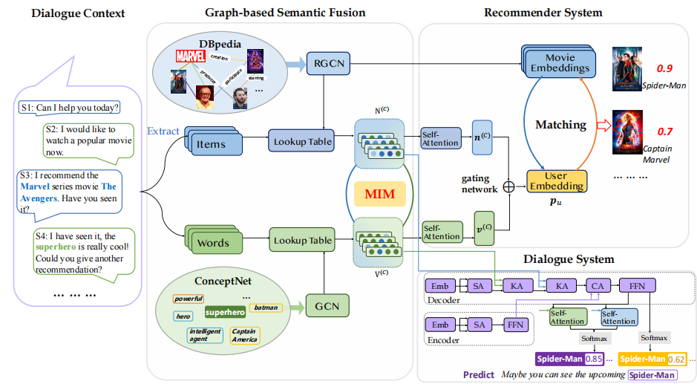
4.1 Encoding External Knowledge Graphs
As shown in Table 1, it is difficult to fully understand user preference and generate a suitable response. We identify the two basic semantic units in dialog and recommender systems, namely word and item,respectively. Here, we utilize two separate KGs to enhance the representations of the basic semantic units on both sides.
4.1.1 Encoding Word-oriented KG. We adopt the widely used ConceptNet as the word-oriented KG. It stores a semantic fact as a triple ⟨𝑤1,𝑟,𝑤2⟩, where 𝑤1,𝑤2 ∈ V are words and 𝑟 is a word relation. Not all the words in ConceptNet are useful for our task.
Hence, we only consider words that appear in our corpus, and extract their related triples from ConceptNet. We also remove words with very few triples related to the words in our corpus.
To encode the word-oriented KG, we adopt (GCN) for capturing the semantic relations between word nodes. At each update, GCN receives the information from the one-hop neighborhood in the graph and performs the aggregation operation as:
where are the representations of nodes（words） and is a learnable matrix at the l-th layer, A is the adjacency matrix of the graph and D is a diagonal degree matrix with entries D[i,i] = By stacking multiple convolutions, node information can be propagated along with the graph structure. When the algorithm ends, we can obtain a dw -dimensional representation nw for a word w. Here, we do not incorporate the relation information, because
the number of relations is large and many relations are not directly useful to the recommendation task.

4.1.2 Encoding Item-oriented KG. Another kind of semantic units to consider are items and their related entities.we utilize DBpedia as item-oriented KG. Similar to ConceptNet, a triple in DBpedia is denoted by e1, r, e2⟩, where e1, e2 ∈ E are items or entities from the entity set E and r is entity relation from the relation set R. To extract the entity subgraph, we collect all the
entities appearing in our corpus by following the approach from [4].
Starting from these items and entities as seeds, we extract their one-hop triples on the DBpedia graph.
For item-oriented KG, relation semantics are important to consider. Different from ConceptNet, we utilize R-GCN to learn item representations on the extracted subgraph. Formally, the representation of node e at (l + 1)-th layer is calculated as:

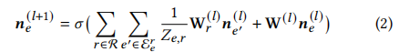
where 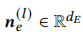 is the node representation of e(entities) at the l-th layer, denotes the set of neighboring nodes for e under the relationis a learnable relation-specific transformation matrix for the embeddings from neighboring nodes with relation r, is a learnable matrix for transforming the representations of nodes at the l-th layer and is a normalization factor.

4.2 KG Fusion via Mutual Information Maximization
Above, we obtain the node representations for the word-oriented KG and item-oriented KG, denoted by two embedding matrices V (𝒗𝑤 for word 𝑤) and N (𝒏𝑒 for item 𝑒), respectively.
In order to bridge the semantic gap between words and items, we propose to use Mutual Information Maximization technique, called MIM. MIM has been used to mutually improve the data representations of two coupled signals (e.g., input and output). Its core idea is based on the concept of Mutual Information (MI).
Given two variables 𝑋 and 𝑌, their MI is defined as:

𝑀𝐼(𝑋, 𝑌) = 𝐷𝐾𝐿 (𝑝(𝑋, 𝑌)||𝑝(𝑋)𝑝(𝑌)), (3)

where 𝐷𝐾𝐿 is the Kullback-Leibler (KL) divergence between the joint distribution 𝑝(𝑋, 𝑌) and the product of marginals 𝑝(𝑋)𝑝(𝑌).Usually, MI is difficult to compute. MIM tries to maximize it instead of seeking the precise value via the following formula:

𝑀𝐼(𝑋, 𝑌) ≥ E𝑃 [𝑔(𝑥, 𝑦)] − E𝑁 [𝑔(𝑥′, 𝑦′)], (4)

where E𝑃 and EN denote the expectation over positive and negative samples respectively, and 𝑔(·) is the binary classification function that outputs a real number which can be modeled by a neural network.

In our setting, we have two kinds of semantic units (namely words and entities), and would like to align their semantic representation spaces. Given a conversation, we first collect words (non-stopwords) and entities (including items) from the utterance text. For an entity-word pair ⟨𝑒,𝑤⟩ that co-occur in a conversation, we pull their representations close through a transformation matrix:
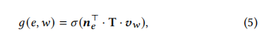
where 𝒏𝑒 and 𝒗𝑤 are the learned node representations for entity 𝑒 and word 𝑤 via KGs, respectively, T ∈ R𝑑𝐸×𝑑𝑊 is the transformation matrix that aligns two semantic spaces, and 𝜎(·) is the sigmoid function. To apply the MIM method, we can consider all the word-entity pairs co-occurring in a conversation as positive,while random word-entity pairs are considered as negative. By integrating Eq. 5 into Eq. 4, we can derive the objective loss over all the conversations and minimize the loss with an optimization algorithm.

However, a conversation usually contains a number of contextual words, and it is time-consuming to enumerate all the word-entity pairs. Besides, some of these words are noisy, which is likely to affect the final performance. Here, we add a super token ˜𝑤 for a conversation, assuming that it is able to represent the overall semantics of the contextual words. Instead of considering all the word-entity pairs, we only model the relation between each entity
and the super token ˜𝑤 using the 𝑔(·) function. We utilize self-attention mechanism for learning the representation of ˜𝑤:
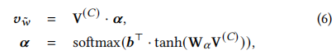
where V(𝐶) is the matrix consisting of the embeddings of all the contextual words in a conversation 𝐶, 𝜶 is an attention weight vector reflecting the importance of each word, and W𝛼 and 𝒃 are parameter matrix and vector to learn. Using such a super token, we can significantly improve efficiency and identify more important semantic information from the entire conversation.

Binary classifier g() 是在找ne 和 v~w是相关的，相关的就接近1，非相关的就接近0. word-entity pairs co-occurring in a conversation as positive, random word-entity pairs are considered as negative. 𝑀𝐼(𝑋, 𝑌) ≥ E𝑃 [𝑔(𝑥, 𝑦)] − E𝑁 [𝑔(𝑥′, 𝑦′)]，

In order to effectively align the semantic space of the two KGs, we adopt the MIM loss for pre-training the parameters of the GNN models in Section 4.1.1 and 4.1.2, which forces the two semantic spaces to be close at the beginning. During the fine-tuning stage,we treat the MIM loss as a regularization constraint for GNN to prevent overfitting.
With the representations of the fused KGs, we next describe how to make recommendations and generate utterances in Section 4.3 and 4.4, respectively.

4.3 KG-enhanced Recommender Module
we assume no previous interaction records are available. We can only utilize the conversation data to infer user preference.
First, we collect all the words that appear in a conversation 𝑐. By using a simple lookup operation, we can obtain the word or item embeddings learned through the graph neural networks in Section 4.2.

We concatenate the word embeddings into a matrix V(𝐶)（全部conversation）. Similarly, we can derive an item embedding matrix N(𝐶)（全部conversation） by combining the embeddings of items.

Next, we apply the similar self-attentive mechanism in Eq. 6 to learn a single word vector 𝒗 (𝐶)
for V(𝐶) and a single item vector 𝒏(𝐶) for N(𝐶) . 不是所有的v和n都有用。In order to combine the two parts of information, we apply the gate mechanism to derive the preference representation 𝒑𝑢 of the user 𝑢:
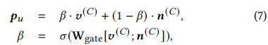
Given the learned user preference, we can compute the probability that recommends an item 𝑖 from the item set to a user 𝑢:
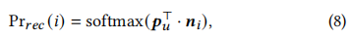
where 𝒏𝑖 is the learned item embedding for item 𝑖. We can utilize Eq. 8 to rank all the items and generate a recommendation set to a user. To learn the parameters, we set a cross-entropy loss as:
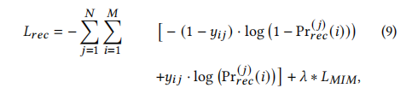

where 𝑗 is the index of a conversation,𝑖 is the index of an item, 𝐿_𝑀𝐼𝑀 is the Mutual Information Maximization loss(regularization), and 𝜆 is a weighted parameter. Here, we loop the entire collection and compute the cross-entropy loss. We only present the case that a conversation
has a ground-truth recommendation. While, it is straightforward to extend the above loss to the case with multiple ground-truth items.

4.4 KG-enhanced Response Generation Module
We adopt Transformer to develop the encoder-decoder framework. Our encoder follows a standard Transformer architecture. We mainly introduce the KG-enhanced decoder. To better generate responses at decoding, we incorporate KG-enhanced representations of context words and items. After the
self-attention sub-layer, we conduct two KG-based attention layerss to fuse the information from the two KGs:
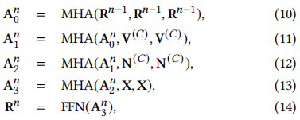
where MHA(Q, K, V) defines the multi-head attention function that takes a query matrix Q, a key matrix K, and a value matrix V as input:
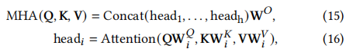
and FFN(x) defines a fully connected feed-forward network, which consists of a linear transformation with a ReLU activation layer:
Above, X is the embedding matrix output by the encoder, V (C) and N (C) are KG-enhanced representation matrices for words and items in a conversation c, respectively. are the representations after self-attention, cross-attention with embeddings from ConceptNet, cross-attention with embeddings from DBpedia and cross-attention with encoder output, respectively. Finally, R^n is the embedding matrix from the decoder at n-th layer.
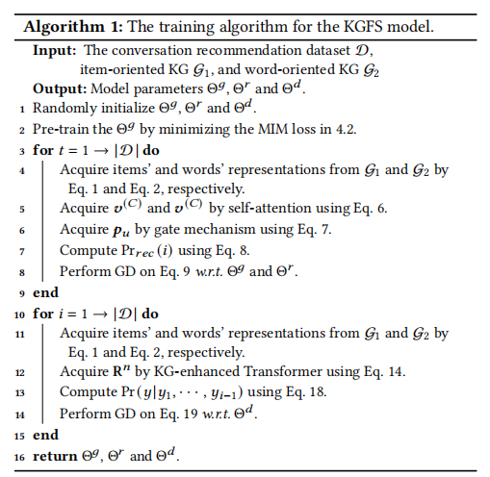
Compared with a standard Transformer decoder, we have two additional steps in Eq. 11 and 12. The idea can be described using a transformation chain: generated words eq11 −−−−−→ word-oriented KG eq12 −−−−−→ item-oriented KG eq13−−−−−→ context words.

Following such a chain, our decoder is able to gradually inject useful knowledge information from the two KGs in a sequential manner. The rationality for Eq. 12 lies in the fact that we have fused the two KGs as in
Section 4.2.
Different from chit-chat models, the generated reply is expected to contain the recommended items, related entities and descriptive keywords. We further adopt the copy mechanism to enhance the
generation of such tokens. Formally, given the predicted subsequence y1, · · · , y_i−1, the probability of generating yi as the next token is given as:
where Pr1 (·) is the generative probability implemented as a softmax function over the vocabulary by taking the decoder output Ri (Eq. 14) as input, Pr2 (·) is the copy probability implemented by following a standard copy mechanism over the nodes of the two KGs, and G1, G2 denote the two KGs we have used. To learn the response generation module, we set the cross-entropy loss as:
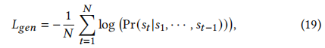where N is the number of turns in a conversation C. We compute this loss for each utterance st from C.

4.5 Parameter Learning
Our parameters to learn are organized by three groups, namely the KG module, recommender module and conversation module, denoted by Θg , Θr and Θd respectively. Algorithm 1 presents the training algorithm for our KGSF model. The three components share parameters and affect each other.
To train the joint model, we pre-train the knowledge graph module Θg using Mutual Information Maximization loss. Next, we optimize the parameters in Θr and Θg . At each iteration, we first
acquire words’ and items’ representations from the KG module.
Then, we perform the self-attention and gate mechanism to derive user representations. Finally, we compute a cross-entropy loss by Eq. 9 with the MIM regularization, and perform gradient descent
to update parameters Θr and Θg .
When the loss of the recommender component converges, we optimize the parameters in Θd . At each iteration, we first obtain words’ and items’ representations from the knowledge graph module. Then, we utilize KG-enhanced Transformer to derive the contextual representations. Finally, we compute the cross-entropy loss by Eq. 19, and perform gradient descent to update parameters in Θd .

