The Proposed Two-level Taxonomy
each level of which consists of two dimensions to，respectively, classify cross-domain recommendation scenarios and recommendation tasks.

The First Level: Classification of Recommendation Scenarios
the overlap of user sets and the overlap of item sets.

Dimension 1: the overlap of user sets
The overlap of user sets refers to whether there are common users between the user sets of two domains. The authors suggest that this overlap can be further divided into partial overlap and full overlap, leading to three sub-categories: user non-overlap, user partial overlap, and user full overlap.The first category is user non-overlap. Following the notations defined above, it can be denoted as UA ∩ UB = ∅. The second category is user partial overlap, which means UA！=UB and UA ∩ UB ！=∅. The third category is user full overlap, which means UA = UB.

Dimension 2: the overlap of item sets
The overlap of item sets refers to whether there are common items between the item sets of two domains. Similar to the user sets, the authors propose three sub-categories for item sets: item non-overlap, item partial overlap, and item full overlap.item nonoverlap, item partial overlap, and item full overlap. Similarly, they can be denoted as IA ∩ IB = ∅, IA ！=IB, IA ∩ IB != ∅, and IA = IB

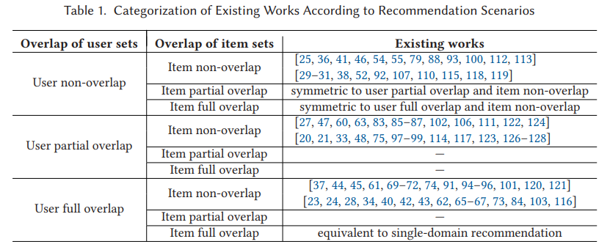
The authors note that there are currently no studies on three scenarios: user partial overlap and item partial overlap, user partial overlap and item full overlap, and user full overlap and item partial overlap.
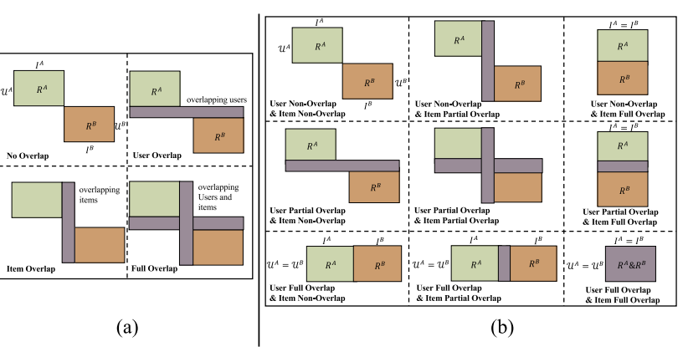
The Second Level: Classification of Recommendation Tasks.
cross-domain recommendation can be divided into two categories, that is, intra-domain recommendation and inter-domain recommendation
Considering whether the number of target domains is single or multiple, cross-domain recommendation can be divided into other two categories, i.e., single-target crossdomain recommendation and multi-target cross-domain recommendation.

Dimension 1: whether recommended items are in the same domain as the user.
Intra-domain means在一个domain中，再把user和item分成若干subset，然后把subet1的user 用过的item 推荐给类似但没用过的user
inter-domain recommendation, the recommended items are from a different domain with the user真正的cross domain

Dimension 2: whether the number of target domains is single or multiple

Single-target recommendation: In this scenario, there are two domains involved - a source (or auxiliary) domain and a target domain. The source domain is typically dense, meaning it has a lot of interactions or data. The target domain, on the other hand, is sparse, meaning it has less data or fewer interactions. The goal here is to use the extensive information from the source domain to improve the recommendation performance in the target domain.

Multi-target recommendation: Here, the assumption is that both domains are sparse, that is, they have fewer interactions or lack certain types of information. The goal of a multi-target recommendation system is to improve the performance of both domains by leveraging the information from each domain. In this scenario, there isn't a clear distinction between a source domain and a target domain. Instead, the system seeks to enhance both domains simultaneously by sharing knowledge between them.
2.3 Method-based Categorization under Different Recommendation Scenarios

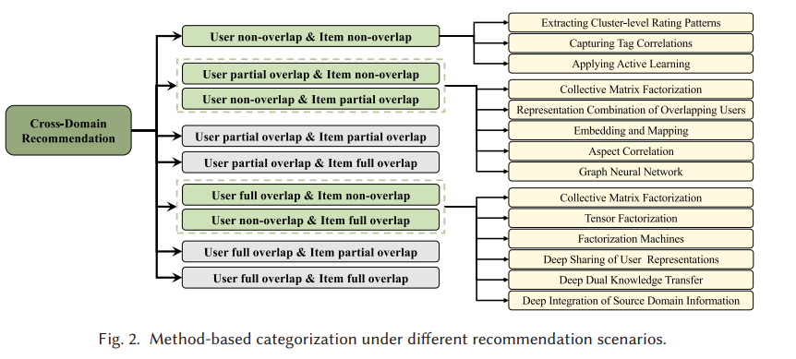
3 SCENARIO 1: USER NON-OVERLAP AND ITEM NON-OVERLAP
Three classes of approaches for this scenario are mentioned:
Extracting cluster-level rating patterns
Capturing tag correlations
Applying active learning technology

Extracting cluster-level rating patterns
.This process helps to overcome the problem of non-overlapping users or items between domains by finding and leveraging underlying similarities among broader clusters of ratings.
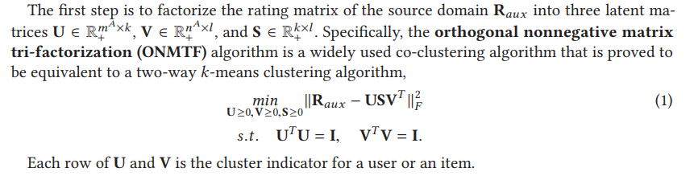
通过ONMTF的loss 来找出best representation of R_aux (USV), you get three matrices: U, V, and S. Here, U and V are the cluster indicators for users and items, and S captures the relationships between these clusters.

Next step,construct a compact matrix B that encodes the cluster-level rating patterns of k clusters of users and l clusters of items that are shared between domains. The third step is to get the cluster indicator matrices Utдt and Vtдt in the target domain by transferring B to the target domain
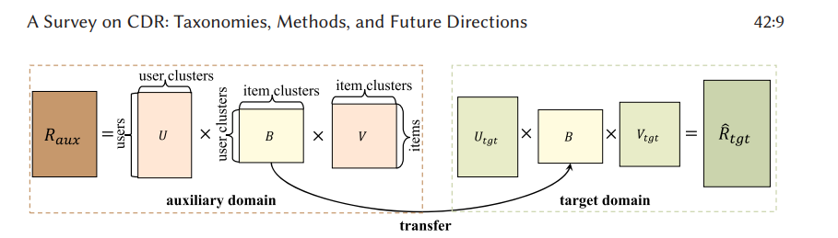
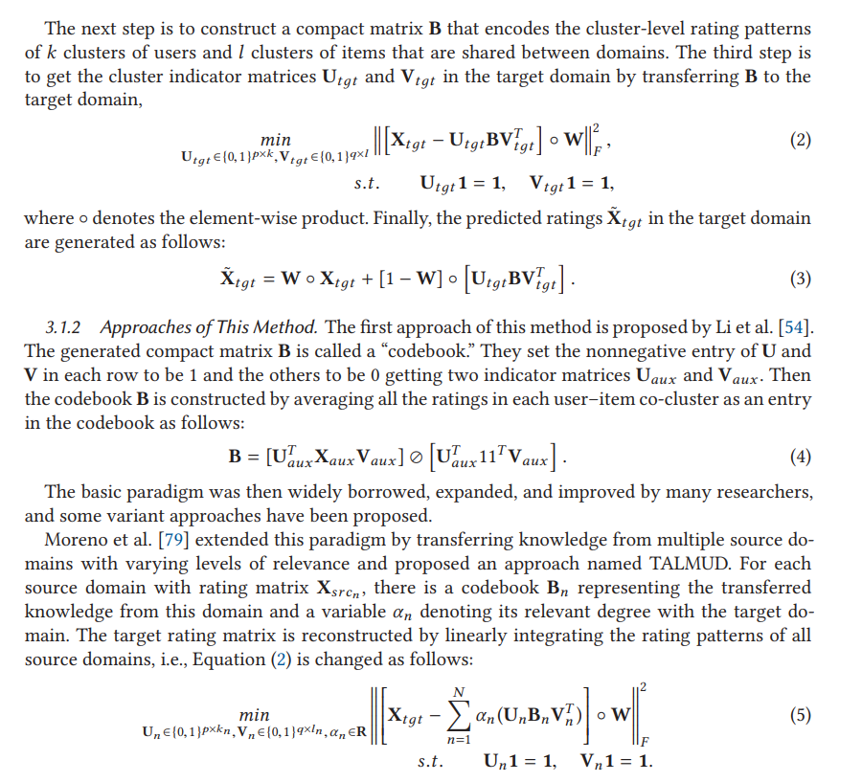
TALMUD，Multiple domain,所以要有权重。

Some researchers proposed that there simultaneously existed common cluster-level rating patterns shared across domains and domain-specific cluster-level rating patterns for each domain.
So the final predicted rating should combine these two patterns

In the Cluster-Level Latent Factor Model (CLFM) proposed by Gao et al., the cluster-level rating patterns B in each domain are divided into a common part (B0) and a domain-specific part (Bτ)that is Bτ = [B0, Bτ ]

Ren et al.'s Probabilistic Cluster-level Latent Factor (PCLF) model takes a similar approach, jointly learning a common cluster-level rating matrix and a domain-specific cluster-level rating matrix.
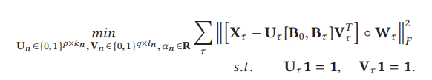

All of the approaches mentioned above are for single-target recommendation as they explicitly extract cluster-level rating patterns in the source domain and then transfer them to the target domain.

3.1.3 Expand to Multi-target Recommendation
(没有很重要）
Li et al. proposed the Rating-Matrix Generative Model (RMGM) which integrates several sparse domains and assumes that these multiple domains share common latent cluster-level patterns(B0). The model then learns the probabilities of each user and item belonging to this shared latent structure.

Iwata et al. suggested that the latent factors of users/items generated by matrix factorization in each domain were from a common Gaussian distribution. The same mean vector and covariance matrix were used to align the latent factors from different domains.

Wang et al. proposed the Cross-Domain Item Embedding method based on Co-Clustering (CDIE-C) for cross-domain session-based recommendations. The core idea of CDIE-C is to extract cluster-level correlations by exploring cross-domain co-occurrence relations of items based on the co-clustering method. This allows the model to capture both item-level sequence information within each domain and cluster-level cross-domain correlation information to generate the final cross-domain recommendation.

Capturing tag correlations

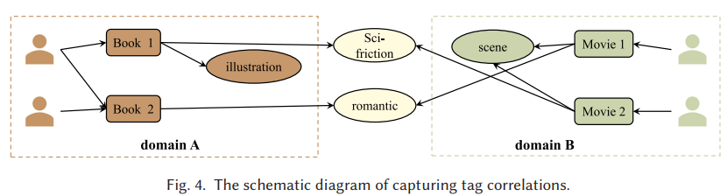

This method assumes that even though the users and items may be different across domains, the tags used by users to annotate their interests may be the same across these domains.

Enhance the profiles of users and items: Tags can be used to enrich the information about the users and the items. For example, Enrich et al. proposed using tags as implicit user feedback to enhance item factors, while Fernandez-Tobias et al. claimed to enrich both user's and item's profiles with the tags they used and received respectively.

Construct similarity matrices: Tags can also be used to construct similarity matrices among users, items, and tags. For example, Shi et al. proposed a tag-induced cross-domain collaborative filtering (TagCDCF) algorithm. This method creates user-to-user and item-to-item similarity matrices based on shared tags. These matrices are then incorporated into the matrix factorization process as additional constraints. This encourages similar users/items to have closer representations, improving the quality of the recommendations.

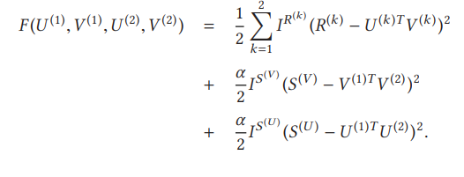

it exploited shared tags to construct cross-domain user-to-user similarity matrix S(U )and item-to-item similarity matrix S(V ) .

不重要！！！
Enhanced Tag-induced Cross-Domain Collaborative Filtering (ETagiCDCF): Hao et al. proposed proposed that the number of shared tags between domains was limited,and wastes domain-dependent tags. ETagiCDCF groups domain-dependent tags into clusters based on their co-occurrences with shared tags, and then uses these tag clusters to compute cross-domain user-to-user and item-to-item similarities.

Semantic Correlations in Tagging Systems (SCT): Zhanget al. proposed that although there were a limited number of shared tags between domains,two non-identical tags in two domains might be semantically related.he considered the possibility of semantically related non-identical tags across domains. They proposed using word2vec to analyze all tags and generate continuous vectors, capturing contextual information and semantic similarities between tags. This allows the calculation of both intra-domain and inter-domain similarities.

Tag Co-occurrence Matrix: Instead of constructing similarity matrices between users and items, Fang et al. proposed constructing a tag co-occurrence matrix that captures the relationships among tags. This matrix is then used to tri-factorize the rating matrix in each domain, and the factorization process is optimized to make the generated co-occurrence matrix as close to the constructed one as possible.

Expand to Inter-domain Recommendation.
Semantic-Clustering-based Cross-Domain (SCD) Recommendation: Kumar et al. suggest that although the vocabularies of different domains may not explicitly match, semantic relationships between words from distinct domains can be derived through ontologies. Their SCD recommendation algorithm first performs semantic clustering to obtain clusters of semantically equivalent words. SCD then generates item-based and user-based topic distributions, and maps the user profiles to the target domain to perform inter-domain recommendations.

3.3 Applying Active Learning
主动学习是一种特殊的机器学习方法，其中模型能够有选择地获得需要学习的信息。在标准的监督学习中，通常会对所有数据进行标记，然后模型会从这些标记的数据中学习。然而，对所有的数据进行标记可能是非常耗费时间和成本的。
在主动学习中，模型会自己选择哪些数据点是它最需要从中学习的，然后请求对这些数据点进行标记。这样可以使得学习过程更加高效，因为模型主要从最有价值的数据中学习。
例如，一个主动学习的图像分类模型可能会发现它对某些图像的分类最不确定。这些图像可能是模糊的，或者是包含模型之前未见过的物体。然后，模型会请求人类专家对这些图像进行标记。一旦这些图像被标记，模型就可以从这些最有挑战性的例子中学习，从而提高其性能。
这边不太懂！
Zhao et al. [118] proposed a margin-based active learning
approach that selected the entities in the target domain with low prediction certainty. They first applied a maximum-margin matrix factorization (MMMF) in the target domain to get the original user and item latent factors.

comparative analysis of three methods used in recommendation systems where there is no overlap between users and items.

Extracting Cluster-Level Rating Patterns: This method transfers knowledge at a group or cluster level, instead of at an individual user level, which may limit its performance. However, this approach is versatile and can be applied when there are no overlapping entities, either users or items, between domains.

Capturing Tag Correlations: This method relates domains explicitly using tags, and tends to perform well. Furthermore, the concepts behind this method can be extended to link domains using comments and external knowledge. However, this method becomes impractical when additional data is unavailable.

Applying Active Learning: This method involves the use of human resources to transform the non-overlap scenario into a partial overlap scenario, enhancing recommendation performance. However, this method requires a budget and its performance depends on the number and quality of identified entity pairs.

4 SCENARIO 2: USER PARTIAL OVERLAP AND ITEM NON-OVERLAP
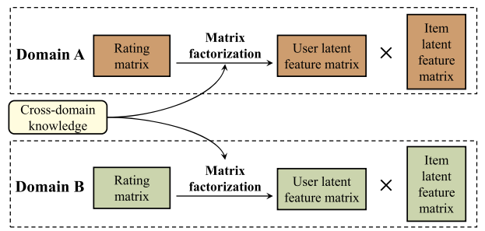

Basic Paradigm of CMF: 与MF不同的是， CMF uses cross-domain knowledge to constrain the matrix factorization process within each domain.

Approaches using CMF:

XPTRANS: Jiang et al. proposed a semi-supervised transfer learning approach, where they argue that similarities between overlapped users are consistent across domains. They add these user-based similarities as constraints in the matrix factorization process.

joint cross-domain user clustering and similarity learning recommendation algorithm
JCSL: Rafailidis et al. proposed a recommendation algorithm that considers both cluster-based and user-based cross-domain similarities. The resulting similarity matrices are used as regularization terms during matrix factorization.

cross-domain recommendation approach with collaborative ranking
CDCR: Rafailidis et al. also proposed an approach that emphasizes ranking performance in generating recommendations. They learn a cross-domain user latent matrix to capture user correlations across domains and incorporate it as a constraint in learning user/item latent factors.

kernel-induced knowledge transfer
KerKT: Zhang et al. proposed a recommender system for scenarios with partially overlapping users. They use overlapping users to train a domain adaptation function and ensure consistency of the transferred knowledge.

Multi-site Probabilistic Factorization
MPF: Yang et al. proposed a generative model that models cross-site user preferences and site-specific user preferences simultaneously. For users present on multiple sites, their latent feature vectors consist of a common part and a site-specific part.

4.2 Representation Combination of Overlapping Users
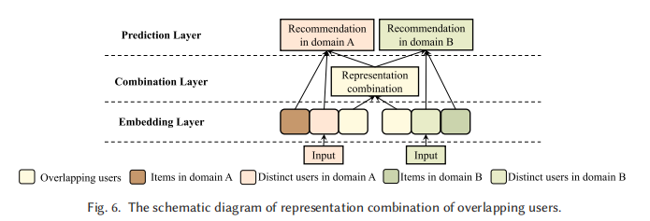
This method involves three layers:

The embedding layer generates embeddings (vector representations) for users and items in each domain.
The combination layer combines embeddings of overlapping users from both domains to generate unified embeddings.
The prediction layer uses the embeddings of distinct users and overlapping users to train the recommendation model separately for each domain.
Several approaches of this method are highlighted:

Zhu et al.'s Dual-Target Cross-Domain Recommendation (DTCDR), which generates user and item embeddings from both rating and content information. It combines the embeddings of overlapping users using concatenation, max-pooling, and average-pooling.

Their Graphical and Attentional framework (GA-DTCDR), uses a graph embedding technique (Node2vec) to generate more representative embeddings, and an element-wise attention mechanism to more effectively combine the representations of overlapping users.

Perera et al.'s approach, captures the dynamic nature of user preferences. It generates user's topical distribution by topic modeling in each domain and uses transfer functions to map these preferences. It fuses preferences from both domains for overlapping users.

Their time-aware unified cross-network solution considers short-, long-, and long short-term levels of user preferences. The three-level preference representations in both domains are integrated to obtain users' final representations.

4.3 Embedding and Mapping

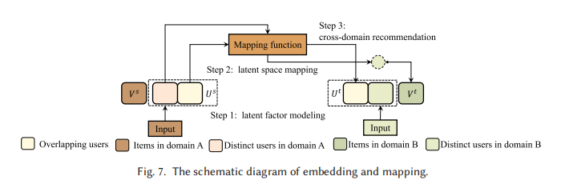
The "Embedding and Mapping" method is an approach to cross-domain recommendation. This method consists of three steps: latent factor modeling, latent space mapping, and cross-domain recommendation. In the latent factor modeling process, user and item latent factors are generated in each domain. The latent space mapping process involves training a mapping function that establishes relationships between the latent spaces of different domains.
Relationship function fu optimization：
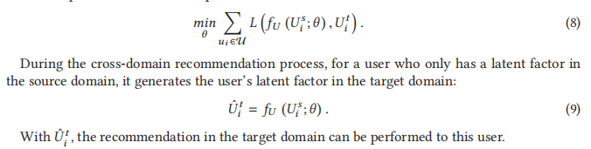

跟PTUPCDR的bridge function 一样，所以mapping function 又叫bridge function

In the cross-domain recommendation step, a user’s latent factor is generated in the target domain, if it only exists in the source domain.

Several different approaches to this method have been proposed. For example, the "Embedding and Mapping framework for Cross-Domain Recommendation" (EMCDR) applies Matrix Factorization and Bayesian Personalized Ranking for latent factor modeling, and uses both linear and non-linear functions based on Multi-Layer Perceptron for latent space mapping.

This idea was widely improved by many researchers and the improvement is mainly in two aspects: One is the latent factor modeling process, and the other is the latent space mapping process.
不重要！！！
For latent factor modeling,
Wang et al. proposed the Cross-Domain Latent Feature Mapping (CDLFM) model, which includes three types of similarity measurements on user rating behaviors. These similarity values are integrated into the matrix factorization process as constraints.
Fu et al. introduced the Review and Content-based Deep Fusion Model (RC-DFM), which uses stacked denoising autoencoders to merge review text and item contents with the rating matrix. This results in user and item representations containing more semantic information.
Bi et al. suggested constructing a heterogeneous information network, taking into account interaction sequence information to effectively learn user/item representations in each domain. These proposed methods have proven effective in cross-domain insurance recommendations.

For latent factor mapping,
Zhu et al. developed a Deep framework for both Cross-Domain and Cross-System Recommendation (DCDCSR), considering the rating sparsity degrees of individual users/items to create benchmark factor matrices. The mapping function was trained to adjust the latent factor matrices of users and items to these benchmarks.

Kang et al. noted that the training of mapping functions in existing EMCDR-based approaches relies solely on overlapping users, which limits their performance due to the typically small number of overlapping users in real-world datasets. They proposed a Semi-Supervised framework for Cross-Domain Recommendation (SSCDR), which uses both overlapping users and source domain items to train the mapping function.

Zhu et al. also argued that the mapping function tends to be biased towards the limited overlapping users, reducing the model's generalization ability. They suggested the transfer-meta framework for CDR (TMCDR), which can replace the training procedure of most existing EMCDR-based methods while maintaining good generalization ability.

Zhu et al. later suggested that the complex relationships between user preferences in the source and target domains vary from user to user, making them difficult to capture with a single mapping function. Their Personalized Transfer of User Preferences for Cross-domain Recommendation (PTUPCDR) framework learns a meta-network to personalize a mapping function for each user.

Wang et al. proposed a similar approach, Low-dimensional Alignment for Cross-Domain Recommendation (LACDR), which trains an encoder and decoder in both the source and target domains using overlapping and non-overlapping users. For a cold-start user, the representation in the target domain is generated by first creating a domain-invariant factor using the encoder from the source domain, then mapping this factor to the latent factor in the target domain using the target domain's decoder.

4.4 Graph Neural Network–based Approaches

