GraphQL

**URL:** <https://backend.lolvvv.com/api/graphql>

**HTTP Method:** POST

# Matches of Pros

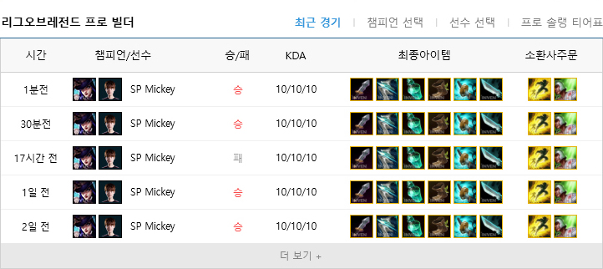

## 1.1 GraphQL Query