******************************
EPSG Geodesy Parameters
Version 4.3, 26th July 1999
******************************

The European Petroleum Survey Group (EPSG) has compiled and is distributing this set of parameters defining various geodetic and cartographic coordinate systems to encourage standardisation across the Exploration and Production segment of the oil industry. The data is included as reference data in the GeoTIFF data exchange specification, in Iris21 the Petroconsultants data model, and in Epicentre the POSC data model. Parameters map directly to the POSC Epicentre model v2.2, except for data item codes which are included in the files for GeoTIFF and data management purposes, and the compound coordinate system data that will map to POSC Epicentre model v3.0.

Contents of this document
- use of the data
- criteria for inclusion of data
- new in this version 4.3
- data availability
- shipping list
- data structure
- tables
- EPSG codes
- queries
- reports
- EPSG geodesy working group
- simplified entity relationship diagram

Use of the Data

1) All data pertinent to a specific coordinate system must be copied without modification and all related pages must be included;

2) All components of this data set pertinent to any given coordinate system must be distributed together (complete distribution of all components of the data set is preferred, but the EPSG recognises the need for a more limited distribution);

3) The data may not be distributed for profit by any third party; and

4) The original source [EPSG] must be acknowledged.

The user assumes the entire risk as to the accuracy and the use of this data. The data may be copied and distributed subject to the following conditions:

INFORMATION PROVIDED IN THIS DOCUMENT IS PROVIDED "AS IS" WITHOUT WARRANTY OF ANY KIND, EITHER EXPRESSED OR IMPLIED, INCLUDING BUT NOT LIMITED TO THE IMPLIED WARRANTIES OF MERCHANTABILITY AND/OR FITNESS FOR A PARTICULAR PURPOSE.

Criteria for inclusion of data
Criteria used for material in these lists include:
- information must be in the public domain: "private" data not released and available to the general public is not included.
- data must be in current use by a significant number of users.
- parameters are given to the precision consistent with the original publication documents. EPSG aims for derived coordinates to be to a precision of one centimetre or better.

Modifications implemented in Version 4.3 include the following:
- Improved reporting capability within the EPSG database, including the ability to search on area of use or coordinate system name.
- The number of queries is greatly reduced from the previous version of the database, with no loss of usable information.
- Changes as documented in Change table records through 99.34, but with actions still remaining on some earlier change requests. The improved reporting now provides a quick summary report of changes implemented in this version and those change requests that remain outstanding.
- EPSG has abandoned the term “compound transformation” in favour of “concatenated transformation” to minimize confusion with compound coordinate systems.

Data Availability

This version 4.3 is available for downloading from the EPSG internet web site at www.petroconsultants.com/products/geodetic2.html at no charge as an MS Access v7 relational database only, as was done for Versions 4.1 and 4.2 (unlike earlier versions which included spreadsheet and comma-separated variable files dumped from database tables). The EPSG has discontinued publication of the data in comma-separated variable (.csv) and MS Excel (.xls) file formats, as well in MS Access v2. Users who cannot cope with this MS Access v7 format should either email the EPSG working group or contact one of the EPSG working group members listed below for assistance.

The parameter listings are "living documents" and will be updated by the EPSG from time to time, usually following meetings in April and October/November. Comments or suggestions for improvements may be submitted at any time.

The master dataset is available only at this site, with data supplied directly from EPSG. Users are discouraged from making the data available on alternate sites, but instead are encouraged to provide hot links to the EPSG site. This will reduce or eliminate the potential problem of users accessing versions of the data that have been superseded.

Copies may also be obtained on MS-DOS formatted diskette from Jean-Patrick Girbig at the address below at a cost of US$100 to cover media and shipping; payment to be made in favour of IHS Energy Group at Union Banque Suisses, 1211 Geneve 11, Switzerland (compte number 403 458 60 K).

To be on an electronic mailing list to receive notification of updates at no charge, select the subscribe option on the EPSG web site.

Shipping List

This Version 4.3 data set consists of
- one MS Access v7 database file (epsg_v43.mdb) which includes 24 related tables, 24 queries which tabulate the information in these related tables in desired formats, 17 reports and 1 form from which to run the various reports.
- a README file in MS Word for Windows v6.0 (this file).
Both files are available zipped or unzipped.

Data Structure

Area of Use
The database includes an area table. When rersources permit, it is intended to populate this and to relate coordinate system and transformation records to it in future versions of the EPSG geodesy parameters. In the mean time, geodetic data records contain text fields describing area of use. ISO country names (in English) are included in these texts.

Horizontal Coordinate Systems
The POSC data model used by EPSG describes a general 2D horizontal coordinate system type with subtypes of geographical 2D and projected 2D. Early versions of the EPSG data have listed these subtypes in separate tabulations. GeogCS and ProjCS data are both held in the Horiz_CS database table. GeogCS and ProjCS subtype data are generated through database queries.

The components required for a geographic coordinate system - geodetic datum, ellipsoid and prime meridian - are held in related tables. This version of the EPSG database provides all ellipsoidal parameters to the precision provided in the original definition. When inverse flattening, 1/f, is one of the published defining parameters it has been given to the original publication precision. In the case of calculated 1/f values where an alternative parameter such as semi-minor axis, b, was used for the original definition, the 1/f values are displayed to five decimal places (which allows computation of semi-minor axis to better than 0.5 mm).

A projected coordinate system is the result of the application of a projection transformation to a geographic coordinate system. Each ProjCS record in the HorizCS table includes the name of the relevant source GeogCS. The projection transformation method and parameters for the ProjCS are recorded in the transformation_method and non-polynomial_transformation tables respectively.

For any one EPSG geographic or projected 2D coordinate system, both axes of that system must have the same units.

Transformations between Geographic Coordinate System
The data includes transformations between geographic coordinate systems. These transformations have been named ‘geodetic transformations’ in the data model; in the survey industry they are commonly called ‘datum transformations’. It must be recognised that the use of these transformations requires geodetic understanding. The EPSG recommends geodetic transformations as published by the appropriate national mapping authority, where available.

The following are highlighted:

- geodetic transformations describe the relationship between two coordinate systems. They do not describe the relationship between a coordinate system and the earth - this is done through a datum definition - and therefore are not essential for coordinate system definition.

- transformations between some coordinate system pairs are executed as a sequenced series of transformations through intermediate coordinate systems. These are named Concatenated Transformations in the database. For example, the transformation recommended by the 6 nations bordering the North Sea between the ED50 and WGS84 geographic coordinate systems is in two stages: ED50 to ED87 and ED87 to WGS84. The database model accommodates this by describing a transformation path comprised of one or more steps, where each step is a separate geodetic transformation.

- transformation methods using 3- or 7-geocentric parameters often do not completely model the relationship between two coordinate systems. As a consequence such transformations may not be sufficiently accurate for all applications. To improve the accuracy of transformations between any pair of geographic coordinate systems, several parameter sets may exist, each relevant to different areas or for different applications. This has been implemented in the model by allowing several ‘variants’ of the transformation between the same two geographic coordinate systems. Each variant has its own set of parameters.

- transformations between geographic coordinate systems often use geocentric transformation methods as an intermediate step. Applications using the parameters listed for such transformations will have to apply a transformation from geographic to geocentric coordinates before applying the geocentric transformation, and afterwards apply a geocentric to geographic transformation. (Geographic to/from geocentric transformations require no parameters other than those defining the ellipsoid appropriate to the geographic coordinate system and thus are not separately given in the EPSG database).

- in this version (v4.3) of the EPSG data it has not been possible to establish reliable parameters for the relationship to WGS84 for all geographic coordinate systems given in the data set, although much progress has been made toward this planned action of the EPSG Geodesy Working Group.

- geodetic transformations usually act on 3-dimensional coordinate systems. This requires the addition of ellipsoidal height to a geographic 2D coordinate system.

Details of transformation formulae with which the EPSG data is compatible are given in EPSG guidance note 7, POSC literature pertaining to Geographic and Projected Coordinate System Transformations

Vertical Coordinate Systems
The database contains separate vertical coordinate system and vertical datum tables. Transformations between vertical coordinate systems are listed in the vertical offset table, describing the height or depth difference between two parallel vertical datum surfaces. This EPSG data set does not cover relationships between vertical coordinate systems more complex than simple offsets.

Compound Coordinate Systems
The horizontal and vertical components of a description of position in three dimensions may sometimes come from different coordinate systems rather than through a single 3D coordinate system. This is always the case with heights related to sea level which have to obtain a horizontal location from an unrelated system. This is handled through a Compound Coordinate System which identifies the two Coordinate Systems utilised. Each of these two systems is then be described in the normal way. The database contains a table of compound coordinate systems. In this version of the database (v4) the table has been populated with sample compound systems to
demonstrate the concept. Data for transformations between compound and other compound or 3D coordinate systems are not included in this version of the database.

Tables
The 24 tables containing the basic data are unchanged in title from the previous version 4.2. All changes in either format or content are documented in the Change table records (run report "changes this release" for details). Data tables are:

area an embryonic table to hold area of use data. This table is not yet linked or utilised in the data model’s relationships.
change a record of corrections to records.
codes used by EPSG for database administration.
compd_cs compound coordinate system data.
ellipsoid ellipsoid data.
ellips_alias ellipsoid alias data.
geod_datum geodetic datum data.
gdatum_alias geodetic datum alias data.
geod_trf geodetic transformation data.
horiz_cs geographic and projected coordinate system data.
p_meridian prime meridian data.
trf_method transformation method and parameter data.
trf_nonpolynomial projection and 3- or 7-parameter geodetic transformation parameter values.
trf_polynomial polynomial geodetic transformation parameter values.
trf_path geodetic transformation path data.
uom_angle angle unit data.
uom_an_alias angle unit alias data: currently not populated.
uom_length length unit data.
uom_le_alias length unit alias data.
uom_scale scale unit data.
uom_sc_alias scale unit alias data: currently not populated.
vert_datum vertical datum data.
vert_cs vertical coordinate system data.
vert_offset vertical coordinate system transformation data.

See the simplified entity relationship diagram at the end of this document.

EPSG Codes

EPSG has reserved the integer range 0 to 32767 for use as codes. To prevent conflict with future EPSG additions to the data, users who wish to augment the data with their own information should utilise codes greater than 32768.

The POSC data model uses EPSG name rather than the code as the key. EPSG names are therefore unique and cannot be used to refer to alternative sets of data

Queries
The 24 queries in v4.3 which tabulate the basic data from the related tables are given below. Where the description includes an asterisk (*), a report [see below] based on this query is also available.

changes still outstanding * Tabulates Change requests with outstanding actions still needed.

changes this release * Tabulates Change requests implemented in this version.

compnd_cs * Tabulation from a search by user input area name of compound coordinate systems, that is those “2D+1D” coordinate systems in which unrelated horizontal and vertical components are combined to form a 3D description of position..

concat trf * Tabulation of concatenated geodetic transformations, that is those geodetic transformations which have more than one step. (This was called “compound.trf” in previous versions of the database).

concatTrfStep Tabulation of concatenated transformation steps. This is used by the concat trf query.

ellips * Tabulation of reference ellipsoids.

g_datum Tabulation of geodetic datums including related ellipsoid data.

geodetic tfm
(Non-polynomial - all) * Tabulation of all non-polynomial geodetic transformation data by user-defined area name or source geographic coordinate system.

geodetic tfm (polynomial) * Tabulation of all polynomial geodetic transformation data by user-defined area name or source geographic coordinate system.

geodetic_tfm
(Bilinear interpolation) Tabulation of geodetic transformation data using bi-linear interpolation methods, by area.

geodetic_tfm
(Geocentric 3-param) Tabulation of geodetic transformations using the 3-parameter geocentric "datum shift" method, by area.

geodetic_tfm
(Geocentric 7-param) Tabulation of geodetic transformations using 7-parameter geocentric "datum shift" methods, by area.

geodetic_tfm (geocentric all) Tabulation of geodetic transformations using 3- and 7-parameter geocentric methods, by area.

geodetic_tfm
(Geographical offset) Tabulation of geodetic transformations using the geographical offset method, by area.

geodetic_tfm
(Longitude rotation) Tabulation of geodetic transformations using the longitude rotation method, by area .

geodetic_tfm
(Other nonpoly) Tabulation of geodetic transformations using methods other than those above, by area .

geogcs * Tabulation of Geographic Coordinate Systems to which latitude and longitude coordinates may be referenced, by user-defined area name. This table includes the related geodetic datum, ellipsoid and prime meridian data.

pmerid * Tabulation of prime meridians.

projcs *Tabulation of Projected Coordinate Systems to which map grid coordinates may be referenced, by user-defined area name. Includes projection parameters.

unit_angle * Tabulation of angle units.

unit_length * Tabulation of length units

unit_scale Tabulation of scale units used in geodetic transformation parameters.

vertcs * Tabulation of Vertical Coordinate Systems based on the geoid to which heights or depths may be referenced, by user-defined area name. (Heights referenced to an ellipsoid form part of a three-dimensional geographic coordinate system).

v_offsets * Tabulation of offsets between Vertical Coordinate Systems, by user-defined area name.

Note that the proj_* queries that were in the version 4.2 of the EPSG database have been removed. There were six files in the v4.2 release of the data, one file for each group of projection transformation methods that used the same set of transformation parameters. These queries are no longer supported. The information is contained in the Projected Coordinate Systems queries.

Reports

This Version 4.3 of the EPSG database has been expanded to include a "run reports" front end form, from which it is possible to lauch a number of specific reports.

The "run reports" screen looks as follows:

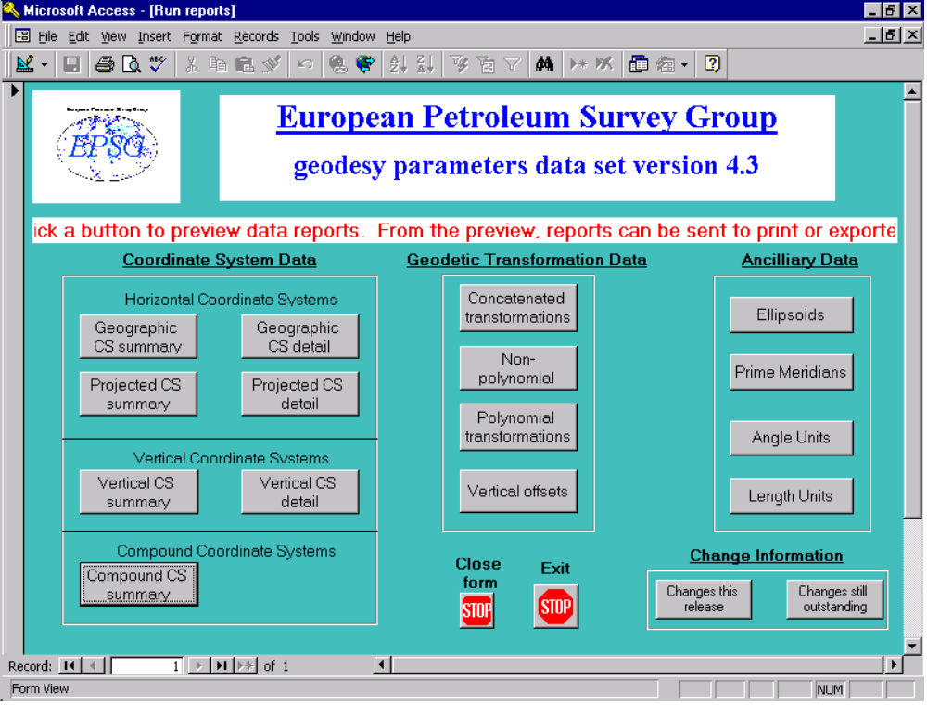

‘Exit’ quits Access. ‘Close form’ puts the user into Access where tables and queries can be viewed directly.

These 17 reports include the ability to seach the database and obtain reports based on user-defined "area of use". Detailed reports based on an input area of use or coordinate system name are available for various transformation types (transformations held in the non-polynomial table, transformations held in the polynomial table, and vertical offsets) and for the primary coordinate system types (geographic coordinate systems, projected coordinate systems and vertical coordinate sytems). In addition, summary reports are available for the four coordinate system types (geographic coordinate systems, projected coordinate systems, vertical coordinate sytems and compound coordinate systems) and for concatenated transformations. Reports for reference purposes can also be run for all ellipsoids, angle units, length units, and prime meridians contained in the database. (Most datum information is included in the EPSG geographic or vertical coordinate system based on that datum). It is also possible to review what changes have been implemented in this version as well as what changes remain outstanding.

Each “area search” is actually a text search that runs on both the area of use and name fields in the relevant tables or queries. The reports are not currently linked to the more general Area table. Searches can be made by country name (ISO English spelling) and in the case of the projected coordinate system report in addition by US state name, state 2-character postal zip code abbreviation, or county name. In all these searches, Access requires an exact text string match. The area fields generally contain several country names and/or regional descriptions and a search on one country name will therefore fail. Users are recommended to include their text string within two wild-card characters; for example to search for Oman enter *oman*. This will retrieve all records which include Oman within the area of use or name fields; however it will also retrieve data for Romania. To produce a report with all possible contents simply enter a single wildcard (*).

Reports are dependent upon printer drivers in use. Users may need to modify printer setup the first time they use the report feature. For screen viewing, the reports work best at 75 % viewing size (user may set in MS Access) using large fonts (set in Control Panel/Display).

EPSG Geodesy Working Group (send any comments or queries to the entire group by email to: epsg@ihsenergy.com )

Roger Lott (chairman),  Head of Survey,  BP Amoco Exploration,  Building 200, Chertsey Road,  Sunbury on Thames,  Middlesex, TW16 7LN,  England, UK. | Jim Cain,  Western Geophysical Company,  3600 Briarpark Drive,  Houston,  Texas 77042-4299,  U.S.A. | Jean-Patrick Girbig,  Manager of Cartography,  IHS Energy Group  PO Box 152,  24 Chemin de la Marie,  1258 Perly,  Geneva,  Switzerland.
Roel Nicolai,  Shell International E&P b.v,  EPT-AM,  Research and Technical Services,  Volmerlaan 8,  PO Box 60,  2288 GD Rijswijk,  The Netherlands. | Pierre Zakia,  Elf Exploration and Production,  CST JF, Avenue Larribau,  64018 Pau,  France.

EPSG
26th July 1999

