Proving that this database is 3NF:

First normal form: Contains no repeating groups of columns, and all atomic values

Attributes:

Daily Date Hourly Date Email

Daily Time Hourly Time Password

Daily zipcode Hourly Zipcode User type

Daily temp Hourly Temp Feedback date

Daily High/low Hourly High/Low Feedback time

Daily feels Hourly Feel Feedback username

Daily Dew point Hourly Dew Point Feedback text

Daily UV Hourly UV

Daily Wind Hourly Wind

Daily Humidity Hourly Humidity

Daily Description Hourly Description

Daily Pressure Hourly Pressure

Second normal form: All columns depend on the primary key

Daily Date (PK) Hourly Date (PK) Email (PK)

Daily Time (PK) Hourly Time (PK) Password

Daily zipcode (PK) Hourly Zipcode (PK) User type

Daily temp Hourly Temp Feedback date (PK)

Daily High/low Hourly High/Low Feedback time

Daily feels Hourly Feel Feedback username

Daily Dew point Hourly Dew Point Feedback text

Daily UV Hourly UV

Daily Wind Hourly Wind

Daily Humidity Hourly Humidity

Daily Description Hourly Description

Daily Pressure Hourly Pressure

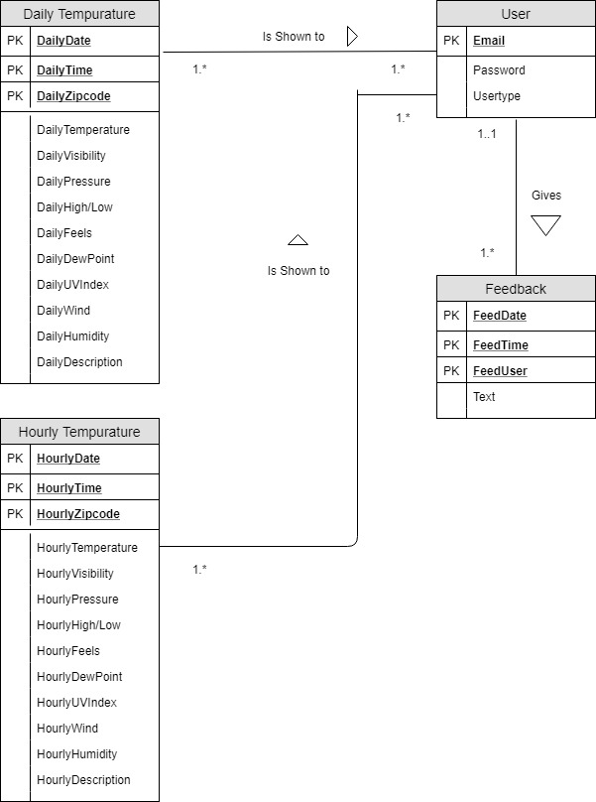Third normal form: All columns are not transitively dependent on the primary key