

 

**Nuke Node Graph Easy Navigate**

Hossein Karamian

Version 2.0

## What is Km NodeGraph Easy Navigate ?

It’s a tool to create node graph bookmarks and jump between them easily. Especially useful in large node graphs.

## Compatibility

OS: Window, Linux

Nuke Version: 13.x, 12.x, 11.x, 10.x

## Installation

Copy "Km_NodeGraphEN" folder to Nuke’s plugins directory and add following single line code to end of the init.py file:

nuke.pluginAddPath('./Km_NodeGraphEN')

For Example, copy "Km_NodeGraphEN" folder to :

C:\Program Files\Nuke12.1v1\plugins

And add the code to :

C:\Program Files\Nuke12.1v1\plugins\init.py

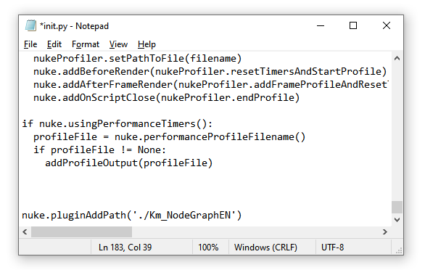

## How to use

**Display BookMark Panel:** Default shortcut to show the main window is “shift+e”

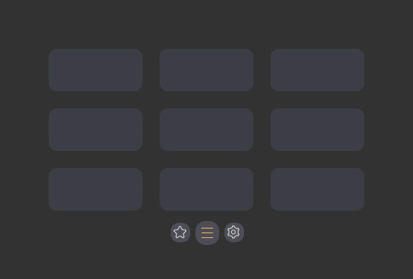

Or from menu bar :  
 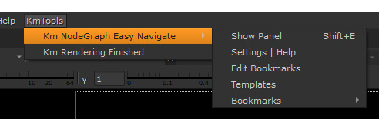

**Assign New Bookmark:** Select a node (or backdrop), then left click on an empty bookmark to assign selected node to it

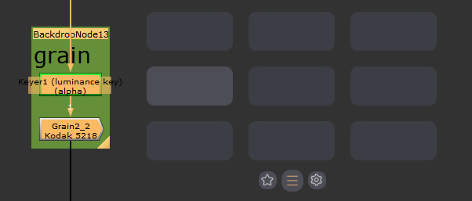

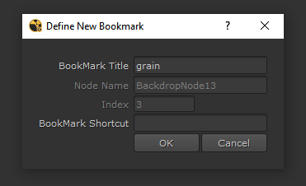

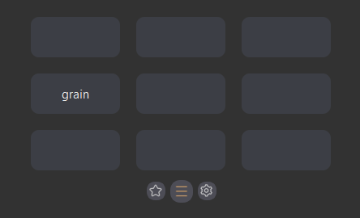

**Jump:** After assigning bookmarks, left click on a bookmark to jump

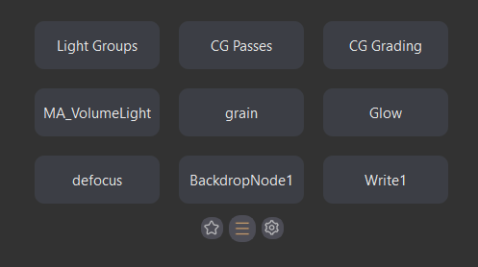

**Edit a Bookmark:** mouse middle click on a bookmark to edit that

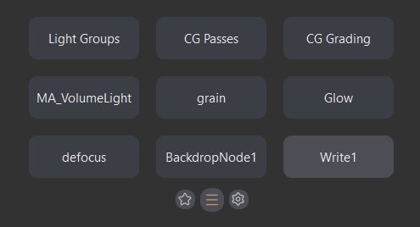

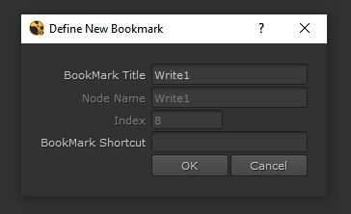

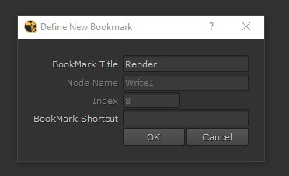

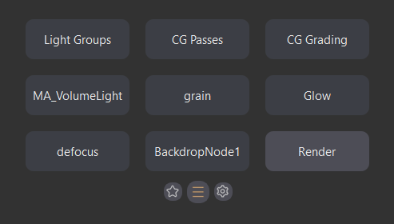

**Remove a Bookmark:** right click on a bookmark to remove that

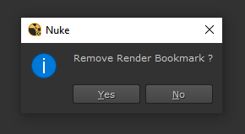

**Edit Bookmarks Window:**

click on middle icon to open Edit Bookmarks window



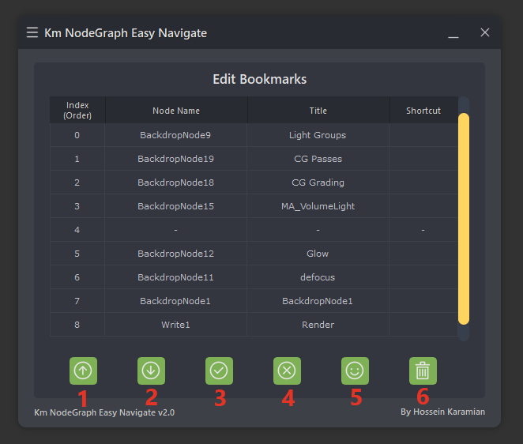

**1,2:** Change order of a bookmark. You can shift up or shift down selected row (selected bookmark) in the list with these icons  
**3:** Define (Assign) a new bookmark: Select a node (or backdrop) then select an empty row (for example in the picture above, the row with order number of 4) and click on this icon to assign  
**4:** remove bookmark: select a row and click on this icon to remove that bookmark  
**5:** Create bookmarks from backdrops: click on this icon will create bookmarks automatically from backdrops  
**6:** Remove all bookmarks

Also you can double click on “title” or “shortcut” of a bookmark in the table to edit that

**Templates Window:**

click on templates icon to open templates window

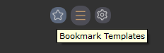

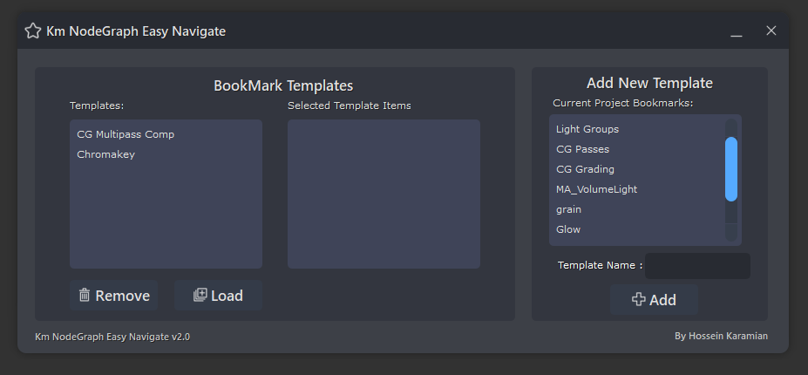

If you have multiple comps with similar node graph, you can define bookmarks once and save them as a template. So, in other comps you can easily load that bookmark template.

To define a bookmark template first define your bookmarks in current project and go to template window, choose a name for the template and click on “Add” button.

For load a bookmark template, from the templates list select a template and click on “Load” button.

**Settings Window:**

click on setting icon to open settings window  
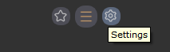

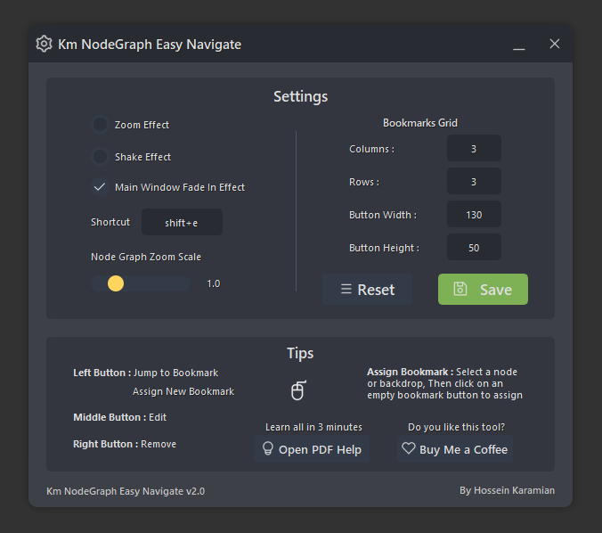

**Zoom Effect:** after click on a bookmark, jump will be done by a zoom effect  
**Shake Effect:** after jump to a bookmark node, it will shake that node for a moment to recognize it easier  
**Main Window Fade In Effect:** main window will appear with a fade in effect, if you don’t like that you can disable it from here.  
**Shortcut:** you can change default shortcut of this tool from here  
**Node Graph Zoom Scale:** zoom level of the node graph after jump to a bookmark node

**Bookmarks Grid:**   
you can set number of bookmarks by setting the columns and rows

Also, you can change size of bookmark button by setting the width and height

## Contact

I am very happy with your feedbacks.

Most appreciated!

Website:

<http://www.hkaramian.com>

E-Mail: [kmworks.call@gmail.com](mailto:kmworks.call@gmail.com)

LinkedIn: <https://www.linkedin.com/in/hkaramian>

Instagram: <https://www.instagram.com/karamian.me>

If you like this tool, you can [Buy Me a Coffee from here](https://www.buymeacoffee.com/karamian)