Serialization: VV Imp for interviews
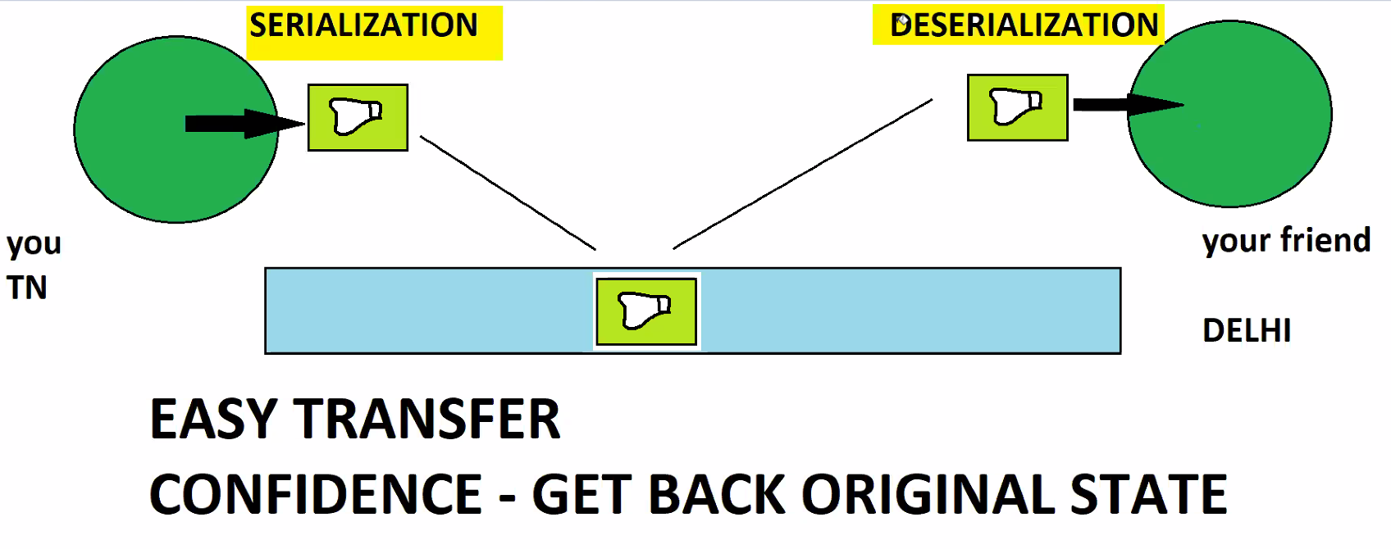

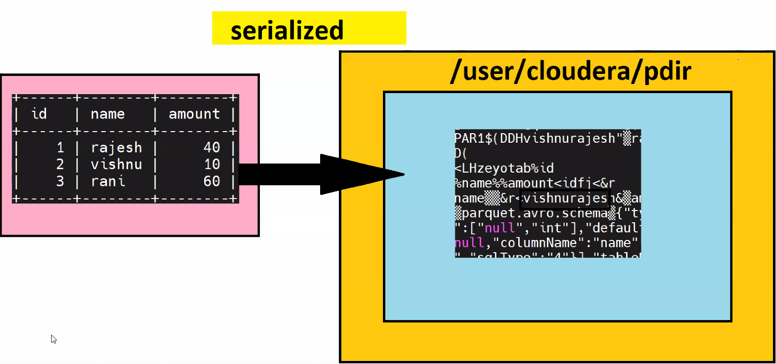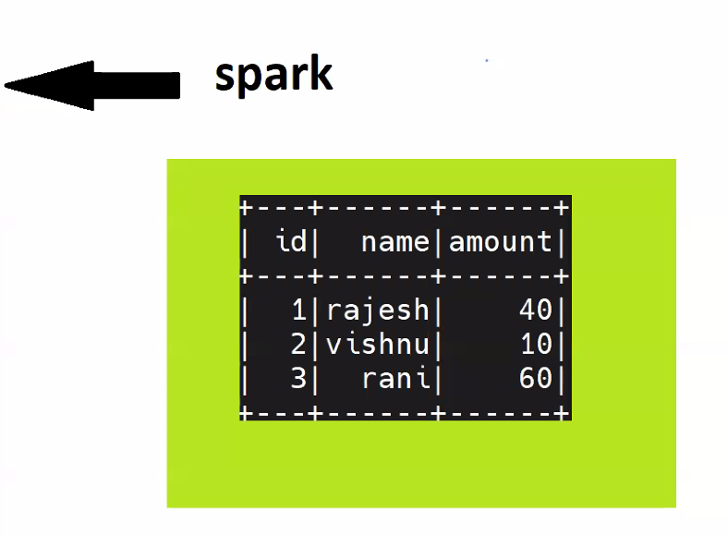
While serializing the data we are losing the READABILITY. In real time, we deal with large amount of data, readability is not a good parameter/feature to consider. We cannot go and see each and every record of 100M records.
Parameters to consider while data Transfer: Best Transfer, Best compression, Faster Processing, Faster Analytics, Better Storage, Schema Evolutions. Readability is never a parameter to consider.

As Hadoop deal with lots of data distributed shuffling between the nodes. It’s very hard to shuffle raw data between nodes. Serializing the data is easy to transfer, easy to shuffle, easy to query, easy to process.
Java Serialization is launched in 1992. Having Java Serialization as base, many serialized file formats came into picture. Of which some of them are 1. Sequence, 2. AVRO, 3. Parquet, 4. ORC.
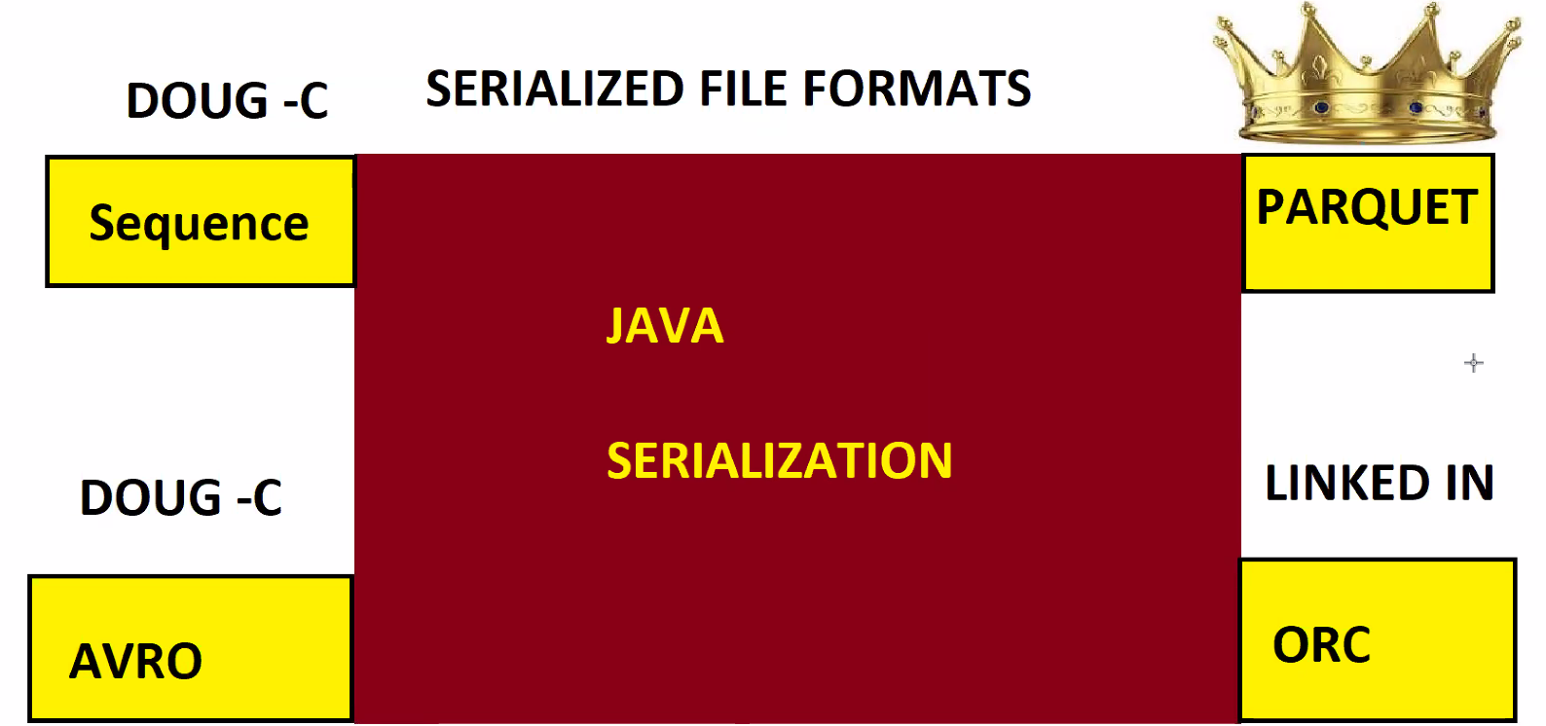
Why not single file format? Every file format has meaning and its own purpose. What one file format can do another file format cannot do.
Parquet is king of file formats. Sequence file format is majorly supported for MapReduce. Nowhere used in industry now.

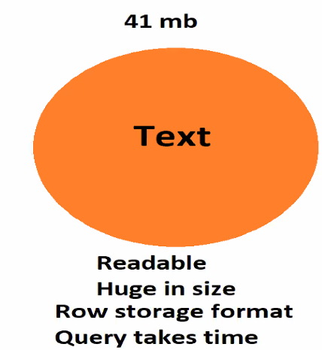
DIFFERENT FILE FORMATS:
TEXT FILE FORMAT
Features:
- Readable
- Huge in Size
- Row storage file format
- Querying takes time
Not recommended because of its storage mechanism
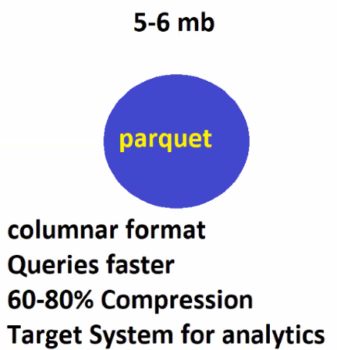
PAQUET FILE FORMAT
Features: KING OF FILE FORMATS
- Columnar File Format
- Queries are damn Faster.
- Supports 60-80% of Compression Rate
- Used in TARGET SYSTEMS for Analytics
Suppose if we have Text File of 41MB size, parquet file format reduces it to 5-6 MB
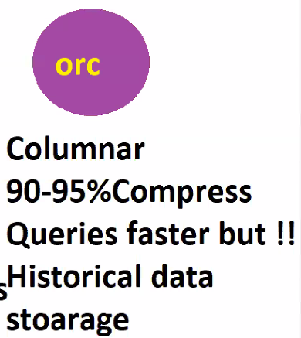
ORC (OPTIMIZED ROW COLUMNAR) FILE FORMAT
Features:
- Columnar File Format
- 90-95% Compression Rate.
- Queries are faster but not as fast as Parquet because of high compression rate which is the biggest challenge for queries.
- LEGACY /HISTORICAL Data Storage
Suppose if we have Text File of 41MB size, parquet file format reduces it to 4-5 MB

ROW FILE FORMAT VS COLUMAR FILE FORMAT:
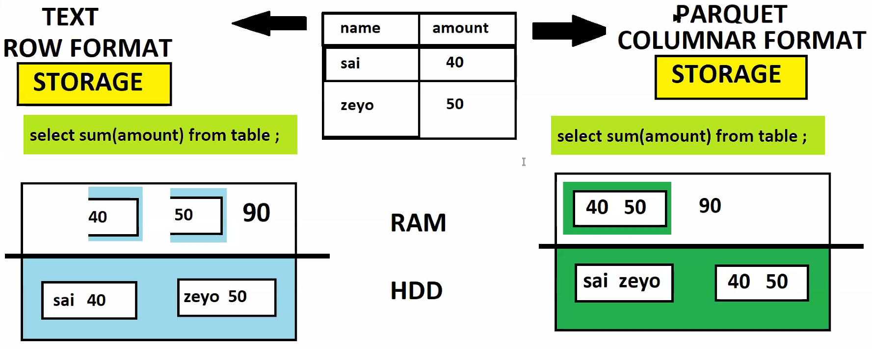

SCHEMA EVOLUTIONS:
While in 2008 Hadoop was not supporting the Schema Evolutions. Schema Evolution is nothing but when data in column changes, any column gets added to existing table, any column gets deleted from existing table.
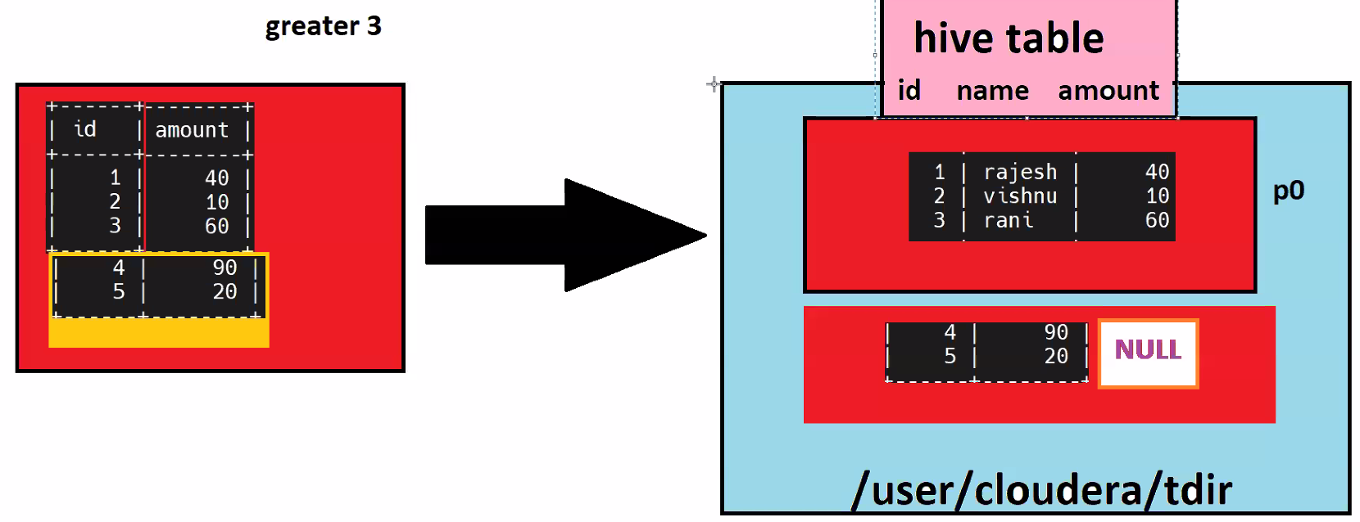
Schema Evolution issue is solved by AVRO.
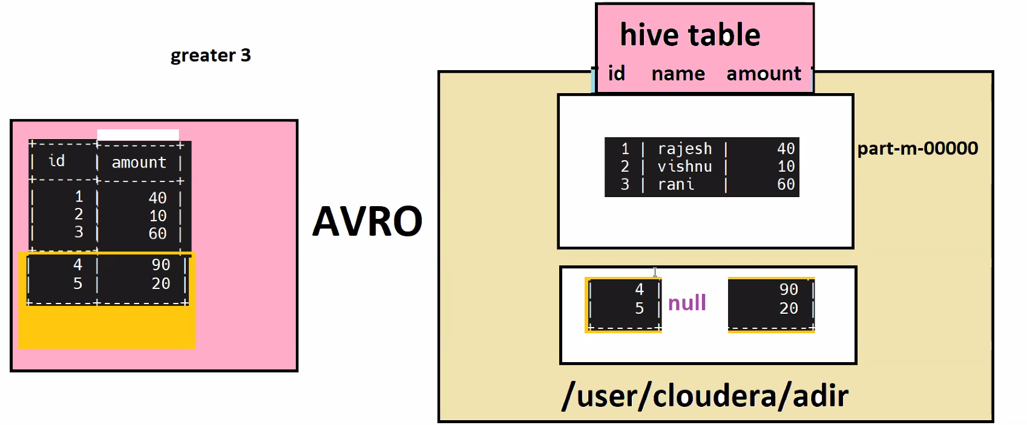
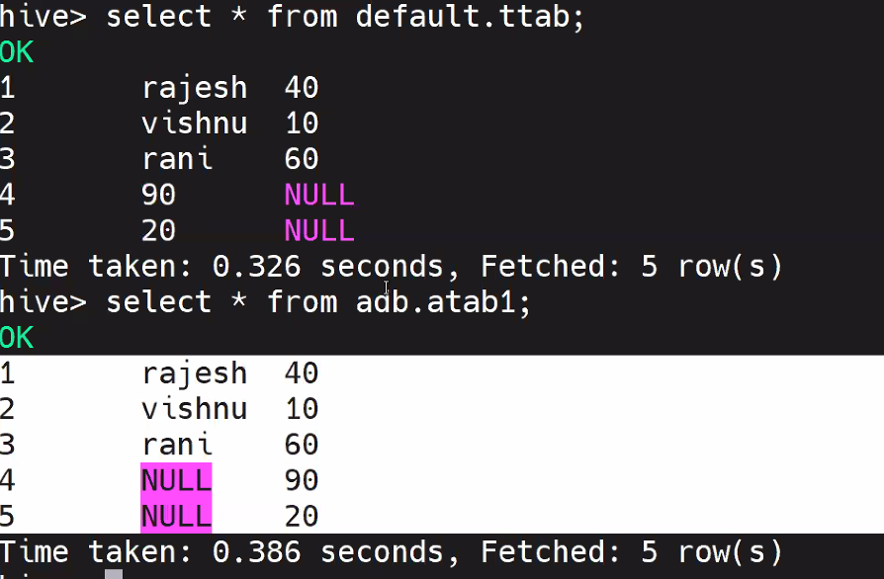
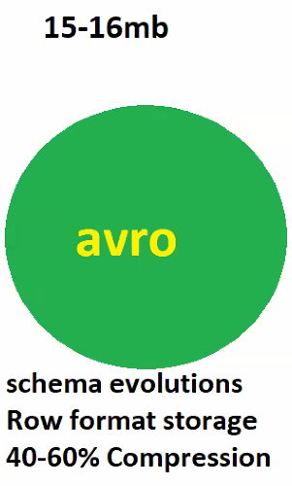
AVRO FILE FORMAT:
Features:
- Supports Schema Evolutions
- Row Format Storage
- 40-60% Compression rate

