DICTIONARY
Python dictionary is an unordered(cannot be indexed) collection of items. While other compound data types have only value as an element, a dictionary has a key:value pair.
Dict Creation:
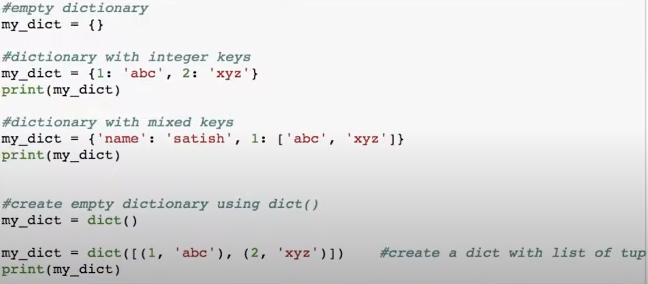
Dict Access:
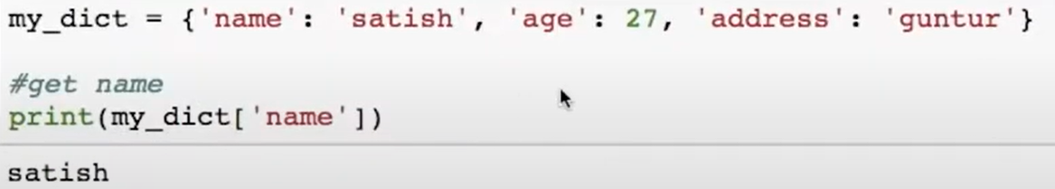
If key is not present it throws keyerror.
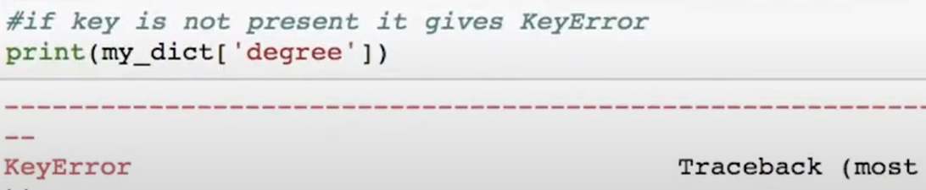
Another way of Accessing dict.
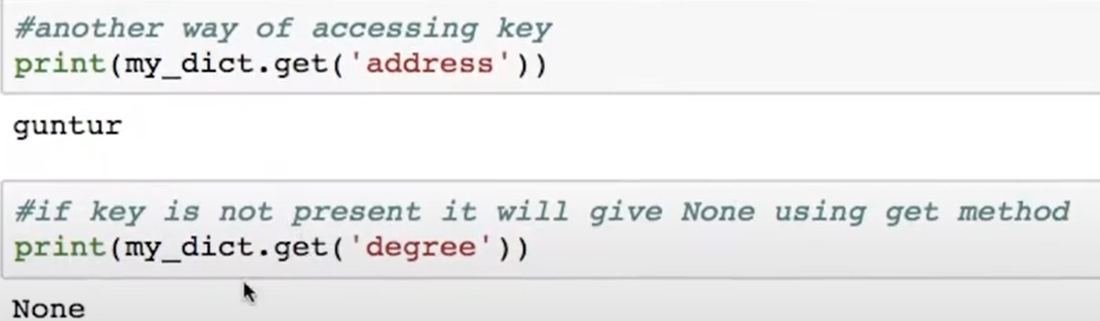
Dict Add or Modify Elements:
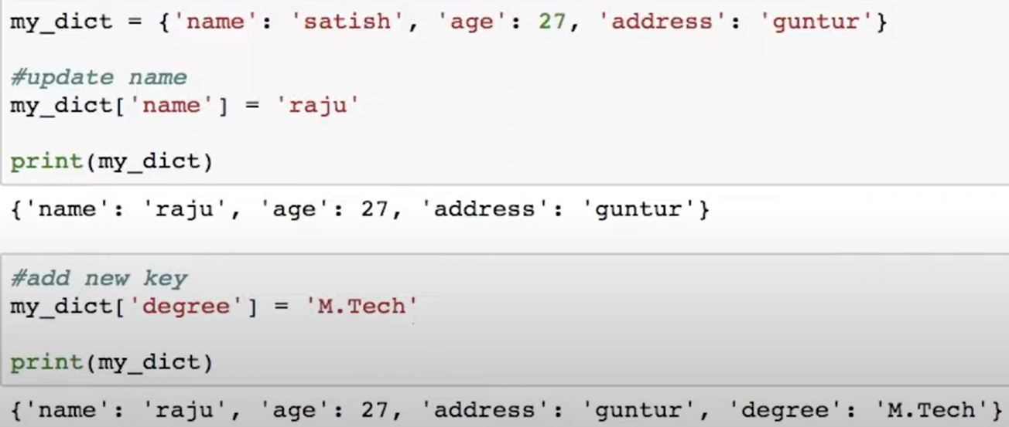
Dict Delete or Remove element:
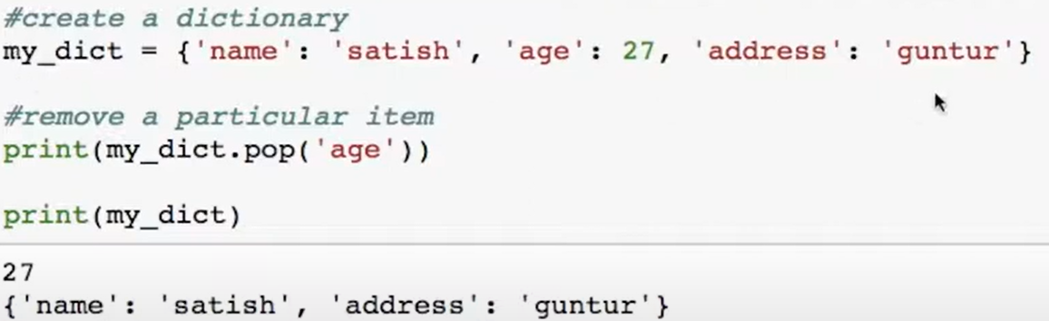
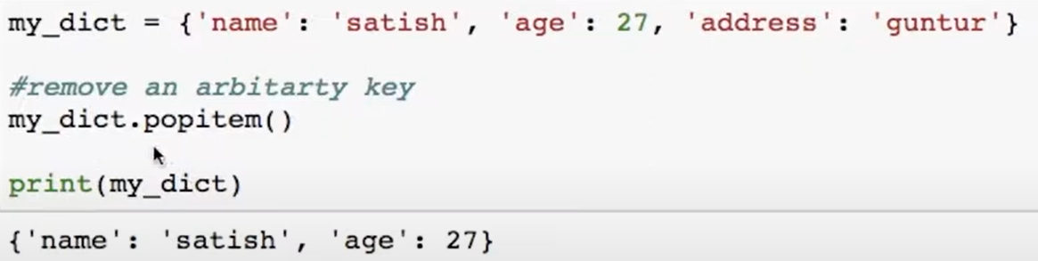
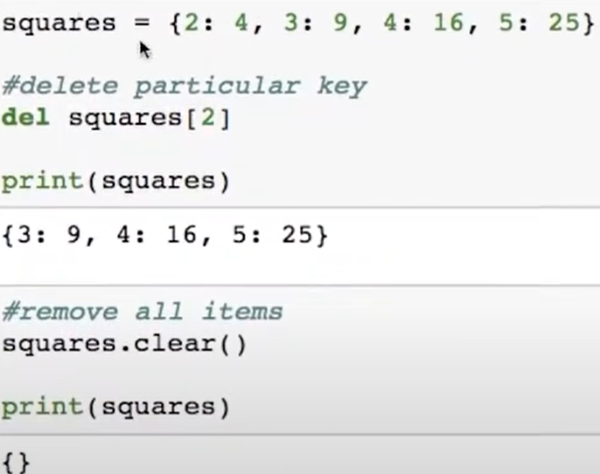
Dictionary Methods:
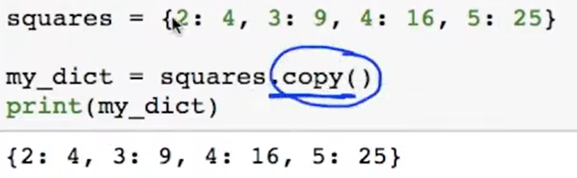
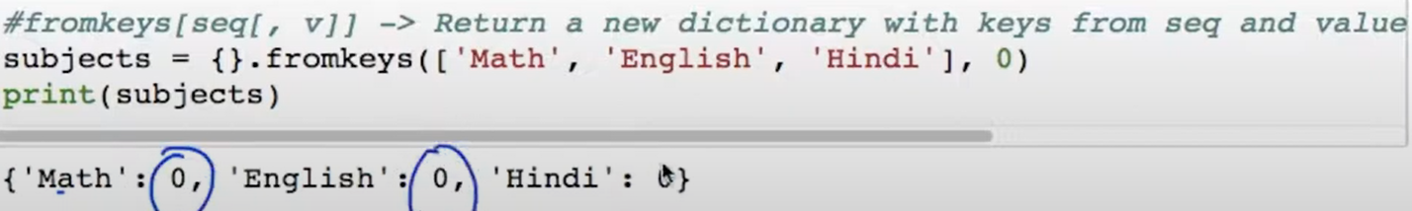
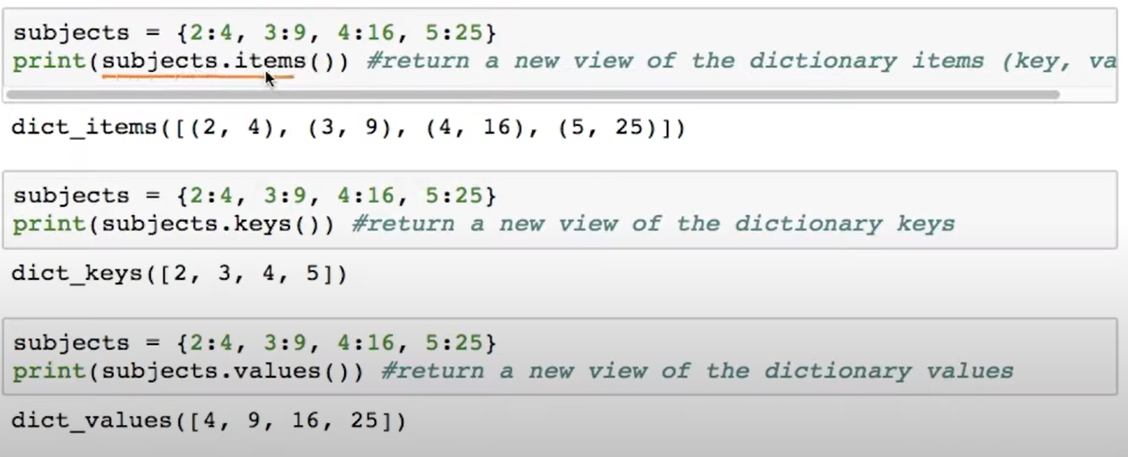
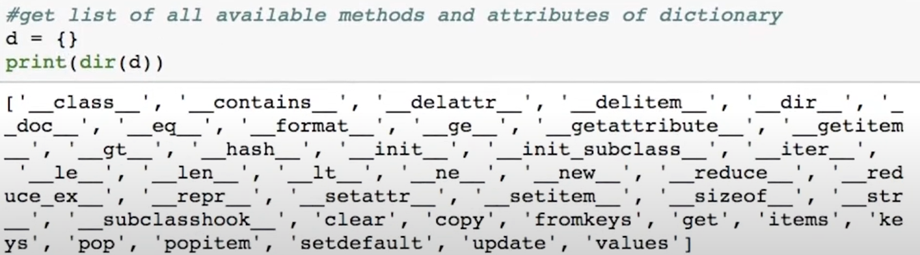

Dictionary Comprehensions:
