MISCELLENOUS
PYTHON COLLECTIONS MODULE:
The collection Module in Python provides different types of containers. A Container is an object that is used to store different objects and provide a way to access the contained objects and iterate over them. Some of the built-in containers are Tuple, List, Dictionary, etc. In this article, we will discuss the different containers provided by the collections module.
- Counters
A counter is a sub-class of the dictionary. It is used to keep the count of the elements in an iterable in the form of an unordered dictionary where the key represents the element in the iterable and value represents the count of that element in the iterable.
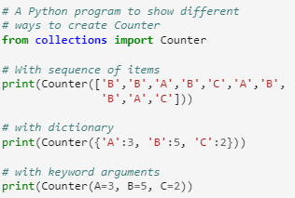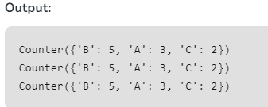
- OrderedDict
An OrderedDict is also a sub-class of dictionary but unlike dictionary, it remembers the order in which the keys were inserted.
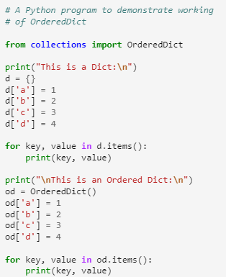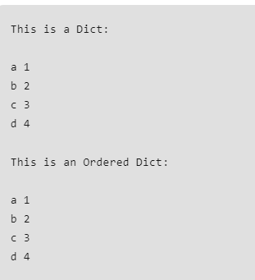

While deleting and re-inserting the same key will push the key to the last to maintain the order of insertion of the key.

- DefaultDict
A DefaultDict is also a sub-class to dictionary. It is used to provide some default values for the key that does not exist and never raises a KeyError.
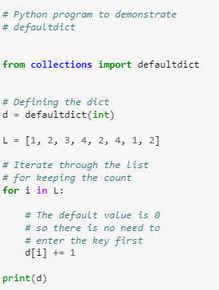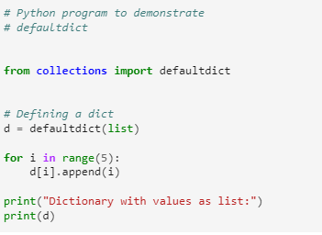
- ChainMap
A ChainMap encapsulates many dictionaries into a single unit and returns a list of dictionaries.
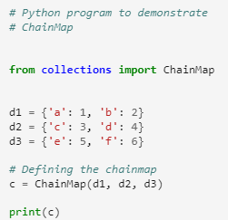
Simillarly, there are NamedTuple, DeQue, UserDict, UserList, UserString under collections module.
Go Thru:
- https://www.javatpoint.com/python-collection-module pefer this.
- https://www.geeksforgeeks.org/python-collections-module/

Iterators in python
An iterator in Python is an object that is used to iterate over iterable objects like lists, tuples, dicts, and sets. The Python iterators object is initialized using the iter() method. It uses the next() method for iteration.

- __iter__(): The iter() method is called for the initialization of an iterator. This returns an iterator object

- __next__(): The next method returns the next value for the iterable. When we use a for loop to traverse any iterable object, internally it uses the iter() method to get an iterator object, which further uses the next() method to iterate over. This method raises a StopIteration to signal the end of the iteration.
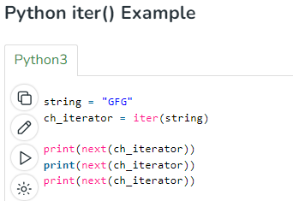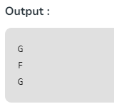

Iterable vs Iterator
Python iterable and Python iterator are different. The main difference between them is, iterable in Python cannot save the state of the iteration, whereas in iterators the state of the current iteration gets saved.
Note: Every iterator is also an iterable, but not every iterable is an iterator in Python.
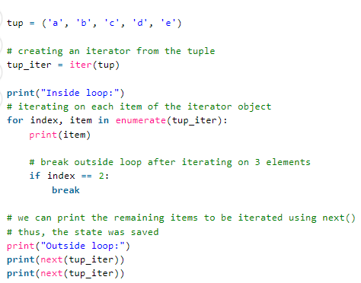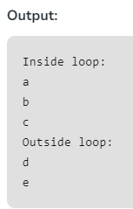

Getting StopIteration Error while using iterator
Iterable in Python can be iterated over multiple times, but iterators raise StopIteration Error when all items are already iterated.
Here, we are trying to get the next element from the iterator after the completion of the for-loop. Since the iterator is already exhausted, it raises a StopIteration Exception. Whereas, using an iterable, we can iterate on multiple times using for loop or can get items using indexing.
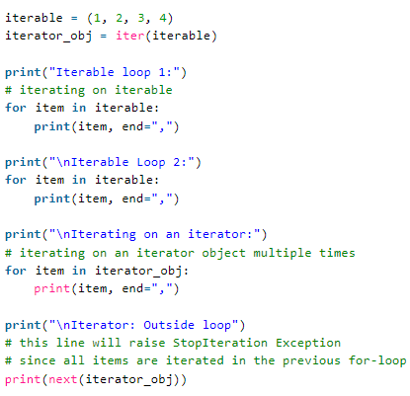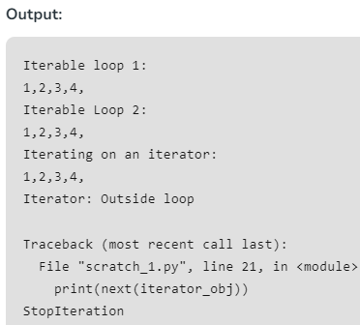

PYTHON JSON
JSON, which stands for JavaScript Object Notation, is a popular data format for online data exchange. JSON is the best format for organizing data between a client and a server.

Utilizing Python JSON

Json is a module that Python offers. Python supports the marshal and pickle modules from the standard library, and JSON API functions similarly to these libraries. Python natively supports JSON characteristics.
The process of serializing JSON data is known as encoding. Data is transformed into a series of bytes and delivered across the network using the serialization technique.
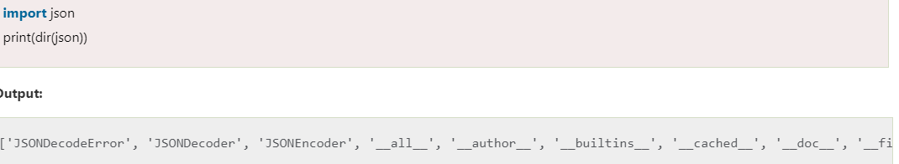

Serializing JSON
The process used to translate Python objects to JSON is known as serialization. When a computer needs to process a lot of data, it is a good idea to store that data in a file. Using the JSON function, we can store JSON data in a file. The dump() and dumps() methods are available in the json module and are used to modify Python objects.
The following JSON items are created from Python objects. Following is a list of each:
Sr. | Python Objects | JSON
1. | Dict | Object
2. | list, tuple | Array
3. | Str | String
4. | int, float | Number
5. | True | true
6. | False | false
7. | None | null

Decorators:
Decorators are a very powerful and useful tool in Python since it allows programmers to modify the behaviour of a function or class. Decorators allow us to wrap another function in order to extend the behaviour of the wrapped function, without permanently modifying it. But before diving deep into decorators let us understand some concepts that will come in handy in learning the decorators.
Generators: source GFG
A Generator in Python is a function that returns an iterator using the Yield keyword
A generator function in Python is defined like a normal function, but whenever it needs to generate a value, it does so with the yield keyword rather than return. If the body of a def contains yield, the function automatically becomes a Python generator function.
Python Generator functions return a generator object that is iterable, i.e., can be used as an Iterator. Generator objects are used either by calling the next method of the generator object or using the generator object in a “for in” loop.
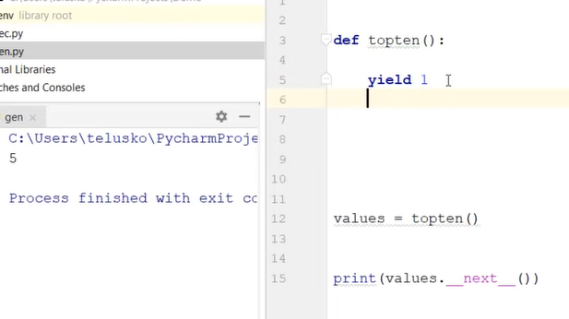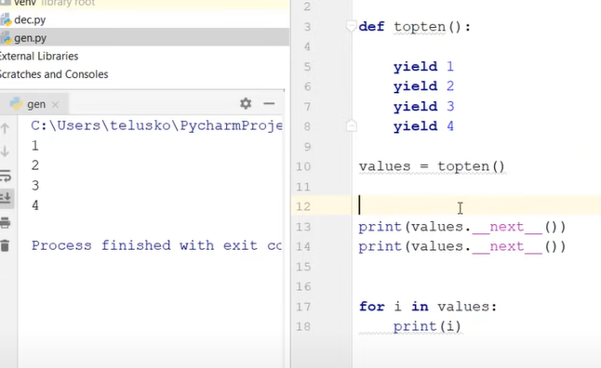

Python Itertools:
Python’s Itertool is a module that provides various functions that work on iterators to produce complex iterators. This module works as a fast, memory-efficient tool that is used either by themselves or in combination to form iterator algebra.
For example, let’s suppose there are two lists and you want to multiply their elements. There can be several ways of achieving this. One can be using the naive approach i.e by iterating through the elements of both the list simultaneously and multiplying them. And another approach can be using the map function i.e by passing the mul operator as the first parameter to the map function and Lists as the second and third parameter to this function. Let’s see the time taken by each approach.

