SETS
- A set is an unordered collection of items. Every element is unique(no duplicates).
- Unordered means elements cannot be indexed.
- The set itself is mutable. We can add or remove items from it.
- Sets can be used to perform mathematical set operations like Union, Intersection, symmetric difference etc.
Set Creation:
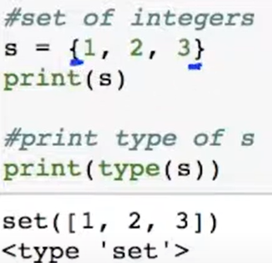
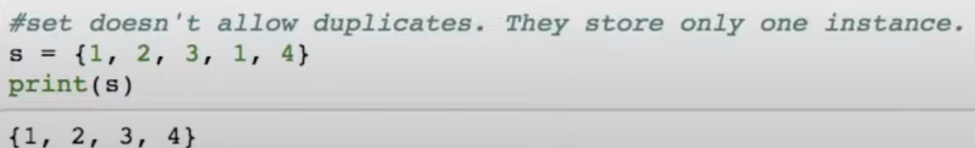
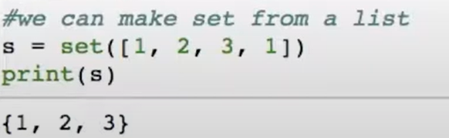
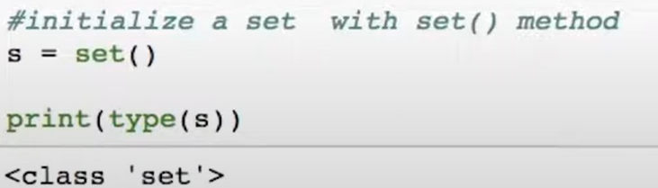
Indexing a set: As set is unordered, we cannot index the elements of set.
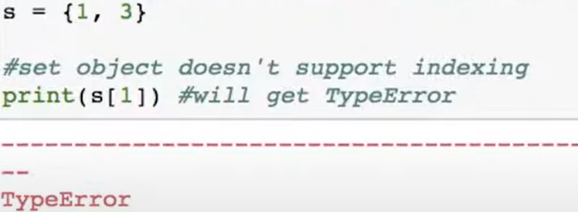
Add Elements to Set:
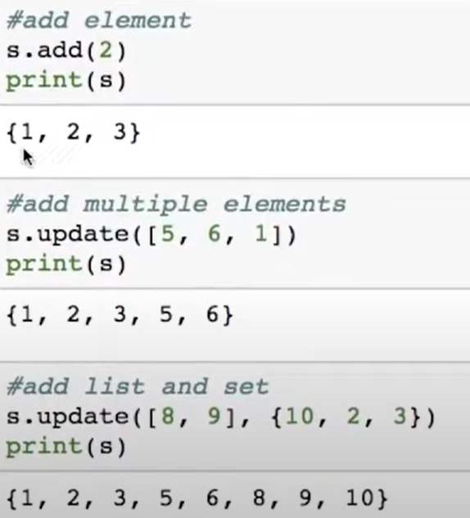
Remove Elements from Set: A particular element or item can be removed from Set using discard() and remove() methods.
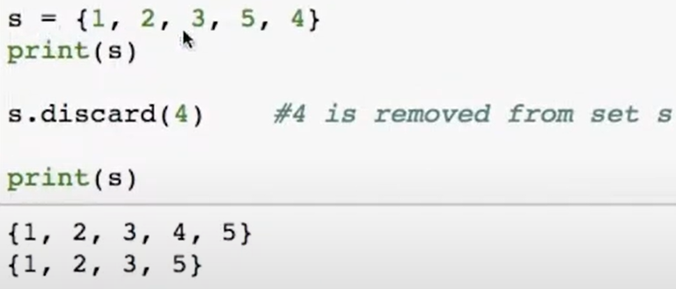
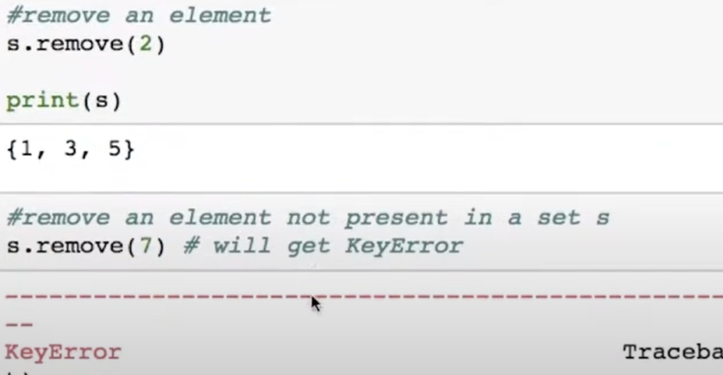
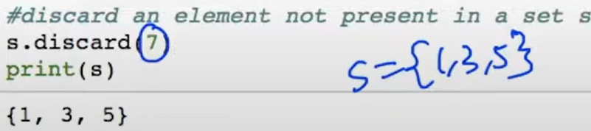
If we try to remove item from set which is not present, remove() method with give KeyError, Where as discard wont give any keyerror.
Pop(): removes any one element at random from set.
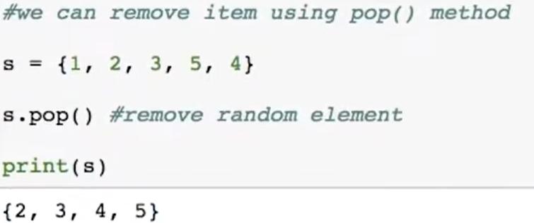
Clear(): removes all the elements from set.
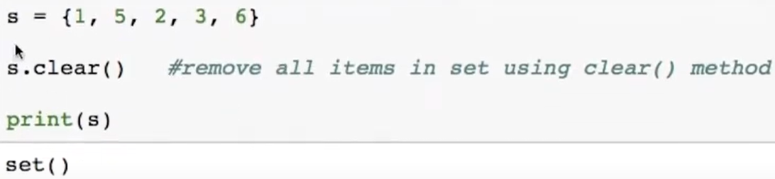
SET OPERATIONS:
Union:
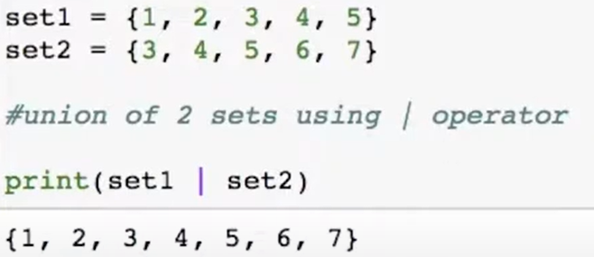
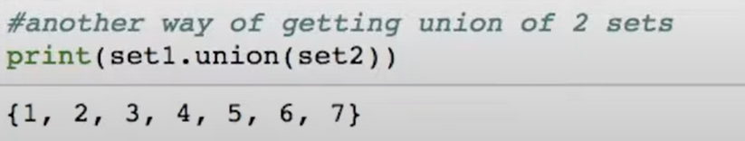

Intersection:
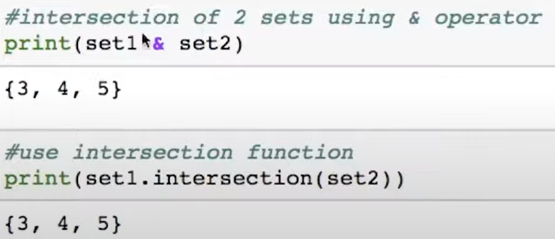
Set Difference:
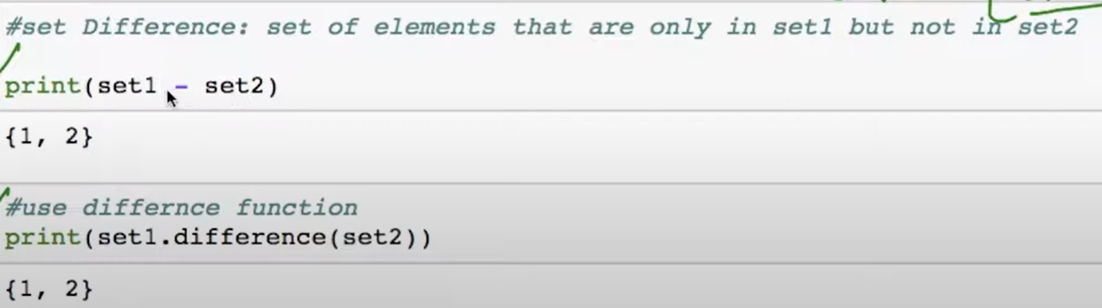
Symmetric Difference: Set of elements in both set1 and set2 except those that are common in both.
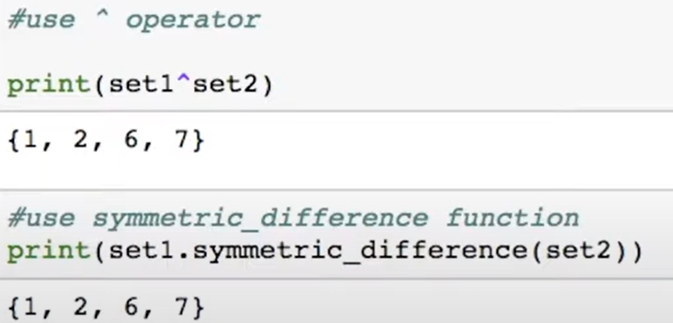
Find issubset():
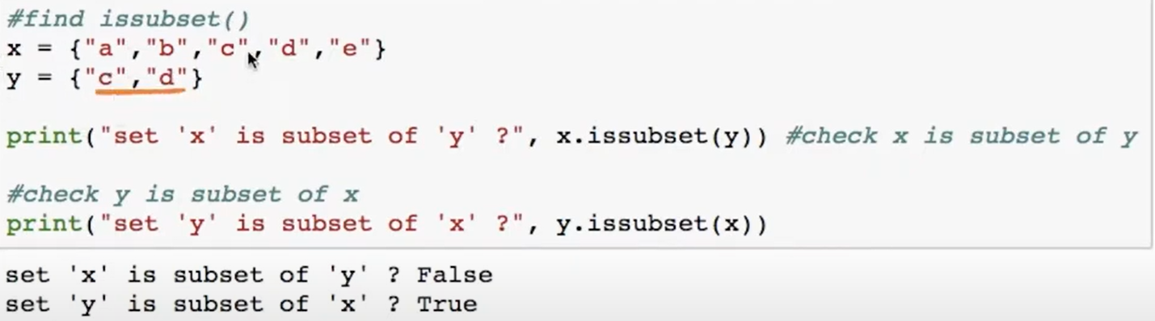

Frozen Sets:
- Frozen sets has the characteristics of sets, but it can’t be changed once it’s assigned. While tuple are immutable lists, frozen sets are immutable sets.
- Frozen sets can be created using the function frozenset().
- Sets being mutable are unhashable, so they can’t be used as dictionary keys. On the other hand, frozensets are hashable and can be used as keys to a dictionary.
- This datatype supports methods like copy(), difference(), intersection(), isdijoint(), issubset(), issuperset(), symmetric_difference() and union(). Being immutable it does not have method that add or remove elements.
