STRINGS
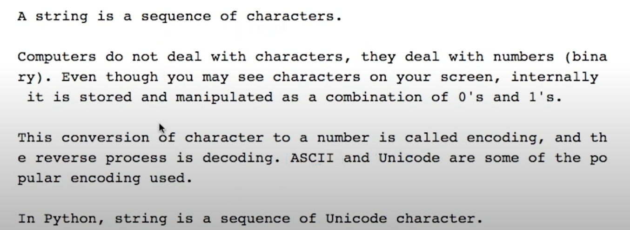
How to create a string?
String can be created by enclosing characters inside a single quote or double quotes.
Even triple quotes can be used in python but generally used to represent multiline strings and docstrings.
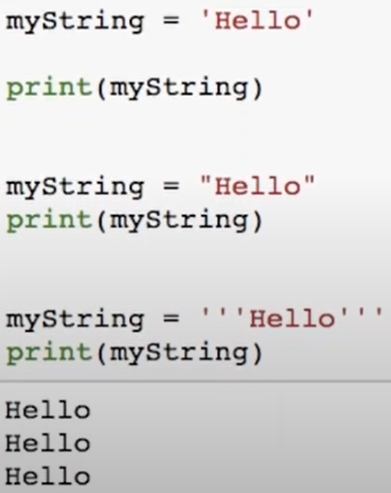
Access characters in string:
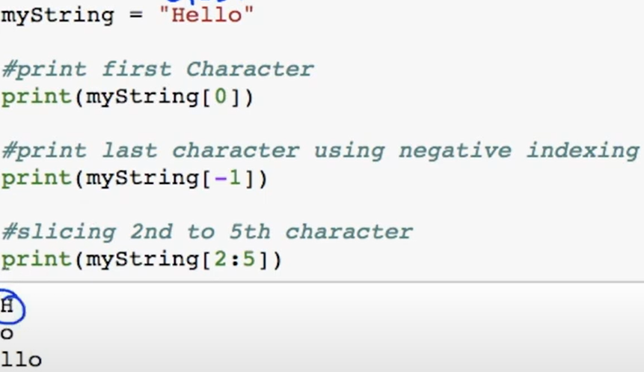
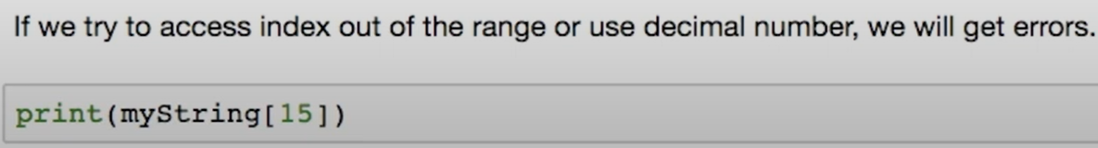
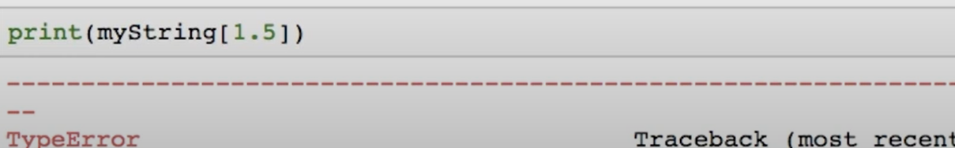
Change or delete a string:
Strings are immutable. This means that elements of a string cannot be changed once it has been assigned.
We simply reassign different strings to the same name.
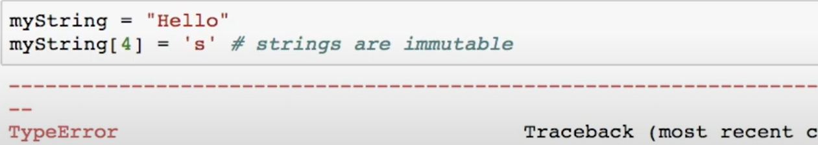
We cannot delete or remove characters from a string. But deleting the string entirely is possible using the keyword del.
String Operations:
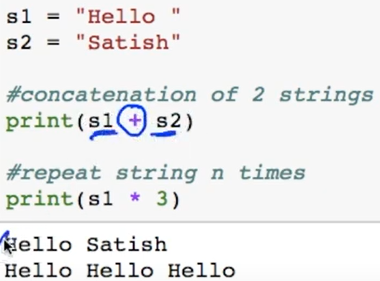

Iterating through string:
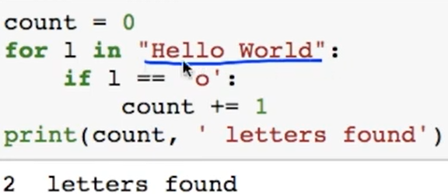
String Membership Test:
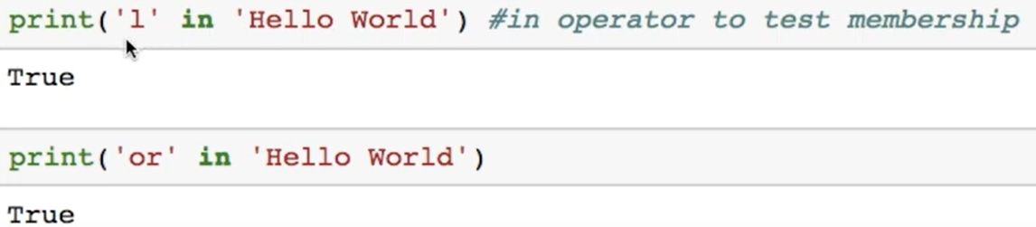
String Methods: Some of the commonly used methods are lower(), upper(), join(), split(), find(), replace() etc
