TUPLES:
Def: Python Tuple is a collection of objects separated by commas. In some ways, a tuple is similar to a Python list in terms of indexing, nested objects, and repetition but the main difference between both is Python tuple is immutable, unlike the Python list which is mutable.
- A tuple is similar to list.
- The difference between the tuples and lists are we cannot change the elements of tuple(IMMUTABLE) once it is assigned whereas in the list, elements can be changed(MUTABLE).
- Tuples are enclosed in parenthesis ().

What is Immutable in Tuples?
Tuples in Python are similar to Python lists but not entirely. Tuples are immutable and ordered and allow duplicate values. Some Characteristics of Tuples in Python.
- We can find items in a tuple since finding any item does not make changes in the tuple.
- One cannot add items to a tuple once it is created.
- Tuples cannot be appended or extended.
- We cannot remove items from a tuple once it is created.

Tuple Creation:
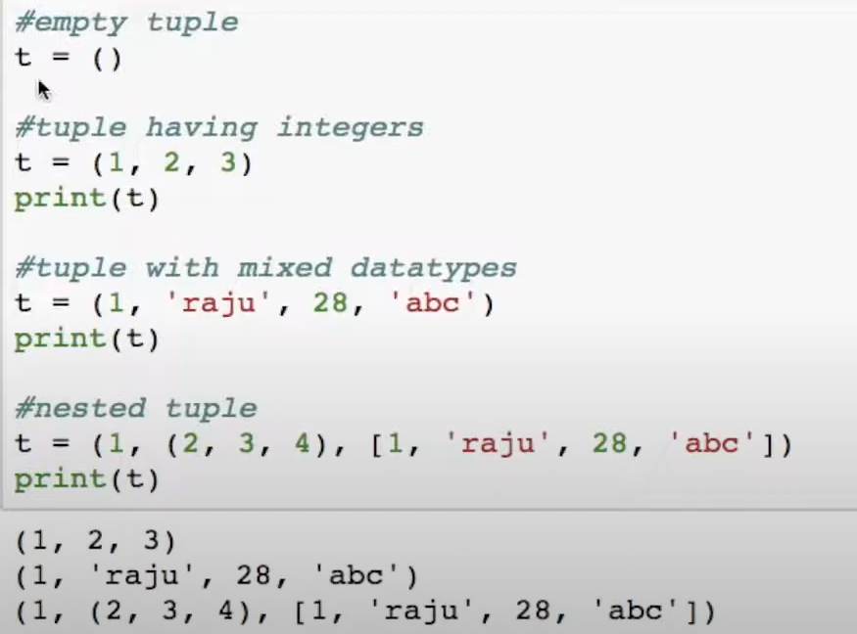
While creating tuple only parenthesis is not enough, we need to end it with comma.
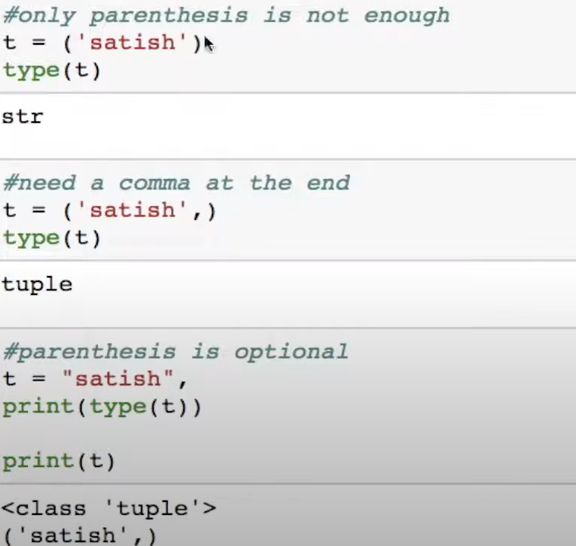
Note : Creation of Python tuple without the use of parentheses is known as Tuple Packing.

Accessing the elements in tuple:
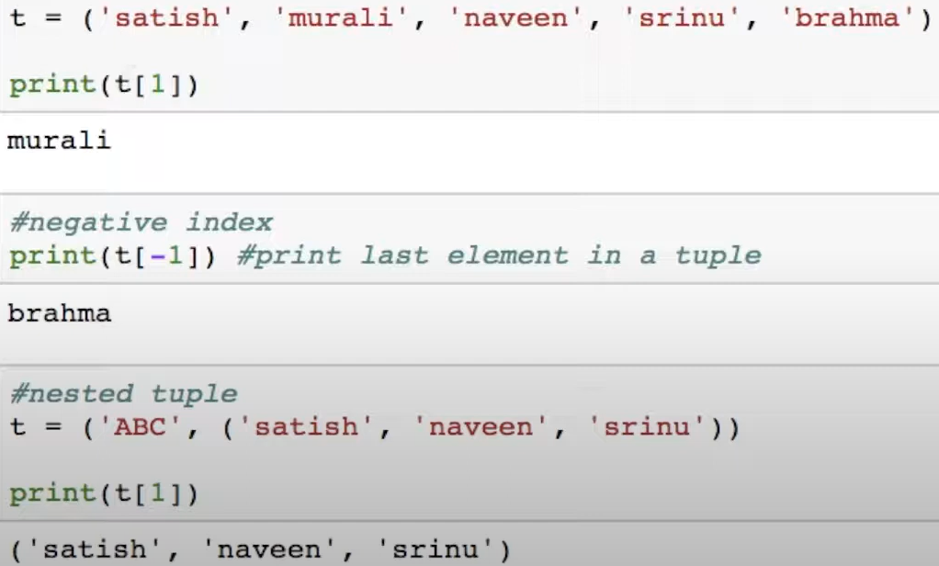
Slicing in tuples:
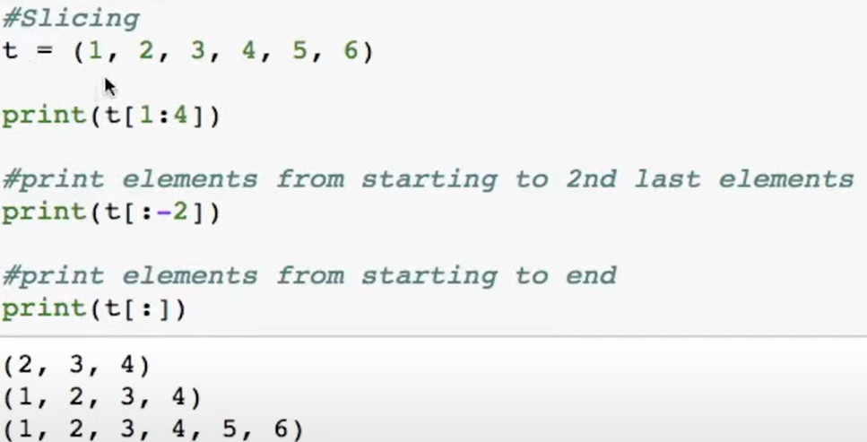
Changing a Tuple:
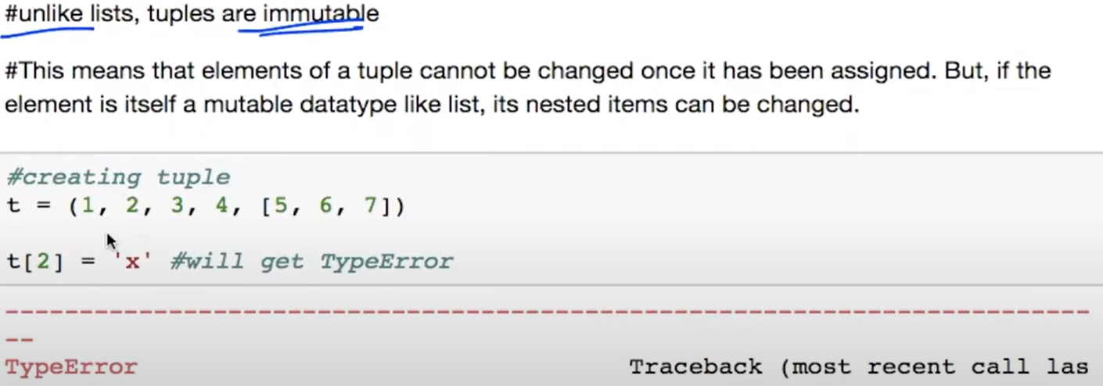
If an element inside tuple is list, it allows us to changes those list values.
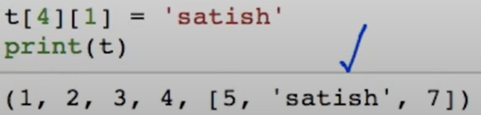
Concatenating tuples:
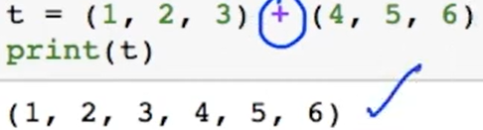
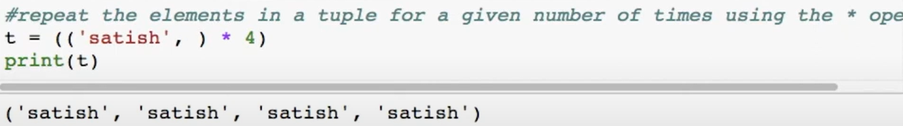
Tuple Deletion:
We cannot change the elements in a tuple. But we can delete entire tuple using del keyword.
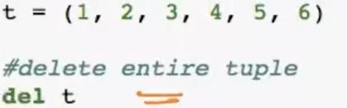
Tuple count: To get the frequency of particular element appears in a tuple.
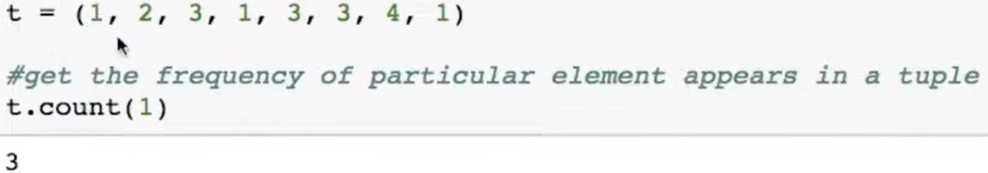
Tuple Index: Return the index of the first element where it is matching.
Tuple Membership:
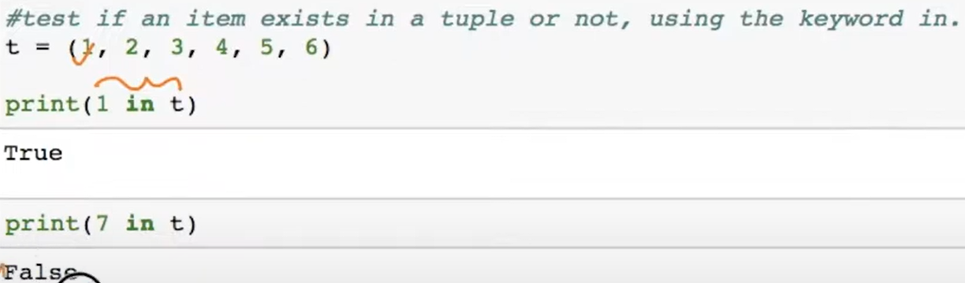
Tuple Length:
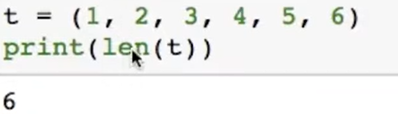

Tuple Sort
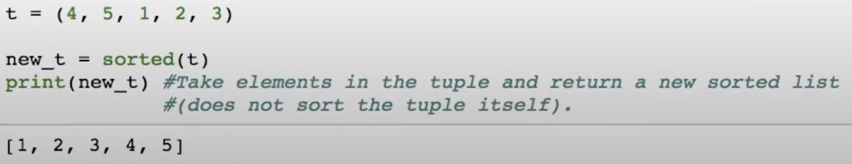
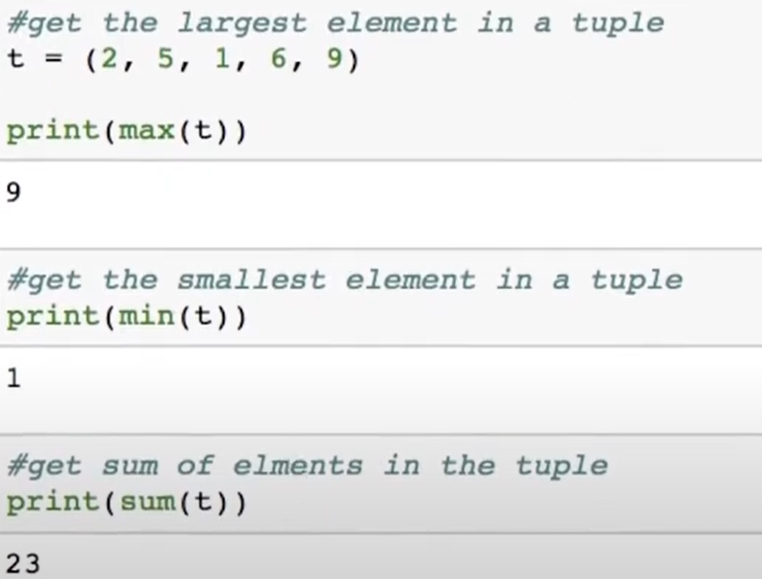
Converting List to Tuple: We can convert a list to Tuple using tuple() constructor and passing list as parameter.
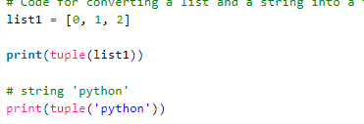
Packing and Unpacking a Tuple: In Python, there is a very powerful tuple assignment feature that assigns the right-hand side of values into the left-hand side. In another way, it is called unpacking of a tuple of values into a variable. In packing, we put values into a new tuple while in unpacking we extract those values into a single variable.
