AIRFLOW
Agenda:
- Whole architecture once
- Requirements
- Execution
- Testing
- AIRFLOW AUTOMATION

Architecture: using AWS S3, EMR, Spark, snowflake, WebAPI, AIRFLOW.
Source: We have three sources: AWS s3, Snowflake, WebAPI.
Processing: We have three spark jobs which consume data from each and every source and write intermediate data s3.
Next, we have master spark job which consume intermediate data from s3 and write output to s3. Then whole entire orchestration will be done with AIRFLOW.
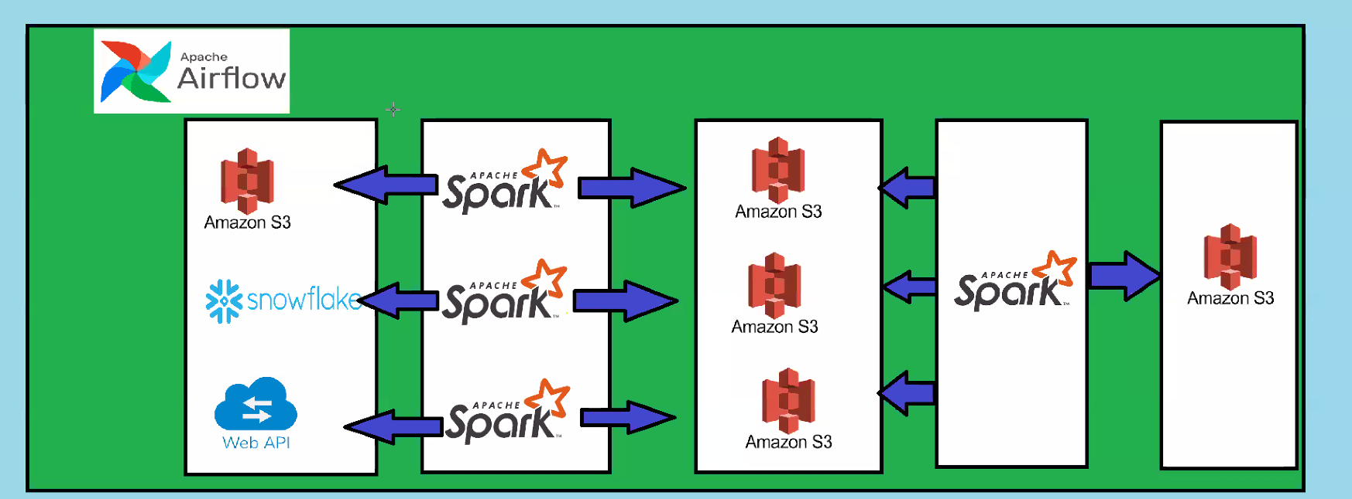
Boss Story:
Boss: we have three sources with us. S3, Snowflake, webapi. we have to build a data pipeline. Its quite a big data pipeline. Can u validate sources and tell me.
Me: Give me source details and let me validate.
Boss: s3 source:
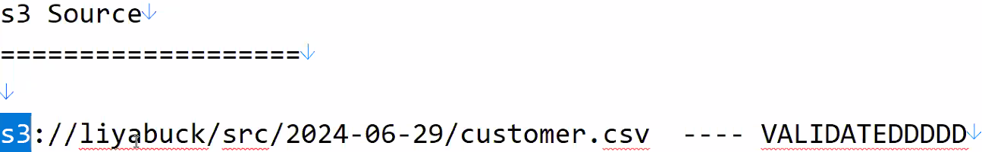

Snowflake:
