CLASS 3: 01/06/2024
Software Overview:
For any application development, it all starts with Idea. Requirements get written to achieve /develop app.
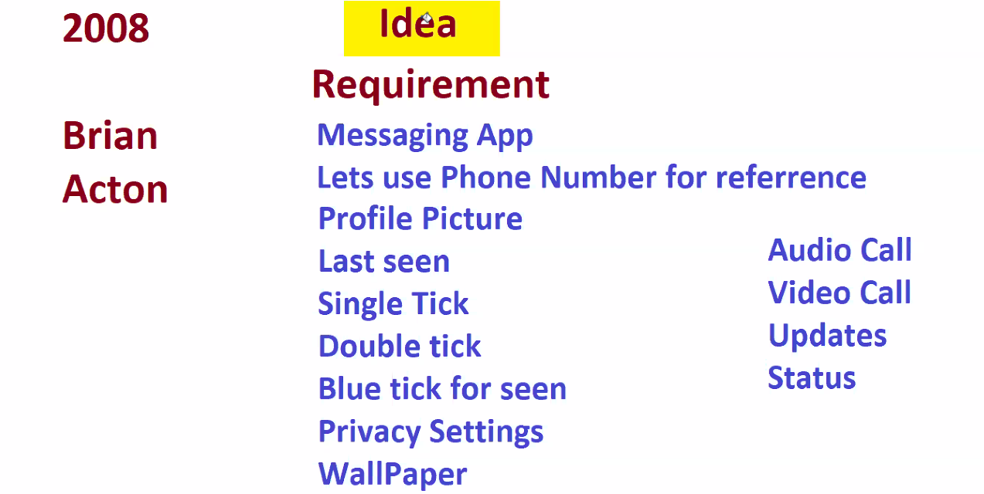
Once the Business is done with his requirements they hire Business Analyst, who closely works with idea guy or boss.

Then Hire 3 managers, i. Dev Manager, ii. ops Manger, iii, Test Manager. Then each manager hires there team based on tech requirements.
Dev Manager and Test Manager works closely with Business analyst. Dev manager asks his team to develop code for requirements, meanwhile testing team writes Test Cases for requirements.
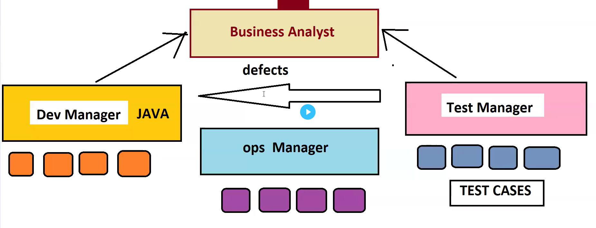
Once Dev team completes his development, Takes Dev/QA Server, runs the code, taking code to server will be assisted by ops manager. Once the code started running, then testers will connect to server and download the application and tests each and every functionality, by executing test cases. If testers find anything broken/bugs they immediately raise defects to Dev team. Then Dev team works on the defect then commit the code to server again. Again testing will be done in Dev/ QA server.
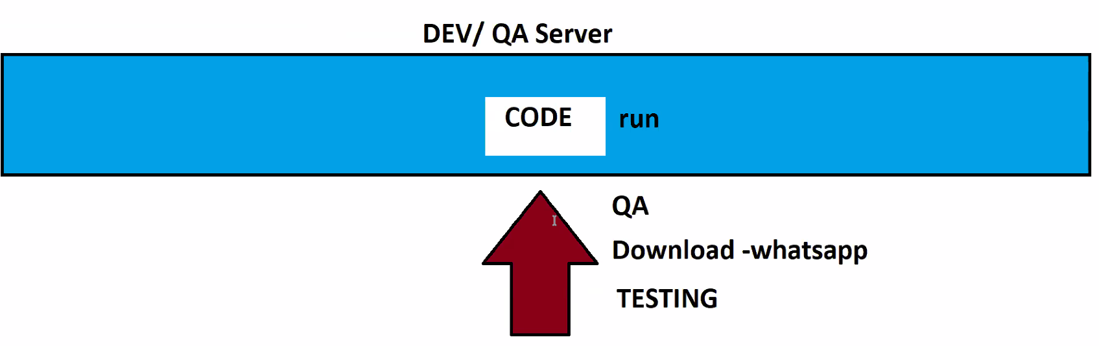
Once code gets tested in Dev/QA server, code will be deployed again in Pre live Server. Then testers again the testcases. If they find bugs they raise defects. If everything is fine, upon getting approval from Boss, they take final copy of code and run it in LIVE server.
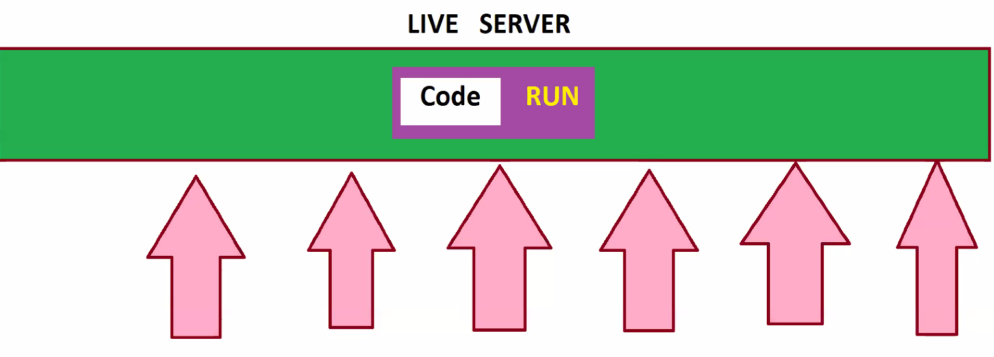
If any issue happens in live server, it creates lots of business loss. In past, WhatsApp was down for 7 hours in live, which made loss of 1.25Billion Dollar loss.
Data Info Deep:
We are generating the data everyday to Google but not uploading or downloading the data. Examples: Lots of shopping in Amazon, Flipkart, Food delivering apps Swiggy, Zomato. Etc.

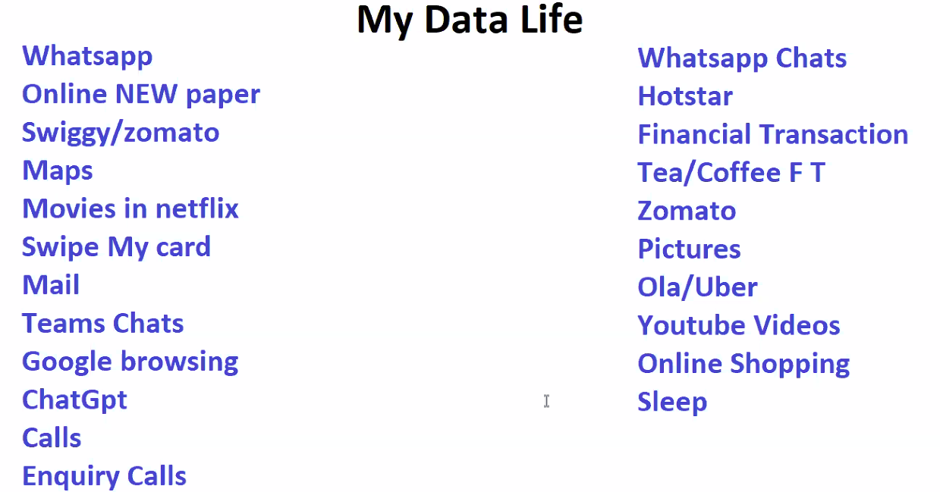

Two Real time use cases of Big Data Analytics:
- Data Analytics, by (Mark Zuckerberg + Cambridge Analytics) made Trump to win Elections in 2016.
- 2014 FIFA Final – Germany Vs Argentina. Germany won because of Big Data Analytics.
Data Evolution:
1960 Data used to be stored in TXT files(Notepad).
1970 Data started increasing a lot, notepad cannot suffice. DMBS got introduced. DMBS in today is ‘EXCEL’. First DBMS is called ‘VISICALC’. Calculations are very easy in Excel.
1980 Even notepad, DMBS cannot suffice data, A person known as Larry Ellison launched RDBMS. But it’s a paid version & people started paying huge money to Larry.
1990 Data increased, population increased, RDBMS cannot withstand the increasing Data. Then Larry again launched Data Warehouse along with RDBMS. Larry asked users to place less used in warehouse and highly used data in RDBMS. When required do migration from warehouse to RDBMS. Asked users to pay for warehouse also.
1995 Doug Cutting looking at Data Analytics(which is highly priced) launched DFS(Distributed File System). DFS was good at storage as it does distributed data storage, but failed at processing, as it brings back data from all Data nodes to Gateway node/server which burden’s the Gateway laptop. DFS failed.
2003 After 8 years, Google released paper on GFS(Google File System).
2004 Google release paper on MapReduce. Upon Reading MapReduce paper Doug Cutting was Shocked.
2005 Doug Cutting Designed similar MapReduce for DFS.
2006 Named (DFS & MapReduce) together as Hadoop(his Son’s Elephant Doll Name).
2007 Hadoop becoming Biggest hit. Everyone started using it.
2008 MapReduce looked so tough to understand. So, Facebook released HIVE. Data ingestions are very tough, so SQOOP was launched.
2009 Installing Hadoop, Sqoop, Hive Maintenance, upgrade are tough. Cloudera come forward and helped with Installation, Maintenance, upgrades setup in own laptops.. Asked to pay in return for all.
2012 Horton Works, stated we will do installation for free and have to pay for Maintenance and upgrades.
2014 Big super power was launched and many famous tools got vanished. That is SPARK.
2017 Cloudera completely bought Horton Works.
Parallely, when Hadoop is getting popular, another end there is something which is also getting popular. That is CLOUD COMPUTING.
2019 Cloud Computing stated, I’ll provide entire setup with giving laptops, installations(Hadoop, Hive, Sqoop, Spark), maintenance, upgrade. But PayMe for Rent, how much used.
2024 Cloud based Big Data Analytics powered with SPARK.
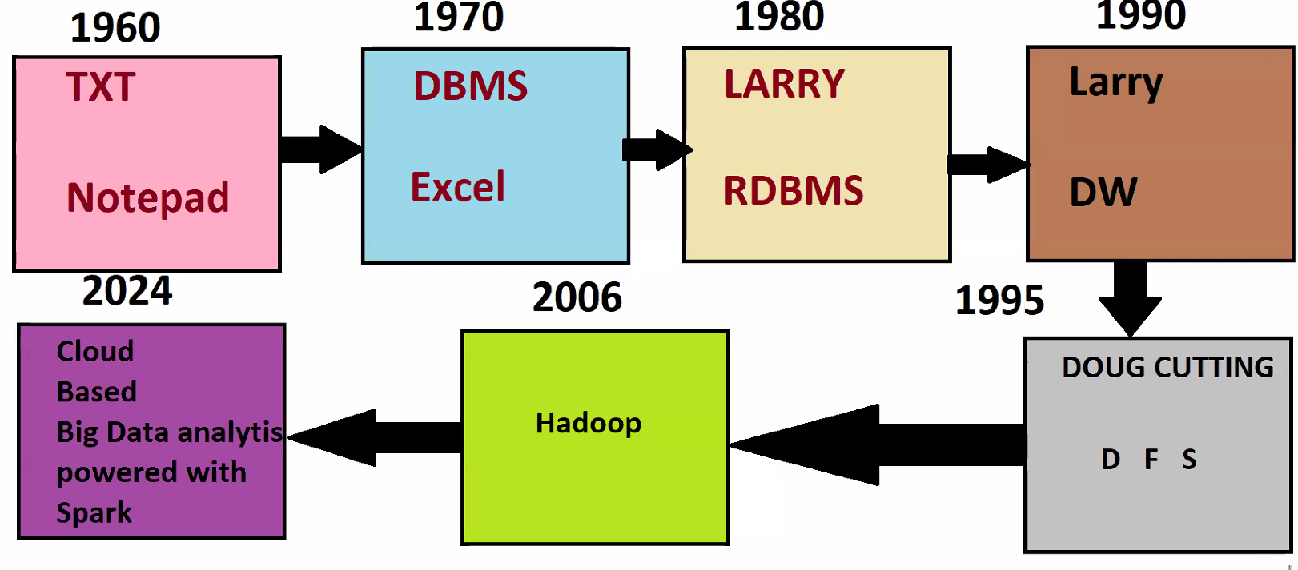

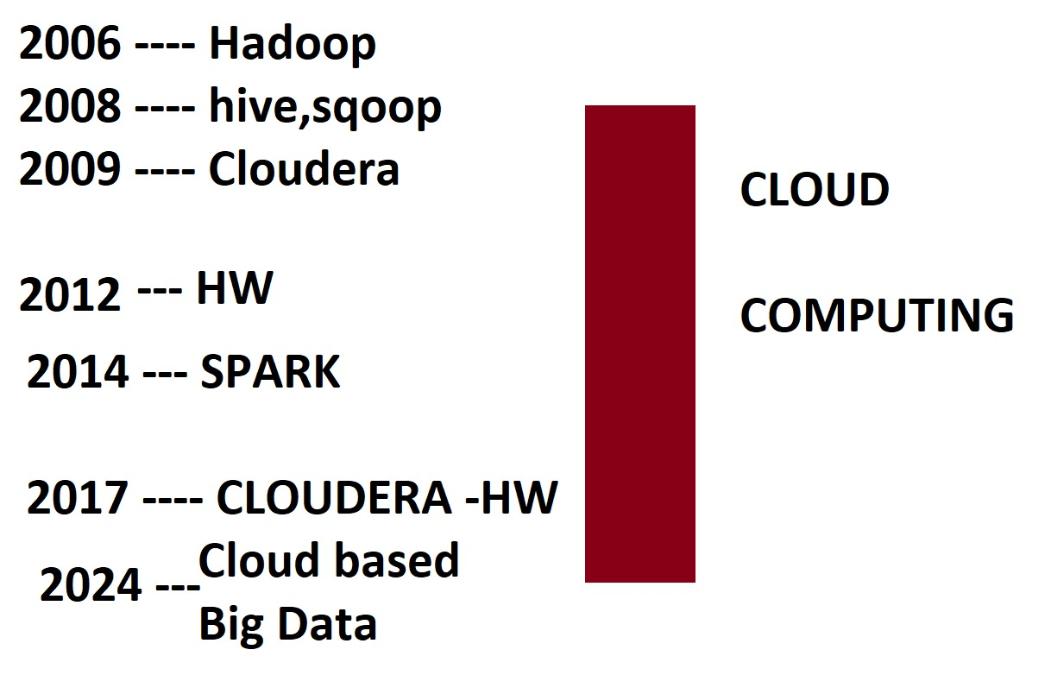
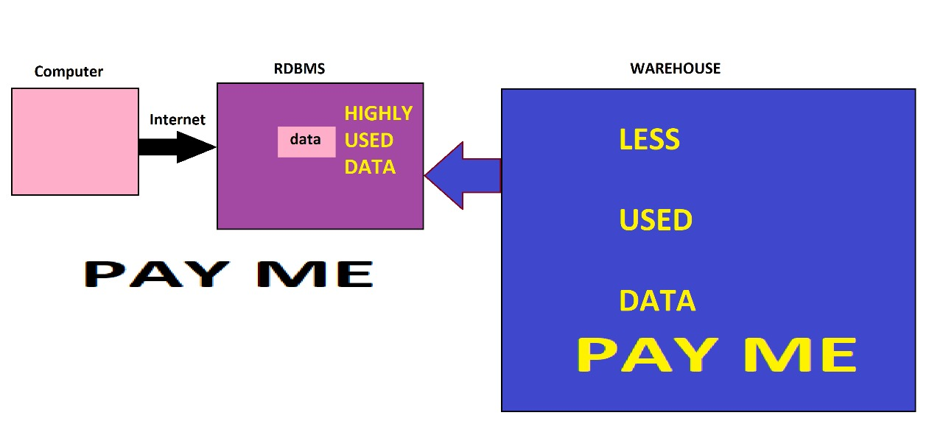
CLASS 4 DATE 02-06-2024
CLUSTERING:
Cluster : Group of Laptops/Instances combines to say as Cluster, which has Gateway Node, Data Node, Master node etc.
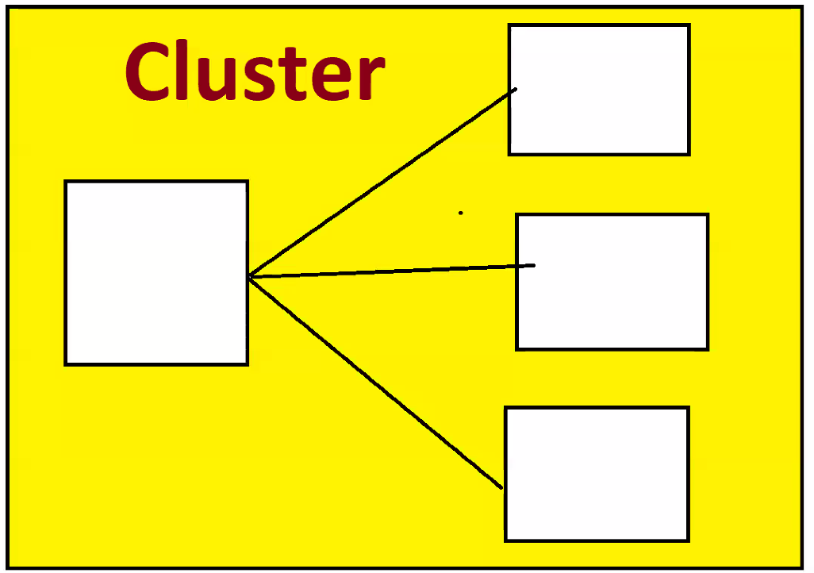
Take 5 laptops/Machines of each 1TB Capacity, install Hadoop in each and interconnect all machine, it becomes 5TB of HDFS(Hadoop Distributed File System). 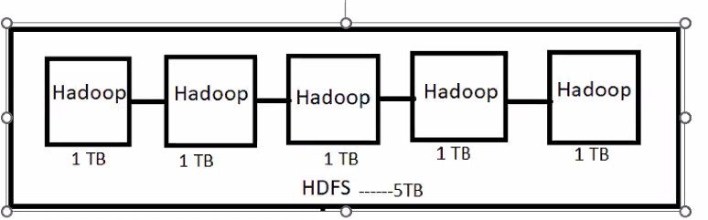
To communicate with HDFS, we need a Gateway Node/Laptop/Machine and specialized softwares like Putty, Mobaxterm. With help of putty or Mobaxterm connect to Gateway Node via IPAddress / HOSTNAME.
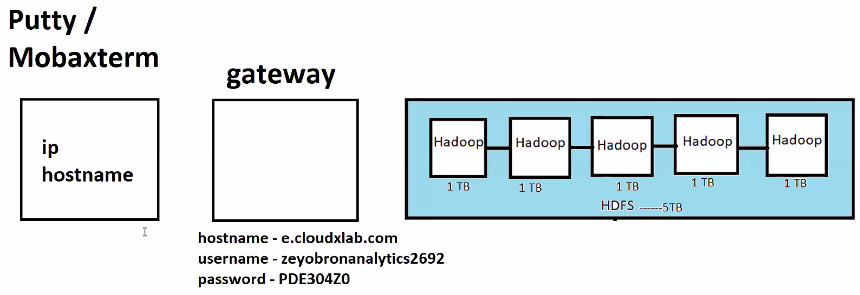

Gateway laptops are powered with Linux Operating System. If we want to talk to Gateway Node, we need to Execute/fire Linux commands.
In order to communicate with HDFS, we directly cannot connect to HDFS, instead we connect to Gateway node and communicate in Hadoop language. Gateway node will help taking our instructions to HDFS.
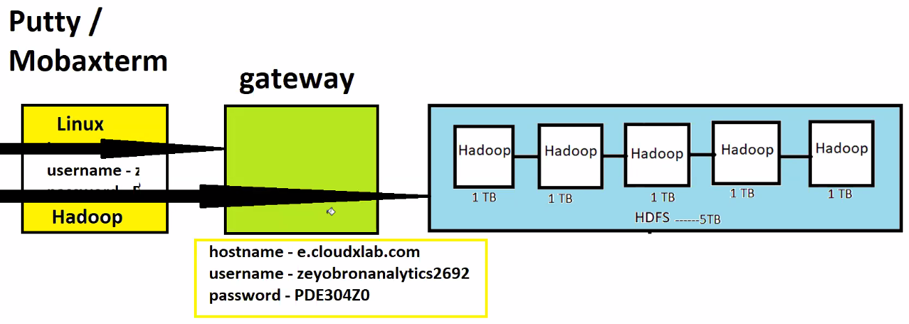
Linux commands ls Command Gateway Node will respond.
Hadoop Commands Hadoop fs -ls HDFS will respond.
HDFS has one Name Node, Secondary Name Node and rest all are Data nodes.
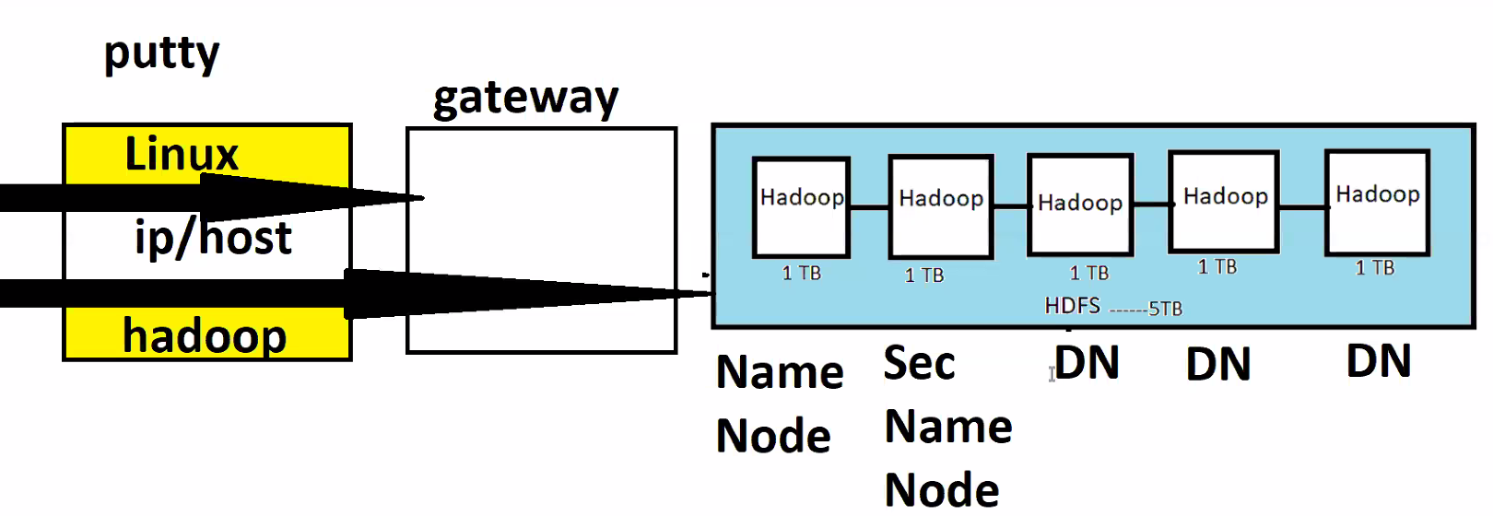

Corporate Story:
There’s product company (say Facebook) agreed to give work to service company (say tcs).

The work is about is get started next week and fb getting prepared to give work to tcs. Tcs started allocating/recruited Delivery manager, and started building a team.
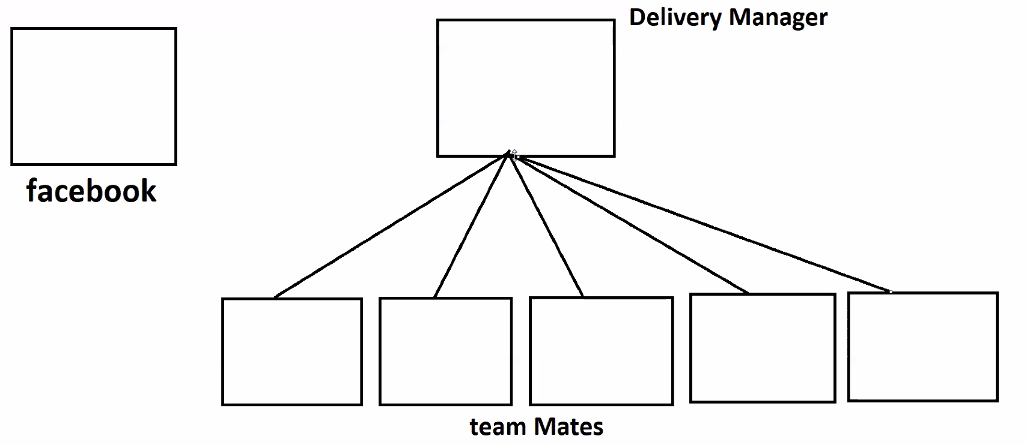
Delivery manager thought of interacting with teammates, one fine day he visited office to meet teammates and asked teammates to meet at conference room. Now Delivery manager started giving some instructions, he gave 4 mandatory instructions to all his teammates:
- Obey me as I’m your manager.
- To understand you are active for every three seconds, raise your hands.
- If you don’t raise for 3sec, I’ll give time till 10 minutes to raise hands, if you don’t raise your hands then I’ll consider you as dead.
- If you got any work from client, please give 2 copies of work to other teammates.
Teammates all went to their desk and started raising their hands.
Now, Fb got some work to do, asked delivery manager about his work.
Delivery manager maintains some excel to keep track of teammates who all are free or occupied. Then delivery manager responded back to FB and said as the work is big, asked it to allocate it to 2 teammates.
Now, teammates who got work, they replicate that work to 2 other teammates.
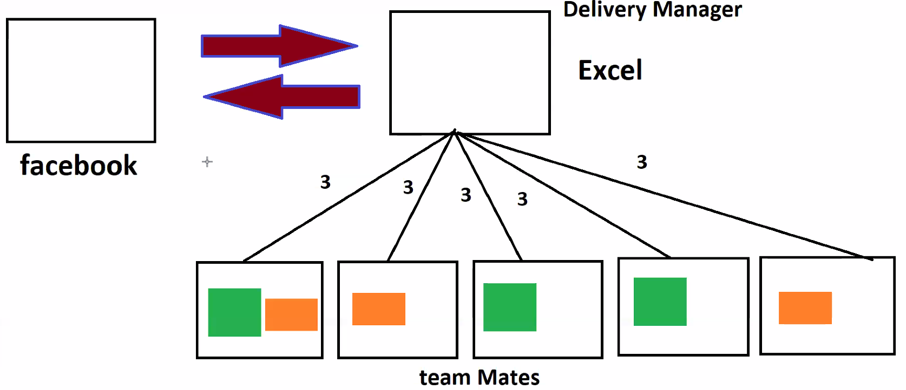
All went very well for 3 days, every teammate is working. Now teammate 1 stopped raising the hand. Manager waited 10mins and teammate 1 didn’t respond for 10 mins and manager considered him as dead.
As the replications got decreased because teammate is dead. Manager asked temmate2 to replicate work to maintain 3 copies. Then manager removes the one how dead and recruits the new one, then he will balance the work by sending the work to new teammate.
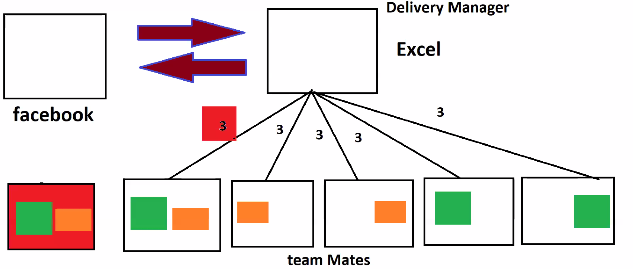
Now, all of a sudden before removing dead teammate, started raising the hand. Then teammate1 stated that he’s not dead, he said, he is sleepy. Now, Issue is we have 4 replicas of work. Now, Manager asked teammate1 to delete all his work and manager balanced the work to maintain 3 replicas.
Now Analogy linking to HDFS:
Facebook is Gateway node, Tcs is Name Node, teammates are data nodes. Edge Node & client all are other names to Gateway node.
Rules of Name Node:
- Obey me
- For every 3 sec, send me Small Java heart Beat code.
- 10 min Stale time.
- If you got any data, maintains 3 replicas
HDFS Architecture:
When Edge Node gets data of 200MB, Name node checks fsimage and says data is huge asks edge node to divide it as max limit is 128MB. Now 200mb of data gets divide into 128mb and 78mb and data will be sent to all data nodes and maintains 3 replicas.
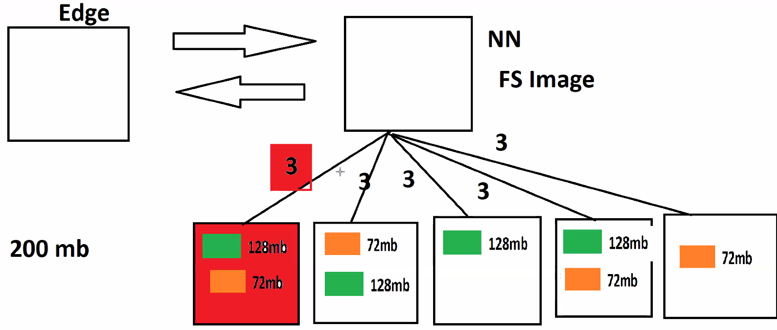
If any of the datanode is dead, namenode brings another new datanode and replicates the data to maintain 3 replicas. If dead datanode starts responding back, name node ask’s that datanode to delete all the data it has and name node manages the work to maintain 3 replicas.

INSTALLATION STEPS:
- Install 7Z
- Install Virtual box. Windows 10 virtual 6/7 or Windows 10 virtual 7
- Extract Cloudera using 7z.
- Open Virtual Box and pull extracted cloudera.
Name:powered version changes to Redhat. If 64 bit no problem. If we get 32 we have to enable VTX.
Base memory 8gb ram go with 4000MB
Processors : 2
Tick Use existing virtual disk file then add extracted cloudera using 7g

Steps to enable VTX:

- Got to settings advanced make it bidirectional.
Installation videos:
🔴 windows 10 Virtual 6 set up steps VIDEO or go with Virtual 7
https://youtu.be/xsTbkZ8r1qo
🔴 Windows 11 Virtual 7 set up steps VIDEO
https://youtu.be/u1x0ZMEeefU
🔴 MAC Installation Steps
https://youtu.be/WESGq7tPRxQ

Class:5 Date: 08-06-2024
Agenda:
- Recap – Cluster and HDFS Cluster Administration.
- Known FACTS
- New -- HDFS Metadata Management
- New -- Hadoop 2.0 Architecture
Commonly Known FACTS:
Five Known Facts:
- Client is extremely important than internal team (TCS and FACEBOOK example).
- Every laptop/mobile would have RAM and Hard Disk.
- RAM is Faster than Hard Disk. Any Application gets stored on HDD and runs on Ram.
- If save large files from RAM to HDD, a chance machine gets hung for a moment.
- If you do not save the file. If a machine get restarted Data on RAM would be lost.
If client asks anything, name node immediately asks FSIMAGE, FSIMAGE maintain all the information related to Data nodes, where data is stored on what node, transaction information etc. FSIMAGE is heart of Hadoop. FSIMAGE plays a crucial role in entire Hadoop environment.
To serve client, FSIMAGE to be maintained/managed in RAM for faster Retrieval. FSIMAGE has lots of data and data increases exponentially,. If we commit FSIMAGE to HDD, there is a chance that node gets hanged and serving client gets delayed.
Now Lets say FSIMAGE got entirely filled up, we need to save/checkpoint the FSIMAGE to some location. If we don’t save the data, data will be lost if machine gets restarted.
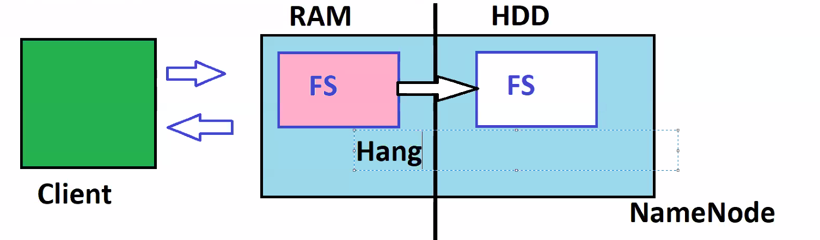
How Doug Cutting managed to save FSIMAGE, without data loss?
That’s the moment he bought Hadoop Metadata management.

Hadoop Metadata Management:
we have a client, name node, secondary name node and data nodes.,
To serve client, by the time cluster gets started, it immediately puts FSIMAGE copy on RAM. Along with FSIMAGE it also places another file on RAM called EDITLOG(lighter in nature, easily commit to HDD, size will be very small).
As the work getting started, some transaction has happened, say some data come into data nodes got divided and stored.
Any data transaction happens say data change, data movement, data deletion etc, that transaction data gets stored in FSIMAGE in RAM, EDITLOG in RAM and also EDITLOG in HDD in Name Node.
As client dependant on FSIMAGE, EDITLOG has no dependency, so any transaction happens, it gets logged inside FSIMAGE in RAM, EDITLOG in RAM and also EDITLOG in HDD in Name Node. After some time if transaction happens, those record will also be stored in FSIMAGE in RAM, EDITLOG in RAM and also EDITLOG in HDD in Name Node .
After one hour, whatever the transactions happens they also be available in FSIMAGE in RAM, EDITLOG in RAM and also EDITLOG in HDD, then secondary name node takes FSIMAGE from HDD of Name Node, recent EDITLOGS on HDD from Name Node and merges EDITLOG file to FSIMAGE in secondary Name node. Then That updated FSIMAGE from secondary Name node gets committed/saved to HDD in name node. EDITLOGS in HDD name node get refreshed.
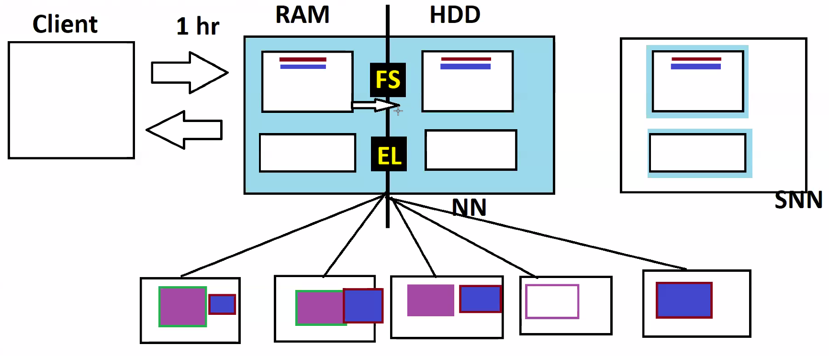
Again after some let say some transactions has happened, after one hour, Secondary name node merges EDITLOG from name node HDD to FSIMAGE in name node HDD and EDITLOGS from name node HDD get refreshed. Sends back FSIMAGE to name node HDD.
Both FSIMAGE in RAM and FSIMAGE in HDD of Name Node will be in sync for every one hour.
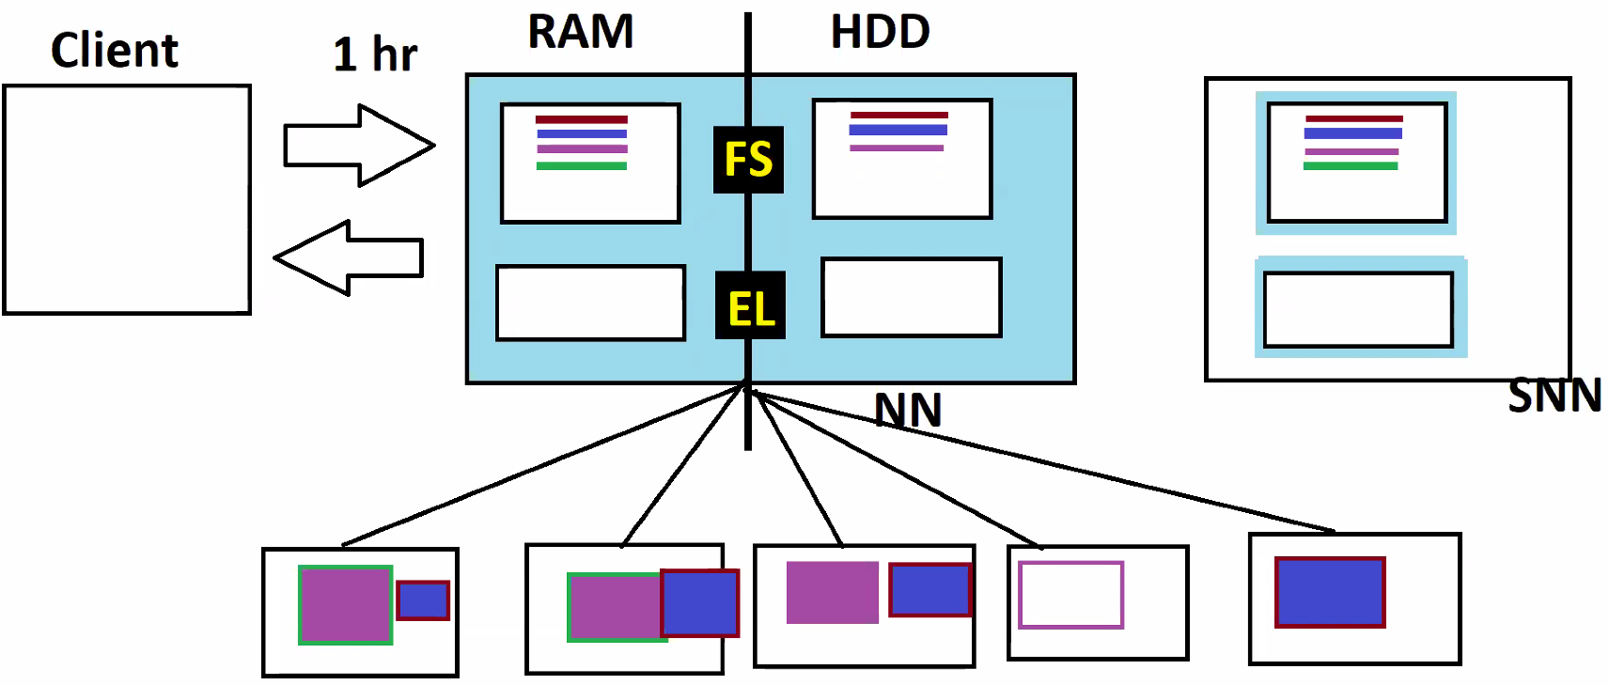
After some time, some transactions happened and gets logged in FSIMAGE in RAM, EDITLOG in RAM and also EDITLOG in HDD of a Name Node , after 30mins suddenly Name node got restarted, data(FSIMAGE,EDITLOG) on RAM in Name node is lost.
Once Name node gets restarted, it immediately goes into SAFEMODE, that time informs client, data nodes to wait, until name node is ready with FSIMAGE on RAM. Now Name node brings FSIMAGE, EDITLOGS from HDD to RAM and does its own checkpointing/merge and starts serving the client.
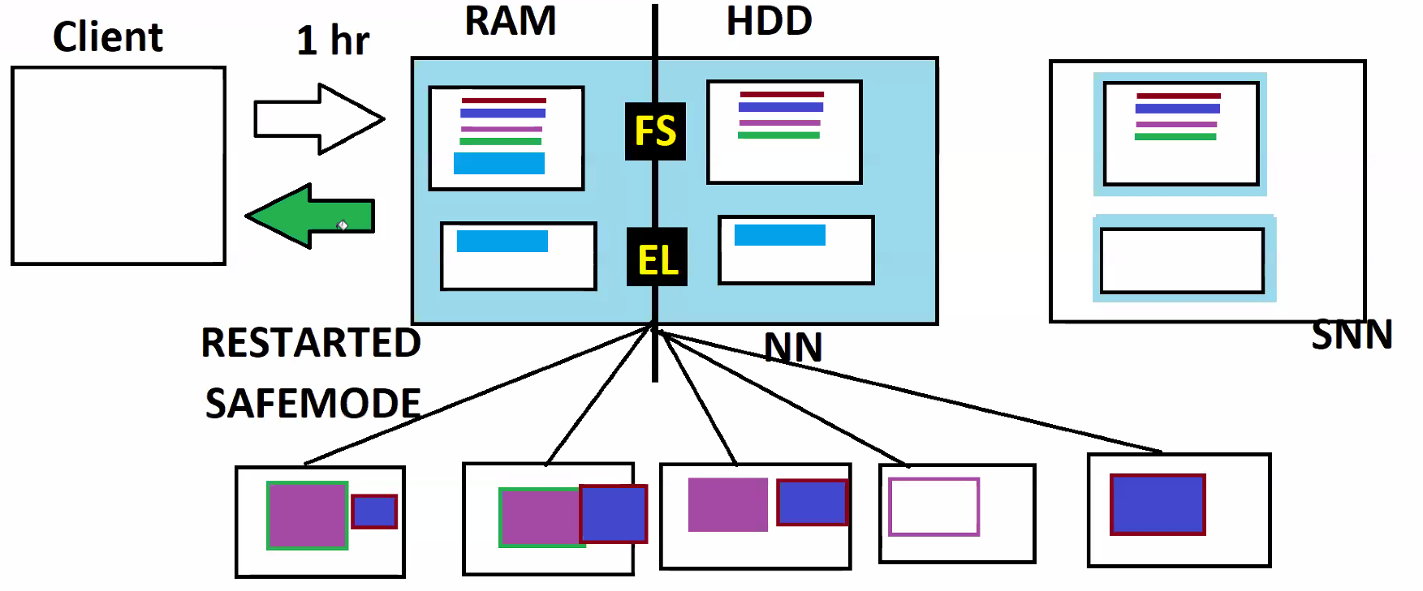

If the name node entirely gets dead or lost, all the data in HDD is lost. We cannot make secondary name node to work as Name node as it has older FSIMAGE, it does not have recent transactions which are not merged with FSIMAGE. That’s the main drawback of Hadoop 1.0 Architecture, called Name Node Failure.

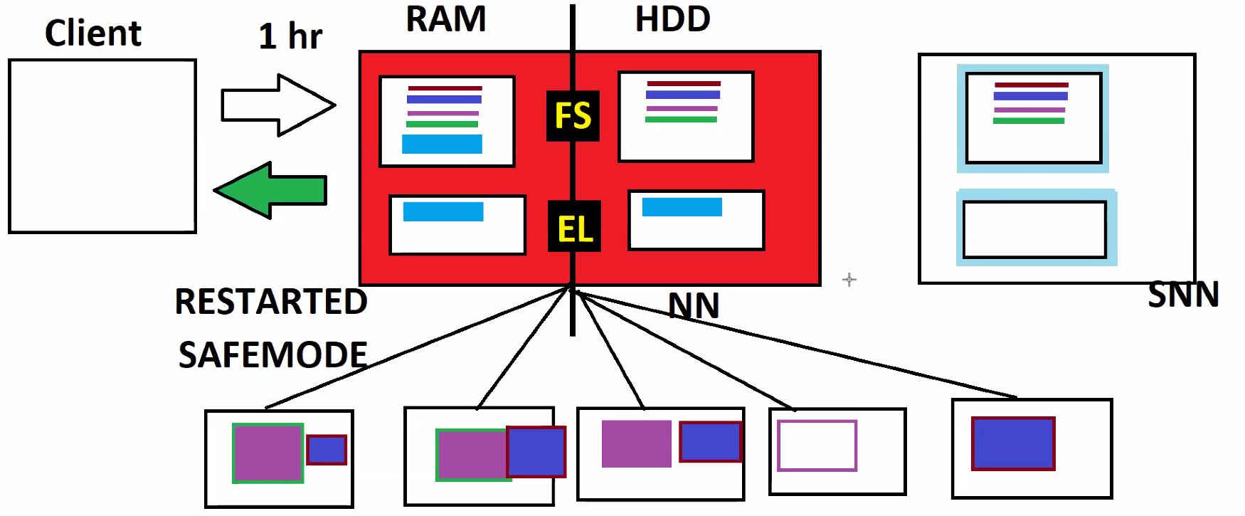

Instead of storing EDITLOGS in Name node, if we store it somewhere, we can send that EDITLOGS to secondary name node and it recreates FSIMAGE and acts as Name Node. That how Hadoop 2.0 works.

Hadoop 2.0 Architecture:
ZOOKEEPER is appointed in Hadoop2.0 to handle all failures. Will have control on all these nodes. Takes care of cluster failures, delays, etc.
Name Node Instructions/Changes:
- Name changed from Name Node to Active Name Node.
- You will have a file in_use.lock, that indicates it’s Active Name Node.
- Keeps writing EDITLOGS to Journal Nodes.
- ZOOKEEPER keeps watching the health of Active Name node.
Secondary Name Node Instructions/Changes::
- Name changed to StandBy Name Node.
- Does not have in_use.lock file. Only Active node has it.
- Reads EDITLOGS from Journal Nodes for merging.
- Follows instructions from ZOOKEEPER.
Date Node Instructions/Changes:
- Before connected only with Name Node in Hadoop1.0, In Hadoop 2.0 Data node gets connected to both Active and stand by Name node.
- Send Transactions information only to the node having in_use.lock file.

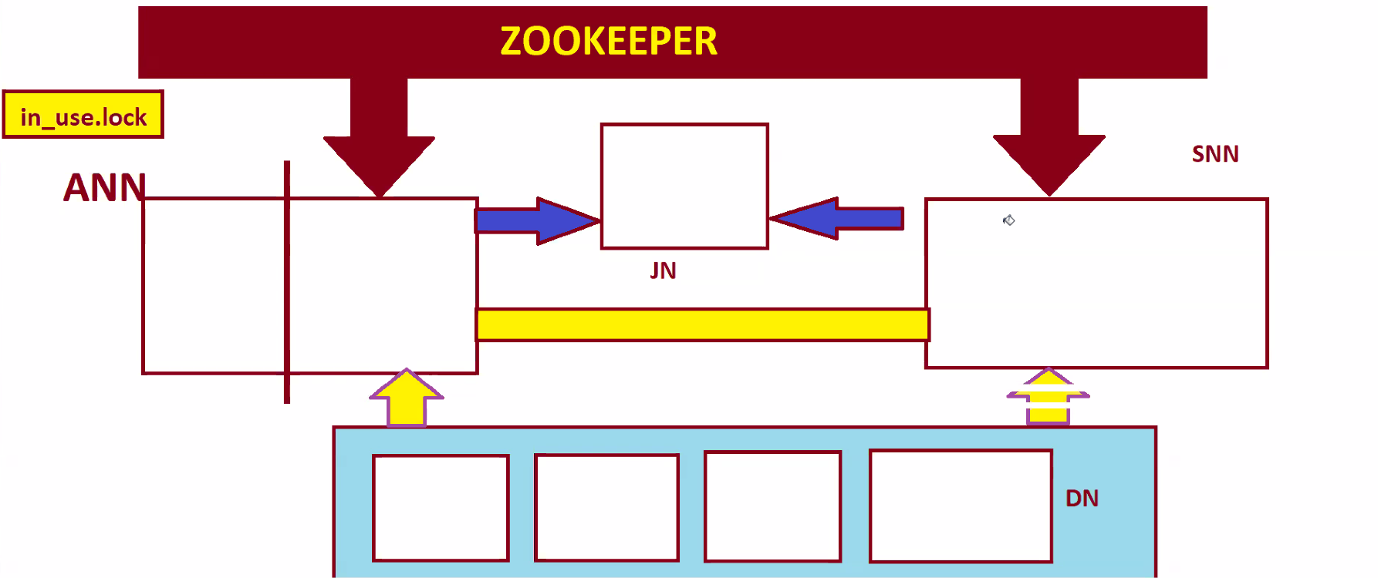
Zookeeper monitors all nodes. Active NN will write EDITLOGS to Journal Nodes. Standby NN takes EDITSLOGS from Journal Nodes. Active NN and Standby Node are connected which shares FSIMAGE.
All the data node are internally connected to each other. Data nodes are strongly connected to Active NN but partially connected to Standby NN.
Active NN and Standby NN are coupled to each other and shares FSIAMGE.

When work gets started, immediately FSIMAGE in HDD comes to RAM in Active Name node. If any, Transactions gets recorded in FSIMAGE IN RAM in Active NN then also in EDITLOGS Journal Node.
After one hour, FSIMAGE FROM Active Name Node will be sent to Standby Name Node, and EDITLOGS from Journal Nodes also sent to Standby name node. Standby NN merges EDITLOGS to FSIMAGE and sends FSIMAGE back to HDD of Active NN.
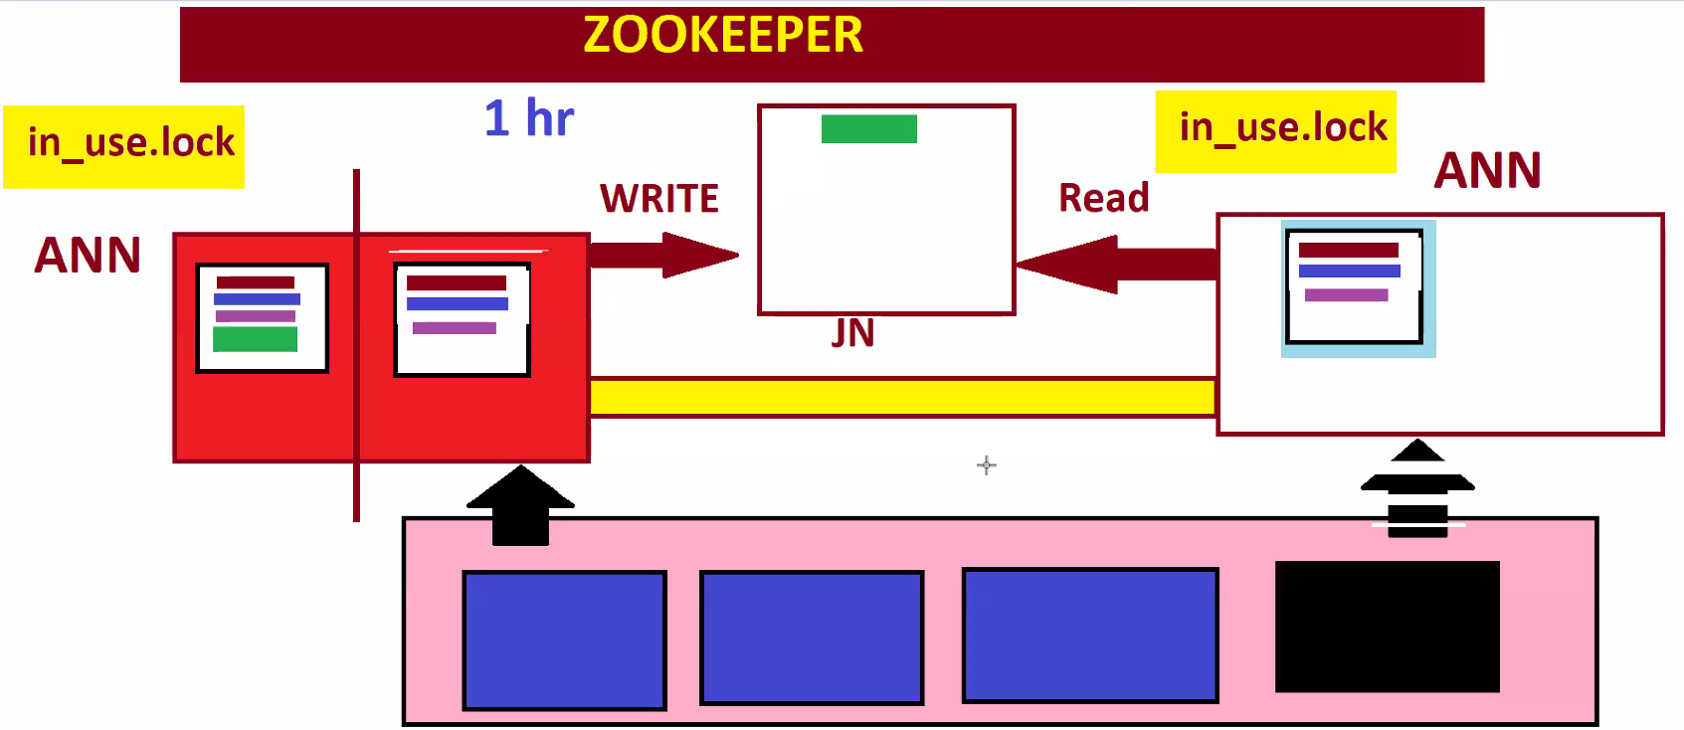
Say some transaction has happened and saved in FSIMAGE in RAM of Active NN, also saved in EIDTLOGS in Journal nodes. Now active Name node stopped responding. Zookeeper is closely watching the health of ANN. As soon as Zookeeper confirms ANN is dead and asks Standby NN to go Safe mode and to create it’s own in_use.lock file, then standby NN reads EDITLOGS from Journal nodes and merge it with FSIMAGE become Active Name node and starts serving client. Now Data node are closely coupled with new Active Name node and partially coupled with dead node. At that particular moment as we don’t have any standby NN, new Active NN also does the work of Standby NN, it goes safe mode every one hour and does checkpointing.
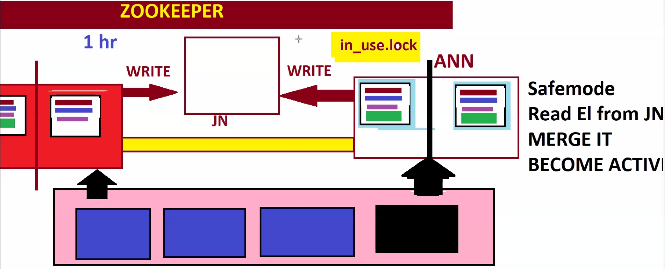
Before we replace dead node, Now major risk is, after some time dead active name node starts responding, now both node are having in_use.lock file, both acts as Active name node And transactions gets duplicated and recorded into EDITLOGS of Journal Node from both Active name nodes. This Scenario is called SPLIT BRAIN SCENARIO.
To stop the write, Zookeeper sends some fencing program to stop the write, then instructs dead Active name node to remove in_use.lock file . so that it acts standby NN. Then Fencing is removed.
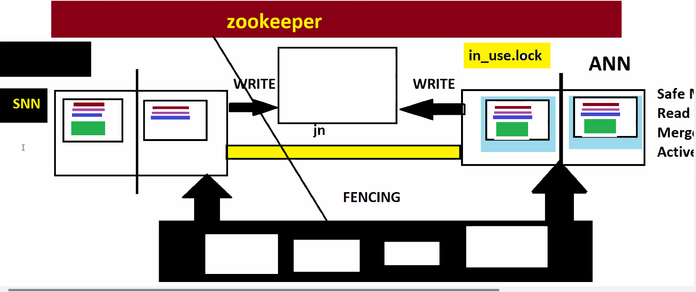

Original Architecture by released by Hadoop 2.0:
