SPARK
2006 Hadoop Launched
2007 faced MapReduce issues
2008 Hive
2011-2012 Data world was changing – more expectations – YARN introduced
More Requirements:
- Data streaming tech Stack
- Machine learning supports
- Whole ETL/ELT Processing
- Highly customizable data processing
- Environment independent
- Faster than Hive
2012 Matei Zaharia, doing masters in UC Berkley, as a part of masters project, he has designed a tool(Framework) called SPARK
Features:
- Extremely Simple
- Extremely Faster
- Easily Customizable
- Very good SQL support
- Data Streaming Support
- Machine Learning Support
- Will do whole ETL/ELT
- Very Good Serialized data processing Support
- Very Good Integration.
- Environment independent
Spark is something can solve many problems. Hive has put some restrictions like it can read data only from HDFS, cannot read data from other sources like s3, Azure etc, no meant for streaming, no meant for ML. But Spark can solve all these problems.
Why spark is Faster? VV imp for interview
Zaharia developed spark on top of having a reference of MapReduce. The actual father of spark is Doug cutting who developed spark. But Zaharia found one mistake and corrected it, that’s where spark has come into picture.
The one issue that made MapReduce slow processing, made spark execution/processing fast. Lets see:
MapReduce Vs Spark: Word Count Example:
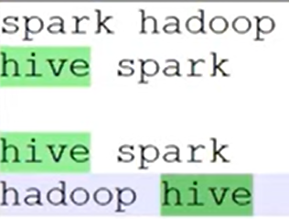
Word count: Data is as show in picture: we need to count number of words.
Program Code: 5 lines
- Read the data.
- Flatten the data with space.
- Suffix 1 for the result
- Group by key sum of value
- Print it

Lets see each step in detail –
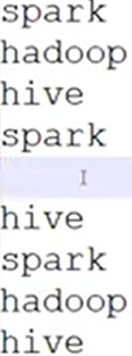
- Read the data: Data will be read as show in figure.

- Flatten the data with space: every data gets into separate line.

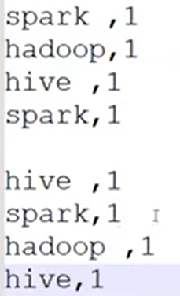

- Suffix 1 for the result:

- Group by Key sum of value
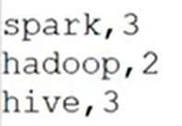

- Print it

Now, we will se what happens if we going to execute above 5 lines of code in MapReduce and spark:
Imagine we have 2 nodes, each node has its own dataset as show in figure. At each node, by the time we read data, this data comes to RAM. By the step2 Flatten executes, data gets flatten on each node, as shown in figure. Step 3 suffix 1 to flatten data, as shown in figure. In Step 4 groupby key, here data from all nodes gets shuffle and data comes to single node, and performs groupby operation. In step 5 data gets printed. All this happens at Node level for word count program.
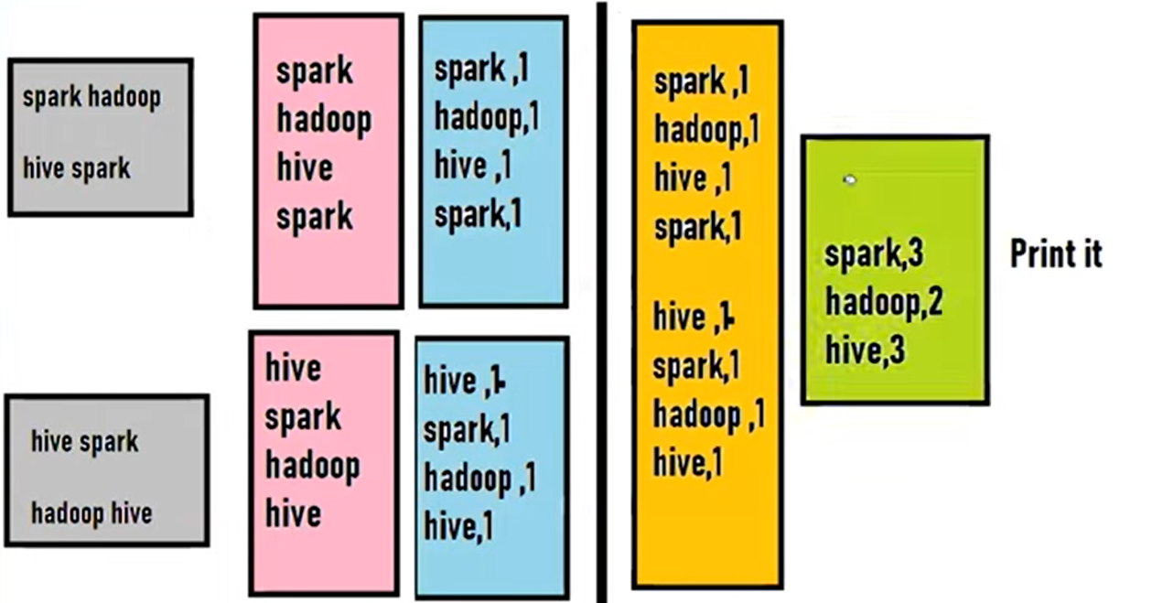
The same word count program mapreduce will handle in 5 lines and spark also handle in 5 lines. But there is minor issue in mapreduce while handling this. That issue found by zaharia and he fixed it then launched corrected mapreduce as spark.
Say we have data in HDD in 2 nodes, by the time we execute code in MapReduce, what happens is at node level is, there is one small issue which would happen in mapreduce that is –
step 1 : by the time we read the data it immediately comes to RAM from HDD. Step2: by the time we trigger, flatten the data: mapreduce will flatten the data. But what mapreduce immediately does is, by the time one process is done, it immediately sends copy of flatten data to HDD, it does intermediate commits to HDD. Step 3: suffix 1 to flatten data: mapreduce will process it. But again it hits the intermediate results to HDD. Step4: group by key sum of value: now data gets shuffled to another node, and again it hits the intermediate results to HDD. Step5: print it
Issue in Mapreduce is for every operation, it hits the intermediate results to HDD.
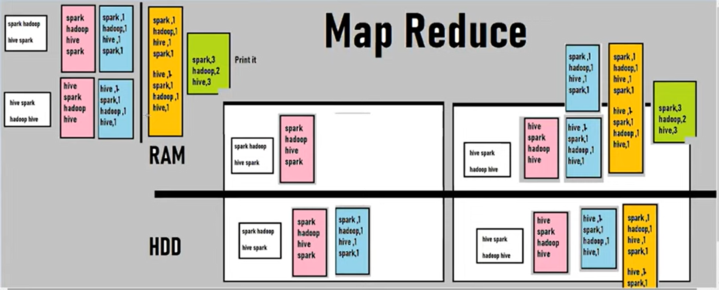
Hadoop documentation mentioned reason behind hitting the intermediate results to Hard disk is –
- MapReduce is Linear in Nature.
- Unsure about next steps not aware next steps in code does. It does what it asked to do at each step, it wont care about Actions and Transformation in Code. It blindly follows steps it asked to do.
- Hitting the intermediate results to HDD Just for data recovery, fault tolerance, data loss it keeps hitting HDD.
Zaharia found this as very big issue. He took MapReduce as reference and understand there is IO issue that is Input-Output between RAM and HDD. Then he introduced SPARK having reference of MapReduce.
SPARK:
- Spark works in distributed environment.
- Not Linear in Nature but spark is LAZY in Nature.
- Spark pretty sure about next steps.
- Will not hit HDD for every intermediate results
Word count program execution in spark:
Say we have data in HDD in 2 nodes, by the time we execute code in SPARK, what happens is at node level is,
step 1 : by the time we read the data , spark will not read the data, but it create logical and physical plan for it. It analyses the code. Step2: by the time we trigger, flatten the data: SPARK will not flatten the data. But spark creates plan for it. Step 3: suffix 1 to flatten data: it won’t instantly suffix the data, creates plan for it. Step4: group by key sum of value: : it won’t instantly group by the data creates plan for it. Step5: By the time print gets executes, so far spark analysed entire code, it analysed entire transformations. By the time Action gets triggered that is print, that time, immediately spark will do all transformations. It Reads, flatten, suffix, group by.
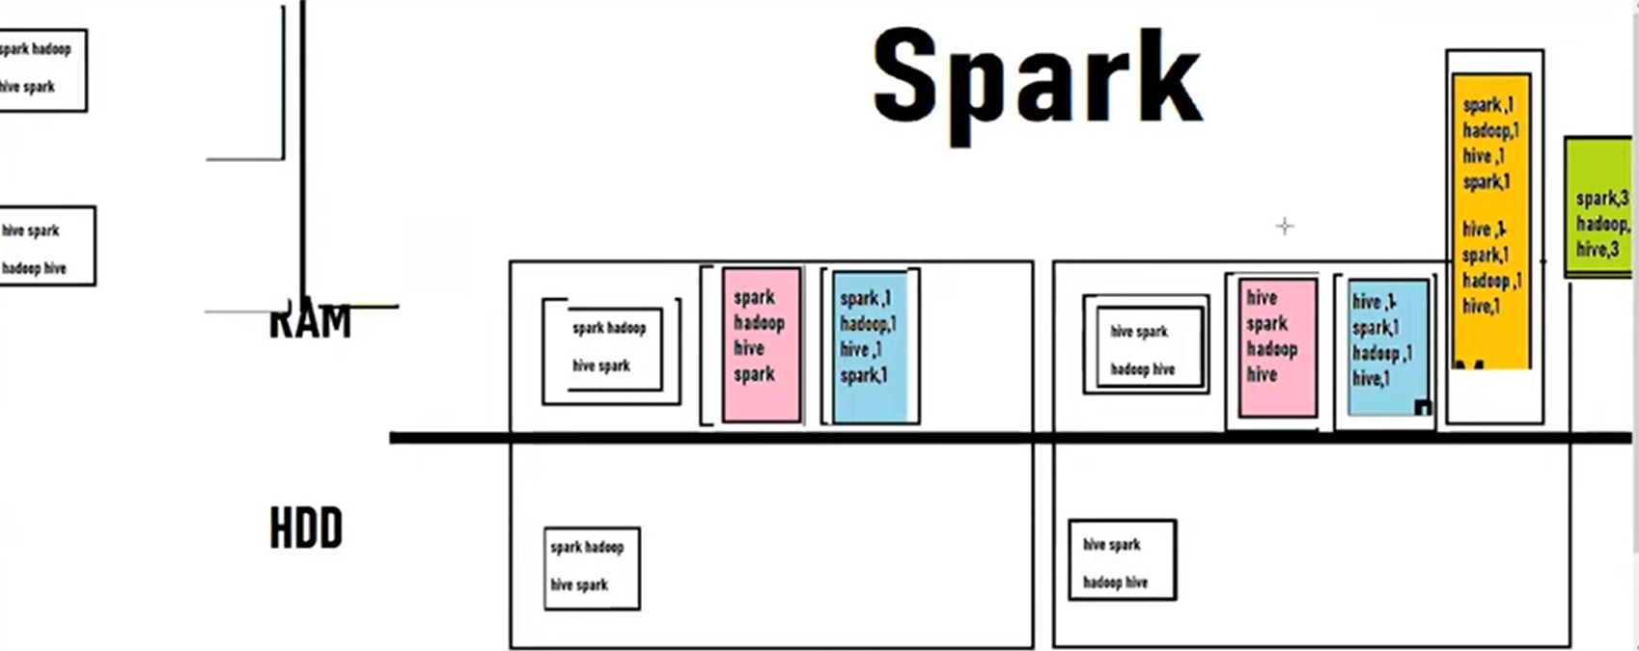
Spark eliminates hitting HDD. Hitting HDD is very costly and time taking operation.
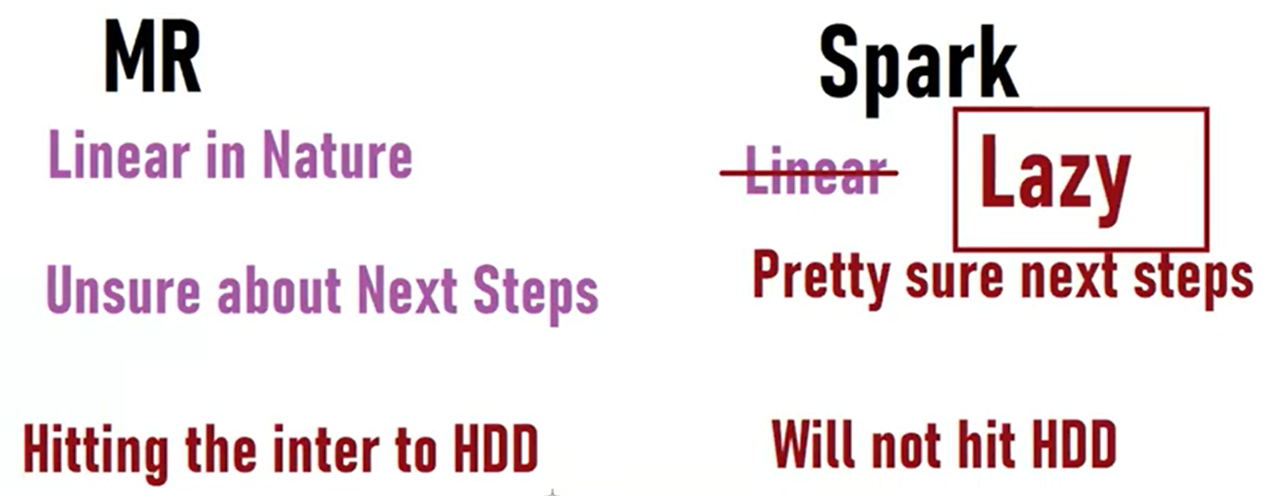
TASK:
- What is map side join – Broadcast join
- What is DAG in spark – I need verbal explanation along with DAG diagram
Agenda:
- Spark Recap
- Lazy evolution Handson
- Spark vs MR performance run with stopwatch
- deployments

