Scenarios
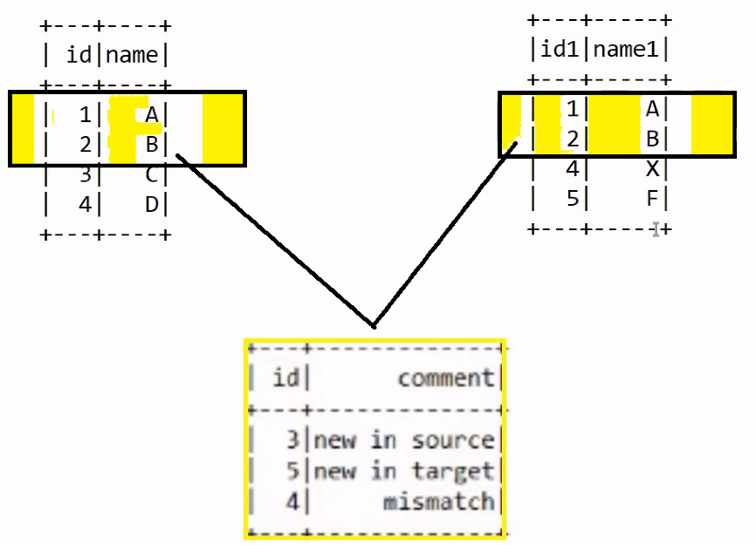
Scenario 1:

source = [(1,'A'),(2,'B'),(3,'C'),(4,'D') ]
target = [(1,'A'),(2,'B'),(4,'X'),(5,'F')]
source_rdd = sc.parallelize(source).coalesce(1)
target_rdd = sc.parallelize(target).coalesce(1)
source_df = source_rdd.toDF(['id','name'])
target_df = target_rdd.toDF(['id','name1'])
fulljoin = source_df.join(target_df,['id'],'full')
fulljoinmatchname = fulljoin.withColumn("comment",
expr("case when name=name1 then 'match' else 'mismatch' end as comment"))
filterdf = fulljoinmatchname.filter("comment='mismatch'")
opdf = filterdf.withColumn('comment', expr("""
case when name is not null and name1 is null then 'new in source
when name is null and name1 is not null then 'new in target’
else 'mismatch' end as comment""") )
opdf.select('id','comment').show()

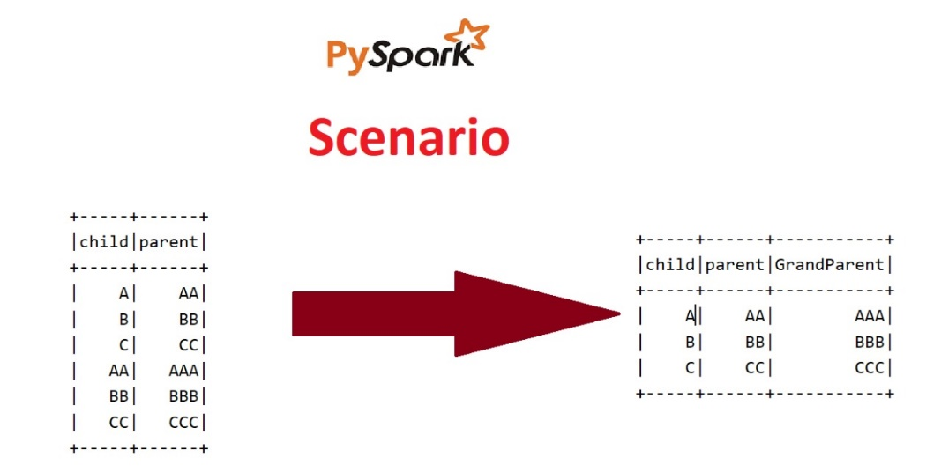
Scenario 2:
data = [
("A", "AA"),
("B", "BB"),
("C", "CC"),
("AA", "AAA"),
("BB", "BBB"),
("CC", "CCC")
]
df = spark.createDataFrame(data, ["child", "parent"],1)
df.show()
df1 = df.alias('df1')
df2 = df.withColumnRenamed("child","childparent").withColumnRenamed("parent","grandparent")
dfjoin = df1.join(df2, df1.parent==df2.childparent, "inner")

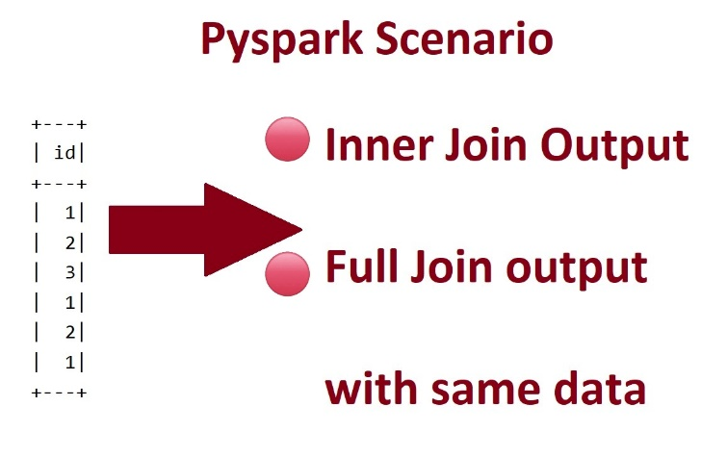
Scenario 3:
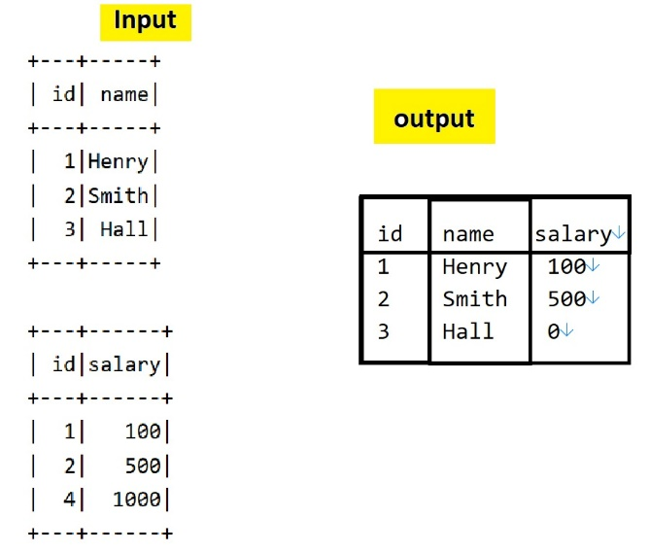
data = [(1,), (2,), (3,), (1,), (2,), (1,)]
df = spark.createDataFrame(data, ["id"],1)
#df.show()
df1=df # FIRST DF
df2=df # Second df
df1.join(df2, df1.id==df2.id,'inner').show()
df1.join(df2, df1.id==df2.id,'full').show()
Scenario 4:
data1 = [ (1, "Henry"), (2, "Smith"),(3, "Hall")]
columns1 = ["id", "name"]
rdd1 = sc.parallelize(data1,1)
df1 = rdd1.toDF(columns1)
df1.show()
data2 = [ (1, 100),(2, 500),(4, 1000)]
columns2 = ["id", "salary"]
rdd2 = sc.parallelize(data2,1)
df2 = rdd2.toDF(columns2)
df2.show()
leftjoin = (df1.join(df2,["id"],"left").orderBy("id")
.withColumn("salary",expr("case when salary is null then 0 else salary end")))
leftjoin.show()
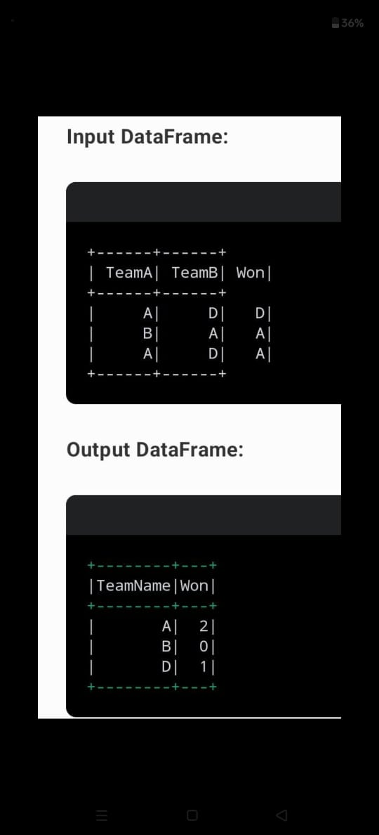
Scenario 5:
Solution 1:
data = [
('A', 'D', 'D'),
('B', 'A', 'A'),
('A', 'D', 'A')
]
df = spark.createDataFrame(data).toDF("TeamA", "TeamB", "Won")
df.show()
teams = df.select("teamA").union(df.select("teamB")).distinct()
.withColumnRenamed('teamA','team').orderBy(col('team'))
teams.show()
wincount = df.groupby('Won').agg(count('Won').alias('cnt'))
.withColumnRenamed('Won','teamB').orderBy('teamB')
wincount.show()
finaldf = (teams.join(wincount, teams.team==wincount.teamB,'left')
.withColumn('cnt',expr("case when cnt is null then 0 else cnt end")) .select('team','cnt').withColumnRenamed('cnt','Won').orderBy('team'))
finaldf.show()
Solution 2:
data = [ ('A', 'D', 'D'), ('B', 'A', 'A'),('A', 'D', 'A')]
df = spark.createDataFrame(data).toDF("TeamA", "TeamB", "Won")
df.show()
allteam = df.select("TeamA").union(df.select("TeamB")).distinct().withColumnRenamed("TeamA","TeamName")
allteam.show()
won = df.groupby("Won").agg(count("Won").alias("WonCount")).withColumnRenamed("Won","TeamName")
won.show()
joindf = allteam.join(won,["TeamName"],"left").withColumn("WonCount",expr("coalesce(WonCount,0)")).withColumnRenamed("WonCount","Won")
joindf.show()

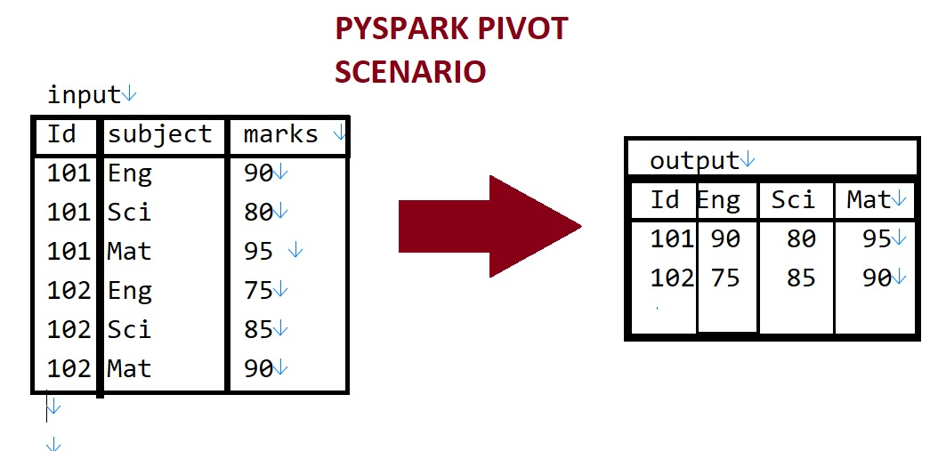
Scenario 6: Pivot Scenario
from pyspark.sql.functions import *
data = [
(101, "Eng", 90),
(101, "Sci", 80),
(101, "Mat", 95),
(102, "Eng", 75),
(102, "Sci", 85),
(102, "Mat", 90)
]
columns = ["Id", "Subject", "Marks"]
rdd = spark.sparkContext.parallelize(data)
df = rdd.toDF(columns)
df.show()
pivot = df.groupBy("Id").pivot("Subject").agg(first("Marks"))
pivot.show()
If a particular pivoted column is not available then null come in final output.
Scenario 7:
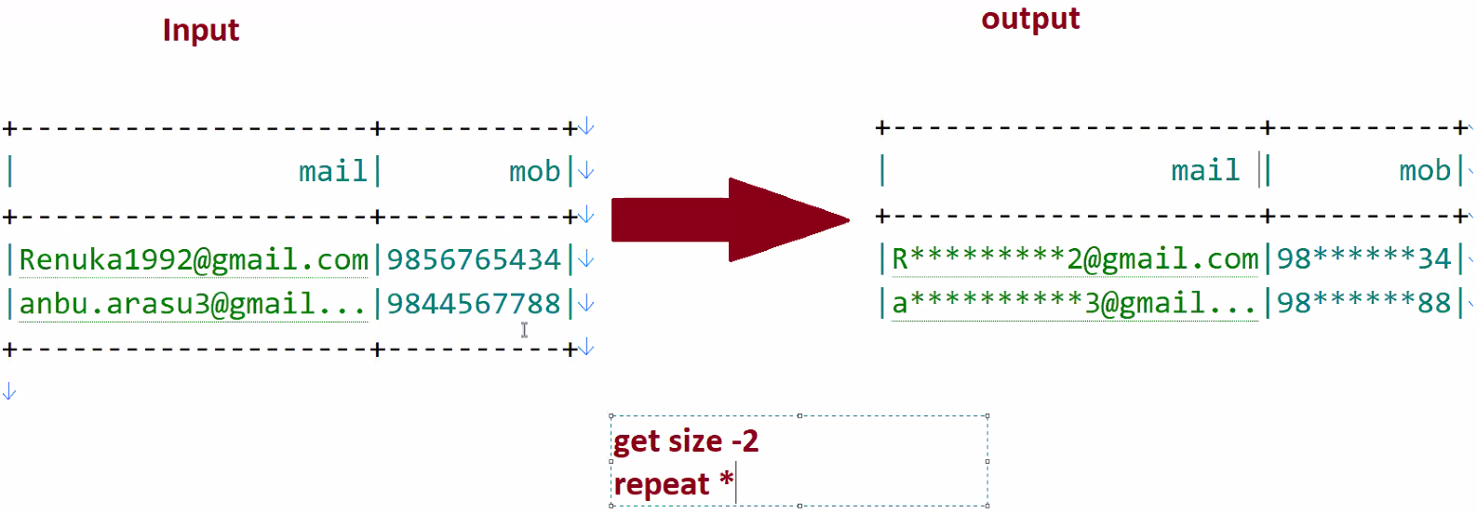
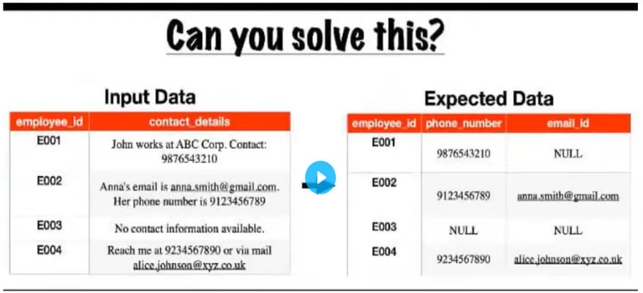
Scenario 7:

