SPARK
INTRODUCTION TO SPARK
In 2009, 2 people Matei Zaharia, Bill Chambers started a research project called AMPLAB in the University of Berkley. We had Hadoop 1.0 at that point. We have people trying to create cluster manager called MESOS similar to YARN present days in Hadoop.
They created SPARK to test Mesos (cluster manager). After a year people thought of faster execution of spark and started development. In 2012 SPARK become an Apache Project. Spark gained its popularity in 2015. Originally spark has version 0.x, 1.x, 2.x. After 1.6 stable version next, stable version is 2.x. Spark is independent project which does not require Hadoop but mostly we see it on top of Hadoop.
The people who found a spark, they give it to Apache and it become open source. Then in 2012, the same people created DATABRICKS for money and fame. This spark is available with Cloudera, Hortonworks etc.
Best Book for spark: Spark – the Definitive Guide. Don’t Buy. Learn from Apache and Databricks documentation.
SPARK HISTORY AND OVERVIEW
Till 2015. One of the problems with MapReduce is batch processing, it is slow. People want to try different workloads on spark, so people came up with HIVE, FLUME, MAHOT for ML etc. Spark alone can do what all these different tools doing.
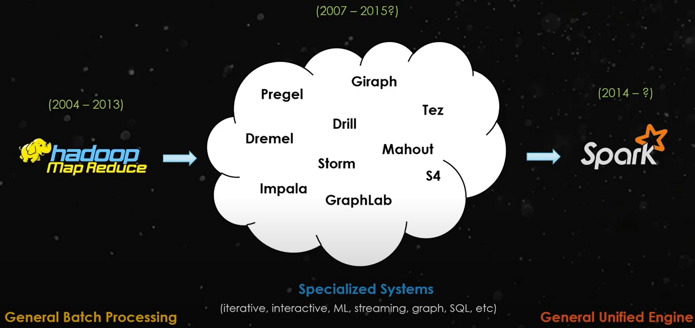
SPARK AND ITS ECOSYSTEM:
When you download spark, we get something called SPARK CORE. Spark CORE is lowest level of Abstraction in spark where we can start programming. Spark can use both RAM, HDD. Spark CORE supports Scala, Python, Java, R,SQL etc. The source of spark is written in Scala. In Spark 1.6, when we write code in python, it was bit slower and scala code was 2x faster. In Spark 2.x, they have written an abstraction, irrespective of language, the program will run at same speed.
Libraries in Spark:
- SparkSQL, create tables, data frames etc. They integrated sparkSQL with Hive. In Hadoop if we install spark and open sparkSQL, I can read data from Hive Table. These days Hive is mostly used for storage, for processing Spark is used.
- GraphX for graphs processing.
- MLlib Machine learning Library
Different modes spark can run 1. Local machine, 2. Mesos, 3. Standalone mode 4. Spark on Kubernetes 5. Cloud 6.Yarn
Mesos, Yarn, Standalone can be made highly available with ZooKeeper.
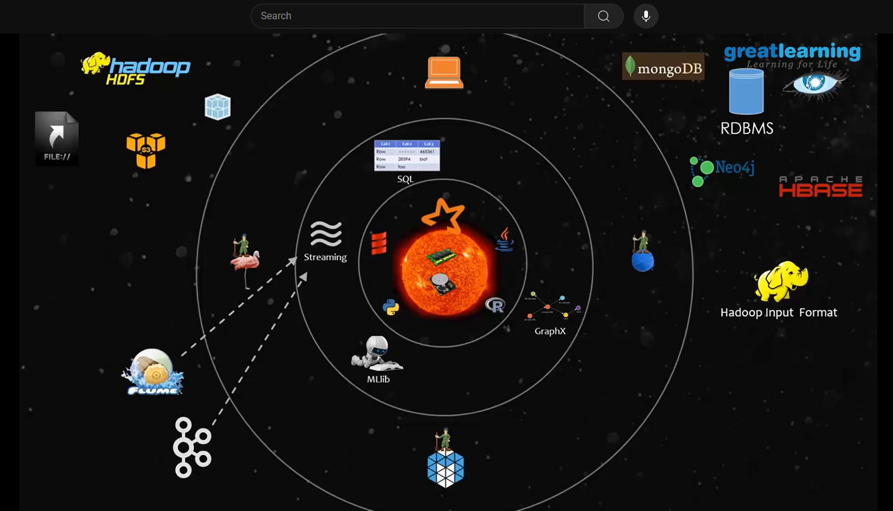
Distributors and Applications:
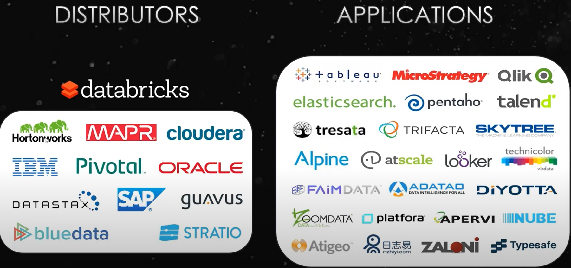

Data sorting Problem:
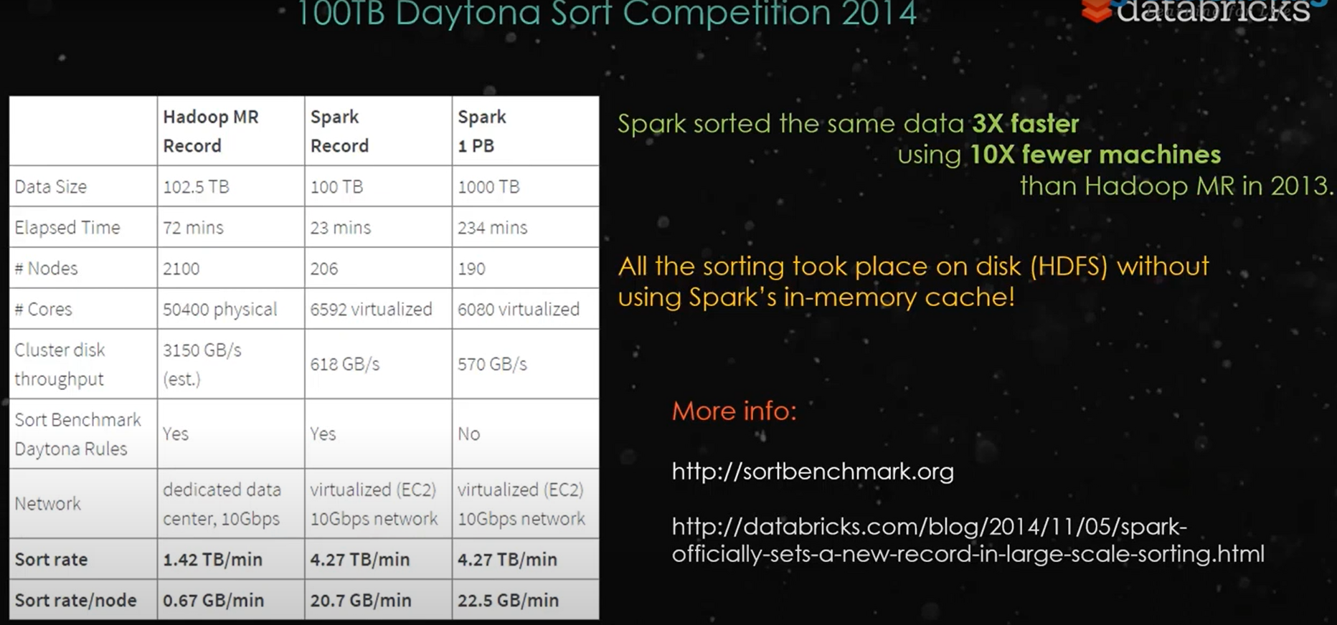
Driver
When are writing spark program. The program will have something called Driver. This driver is the Master of the program. Then we have something called Executor as Slave.
When we want to run spark program, one way we can run it Local. A JVM will be created my both driver and Executor will be inside That JVM. Local is not efficient as we have only one container and everything will be running inside it. Only used for test the code and practice purpose.
When we submit a spark code to cluster, we have to ask YARN for Executors (how many executors and its capacity). Say 1 executor and 20 GB for processing, here only one executor will be processing the code. Instead, we can ask YARN to give 5 Executors with each of 5GB. Then there is Driver, will be running in any of the one the executor. This Driver will push spark code into all executors at a time and then executors process this code. The output comes back to driver from all executors. This driver is normally App Master from YARN. This is how spark is processing in Cluster. Before running spark code in cluster, we should be aware of RAM and executor. If cluster does not have specific executors and RAM, processing fails.
We have some to configure in YARN called Application master Restart Timer. Say 3 min, 5 mins etc. It tries to restart the App master on same machine. If that doesn’t work then only we go to another machine and start from where we left off.

RDD FUNDAMENTALS:
RDD are the basic building of Spark. In Spark, data is represented as RDD. Any data that we have the first step that we do is we create something called RDD (RESILIENT DISTRIBUTED DATASET). RDD is just variable or pointer.
Suppose say we have logs file data in 4 blocks on 4 data nodes and we want to process them.
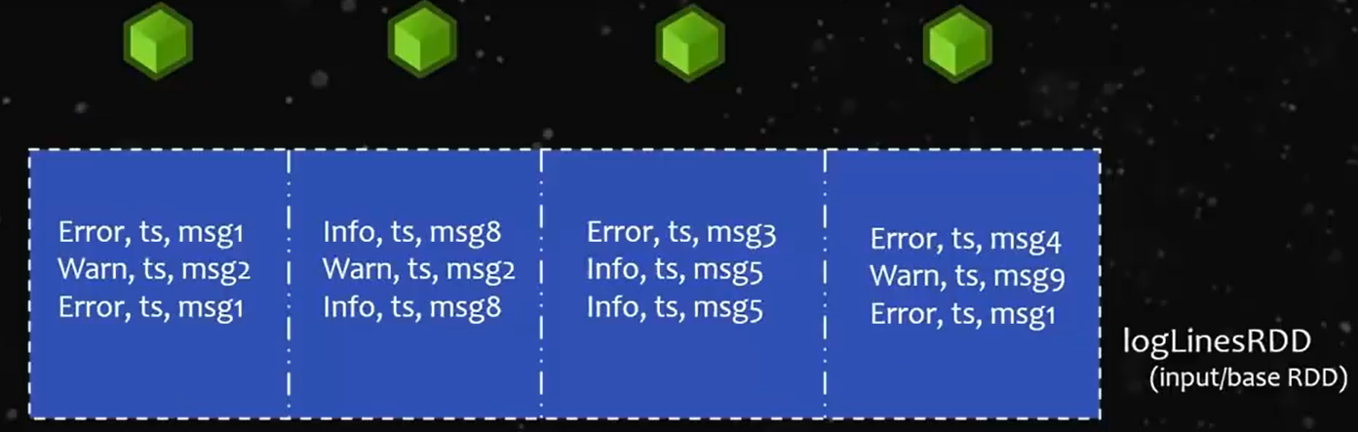
We have original data in HDD as Blocks in HDFS. Image we have already written spark program to process the data. In the program first step we have to do is to create an RDD (LogLines RDD from above image). Then when I run spark code with 4 executors. In each data node one executor gets launched and each data node have one block to process. Then all this data gets copied into RAM Memory. Because RDD represent our data into Main memory or RAM.
Imaging we have 6 data nodes of which we have 4 blocks of data in 4 data nodes. Now, which machine will launch Executors ? YARN doesn’t have data locality awareness, it doesn’t know where our data is.

WHAT HAPPENS BEHIND THE SCENES WITH SPARK
We going to see simple use case where spark ingest the data from a csv file, then performs a simple operation then stores the result in database.
Connecting to Master: For Every spark application, the first operation is to connect to the spark master and get a spark session.
Connecting to spark in local:
SparkSession spark = SparkSession.builder().appName(“CSV to DB”).master(“local”).getOrCreate();
Spark API uses lots of method chaining. Method chaining makes code more compact, readable. One major drawback is debugging: image a NullPointerException in the middle of the chain and have to spend more time debugging it.
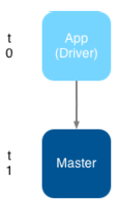
In order to run the example, we have given ‘local’ as value to master while creating spark session, because we are running spark in local mode. If we had a cluster, we would give the address of the cluster instead.
Beside figure says, the application (or driver) connects to the master and gets a spark session. The arrow indicates flow of sequence: at t0, you start your application and t1, you start spark session.
This first step is always to connect to master.Now we can ask spark to load CSV file.
Loading or ingesting the CSV File
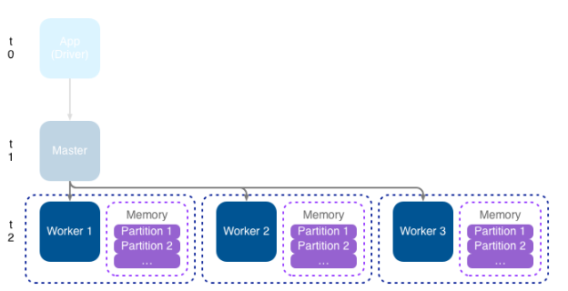
Loading ingesting, reading are synonyms for what we are going to do now: ask spark to load the data contained in the CSV file. Spark can use distributed ingestion through the different nodes of the cluster. Say in our Scenario, we have 3 workers. Distributed Ingestion means we’ll ask our three workers to ingest at the same time.
Here we have three workers, it’s a logical representation: any worker could be on the same physical nodes as the master. Each worker has memory, which it uses via partition.
At t2, The master tells the workers to load the file. Normal question would be if you have three workers, which one is loading the file?, if they load simultaneously, how do they know where to start and finish? Spark ingests the csv file in a distributed way. The file must be on a shared drive, distributed file system, or shared via a shared file system mechanism like Dropbox, NextCloud etc.
In this context, a partition is a dedicated area in the workers memory.
Code:
Dataset<Row> df = spark.read().format(“csv”).option(“header”,”true”).load(“data/authors.csv”,”csv”);
Data:
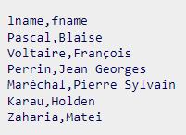
The workers create tasks to read the file. Each worker has access to the nodes memory and assigns a memory partition to the task.
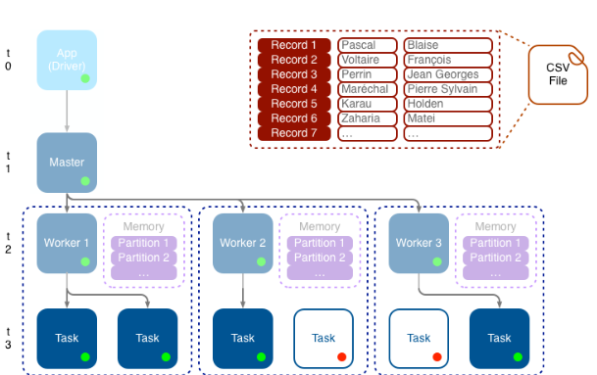
Tasks are being created based on available resources. The worker may create several tasks and assign a memory partition to the task. The solid tasks are running (they also have a green dot), in contrast with non-working tasks (from another application for example), which are hollow and have a red dot.
At t4, each task continues by reading a part of the CSV file. As the task is ingesting its rows, it stores them in a dedicated partition.
Why should we care about partitions and their locations: When your operations are simple, like concatenating two fields into a third one. Spark is fast. Spark can join data between datasets and can perform aggregate, exactly as you do those operations with your relational database. Now imagine, that you are joining data in the first partition of worker 1 with the second partition of worker 2: all the data must be transferred, which is a costly operation.
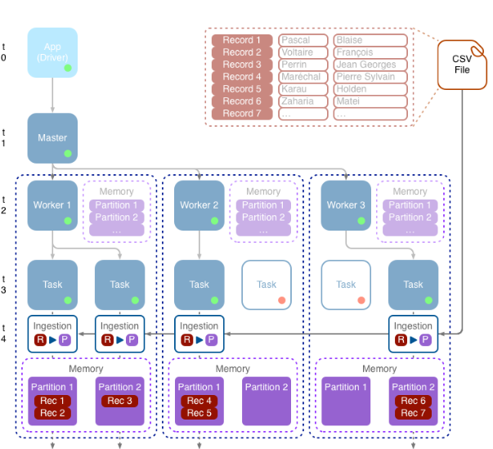
The beside figure shows the record being copied from the csv file to partition during the ingestion process, within the R>P (record to partition) box. The memory box, in purple shows which records are in which partition on each partition. In this example, record 1, which contains Blaise pascal, is in the first partition of the first worker.
The ingestion is taking place, each task is now loading some records into its own memory partition. As suggested by Record to partition block. You can also see the purple box which contains the records after the ingestion has been done.

Transforming the Data
After the data has been loaded, at t5, we can process the records, operation is fairly simple: add a new column to the data frame, called name. The full name (column name) is a concatenation of the last name (column lname), a comma, a space, and the first name (in fname). For example, Jean Georges (first name) and Perrin (last name) becomes Perrin, Jean Georges.
Spark’s Lazy:
At this point, we told spark to concatenate the fields, but it didn’t do anything.
Spark is lazy: it only works when asked. Spark stacks up all your requests and, when it needs to, it optimizes the operations and does the hard work. In this situation, we’re using the withColumn() method, which is a transformation. Spark only starts processing when he sees an action, such as the write() method.
df = df.withColumn(“name”,concat(df.col(“lname”),lit(“, “),df.col(“fname”)))
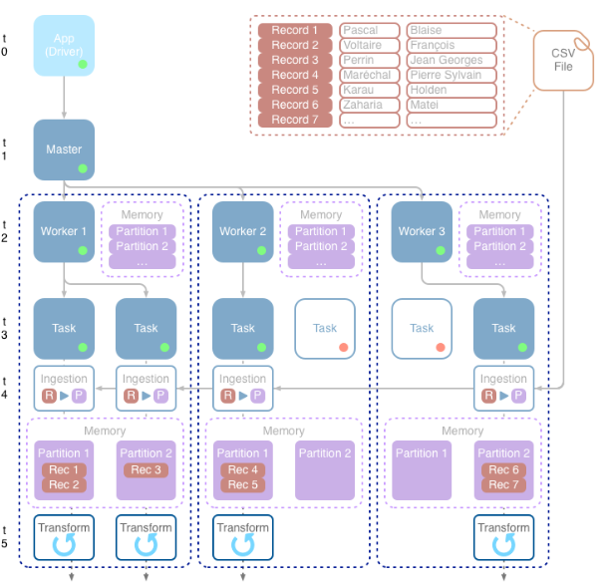
At t5, spark adds the transformation step in your flow. Each task continuous to perform its work, getting all first and last names from the memory partition and creates the new name.

