Formatting Guides for Authors of AIRCC Papers
Hubert Kyeremateng-Boateng¹, Marvin Conn² and Darsana Josyula³
¹Department of Computer Science, Bowie State University, Bowie, Maryland USA
kyerematengboh0404@students.bowiestate.edu
²Department of Computer Science, Bowie State University, Bowie, Maryland, USA
marvinconn@gmail.com

Abstract
As more people and organization use wireless networking for communication and business, spectrum availability will become a scarce resource commodity that will not readily available for both licensed and unlicensed users. The ability to detect or predict when a spectrum is available or not available for use is of great importance and that is the purpose of this research. In this work, we validate a previous research conducted by Jacob A. Kovarskiya et al in the paper “Predictive Energy Detection for Inferring Radio Frequency Activity” using Support Vector Regression (SVR), and then we improve upon it. Radio frequency (RF) energy level is used to detect whether the spectrum is busy or idle for transmission. We calculate the energy level of the simulated RF signal using two methods: average of the RF or the Cumulant (first-order). As part of this research we compare both methods to determine which one trains and predicts faster and accurately.

Keywords

Network Protocols, Wireless Network, Mobile Network, Virus, Worms &Trojon
1. Introduction
As more people continue to use wireless electronic devices, there will come a time where radio frequency will be a scarce resource. Both licensed and non licensed user’s will be scrambling for radio frequency bandwidth. The ability to detect and predict accuractly Cognitive Radio (CR) is a system which senses its electromagnetic environment and dynamically adjusts its radio parameters to improve performance [5]. With CR and radio frequency detection, network providers can detect or predict which radio frequency bandwidth is currently in use and which bandwidth is not in use. Network providers can also prevent congestion in bandwidth by detection if a specific bandwidth is in use before another user attempts to connect to the same bandwidth.
In order to prevent spectrum bandwidth inference and congestion, there is the need to accurately predict when a bandwidth is available or not for use. This research work seeks to validate the one-step look ahead method proposed by Jacob et al [1] by using Python’s Sklearn Support Vector Regression (SVR) module.
This paper first provides an overview of previous work by Jacob A. Kovarskiya et al and then discuss our research. At the end of the paper, we compare the results of using Python Sklearn and MATLAB SVM. We also compare the error rate of predicting the presence or absence of a radio frequency using the average power level or Cumulant (first-order). We center our comparison along the following dimensions: training speed, prediction speed and prediction accuracy. We then discuss how these two machine learning algorithms and methods of generating the energy levels compare with the original research.
2. OVERVIEW
Kovarskiya’s original research work calculates the average energy level of the spectrum in order to predict the idle and busy state of the spectrum bandwidth [1]. The time series of energy levels of the training data is used to train the Matlab SVR model and the trained model is then used to predict future spectrum occupancy state.
Kovarskiya’s work uses a one-step look ahead methodology to predict the RF signal down (idle) and up (busy) state. One-step look ahead prediction uses past predicted data to predict the next state of the spectrum. To use the one-step methodology, the entire test data is given as input to the previously trained Matlab SVR model. Once the Matlab SVR model has predicted the initial prediction using the test data, the original test data less the first sample is concatenated with the new prediction to create the new test data which is then used to get a new prediction from the SVR model. This method has shown to provide better results than the initial predicted results using the original test data.
To be able to make comparison between the Python and MATLAB codes, this work converts the Jacob’s et al code (MATLAB) to Python. At the last section, we compare the accuracy performance of both MATLAB and Python code if similar results were achieved with the Python cade as in the MATLAB code.
3. SIMULATING RD DATA
2.1. Generating Data
Radio frequency signals at constant intervals were generated using a fixed sample size. The idle and busy state of the spectrum was simulated using probability values ranging between 0 and 1 for each interval [1]. Addictive white Gaussian noise was added to the generated signal to simulate RF signals. A noise floor variance of -100 dBm and a power level of -40 dBm.
2.2. Title
The title is to be written in 20 pt. Garamond font, centred and using the bold and “Small Caps” formats. There should be 24 pt. (paragraph) spacing after the last line.
2.3. Authors
Author names are to be written in 13 pt. Times New Roman format, centred and followed by a 12pt. paragraph spacing. If necessary, use superscripts to link individual authors with institutions as shown above. Author affiliations are to be written in 12 pt. Times New Roman, centred, with email addresses, in 10 pt. Courier New, on the line following. The last email address will have an 18 pt. (paragraph) spacing following.
2.4. Abstract
The Abstract section begins with the word, “Abstract” in 13 pt. Times New Roman, bold italics, “Small Caps” font with a 6pt. spacing following. The abstract must not exceed 150 words in length in 10 pt. Times New Roman italics. The text must be fully justified, with a 12 pt. paragraph spacing following the last line.
2.5. Keywords
The Keywords section begins with the word, “Keywords” in 13 pt. Times New Roman, bold italics, “Small Caps” font with a 6pt. spacing following. There may be up to five keywords (or short phrases) separated by commas and six spaces, in 10 pt. Times New Roman italics. An 18 pt. line spacing follows.
2.6. Section and sub-section headings
Section headings are numbered 1. Xxx, 2. Yyy, etc. in 14 pt. bold “Small Caps” Times New Roman font with a 6 pt. line spacing following.
Subsection headings are numbered 1.1. Aaa, 1.2. Bbb, etc. in 12 pt. bold Times New Roman font with a 6pt line spacing following.
2.6.1. Further Subsections
Further sub-sectioning, if required, is indicated using 1.1.1. Qqq, etc. headings with 11 pt. bold Times New Roman font with a 6pt line spacing following.
2.7. Text
Main-body text is to written in fully (left and right) justified 11 pt. Times New Roman font with a 6pt. (paragraph) line spacing following the last line of each paragraph, but a 12pt. (paragraph) line spacing following the last paragraph. Do not indent paragraphs.
2.8. Figures and Tables
Table 1. Heading and text fonts.
Text | Alingnment | Font | Followed by:
Title | Centre | 20 pt. TNR, bold, small-caps | 24 pt. line sp.
Authors | Centre | 13 pt. TNR | 12 pt. line sp.
Addresses | Centre | 12 pt. TNR
emails | Centre | 11 pt. italic TNR | 18 pt. line sp. (last)
Abstract heading | Left | 13 pt. bold italic TNR, small caps | 6 pt. line sp.
Abstract text | Left | 10 pt. italic TNR | 12 pt. line sp.
Keywords heading | Left | 13 pt. bold italic TNR, small caps | 6 pt. line sp.
Keywords | Left, left, .. | 10 pt. italic TNR | 18 pt line sp.
Section headings | Left | 14 pt. bold TNR, small caps | 6 pt. line sp.
Sub-section heads | Left | 12 pt. bold TNR | 6 pt. line sp.
Sub-sub-sections | Left | 11 pt. bold TNR | 6 pt. line sp.
Body text | Full (left/right) | 11 pt. TNR | 12 pt line sp. (last)
Figures | Centre |  | 6 pt. line sp.
Figure captions | Centre | 11 pt. TNR | 12 pt. line sp.
References | Left | 10 pt. TNR (as shown) | 6 pt. line sp

All inserts, figures, diagrams, photographs and tables must be centre-aligned, clear and appropriate for black/white or greyscale reproduction.
Figures (eg, Figure 1) must be numbered consecutively, 1, 2, etc., from start to finish of the paper, ignoring sections and subsections. Tables (eg, Table 1) are also numbered consecutively, 1, 2, etc., from start to finish of the paper, ignoring sections and subsections, and independently from figures
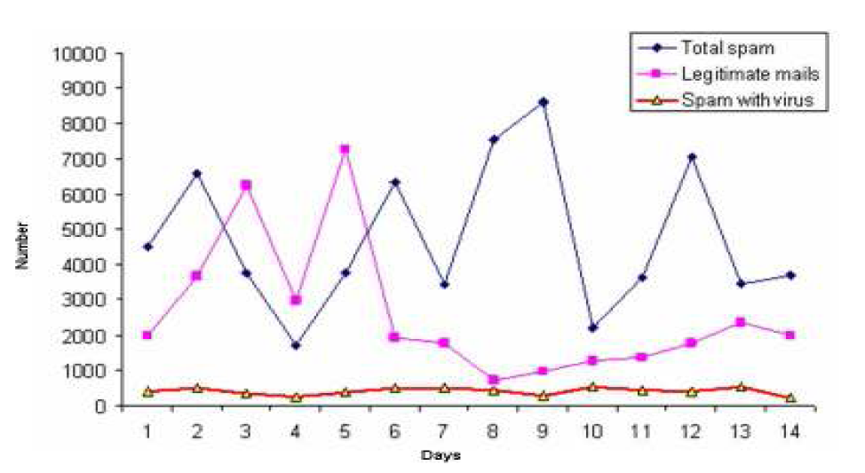
Figure 1. Spam traffic sample
All figures, tables, etc. must have a caption, centre-justified in 11 pt. Times New Roman. Captions precede tables but follow figures. Tables and figures must appear as close to their point of reference as satisfactory formatting of the final document permits.
2.9. Acknowledgements
An (unnumbered) acknowledgements section may be inserted if required.
2.10. References
References should be cited in the main text, in passing [1] or explicitly as in [2]. The full references should be given as below (essentially IEEE format), in the order in which they are cited, in 10 pt. Times New Roman, with a 6pt spacing between each.
3. Conclusions
Papers in this format must not exceed twenty (20) pages in length. Papers should be submitted to the secretary AIRCC. Papers for initial consideration may be submitted in either .doc or .pdf format. Final, camera-ready versions should take into account referees’ suggested amendments.
Acknowledgements
The authors would like to thank everyone, just everyone!

References
[1] Lee, S.hyun. & Kim Mi Na, (2008) “This is my paper”, ABC Transactions on ECE, Vol. 10, No. 5, pp120-122.
[2] Gizem, Aksahya & Ayese, Ozcan (2009) Coomunications & Networks, Network Books, ABC Publishers.

Authors
Photo

Short Biography

