KTN1 - Group 43
2013-03-11

Sequence diagram
Connect:
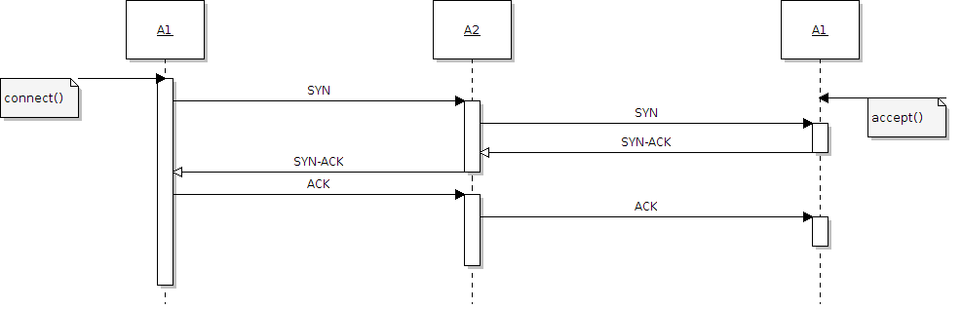
Figure 1: Connect sequence

Send/receive:
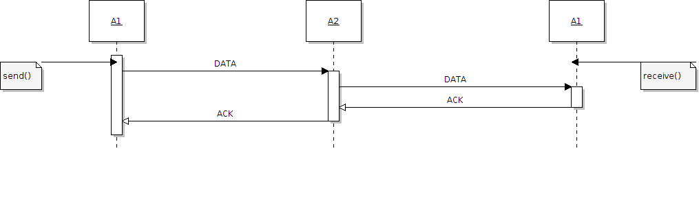
Figure 2: Send/receive sequence

Close:
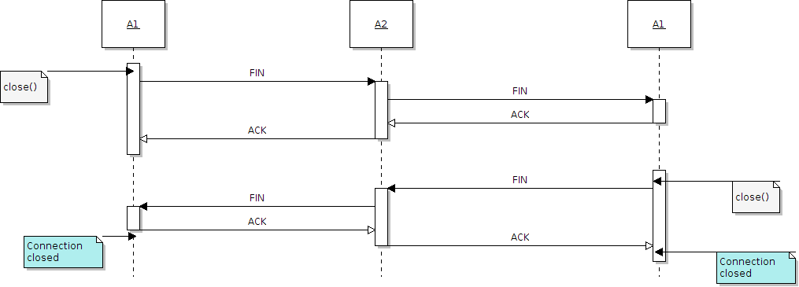
Figure 3: Close connection sequence
State diagram
Client:
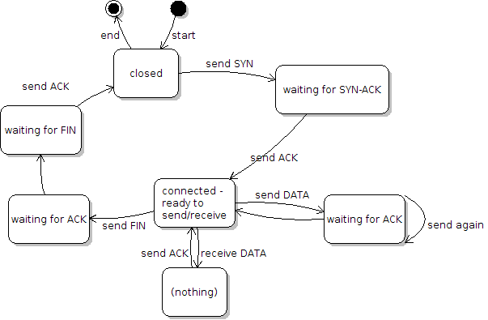
Figure 4: Client sided state diagram

Server:
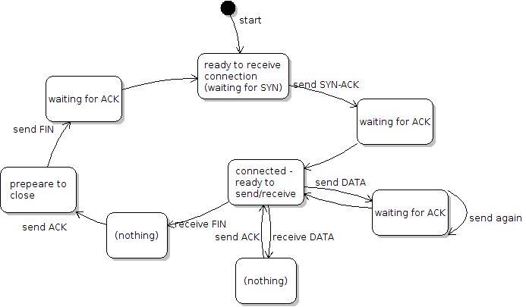
Figure 5: Server sided state diagram

Description

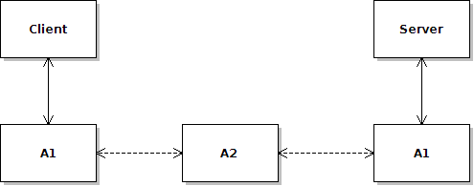
Figure 6: Overview

Client/server
The role of the client and server application is to control the network part, A1, of the program.

A1
A1 is the transport layer of the system. It will do the low-level control of the network communication.

When the client want to connect to the server, it will call the connect() method. The connect() method's parameters are the remote address and the remote port. The A1 will then initiate the connect sequence by sending a SYN package to the remote address, see [connectseq].

When the client or server want to send a data, it will call the send() method. The send() method's parameter is the message in string data type. The A1 will then initiate the sending sequence, see [sendreceiveseq]

When the client or server is waiting to receive data, it will call receive(). The receive() method will listen for packages from the source it is connected to, see [sendreceiveseq].

When the client going to close the connection, it will call the close() method. The close() method will initiate the close sequence, see [closeseq].

All the packages contains source IP, source port, remote IP, remote port, sequence number, acknowledge number, checksum, flags and the data. Packages sent will have a sequence number and the sender won't send the next package before it receives the acknowledge number for the next sequence number.

A2
The A2 is a module to test that the A1 is fail-safe. It can be configured through a administration package to generate errors in the network.

Error handling
Error 1 – package loss
Problem:
The sender sends a package, but the receiver does not get it.

Solution:
Every time a receiver gets a package, it will send an acknowledge package requesting the next sequence number. If the sender does not receive the acknowledge package, it means that either the receiver didn't receive the package in the first place, or the acknowledge package was lost on the way back. What happened does not matter. If the sender does not receive the acknowledge package after a wait time, it will resend the previous package. If no acknowledge packages are received in 30 seconds, it will close the connection and notify the application of a connection timeout.

Error 2 – package delayed
Problem:
The sender sends a package. The receiver gets the package and sends an acknowledge package. However, the sender does not get the acknowledge package, and therefore resends the previous package, resulting in the same package appearing twice.

Solution:
The receiver will discard the double package received because it does not have the sequence number it expects. It will still send an acknowledge package with the expected sequence number. When the sender gets the acknowledge package with the sequence number of the next package it will send the next package. The sender will discard the previous acknowledge package and wait for the next acknowledge package.

Error 3 – wrong checksum
Problem:
A received package's checksum does not match the checksum of the package.

Solution:
If the receiver gets a package with wrong checksum, it will discard the package and send a acknowledge package with the expected sequence number. If the sender gets a package with wrong checksum, it will discard the package and act as if the package never get there.

Error 4 – ghost package
Problem:
The package received is not sent from the outside the current connection session.

Solution:
If the sequence number or acknowledge number or the checksum is wrong, the package will be discarded.

Tests
The tests will run with two testprograms connected through the network A2. Every test consist of connecting, data transfer and disconnecting.

TestID | A100
Description | No errors
Purpose | This test will check if A1 works on a reliable network
settings.xml | <errors>false</errors>  <loss>0.0</loss>  <delay>0.0</delay>  <ghost>0.0</ghost>  <payload>0.0</payload>  <header>0.0</header>  <onlydata>true</onlydata>

TestID | A101
Description | 10 % packet loss
Purpose | This test will check if A1 is able to send data through a network with medium high packet loss
settings.xml | <errors>true</errors>  <loss>0.1</loss>  <delay>0.0</delay>  <ghost>0.0</ghost>  <payload>0.0</payload>  <header>0.0</header>  <onlydata>true</onlydata>

TestID | A102
Description | 50 % packet loss
Purpose | This test will check if A1 is able to send data through a network with high packet loss
settings.xml | <errors>true</errors>  <loss>0.5</loss>  <delay>0.0</delay>  <ghost>0.0</ghost>  <payload>0.0</payload>  <header>0.0</header>  <onlydata>true</onlydata>

TestID | A103
Description | 10 % delayed packages
Purpose | This test will check if A1 is able to handle delay on some packages without cancelling or stop the transfer
settings.xml | <errors>true</errors>  <loss>0.0</loss>  <delay>0.1</delay>  <ghost>0.0</ghost>  <payload>0.0</payload>  <header>0.0</header>  <onlydata>true</onlydata>

TestID | A104
Description | 50 % delayed packages
Purpose | This test will check if A1 is able to handle delay on many packages without cancelling or stop the transfer
settings.xml | <errors>true</errors>  <loss>0.0</loss>  <delay>0.5</delay>  <ghost>0.0</ghost>  <payload>0.0</payload>  <header>0.0</header>  <onlydata>true</onlydata>

TestID | A105
Description | 10 % ghost packages
Purpose | This test will check if A1 is able to detect and drop ghost packages
settings.xml | <errors>true</errors>  <loss>0.0</loss>  <delay>0.0</delay>  <ghost>0.1</ghost>  <payload>0.0</payload>  <header>0.0</header>  <onlydata>true</onlydata>

TestID | A106
Description | 50 % ghost packages
Purpose | This test will check if A1 is able to detect and drop a lot of ghost packages
settings.xml | <errors>true</errors>  <loss>0.0</loss>  <delay>0.0</delay>  <ghost>0.5</ghost>  <payload>0.0</payload>  <header>0.0</header>  <onlydata>true</onlydata>

TestID | A107
Description | 10 % payload error
Purpose | This test will check if A1 detects and request new package when the data section of the package is corrupted
settings.xml | <errors>true</errors>  <loss>0.0</loss>  <delay>0.0</delay>  <ghost>0.0</ghost>  <payload>0.1</payload>  <header>0.0</header>  <onlydata>true</onlydata>

TestID | A108
Description | 50 % payload error
Purpose | This test will check if A1 detects and request new package if the data section of the package is corrupted when there are a lot of those packages
settings.xml | <errors>true</errors>  <loss>0.0</loss>  <delay>0.0</delay>  <ghost>0.0</ghost>  <payload>0.5</payload>  <header>0.0</header>  <onlydata>true</onlydata>

TestID | A109
Description | 10 % header error
Purpose | This test will check if A1 drops packages and eventually request new ones if the package header is corrupted
settings.xml | <errors>true</errors>  <loss>0.0</loss>  <delay>0.0</delay>  <ghost>0.0</ghost>  <payload>0.0</payload>  <header>0.1</header>  <onlydata>true</onlydata>

TestID | A110
Description | 50 % header error
Purpose | This test will check if A1 drops packages and eventually request new ones if the package header is corrupted when there are a lot of packages with corrupted header
settings.xml | <errors>true</errors>  <loss>0.0</loss>  <delay>0.0</delay>  <ghost>0.0</ghost>  <payload>0.0</payload>  <header>0.5</header>  <onlydata>true</onlydata>

TestID | A111
Description | Packet loss and delay
Purpose | This test will check if A1 is able to transfer data even if it is a high packet loss and delays once in a while. This will test if there are problems in A1 related to wait times. Packet loss and delays are problems that may occur even to a stable and reliable network if it is under heavy traffic.
settings.xml | <errors>true</errors>  <loss>0.3</loss>  <delay>0.3</delay>  <ghost>0.0</ghost>  <payload>0.0</payload>  <header>0.0</header>  <onlydata>true</onlydata>

TestID | A112
Description | Packet spoofing
Purpose | This test will check if A1 can detect packets that are being sent with false information. If someone is trying to illegally insert packages, there will be a lot of ghost packages and checksum errors on incoming packages.
settings.xml | <errors>true</errors>  <loss>0.0</loss>  <delay>0.0</delay>  <ghost>0.4</ghost>  <payload>0.2</payload>  <header>0.1</header>  <onlydata>true</onlydata>

TestID | A113
Description | 100 % packet loss
Purpose | This test will check if A1 will trigger connection timeout when no packages are received. It is important that a connection timeout is triggered correctly in case the connection is terminated without the default close routine.
settings.xml | <errors>true</errors>  <loss>1.0</loss>  <delay>0.0</delay>  <ghost>0.0</ghost>  <payload>0.0</payload>  <header>0.0</header>  <onlydata>true</onlydata>

TestID | A114
Description | Terrible network
Purpose | This test will check if A1 is able to transer data even if there are a lot of problems on the network. This test is an overall test that will test many sides of A1.
settings.xml | <errors>true</errors>  <loss>0.09</loss>  <delay>0.15</delay>  <ghost>0.06</ghost>  <payload>0.06</payload>  <header>0.06</header>  <onlydata>false</onlydata>

