# Optional Criteria 3.1 - Amazon Prime Video Performance Optimization

Prime Video has millions of customers all over the world - more than 1% of the world’s population runs my code. Even customers with low-end devices want to enjoy smooth streaming, so performance is critical to the business. I worked on making the app run faster and smoother by optimizing the user interface components at the backend level. I achieved a 20% reduction in UI rendering time and 4% memory optimization across 200M+ devices, meaning millions of customers now enjoy a faster, more responsive app. This directly increased revenue and user retention through improved performance.

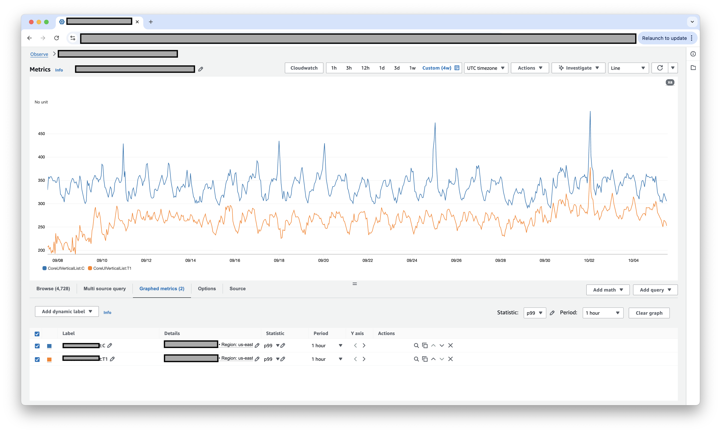 *UI processing time comparison showing the difference between control (legacy) and T1 (improved) groups - 20% improvement for 100M+ devices*

**Key numbers:** 20% UI rendering time reduction for 100M+ Prime Video customers • 4% memory optimization for 200M+ devices • Over 1% of world population runs my code • Increased revenue and user retention through improved performance