# Optional Criteria 4.2 - Cross-Institutional AI Research

I have contributed to AI/ML research across multiple institutions, working on diverse problems spanning computational physics, medical imaging, and fluid dynamics. My research covers computational fluid dynamics at Max Planck Institute, machine learning for biomedical imaging at Koç University, and grid-invariant AI for turbulent flows at Imperial College London. This breadth demonstrates my ability to apply AI/ML techniques to solve complex problems across different scientific domains.

 *My research portfolio: 5 publications, 27+ citations across Max Planck, Koç, and Imperial research*

### Imperial College London - RAPIDS Project (Ongoing)

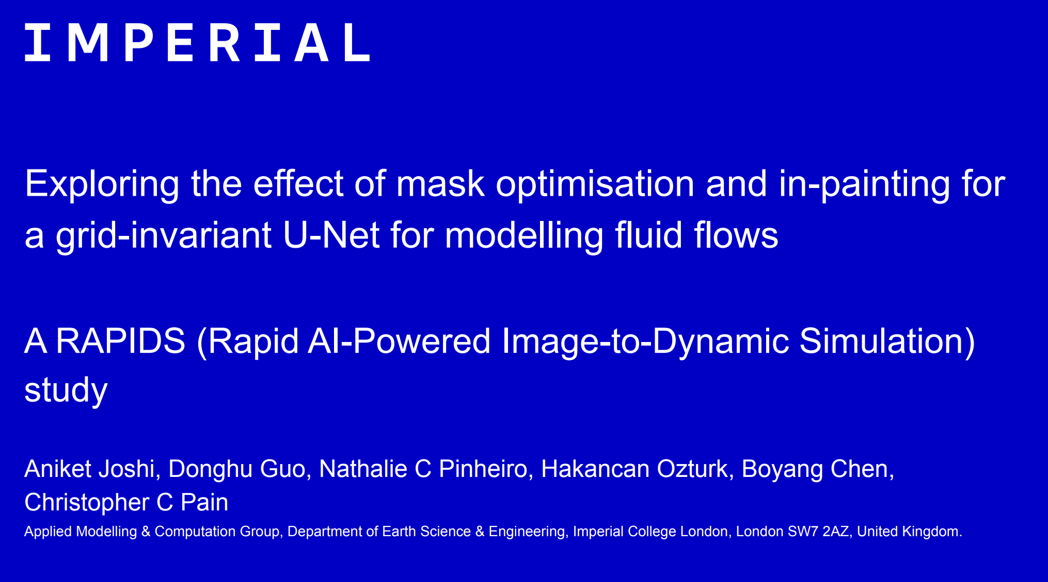 *Grid-Invariant AI architecture for turbulent flow simulation - my MSc research*

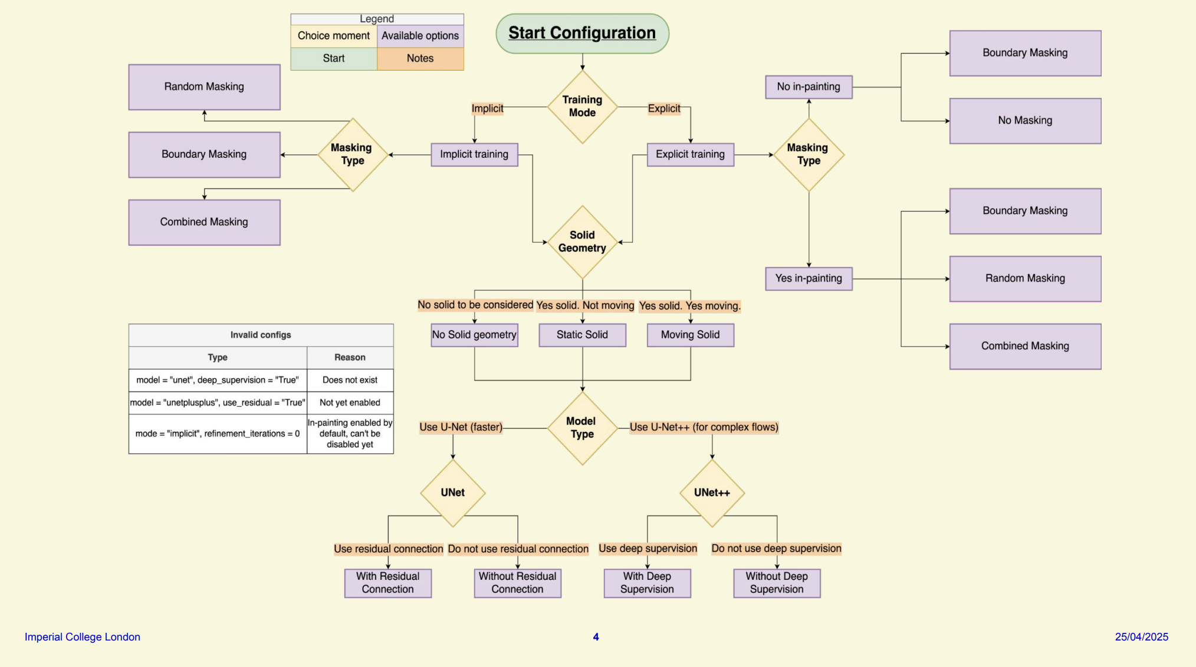 *Neural network architecture I developed combining autoencoders and adversarial networks*

 *RAPIDS open-source repository - manuscript currently in preparation*

This is ongoing research from my Imperial College MSc where I developed a grid-invariant AI architecture for turbulent flow simulation using PyTorch. I ran over 2,000 GPU hours of optimization and achieved 35% improvement in long-term stability and 50% better prediction accuracy. The project is backed by NVIDIA and automotive companies, and we are currently preparing the manuscript for publication.

### Koç University - Biomedical AI

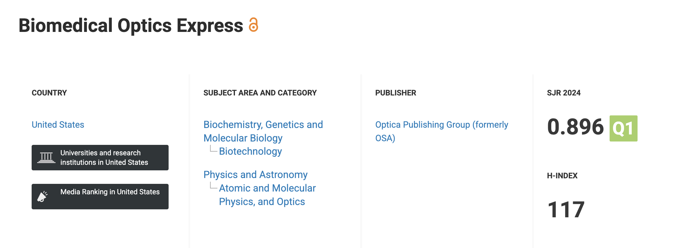 *Optica Publishing - Impact Factor: 3.9, h-index: 117*

**Saruhan, E. N., Ozturk, H., et al. (2025).** Learning-enhanced 3D fiber orientation mapping in thick cardiac tissues. *Biomedical Optics Express*, 16(8), 3315-3336.

I contributed AI/ML enhancements to 3D fiber mapping for cardiac tissue analysis in collaboration with Koç University’s cardiovascular lab.

**Key numbers:** 5 publications across 3 institutions • 27+ citations • Research areas: computational fluid dynamics, medical imaging, turbulent flow simulation • Imperial research ongoing (manuscript in preparation) • 2,000+ GPU hours of optimization • Published in Nature journals, Optica, and Wiley