IELM 2510 Project Group 19

CHENG, Ho Kei (12219689)

SZE, Ka Yu (20348496)

CHAN, Nok Hin (20349103)

Analysis on the distribution of return by simulating stock trading strategy in historical data

**Introduction**

With the popularity of algo-trading, this project aims to have a glimpse at the performance of the certain algo-trading strategy. A simulation software was implemented and deployed on historical data. The performance of the strategy will be analyzed in this project report.

**Method**

Market prices of 500 S&P (Standard & Poor's) stocks from 1998 to 2013 were provided by QuantQuote[1]. The simulation software will create one agent for each stock, and the agent will determine whether to buy or sell the stock based on the trading strategy daily. (Figure 1)

The strategy that we have tested is a simple “buy low sell high” method. When the price is higher than the 20-day average, the agent buys, and vice versa. The agent tends to buy or sell more if the price deviates more from the 20-day average.

For the ease of analysis, the principal and the profit were separated (imagine a trader in a company who always handle a fixed amount of money, regardless of profit or loss). All agents are given one million dollars to start with. As in Hong Kong, one percent trading tax is also included in the simulation.

**Analysis**

M. Hebner [2][3] suggested that the market return can be approximated by a normal distribution with a slightly fatter tail. As the profit in our simulation are independent, with another bold assertion that the price changes each day are independent, the total profit, being a sum of independent normal distributed random variables, is also normally distributed.

Thus, the percentage profits from the simulation for the 500 stocks are 500 samples from a population with a normal distribution, having unknown mean and variance. The mean and the variance are then estimated to evaluate the performance of the given trading strategy. (The graph obtained from the samples indeed has a nearly symmetric bell shape, which means the approximation makes sense. See Figure 2.)

Using maximum likelihood estimator (MLE) for normal distribution,

$\hat{μ}=\frac{\sum_{i=1}^{n}{x_{i}}}{n}=331.73\%, \hat{σ}={\left[\sum_{i=1}^{n}{\frac{{\left(x_{i}-\hat{μ}\right)}^{2}}{n}}\right]}^{\frac{1}{2}}=343.03\%, s={\left[\sum_{i=1}^{n}{\frac{{\left(x_{i}-\hat{μ}\right)}^{2}}{n-1}}\right]}^{\frac{1}{2}}=343.37\%$

With 95% confidence level,

$331.73\%-\frac{2.306\left(343.37\%\right)}{\sqrt{500}}<μ<331.73\%+\frac{2.306\left(343.37\%\right)}{\sqrt{500}}$

$296.32\%<μ<367.14\%$

Probability that there is no profit,

$$P\left(x≤0\right)=Φ\left(\frac{0-\hat{μ}}{s}\right)=0.167$$

Probability that the profit is less than inflation (which is about 42% in the US in the period) [4],

$$P\left(x<42\%\right)=Φ\left(\frac{42\%-\hat{μ}}{s}\right)=0.199$$

**Discussion**

Although the given “buy low sell high” strategy is one of the simplest methods, the performance is quite satisfactory. Notable profit is almost assured if multiple stocks are invested together to share the risk. Like, for five stocks,

$P\left(x>200\%\right)=1-Φ\left(\frac{200\%-5\hat{μ}}{\sqrt{5}s}\right)=97.14\%$

There is over 97% probability that you would get more than 200% profit (meanwhile, inflation was 42%). This brought to the curiosity that the growth in the entire economy from 1998 to 2013 in the US makes this kind of profit easy, and this kind of growth cannot simply be explained with inflation.

Then, the growth of each of the stock is obtained by the percentage change in stock price from 1988 to 2013 (over 100 companies are no longer in the market by 2013, their last market price will be used). See Figure 3. For these data,

$$\hat{μ}=658.49\%, s=2868.23\%$$

Although the average growth of the companies is much higher than the mean profit, its standard deviation is even higher, implying increased risk and uncertainty. Using similar formula as above, for five stocks,

$P\left(x>200\%\right)=1-Φ\left(\frac{200\%-5\hat{μ}}{\sqrt{5}s}\right)=68.52\%$

This proves the given strategy is still advantageous.

Yet, it is believed that the growth of the companies should be related to the percentage profit that we obtained as it is not possible to gain money from an always dropping stock in a simple buy or sell market. The relationship is shown in Figure 4.

$Correlation=\frac{Cov\left(Profit, Growth\right)}{\sqrt{Var\left(Profit\right)Var\left(Growth\right)}}=0.188$

A correlation exists, but it is not very high. It is suggested that a good trading strategy should have lower correlation so that profit is obtainable from a fluctuating market.

**Conclusion**

The “buy low sell high” strategy is simple yet works well, it provides a notable profit when relatively low-risk investment. The profit is partly benefited from the growing economies from 1988 to 2013, as the overall growth of the companies are magnificence. Still, it has a relatively low correlation with the growth of the companies and provides lower risk. Looking at the raw data, a lot of companies that are having negative growth give us positive profit. Further improvement can be made by trading at a higher frequency, which would unleash the full power of algo-trading, though higher-resolution data is required.

**Appendix**

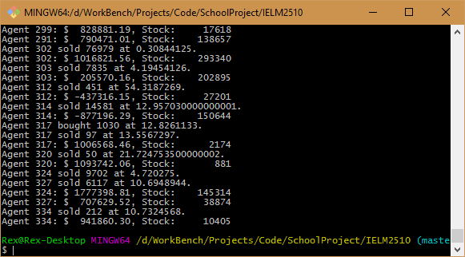

Figure 1. Simulation software in run-time.

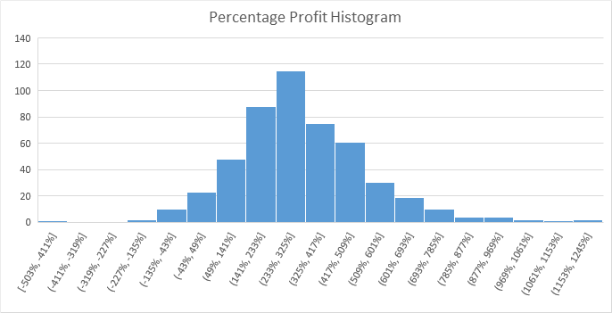

Figure 2. Histogram of the percentage profit from the 500 samples. Note that, for visibility, 1 data at the very far right (having extremely high return) was ignored. It will be included in actual calculation.

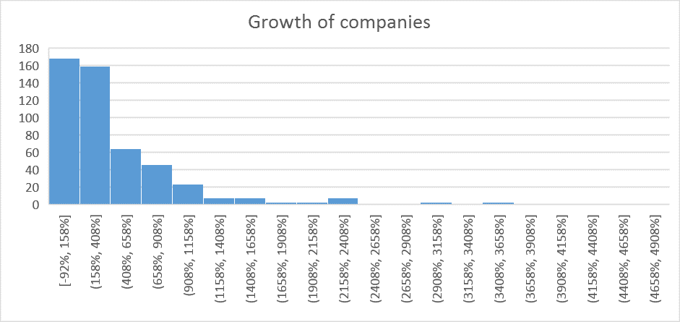

Figure 3. The growth of the companies. Four companies with extreme high growth have already been ignored for the visibility of the graph.

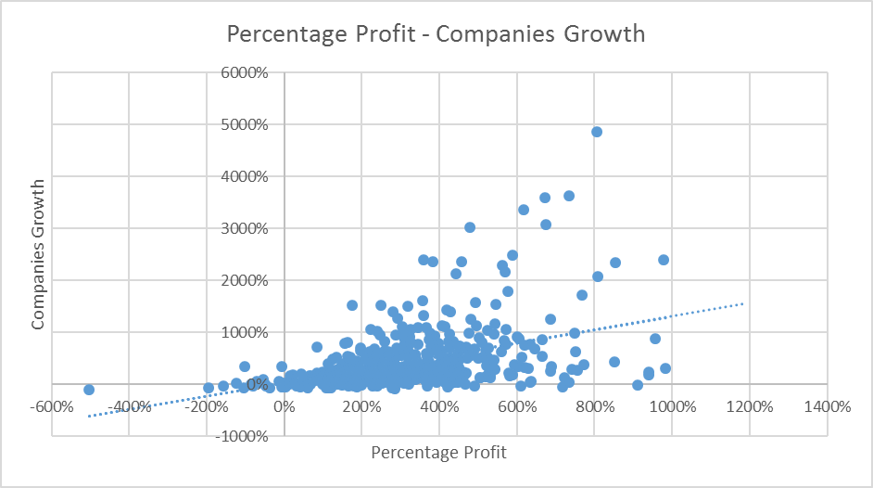

Figure 4. The relationship between percentage profit and companies’ growth.

**Reference**

[1] <https://quantquote.com/>

[2] <https://www.ifa.com/articles/does_this_machine_simulate_market_returns/>

[3] <https://www.ifa.com/articles/with_stock_returns_normally_distributed/>

[4] <http://www.in2013dollars.com/1998-dollars-in-2013>