Science & Tech Miscellaneous
Concept
Normal-csat
1.
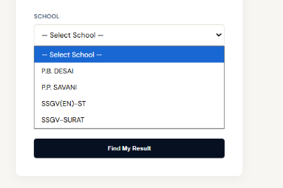

(a) Promotion of traditional medicine only
(b) Establishing India as a global biomanufacturing hub
(c) Regulating pharmaceutical imports
(d) Eliminating private participation in pharma sector
Answer: (b)

Solution:
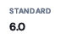


Budgeting Process And Tax
Concept
Statement-csat
2.
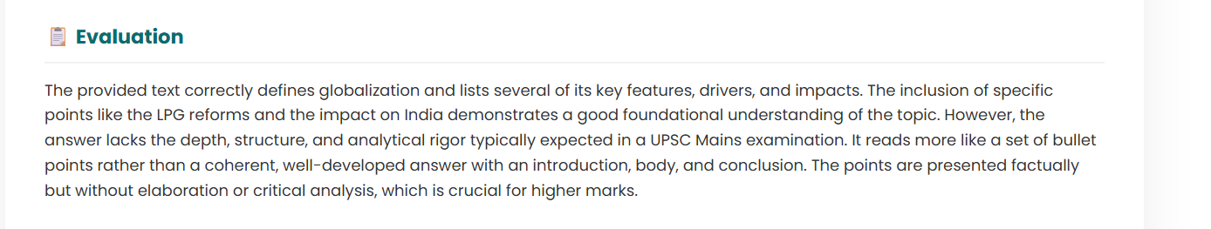


1.
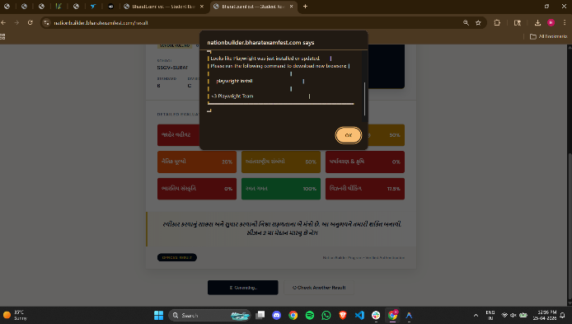

2.

Which of the statements given above is/are correct?
(a) 1 only
(b) 2 only
(c) Both 1 and 2
(d) Neither 1 nor 2
Answer: (a)

Solution:



Infrastructure & Industries
Concept
Statement-csat
3.
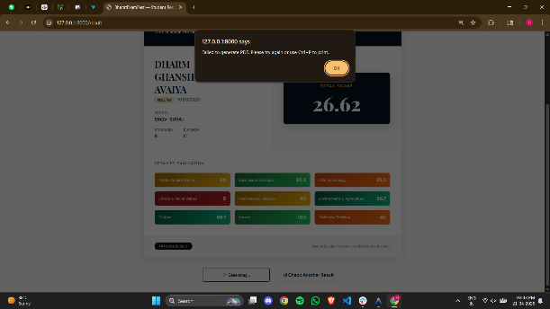


1.
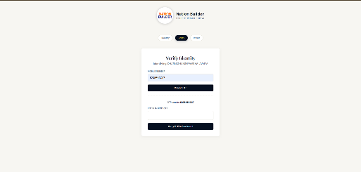

2.
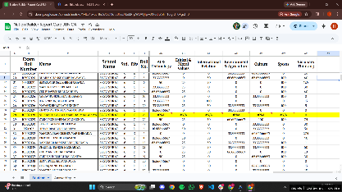

3.
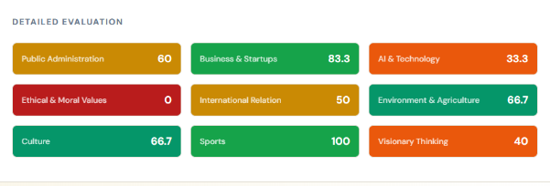

Which of the statements given above are correct?
(a) 1 only
(b) 1 and 2 only
(c) 2 and 3 only
(d) All three
Answer: (b)

Solution:
