**Linear Regression**

# Importing the libraries

import numpy as np

import matplotlib.pyplot as plt

import pandas as pd

# Importing the dataset

dataset = pd.read_csv('Salary_Data.csv')

X = dataset.iloc[:, :-1].values

y = dataset.iloc[:, 1].values

# Splitting the dataset into the Training set and Test set

from sklearn.cross_validation import train_test_split

X_train, X_test, y_train, y_test = train_test_split(X, y, test_size = 1/3, random_state = 0)

#Fitting Simple Linear Regression to the training set

from sklearn.linear_model import LinearRegression

regressor = LinearRegression()

regressor.fit(X_train, y_train)

#Predicting the test set results

y_pred = regressor.predict(X_test)

#Visualising the training set results

plt.scatter(X_train, y_train, color = 'red')

plt.plot(X_train, regressor.predict(X_train), color = 'blue')

plt.title('Salary vs Experience (Training set)')

plt.xlabel('Years of Experience')

plt.ylabel('Salary')

plt.show()

#Visualising the test set results

plt.scatter(X_test, y_test, color = 'red')

plt.plot(X_train, regressor.predict(X_train), color = 'blue')

plt.title('Salary vs Experience (Test set)')

plt.xlabel('Years of Experience')

plt.ylabel('Salary')

plt.show()

**Multiple Linear Regression**

# Importing the libraries

import numpy as np

import matplotlib.pyplot as plt

import pandas as pd

# Importing the dataset

dataset = pd.read_csv('50_Startups.csv')

X = dataset.iloc[:, :-1].values

y = dataset.iloc[:, 4].values

# Encoding the Independent Variable

from sklearn.preprocessing import LabelEncoder, OneHotEncoder

labelencoder_X = LabelEncoder()

X[:, 3] = labelencoder_X.fit_transform(X[:, 3])

onehotencoder = OneHotEncoder(categorical_features = [3])

X = onehotencoder.fit_transform(X).toarray()

#Avoiding the Dummy Variable Trap

X = X[:, 1:]

# Splitting the dataset into the Training set and Test set

from sklearn.cross_validation import train_test_split

X_train, X_test, y_train, y_test = train_test_split(X, y, test_size = 0.2, random_state = 0)

#Fitting Multiple linear regression to the training set

from sklearn.linear_model import LinearRegression

regressor = LinearRegression()

regressor.fit(X_train, y_train)

#Predicting the test set results

y_pred = regressor.predict(X_test)

#Using Backward Elimination

import statsmodels.formula.api as sm

X = np.append(arr = np.ones((50, 1)).astype(int), values = X, axis = 1)

X_opt = X[:, [0, 1, 2, 3, 4, 5]]

regressor_OLS = sm.OLS(endog = y, exog = X_opt).fit()

regressor_OLS.summary()

X_opt = X[:, [0, 1, 3, 4, 5]]

regressor_OLS = sm.OLS(endog = y, exog = X_opt).fit()

regressor_OLS.summary()

X_opt = X[:, [0, 3, 4, 5]]

regressor_OLS = sm.OLS(endog = y, exog = X_opt).fit()

regressor_OLS.summary()

X_opt = X[:, [0, 3, 5]]

regressor_OLS = sm.OLS(endog = y, exog = X_opt).fit()

regressor_OLS.summary()

X_opt = X[:, [0, 3]]

regressor_OLS = sm.OLS(endog = y, exog = X_opt).fit()

regressor_OLS.summary()

**Decision Tree (Regression)**

# Importing the libraries

import numpy as np

import matplotlib.pyplot as plt

import pandas as pd

# Importing the dataset

dataset = pd.read_csv('Position_Salaries.csv')

X = dataset.iloc[:, 1:2].values

y = dataset.iloc[:, 2].values

# Fitting the Decision Tree Regression Model to the dataset

from sklearn.tree import DecisionTreeRegressor

regressor = DecisionTreeRegressor(random_state = 0)

regressor.fit(X, y)

# Predicting a new result

y_pred = regressor.predict(6.5)

# Visualising the Decision Tree Regression results (for higher resolution and smoother curve)

X_grid = np.arange(min(X), max(X), 0.0001)

X_grid = X_grid.reshape((len(X_grid), 1))

plt.scatter(X, y, color = 'red')

plt.plot(X_grid, regressor.predict(X_grid), color = 'blue')

plt.title('Truth or Bluff (Decision Tree Regression Model)')

plt.xlabel('Position level')

plt.ylabel('Salary')

plt.show()

**Logistic Regression**

# Importing the libraries

import numpy as np

import matplotlib.pyplot as plt

import pandas as pd

# Importing the dataset

dataset = pd.read_csv('Social_Network_Ads.csv')

X = dataset.iloc[:, [2,3]].values

y = dataset.iloc[:, 4].values

# Splitting the dataset into the Training set and Test set

from sklearn.cross_validation import train_test_split

X_train, X_test, y_train, y_test = train_test_split(X, y, test_size = 0.25, random_state = 0)

# Feature Scaling

from sklearn.preprocessing import StandardScaler

sc_X = StandardScaler()

X_train = sc_X.fit_transform(X_train)

X_test = sc_X.transform(X_test)

#fitting Logistic Regression to the training set

from sklearn.linear_model import LogisticRegression

classifier = LogisticRegression(random_state = 0)

classifier.fit(X_train,y_train)

#Predicting the test set results

y_pred = classifier.predict(X_test)

#Making Confusion Matrix

from sklearn.metrics import confusion_matrix

cm = confusion_matrix(y_test, y_pred)

#visualizing the Training set results

from matplotlib.colors import ListedColormap

X_set, y_set = X_train, y_train

X1, X2 = np.meshgrid(np.arange(start = X_set[:, 0].min() - 1, stop = X_set[:, 0].max() + 1, step = 0.01),

np.arange(start = X_set[:, 1].min() - 1, stop = X_set[:, 1].max() + 1, step = 0.01))

plt.contourf(X1, X2, classifier.predict(np.array([X1.ravel(), X2.ravel()]).T).reshape(X1.shape),

alpha = 0.75, cmap = ListedColormap(('red', 'green')))

plt.xlim(X1.min(), X1.max())

plt.ylim(X2.min(), X2.max())

for i, j in enumerate(np.unique(y_set)):

plt.scatter(X_set[y_set == j, 0], X_set[y_set == j, 1],

c = ListedColormap(('red', 'green'))(i), label = j)

plt.title('Logistic Regression (Training set)')

plt.xlabel('Age')

plt.ylabel('Estimated Salary')

plt.legend()

plt.show()

#visualizing the Test set results

from matplotlib.colors import ListedColormap

X_set, y_set = X_test, y_test

X1, X2 = np.meshgrid(np.arange(start = X_set[:, 0].min() - 1, stop = X_set[:, 0].max() + 1, step = 0.01),

np.arange(start = X_set[:, 1].min() - 1, stop = X_set[:, 1].max() + 1, step = 0.01))

plt.contourf(X1, X2, classifier.predict(np.array([X1.ravel(), X2.ravel()]).T).reshape(X1.shape),

alpha = 0.75, cmap = ListedColormap(('red', 'green')))

plt.xlim(X1.min(), X1.max())

plt.ylim(X2.min(), X2.max())

for i, j in enumerate(np.unique(y_set)):

plt.scatter(X_set[y_set == j, 0], X_set[y_set == j, 1],

c = ListedColormap(('red', 'green'))(i), label = j)

plt.title('Logistic Regression (Test set)')

plt.xlabel('Age')

plt.ylabel('Estimated Salary')

plt.legend()

plt.show()

**Decision Tree (Classification)**

# Importing the libraries

import numpy as np

import matplotlib.pyplot as plt

import pandas as pd

# Importing the dataset

dataset = pd.read_csv('Social_Network_Ads.csv')

X = dataset.iloc[:, [2, 3]].values

y = dataset.iloc[:, 4].values

# Splitting the dataset into the Training set and Test set

from sklearn.cross_validation import train_test_split

X_train, X_test, y_train, y_test = train_test_split(X, y, test_size = 0.25, random_state = 0)

# Feature Scaling

from sklearn.preprocessing import StandardScaler

sc = StandardScaler()

X_train = sc.fit_transform(X_train)

X_test = sc.transform(X_test)

# Fitting classifier to the Training set

from sklearn.tree import DecisionTreeClassifier

classifier = DecisionTreeClassifier(criterion = 'entropy', random_state = 0)

classifier.fit(X_train,y_train)

# Predicting the Test set results

y_pred = classifier.predict(X_test)

# Making the Confusion Matrix

from sklearn.metrics import confusion_matrix

cm = confusion_matrix(y_test, y_pred)

# Visualising the Training set results

from matplotlib.colors import ListedColormap

X_set, y_set = X_train, y_train

X1, X2 = np.meshgrid(np.arange(start = X_set[:, 0].min() - 1, stop = X_set[:, 0].max() + 1, step = 0.01),

np.arange(start = X_set[:, 1].min() - 1, stop = X_set[:, 1].max() + 1, step = 0.01))

plt.contourf(X1, X2, classifier.predict(np.array([X1.ravel(), X2.ravel()]).T).reshape(X1.shape),

alpha = 0.75, cmap = ListedColormap(('red', 'green')))

plt.xlim(X1.min(), X1.max())

plt.ylim(X2.min(), X2.max())

for i, j in enumerate(np.unique(y_set)):

plt.scatter(X_set[y_set == j, 0], X_set[y_set == j, 1],

c = ListedColormap(('red', 'green'))(i), label = j)

plt.title('Decision Tree Classifier (Training set)')

plt.xlabel('Age')

plt.ylabel('Estimated Salary')

plt.legend()

plt.show()

# Visualising the Test set results

from matplotlib.colors import ListedColormap

X_set, y_set = X_test, y_test

X1, X2 = np.meshgrid(np.arange(start = X_set[:, 0].min() - 1, stop = X_set[:, 0].max() + 1, step = 0.01),

np.arange(start = X_set[:, 1].min() - 1, stop = X_set[:, 1].max() + 1, step = 0.01))

plt.contourf(X1, X2, classifier.predict(np.array([X1.ravel(), X2.ravel()]).T).reshape(X1.shape),

alpha = 0.75, cmap = ListedColormap(('red', 'green')))

plt.xlim(X1.min(), X1.max())

plt.ylim(X2.min(), X2.max())

for i, j in enumerate(np.unique(y_set)):

plt.scatter(X_set[y_set == j, 0], X_set[y_set == j, 1],

c = ListedColormap(('red', 'green'))(i), label = j)

plt.title('Decision Tree Classifier (Test set)')

plt.xlabel('Age')

plt.ylabel('Estimated Salary')

plt.legend()

plt.show()

**K NN**

**CODE-1**

import csv

import random

import math

import operator

def loadDataset(filename, split, trainingSet=[] , testSet=[]):

with open(filename, 'rb') as csvfile:

lines = csv.reader(csvfile)

dataset = list(lines)

for x in range(2,len(dataset)):

for y in range(4):

dataset[x][y] = float(dataset[x][y])

if random.random() < split:

trainingSet.append(dataset[x])

else:

testSet.append(dataset[x])

def euclideanDistance(instance1, instance2, length):

distance = 0

for x in range(length):

distance += pow((instance1[x] - instance2[x]), 2)

return math.sqrt(distance)

def getNeighbors(trainingSet, testInstance, k):

distances = []

length = len(testInstance)-1

for x in range(len(trainingSet)):

dist = euclideanDistance(testInstance, trainingSet[x], length)

distances.append((trainingSet[x], dist))

distances.sort(key=operator.itemgetter(1))

neighbors = []

for x in range(k):

neighbors.append(distances[x][0])

return neighbors

def getResponse(neighbors):

classVotes = {}

for x in range(len(neighbors)):

response = neighbors[x][-1]

if response in classVotes:

classVotes[response] += 1

else:

classVotes[response] = 1

sortedVotes = sorted(classVotes.iteritems(), key=operator.itemgetter(1), reverse=True)

return sortedVotes[0][0]

def getAccuracy(testSet, predictions):

correct = 0

for x in range(len(testSet)):

if testSet[x][-1] == predictions[x]:

correct += 1

return (correct/float(len(testSet))) * 100.0

def main():

# prepare data

trainingSet=[]

testSet=[]

split = 0.67

loadDataset('data.csv', split, trainingSet, testSet)

print 'Train set: ' + repr(len(trainingSet))

print 'Test set: ' + repr(len(testSet))

# generate predictions

predictions=[]

k = 3

for x in range(len(testSet)):

neighbors = getNeighbors(trainingSet, testSet[x], k)

result = getResponse(neighbors)

predictions.append(result)

print('> predicted=' + repr(result) + ', actual=' + repr(testSet[x][-1]))

accuracy = getAccuracy(testSet, predictions)

print('Accuracy: ' + repr(accuracy) + '%')

main()

**CODE-2**

# Importing the libraries

import numpy as np

import matplotlib.pyplot as plt

import pandas as pd

# Importing the dataset

dataset = pd.read_csv('Social_Network_Ads.csv')

X = dataset.iloc[:, [2, 3]].values

y = dataset.iloc[:, 4].values

# Splitting the dataset into the Training set and Test set

from sklearn.cross_validation import train_test_split

X_train, X_test, y_train, y_test = train_test_split(X, y, test_size = 0.25, random_state = 0)

# Feature Scaling

from sklearn.preprocessing import StandardScaler

sc = StandardScaler()

X_train = sc.fit_transform(X_train)

X_test = sc.transform(X_test)

# Fitting classifier to the Training set

from sklearn.neighbors import KNeighborsClassifier

classifier = KNeighborsClassifier(n_neighbors=5, p=2, metric='minkowski')

classifier.fit(X_train,y_train)

# Predicting the Test set results

y_pred = classifier.predict(X_test)

# Making the Confusion Matrix

from sklearn.metrics import confusion_matrix

cm = confusion_matrix(y_test, y_pred)

# Visualising the Training set results

from matplotlib.colors import ListedColormap

X_set, y_set = X_train, y_train

X1, X2 = np.meshgrid(np.arange(start = X_set[:, 0].min() - 1, stop = X_set[:, 0].max() + 1, step = 0.01),

np.arange(start = X_set[:, 1].min() - 1, stop = X_set[:, 1].max() + 1, step = 0.01))

plt.contourf(X1, X2, classifier.predict(np.array([X1.ravel(), X2.ravel()]).T).reshape(X1.shape),

alpha = 0.75, cmap = ListedColormap(('red', 'green')))

plt.xlim(X1.min(), X1.max())

plt.ylim(X2.min(), X2.max())

for i, j in enumerate(np.unique(y_set)):

plt.scatter(X_set[y_set == j, 0], X_set[y_set == j, 1],

c = ListedColormap(('red', 'green'))(i), label = j)

plt.title('K-NN (Training set)')

plt.xlabel('Age')

plt.ylabel('Estimated Salary')

plt.legend()

plt.show()

# Visualising the Test set results

from matplotlib.colors import ListedColormap

X_set, y_set = X_test, y_test

X1, X2 = np.meshgrid(np.arange(start = X_set[:, 0].min() - 1, stop = X_set[:, 0].max() + 1, step = 0.01),

np.arange(start = X_set[:, 1].min() - 1, stop = X_set[:, 1].max() + 1, step = 0.01))

plt.contourf(X1, X2, classifier.predict(np.array([X1.ravel(), X2.ravel()]).T).reshape(X1.shape),

alpha = 0.75, cmap = ListedColormap(('red', 'green')))

plt.xlim(X1.min(), X1.max())

plt.ylim(X2.min(), X2.max())

for i, j in enumerate(np.unique(y_set)):

plt.scatter(X_set[y_set == j, 0], X_set[y_set == j, 1],

c = ListedColormap(('red', 'green'))(i), label = j)

plt.title('K-NN (Test set)')

plt.xlabel('Age')

plt.ylabel('Estimated Salary')

plt.legend()

plt.show()

**OUTPUT:**

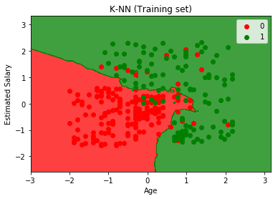

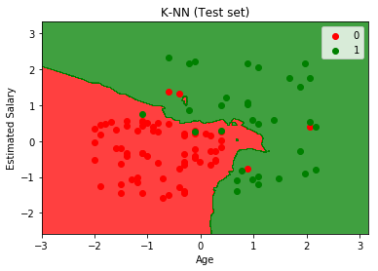

**K Means**

# -*- coding: utf-8 -*-

"""

Created on Wed Jan 31 22:18:37 2018

@author: Piyushjaiswal

"""

# K-Means Clustering

# Importing the libraries

import numpy as np

import matplotlib.pyplot as plt

import pandas as pd

# Importing the dataset

dataset = pd.read_csv('Mall_Customers.csv')

X = dataset.iloc[:, [3, 4]].values

#Using the elbow method to find the optimal number of clusters

from sklearn.cluster import KMeans

wcss = []

for i in range(1,11):

kmeans = KMeans(n_clusters = i, init = 'k-means++', max_iter = 300, n_init = 10,random_state = 0)

kmeans.fit(X)

wcss.append(kmeans.inertia_)

plt.plot(range(1,11),wcss)

plt.title('The Elbow Method')

plt.xlabel('Number of Clusters')

plt.ylabel('WCSS')

plt.show()

#Applying K-means to the Dataset

kmeans = KMeans(n_clusters = 5, max_iter = 300, n_init = 10,random_state = 0)

y_kmeans = kmeans.fit_predict(X)

#Visualizing the clusters

plt.scatter(X[y_kmeans == 0, 0], X[y_kmeans == 0, 1], s = 100,c ='red', label = 'Careful')

plt.scatter(X[y_kmeans ==1, 0], X[y_kmeans ==1, 1], s = 100,c ='blue', label = 'Standard')

plt.scatter(X[y_kmeans ==2, 0], X[y_kmeans ==2, 1], s = 100,c ='green', label = 'Target')

plt.scatter(X[y_kmeans ==3, 0], X[y_kmeans ==3, 1], s = 100,c ='cyan', label = 'Careless')

plt.scatter(X[y_kmeans ==4, 0], X[y_kmeans ==4, 1], s = 100,c ='magenta', label = 'Sensible')

plt.scatter(kmeans.cluster_centers_[:, 0], kmeans.cluster_centers_[:, 1], s = 300,c ='yellow', label = 'Centroid')

plt.title('Clusters pf clients')

plt.xlabel('Annual Income (k$)')

plt.ylabel('Spending Score (1-100)')

plt.legend()

plt.show()

**OUTPUT:**

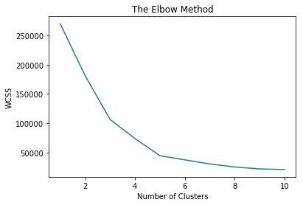

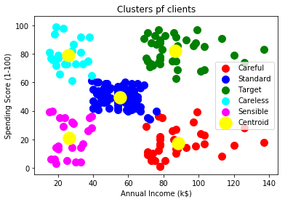

**K Modes**

from kmodes import kmodes

from sklearn.datasets import load_iris

from sklearn.model_selection import train_test_split

from sklearn.metrics import accuracy_score

import pandas as pd

import numpy as np

iris=load_iris()

irisX=pd.DataFrame(iris.data,columns=iris.feature_names)

irisY=pd.DataFrame(iris.target,columns=["Target"])

xTrain,xTest,yTrain,yTest=train_test_split(irisX,irisY, test_size=0.2)

print(xTrain.shape)

print(yTrain.shape)

print(xTest.shape)

print(yTest.shape)

cl=kmodes.KModes(n_clusters=3)

get_ipython().magic(u'pinfo cl')

clusters=cl.fit_predict(xTrain)

pred4=cl.predict(xTest)

accuracy=accuracy_score(yTest,pred4)

print(accuracy)

**OUTPUT:**

(120, 4)

(120, 1)

(30, 4)

(30, 1)

**0.3**

**SVM REGRESSION**

**R Code:**

setwd("Z:\\MACHINE LEARNING")

install.packages("e1071")

library(e1071)

data <- read.csv( "svm_regression.csv", header = TRUE)

plot(data, pch=16)

model <- svm(Y ~ X , data)

abline(model)

predictedY <- predict(model, data)

points(data$X, predictedY, col = "red", pch=4)

error <- data$Y - predictedY

svrPredictionRMSE <- sqrt(mean(error^2))

svrPredictionRMSE

tuneResult <- tune(svm, Y ~ X, data = data, ranges = list(epsilon = seq(0,1,0.1), cost = 2^(2:9)) )

print(tuneResult)

tuneResult <- tune(svm, Y ~ X, data = data, ranges = list(epsilon = seq(0,0.2,0.01), cost = 2^(2:9)) )

print(tuneResult)

tunedModel <- tuneResult$best.model

tunedModelY <- predict(tunedModel, data)

error <- data$Y - tunedModelY

plot(data, pch=16)

points(data$X, tunedModelY, col = "green", pch=4)

**OUTPUT:**

svrPredictionRMSE

[1] 3.157061

print(tuneResult)

Parameter tuning of ‘svm’:

- sampling method: 10-fold cross validation

- best parameters:

epsilon cost

0 4

- best performance: 14.52175

print(tuneResult)

Parameter tuning of ‘svm’:

- sampling method: 10-fold cross validation

- best parameters:

epsilon cost

0.08 32

- best performance: 8.161363

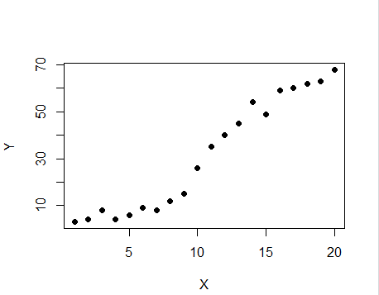

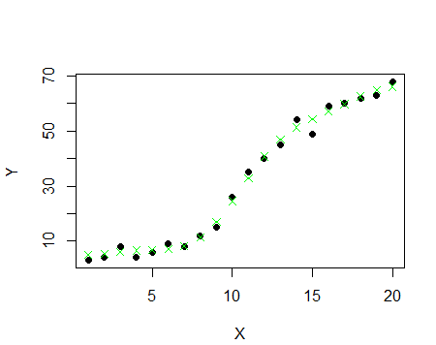

**SVM CLASSIFICATION**

# Support Vector Machine(SVM)

# Importing the libraries

import numpy as np

import matplotlib.pyplot as plt

import pandas as pd

# Importing the dataset

dataset = pd.read_csv('Social_Network_Ads.csv')

X = dataset.iloc[:, [2, 3]].values

y = dataset.iloc[:, 4].values

# Splitting the dataset into the Training set and Test set

from sklearn.cross_validation import train_test_split

X_train, X_test, y_train, y_test = train_test_split(X, y, test_size = 0.25, random_state = 0)

# Feature Scaling

from sklearn.preprocessing import StandardScaler

sc = StandardScaler()

X_train = sc.fit_transform(X_train)

X_test = sc.transform(X_test)

# Fitting SVM to the Training set

from sklearn.svm import SVC

classifier = SVC(kernel = 'linear', random_state = 0)

classifier.fit(X_train,y_train)

# Predicting the Test set results

y_pred = classifier.predict(X_test)

# Making the Confusion Matrix

from sklearn.metrics import confusion_matrix

cm = confusion_matrix(y_test, y_pred)

# Visualising the Training set results

from matplotlib.colors import ListedColormap

X_set, y_set = X_train, y_train

X1, X2 = np.meshgrid(np.arange(start = X_set[:, 0].min() - 1, stop = X_set[:, 0].max() + 1, step = 0.01),

np.arange(start = X_set[:, 1].min() - 1, stop = X_set[:, 1].max() + 1, step = 0.01))

plt.contourf(X1, X2, classifier.predict(np.array([X1.ravel(), X2.ravel()]).T).reshape(X1.shape),

alpha = 0.75, cmap = ListedColormap(('red', 'green')))

plt.xlim(X1.min(), X1.max())

plt.ylim(X2.min(), X2.max())

for i, j in enumerate(np.unique(y_set)):

plt.scatter(X_set[y_set == j, 0], X_set[y_set == j, 1],

c = ListedColormap(('red', 'green'))(i), label = j)

plt.title('SVM (Training set)')

plt.xlabel('Age')

plt.ylabel('Estimated Salary')

plt.legend()

plt.show()

# Visualising the Test set results

from matplotlib.colors import ListedColormap

X_set, y_set = X_test, y_test

X1, X2 = np.meshgrid(np.arange(start = X_set[:, 0].min() - 1, stop = X_set[:, 0].max() + 1, step = 0.01),

np.arange(start = X_set[:, 1].min() - 1, stop = X_set[:, 1].max() + 1, step = 0.01))

plt.contourf(X1, X2, classifier.predict(np.array([X1.ravel(), X2.ravel()]).T).reshape(X1.shape),

alpha = 0.75, cmap = ListedColormap(('red', 'green')))

plt.xlim(X1.min(), X1.max())

plt.ylim(X2.min(), X2.max())

for i, j in enumerate(np.unique(y_set)):

plt.scatter(X_set[y_set == j, 0], X_set[y_set == j, 1],

c = ListedColormap(('red', 'green'))(i), label = j)

plt.title('SVM (Test set)')

plt.xlabel('Age')

plt.ylabel('Estimated Salary')

plt.legend()

plt.show()

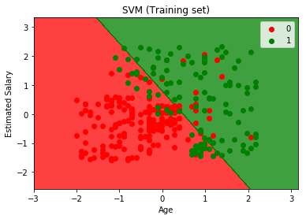

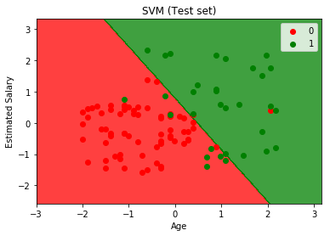

**VOTING**

from sklearn import datasets

from sklearn.base import BaseEstimator

from sklearn.base import ClassifierMixin

import operator

from sklearn import cross_validation

iris = datasets.load_iris()

X, y = iris.data[:, 1:3], iris.target

from sklearn import model_selection

from sklearn.linear_model import LogisticRegression

from sklearn.naive_bayes import GaussianNB

from sklearn.ensemble import RandomForestClassifier

import numpy as np

clf1 = LogisticRegression(random_state=1)

clf2 = RandomForestClassifier(random_state=1)

clf3 = GaussianNB()

print('5-fold cross validation:\n')

labels = ['Logistic Regression', 'Random Forest', 'Naive Bayes']

for clf, label in zip([clf1, clf2, clf3], labels):

scores = model_selection.cross_val_score(clf, X, y,

cv=5,

scoring='accuracy')

print("Accuracy: %0.2f (+/- %0.2f) [%s]"

% (scores.mean(), scores.std(), label))

class EnsembleClassifier(BaseEstimator, ClassifierMixin):

"""

Ensemble classifier for scikit-learn estimators.

Parameters

----------

clf : `iterable`

A list of scikit-learn classifier objects.

weights : `list` (default: `None`)

If `None`, the majority rule voting will be applied to the predicted class labels.

If a list of weights (`float` or `int`) is provided, the averaged raw probabilities (via `predict_proba`)

will be used to determine the most confident class label.

"""

def __init__(self, clfs, weights=None):

self.clfs = clfs

self.weights = weights

def fit(self, X, y):

"""

Fit the scikit-learn estimators.

Parameters

----------

X : numpy array, shape = [n_samples, n_features]

Training data

y : list or numpy array, shape = [n_samples]

Class labels

"""

for clf in self.clfs:

clf.fit(X, y)

def predict(self, X):

"""

Parameters

----------

X : numpy array, shape = [n_samples, n_features]

Returns

----------

maj : list or numpy array, shape = [n_samples]

Predicted class labels by majority rule

"""

self.classes_ = np.asarray([clf.predict(X) for clf in self.clfs])

if self.weights:

avg = self.predict_proba(X)

maj = np.apply_along_axis(lambda x: max(enumerate(x), key=operator.itemgetter(1))[0], axis=1, arr=avg)

else:

maj = np.asarray([np.argmax(np.bincount(self.classes_[:,c])) for c in range(self.classes_.shape[1])])

return maj

def predict_proba(self, X):

"""

Parameters

----------

X : numpy array, shape = [n_samples, n_features]

Returns

----------

avg : list or numpy array, shape = [n_samples, n_probabilities]

Weighted average probability for each class per sample.

"""

self.probas_ = [clf.predict_proba(X) for clf in self.clfs]

avg = np.average(self.probas_, axis=0, weights=self.weights)

return avg

np.random.seed(123)

eclf = EnsembleClassifier(clfs=[clf1, clf2, clf3], weights=[1,1,1])

for clf, label in zip([clf1, clf2, clf3, eclf], ['Logistic Regression', 'Random Forest', 'naive Bayes', 'Ensemble']):

scores = cross_validation.cross_val_score(clf, X, y, cv=5, scoring='accuracy')

print("Accuracy: %0.2f (+/- %0.2f) [%s]" % (scores.mean(), scores.std(), label))

**OUTPUT:**

5-fold cross validation:

Accuracy: 0.90 (+/- 0.05) [Logistic Regression]

Accuracy: 0.93 (+/- 0.05) [Random Forest]

Accuracy: 0.91 (+/- 0.04) [Naive Bayes]

**MAJORITY VOTING:**

Accuracy: 0.90 (+/- 0.05) [Logistic Regression]

Accuracy: 0.93 (+/- 0.05) [Random Forest]

Accuracy: 0.91 (+/- 0.04) [naive Bayes]

Accuracy: 0.95 (+/- 0.04) [Ensemble]

**SCREENSHOT:**

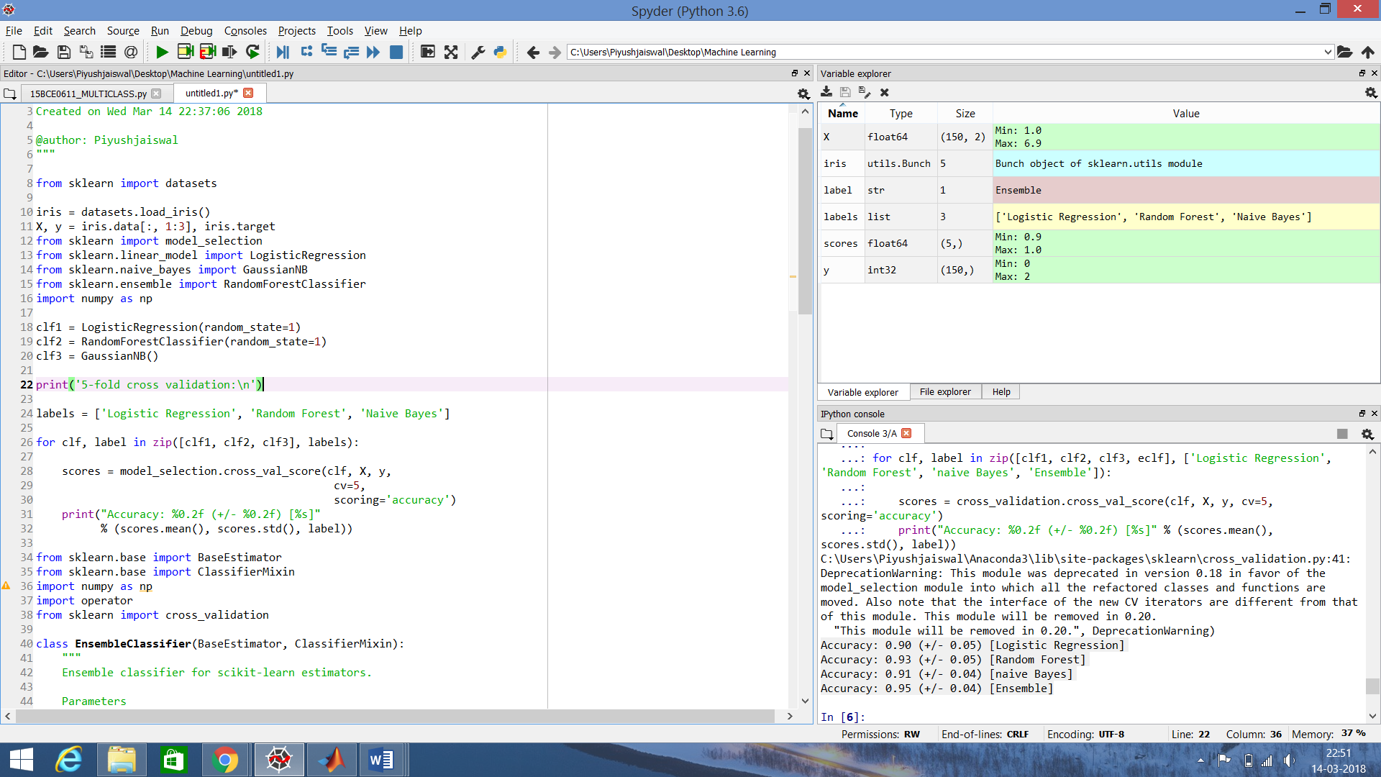

**Random Forest Regression**

# Importing the libraries

import numpy as np

import matplotlib.pyplot as plt

import pandas as pd

# Importing the dataset

dataset = pd.read_csv('Position_Salaries.csv')

X = dataset.iloc[:, 1:2].values

y = dataset.iloc[:, 2].values

# Fitting the Random Forest Regression Model to the dataset

from sklearn.ensemble import RandomForestRegressor

regressor = RandomForestRegressor(n_estimators = 300, random_state = 0)

regressor.fit(X, y)

# Predicting a new result

y_pred = regressor.predict(6.5)

# Visualising the Random Forest Regression results (for higher resolution and smoother curve)

X_grid = np.arange(min(X), max(X), 0.01)

X_grid = X_grid.reshape((len(X_grid), 1))

plt.scatter(X, y, color = 'red')

plt.plot(X_grid, regressor.predict(X_grid), color = 'blue')

plt.title('Truth or Bluff (Random Forest Regression Model)')

plt.xlabel('Position level')

plt.ylabel('Salary')

plt.show()

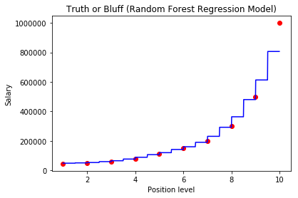

**Random Forest Classifier**

# Importing the libraries

import numpy as np

import matplotlib.pyplot as plt

import pandas as pd

# Importing the dataset

dataset = pd.read_csv('Social_Network_Ads.csv')

X = dataset.iloc[:, [2, 3]].values

y = dataset.iloc[:, 4].values

# Splitting the dataset into the Training set and Test set

from sklearn.cross_validation import train_test_split

X_train, X_test, y_train, y_test = train_test_split(X, y, test_size = 0.25, random_state = 0)

# Feature Scaling

from sklearn.preprocessing import StandardScaler

sc = StandardScaler()

X_train = sc.fit_transform(X_train)

X_test = sc.transform(X_test)

# Fitting classifier to the Training set

from sklearn.ensemble import RandomForestClassifier

classifier = RandomForestClassifier(n_estimators = 10, criterion = 'entropy', random_state = 0 )

classifier.fit(X_train,y_train)

# Predicting the Test set results

y_pred = classifier.predict(X_test)

# Making the Confusion Matrix

from sklearn.metrics import confusion_matrix

cm = confusion_matrix(y_test, y_pred)

# Visualising the Training set results

from matplotlib.colors import ListedColormap

X_set, y_set = X_train, y_train

X1, X2 = np.meshgrid(np.arange(start = X_set[:, 0].min() - 1, stop = X_set[:, 0].max() + 1, step = 0.01),

np.arange(start = X_set[:, 1].min() - 1, stop = X_set[:, 1].max() + 1, step = 0.01))

plt.contourf(X1, X2, classifier.predict(np.array([X1.ravel(), X2.ravel()]).T).reshape(X1.shape),

alpha = 0.75, cmap = ListedColormap(('red', 'green')))

plt.xlim(X1.min(), X1.max())

plt.ylim(X2.min(), X2.max())

for i, j in enumerate(np.unique(y_set)):

plt.scatter(X_set[y_set == j, 0], X_set[y_set == j, 1],

c = ListedColormap(('red', 'green'))(i), label = j)

plt.title('Random Forest Classifier (Training set)')

plt.xlabel('Age')

plt.ylabel('Estimated Salary')

plt.legend()

plt.show()

# Visualising the Test set results

from matplotlib.colors import ListedColormap

X_set, y_set = X_test, y_test

X1, X2 = np.meshgrid(np.arange(start = X_set[:, 0].min() - 1, stop = X_set[:, 0].max() + 1, step = 0.01),

np.arange(start = X_set[:, 1].min() - 1, stop = X_set[:, 1].max() + 1, step = 0.01))

plt.contourf(X1, X2, classifier.predict(np.array([X1.ravel(), X2.ravel()]).T).reshape(X1.shape),

alpha = 0.75, cmap = ListedColormap(('red', 'green')))

plt.xlim(X1.min(), X1.max())

plt.ylim(X2.min(), X2.max())

for i, j in enumerate(np.unique(y_set)):

plt.scatter(X_set[y_set == j, 0], X_set[y_set == j, 1],

c = ListedColormap(('red', 'green'))(i), label = j)

plt.title('Random Forest Classifier (Test set)')

plt.xlabel('Age')

plt.ylabel('Estimated Salary')

plt.legend()

plt.show()

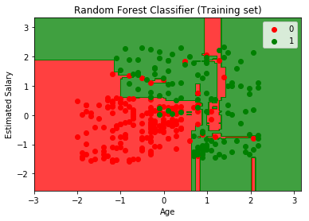

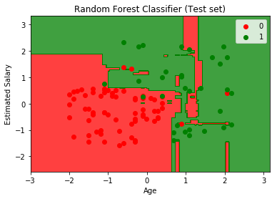

**ADABOOST**

import pandas as pd

import numpy as np

from sklearn.tree import DecisionTreeClassifier

from sklearn.cross_validation import train_test_split

from sklearn.datasets import make_hastie_10_2

import matplotlib.pyplot as plt

""" HELPER FUNCTION: GET ERROR RATE ========================================="""

def get_error_rate(pred, Y):

return sum(pred != Y) / float(len(Y))

""" HELPER FUNCTION: PRINT ERROR RATE ======================================="""

def print_error_rate(err):

print ('Error rate: Training: %.4f - Test: %.4f' % err)

""" HELPER FUNCTION: GENERIC CLASSIFIER ====================================="""

def generic_clf(Y_train, X_train, Y_test, X_test, clf):

clf.fit(X_train,Y_train)

pred_train = clf.predict(X_train)

pred_test = clf.predict(X_test)

return get_error_rate(pred_train, Y_train), \

get_error_rate(pred_test, Y_test)

""" ADABOOST IMPLEMENTATION ================================================="""

def adaboost_clf(Y_train, X_train, Y_test, X_test, M, clf):

n_train, n_test = len(X_train), len(X_test)

# Initialize weights

w = np.ones(n_train) / n_train

pred_train, pred_test = [np.zeros(n_train), np.zeros(n_test)]

for i in range(M):

# Fit a classifier with the specific weights

clf.fit(X_train, Y_train, sample_weight = w)

pred_train_i = clf.predict(X_train)

pred_test_i = clf.predict(X_test)

# Indicator function

miss = [int(x) for x in (pred_train_i != Y_train)]

# Equivalent with 1/-1 to update weights

miss2 = [x if x==1 else -1 for x in miss]

# Error

err_m = np.dot(w,miss) / sum(w)

# Alpha

alpha_m = 0.5 * np.log( (1 - err_m) / float(err_m))

# New weights

w = np.multiply(w, np.exp([float(x) * alpha_m for x in miss2]))

# Add to prediction

pred_train = [sum(x) for x in zip(pred_train,

[x * alpha_m for x in pred_train_i])]

pred_test = [sum(x) for x in zip(pred_test,

[x * alpha_m for x in pred_test_i])]

pred_train, pred_test = np.sign(pred_train), np.sign(pred_test)

# Return error rate in train and test set

return get_error_rate(pred_train, Y_train), \

get_error_rate(pred_test, Y_test)

""" PLOT FUNCTION ==========================================================="""

def plot_error_rate(er_train, er_test):

df_error = pd.DataFrame([er_train, er_test]).T

df_error.columns = ['Training', 'Test']

plot1 = df_error.plot(linewidth = 3, figsize = (8,6),

color = ['lightblue', 'darkblue'], grid = True)

plot1.set_xlabel('Number of iterations', fontsize = 12)

plot1.set_xticklabels(range(0,450,50))

plot1.set_ylabel('Error rate', fontsize = 12)

plot1.set_title('Error rate vs number of iterations', fontsize = 16)

plt.axhline(y=er_test[0], linewidth=1, color = 'red', ls = 'dashed')

""" MAIN SCRIPT ============================================================="""

if __name__ == '__main__':

# Read data

x, y = make_hastie_10_2()

df = pd.DataFrame(x)

df['Y'] = y

# Split into training and test set

train, test = train_test_split(df, test_size = 0.2)

X_train, Y_train = train.ix[:,:-1], train.ix[:,-1]

X_test, Y_test = test.ix[:,:-1], test.ix[:,-1]

# Fit a simple decision tree first

clf_tree = DecisionTreeClassifier(max_depth = 1, random_state = 1)

er_tree = generic_clf(Y_train, X_train, Y_test, X_test, clf_tree)

# Fit Adaboost classifier using a decision tree as base estimator

# Test with different number of iterations

er_train, er_test = [er_tree[0]], [er_tree[1]]

x_range = range(10, 410, 10)

for i in x_range:

er_i = adaboost_clf(Y_train, X_train, Y_test, X_test, i, clf_tree)

er_train.append(er_i[0])

er_test.append(er_i[1])

# Compare error rate vs number of iterations

plot_error_rate(er_train, er_test)

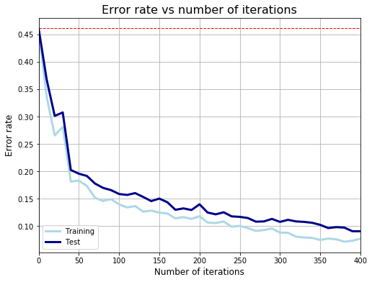

**CODE – 2**

# AdaBoost Classification

import pandas

from sklearn import model_selection

from sklearn.ensemble import AdaBoostClassifier

url = "https://raw.githubusercontent.com/jbrownlee/Datasets/master/pima-indians-diabetes.data.csv"

names = ['preg', 'plas', 'pres', 'skin', 'test', 'mass', 'pedi', 'age', 'class']

dataframe = pandas.read_csv(url, names=names)

array = dataframe.values

X = array[:,0:8]

Y = array[:,8]

seed = 7

num_trees = 30

kfold = model_selection.KFold(n_splits=10, random_state=seed)

model = AdaBoostClassifier(n_estimators=num_trees, random_state=seed)

results = model_selection.cross_val_score(model, X, Y, cv=kfold)

print(results.mean())

**0.760457963089542**

**MLP**

**R CODE**

library(RSNNS)

data(iris)

iris

iris <- iris[sample(1:nrow(iris),length(1:nrow(iris))),1:ncol(iris)]

irisValues <- iris[,1:4]

irisTargets <- decodeClassLabels(iris[,5])

iris <- splitForTrainingAndTest(irisValues, irisTargets, ratio=0.15)

iris <- normTrainingAndTestSet(iris)

model <- mlp(iris$inputsTrain, iris$targetsTrain, size=5, learnFuncParams=c(0.1),maxit=50, inputsTest=iris$inputsTest, targetsTest=iris$targetsTest)

summary(model)

model

weightMatrix(model)

extractNetInfo(model)

par(mfrow=c(2,2))

plotIterativeError(model)

predictions <- predict(model,iris$inputsTest)

plotRegressionError(predictions[,2], iris$targetsTest[,2])

confusionMatrix(iris$targetsTrain,fitted.values(model))

confusionMatrix(iris$targetsTest,predictions)

#The more each curve hugs the left and top edges of the plot, the better the classification.

plotROC(fitted.values(model)[,2], iris$targetsTrain[,2])

plotROC(predictions[,2], iris$targetsTest[,2])

confusionMatrix(iris$targetsTrain, encodeClassLabels(fitted.values(model),method="402040", l=0.4, h=0.6))

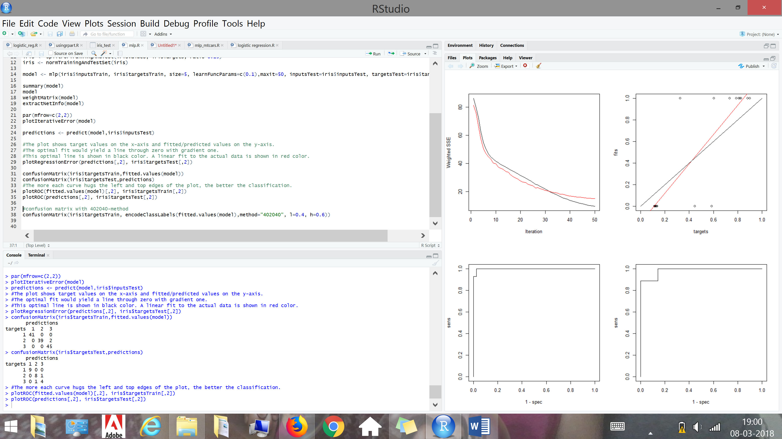

**Python**

from random import seed

from random import randrange

from csv import reader

# Load a CSV file

def load_csv(filename):

dataset = list()

with open(filename, 'r') as file:

csv_reader = reader(file)

for row in csv_reader:

if not row:

continue

dataset.append(row)

return dataset

# Convert string column to float

def str_column_to_float(dataset, column):

for row in dataset:

row[column] = float(row[column].strip())

# Convert string column to integer

def str_column_to_int(dataset, column):

class_values = [row[column] for row in dataset]

unique = set(class_values)

lookup = dict()

for i, value in enumerate(unique):

lookup[value] = i

for row in dataset:

row[column] = lookup[row[column]]

return lookup

# Split a dataset into k folds

def cross_validation_split(dataset, n_folds):

dataset_split = list()

dataset_copy = list(dataset)

fold_size = int(len(dataset) / n_folds)

for i in range(n_folds):

fold = list()

while len(fold) < fold_size:

index = randrange(len(dataset_copy))

fold.append(dataset_copy.pop(index))

dataset_split.append(fold)

return dataset_split

# Calculate accuracy percentage

def accuracy_metric(actual, predicted):

correct = 0

for i in range(len(actual)):

if actual[i] == predicted[i]:

correct += 1

return correct / float(len(actual)) * 100.0

# Evaluate an algorithm using a cross validation split

def evaluate_algorithm(dataset, algorithm, n_folds, *args):

folds = cross_validation_split(dataset, n_folds)

scores = list()

for fold in folds:

train_set = list(folds)

train_set.remove(fold)

train_set = sum(train_set, [])

test_set = list()

for row in fold:

row_copy = list(row)

test_set.append(row_copy)

row_copy[-1] = None

predicted = algorithm(train_set, test_set, *args)

actual = [row[-1] for row in fold]

accuracy = accuracy_metric(actual, predicted)

scores.append(accuracy)

return scores

# Make a prediction with weights

def predict(row, weights):

activation = weights[0]

for i in range(len(row)-1):

activation += weights[i + 1] * row[i]

return 1.0 if activation >= 0.0 else 0.0

# Estimate Perceptron weights using stochastic gradient descent

def train_weights(train, l_rate, n_epoch):

weights = [0.0 for i in range(len(train[0]))]

for epoch in range(n_epoch):

for row in train:

prediction = predict(row, weights)

error = row[-1] - prediction

weights[0] = weights[0] + l_rate * error

for i in range(len(row)-1):

weights[i + 1] = weights[i + 1] + l_rate * error * row[i]

return weights

# Perceptron Algorithm With Stochastic Gradient Descent

def perceptron(train, test, l_rate, n_epoch):

predictions = list()

weights = train_weights(train, l_rate, n_epoch)

for row in test:

prediction = predict(row, weights)

predictions.append(prediction)

return(predictions)

# Test the Perceptron algorithm on the sonar dataset

seed(1)

# load and prepare data

filename = 'C:\Users\HarshitSharma\Desktop\sonar.csv'

dataset = load_csv(filename)

for i in range(len(dataset[0])-1):

str_column_to_float(dataset, i)

# convert string class to integers

str_column_to_int(dataset, len(dataset[0])-1)

# evaluate algorithm

n_folds = 3

l_rate = 0.01

n_epoch = 500

scores = evaluate_algorithm(dataset, perceptron, n_folds, l_rate, n_epoch)

print('Scores: %s' % scores)

print('Mean Accuracy: %.3f%%' % (sum(scores)/float(len(scores))))

**Output:**

Scores: [73.91304347826086, 78.26086956521739, 68.11594202898551]

Mean Accuracy: 73.430%

**Error Correcting for Multi Class Learning Problem**

import pandas as pd

import numpy as np

from sklearn.metrics import accuracy_score

from sklearn.model_selection import train_test_split

from sklearn.multiclass import OutputCodeClassifier

from sklearn import tree

from sklearn.datasets import load_iris

iris= load_iris()

X=iris.data

y=iris.target

Xtrain,Xtest,ytrain,ytest=train_test_split(X,y)

OC=OutputCodeClassifier(tree.DecisionTreeClassifier(),code_size=2,random_state=0)

OC.fit(Xtrain,ytrain)

res= OC.predict(Xtest)

print(res)

acc=accuracy_score(res,ytest)

print(acc)

**OUTPUT:**

[2 2 0 0 0 1 2 2 0 2 1 2 0 1 0 2 1 2 1 1 2 1 1 0 0 0 2 0 1 0 0 1 0 1 1 0 2 2]

**ACCURACY:**

0.9473684210526315

**GAUSSIAN MIXTURE MODEL USING EXPECTATION MAXIMIZATION**

import numpy as np

class GMM:

def __init__(self, k = 3, eps = 0.0001):

self.k = k ## number of clusters

self.eps = eps ## threshold to stop `epsilon`

# All parameters from fitting/learning are kept in a named tuple

from collections import namedtuple

def fit_EM(self, X, max_iters = 1000):

# n = number of data-points, d = dimension of data points

n, d = X.shape

# randomly choose the starting centroids/means

## as 3 of the points from datasets

mu = X[np.random.choice(n, self.k, False), :]

# initialize the covariance matrices for each gaussians

Sigma= [np.eye(d)] * self.k

# initialize the probabilities/weights for each gaussians

w = [1./self.k] * self.k

# responsibility matrix is initialized to all zeros

# we have responsibility for each of n points for eack of k gaussians

R = np.zeros((n, self.k))

### log_likelihoods

log_likelihoods = []

P = lambda mu, s: np.linalg.det(s) ** -.5 ** (2 * np.pi) ** (-X.shape[1]/2.) \

* np.exp(-.5 * np.einsum('ij, ij -> i',\

X - mu, np.dot(np.linalg.inv(s) , (X - mu).T).T ) )

# Iterate till max_iters iterations

while len(log_likelihoods) < max_iters:

# E - Step

## Vectorized implementation of e-step equation to calculate the

## membership for each of k -gaussians

for k in range(self.k):

R[:, k] = w[k] * P(mu[k], Sigma[k])

### Likelihood computation

log_likelihood = np.sum(np.log(np.sum(R, axis = 1)))

log_likelihoods.append(log_likelihood)

## Normalize so that the responsibility matrix is row stochastic

R = (R.T / np.sum(R, axis = 1)).T

## The number of datapoints belonging to each gaussian

N_ks = np.sum(R, axis = 0)

# M Step

## calculate the new mean and covariance for each gaussian by

## utilizing the new responsibilities

for k in range(self.k):

## means

mu[k] = 1. / N_ks[k] * np.sum(R[:, k] * X.T, axis = 1).T

x_mu = np.matrix(X - mu[k])

## covariances

Sigma[k] = np.array(1 / N_ks[k] * np.dot(np.multiply(x_mu.T, R[:, k]), x_mu))

## and finally the probabilities

w[k] = 1. / n * N_ks[k]

# check for onvergence

if len(log_likelihoods) < 2 : continue

if np.abs(log_likelihood - log_likelihoods[-2]) < self.eps: break

## bind all results together

from collections import namedtuple

self.params = namedtuple('params', ['mu', 'Sigma', 'w', 'log_likelihoods', 'num_iters'])

self.params.mu = mu

self.params.Sigma = Sigma

self.params.w = w

self.params.log_likelihoods = log_likelihoods

self.params.num_iters = len(log_likelihoods)

return self.params

def plot_log_likelihood(self):

import pylab as plt

plt.plot(self.params.log_likelihoods)

plt.title('Log Likelihood vs iteration plot')

plt.xlabel('Iterations')

plt.ylabel('log likelihood')

plt.show()

def predict(self, x):

p = lambda mu, s : np.linalg.det(s) ** - 0.5 * (2 * np.pi) **\

(-len(x)/2) * np.exp( -0.5 * np.dot(x - mu , \

np.dot(np.linalg.inv(s) , x - mu)))

probs = np.array([w * p(mu, s) for mu, s, w in \

zip(self.params.mu, self.params.Sigma, self.params.w)])

return probs/np.sum(probs)

def demo_2d():

# Load data

#X = np.genfromtxt('data1.csv', delimiter=',')

### generate the random data

np.random.seed(3)

m1, cov1 = [9, 8], [[.5, 1], [.25, 1]] ## first gaussian

data1 = np.random.multivariate_normal(m1, cov1, 90)

m2, cov2 = [6, 13], [[.5, -.5], [-.5, .1]] ## second gaussian

data2 = np.random.multivariate_normal(m2, cov2, 45)

m3, cov3 = [4, 7], [[0.25, 0.5], [-0.1, 0.5]] ## third gaussian

data3 = np.random.multivariate_normal(m3, cov3, 65)

X = np.vstack((data1,np.vstack((data2,data3))))

np.random.shuffle(X)

# np.savetxt('sample.csv', X, fmt = "%.4f", delimiter = ",")

####

gmm = GMM(3, 0.000001)

params = gmm.fit_EM(X, max_iters= 100)

print (params.log_likelihoods)

import pylab as plt

from matplotlib.patches import Ellipse

def plot_ellipse(pos, cov, nstd=2, ax=None, **kwargs):

def eigsorted(cov):

vals, vecs = np.linalg.eigh(cov)

order = vals.argsort()[::-1]

return vals[order], vecs[:,order]

if ax is None:

ax = plt.gca()

vals, vecs = eigsorted(cov)

theta = np.degrees(np.arctan2(*vecs[:,0][::-1]))

# Width and height are "full" widths, not radius

width, height = 2 * nstd * np.sqrt(abs(vals))

ellip = Ellipse(xy=pos, width=width, height=height, angle=theta, **kwargs)

ax.add_artist(ellip)

return ellip

def show(X, mu, cov):

plt.cla()

K = len(mu) # number of clusters

colors = ['b', 'k', 'g', 'c', 'm', 'y', 'r']

plt.plot(X.T[0], X.T[1], 'm*')

for k in range(K):

plot_ellipse(mu[k], cov[k], alpha=0.6, color = colors[k % len(colors)])

fig = plt.figure(figsize = (13, 6))

fig.add_subplot(121)

show(X, params.mu, params.Sigma)

fig.add_subplot(122)

plt.plot(np.array(params.log_likelihoods))

plt.title('Log Likelihood vs iteration plot')

plt.xlabel('Iterations')

plt.ylabel('log likelihood')

plt.show()

print (gmm.predict(np.array([1, 2])))

if __name__ == "__main__":

demo_2d()

from optparse import OptionParser

parser = OptionParser()

parser.add_option("-f", "--file", dest="filepath", help="File path for data")

parser.add_option("-k", "--clusters", dest="clusters", help="No. of gaussians")

parser.add_option("-e", "--eps", dest="epsilon", help="Epsilon to stop")

parser.add_option("-m", "--maxiters", dest="max_iters", help="Maximum no. of iteration")

options, args = parser.parse_args()

if not options.filepath : raise('File not provided')

if not options.clusters :

print("Used default number of clusters = 3" )

k = 3

else: k = int(options.clusters)

if not options.epsilon :

print("Used default eps = 0.0001" )

eps = 0.0001

else: eps = float(options.epsilon)

if not options.max_iters :

print("Used default maxiters = 1000" )

max_iters = 1000

else: eps = int(options.maxiters)

X = np.genfromtxt(options.filepath, delimiter=',')

gmm = GMM(k, eps)

params = gmm.fit_EM(X, max_iters)

print (params.log_likelihoods)

gmm.plot_log_likelihood()

print (gmm.predict(np.array([1, 2])))

**OUTPUT:**

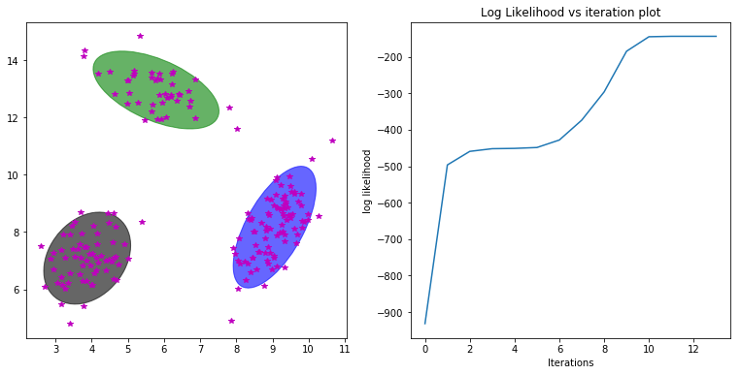

[2.20783559e-036 1.00000000e+000 1.55285737e-109]