EE 316
Section 3
Lab 04
By: Hannah Kelley
DAC Op-Amp
Introduction:
This experiment investigates the operation of a basic digital-to-analog converter using an op-amp and a binary-weighted resistor network. The circuit’s output behavior is examined to evaluate its step size, range, resolution, and accuracy using both theoretical calculations and simulations. Experimental measurements are also compared with the theoretical and simulated results to evaluate the practical performance of the DAC.
Theoretical Analysis:
The theoretical results for the R-2R DAC op-amp found in Table 1 were calculated using the following formula given in the lab manual:
$$\begin{aligned}V_{O}\left(V_{A}, V_{B},V_{C},V_{D}\right)=-\left(\frac{V_{A}}{2}+\frac{V_{B}}{4}+\frac{V_{C}}{8}+\frac{V_{D}}{16}\right)\#\left(1\right)\end{aligned}$$
Equation 2 shows an example of this formula for the input sequence (0, 5, 5, 0). It is important to know that 5V is used here instead of 1V. The “1” in the input column of Table 1 simply refers to that input being active high at 5V.
$$\begin{aligned}V_{O}\left(V_{A}, V_{B},V_{C},V_{D}\right)=-\left(\frac{0}{2}+\frac{5}{4}+\frac{5}{8}+\frac{0}{16}\right)=-1.875 V\#\left(2\right)\end{aligned}$$
Input |  |  |  |  | Theoretical
 | V_{A} | V_{B} | V_{C} | V_{D} | V_{O}
0 | 0 | 0 | 0 | 0 | 0 V
1 | 0 | 0 | 0 | 1 | -0.3125 V
2 | 0 | 0 | 1 | 0 | -0.625 V
3 | 0 | 0 | 1 | 1 | -0.9375 V
4 | 0 | 1 | 0 | 0 | -1.25 V
5 | 0 | 1 | 0 | 1 | -1.5625 V
6 | 0 | 1 | 1 | 0 | -1.875 V
7 | 0 | 1 | 1 | 1 | -2.1875 V
8 | 1 | 0 | 0 | 0 | -2.5 V
9 | 1 | 0 | 0 | 1 | -2.8125
10 | 1 | 0 | 1 | 0 | -3.125 V
11 | 1 | 0 | 1 | 1 | -3.4375 V
12 | 1 | 1 | 0 | 0 | -3.75 V
13 | 1 | 1 | 0 | 1 | -4.0625 V
14 | 1 | 1 | 1 | 0 | -4.375 V
15 | 1 | 1 | 1 | 1 | -4.6875 V
Table #1: Theoretical Results
Simulations and Results:
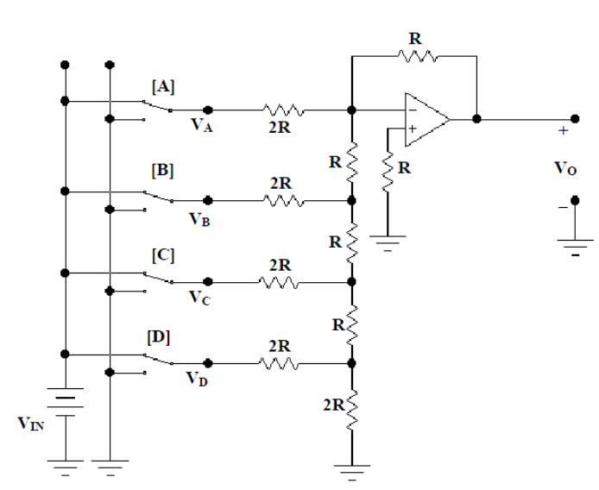
Figure #1: DAC Op-Amp Schematic from Lab Manual
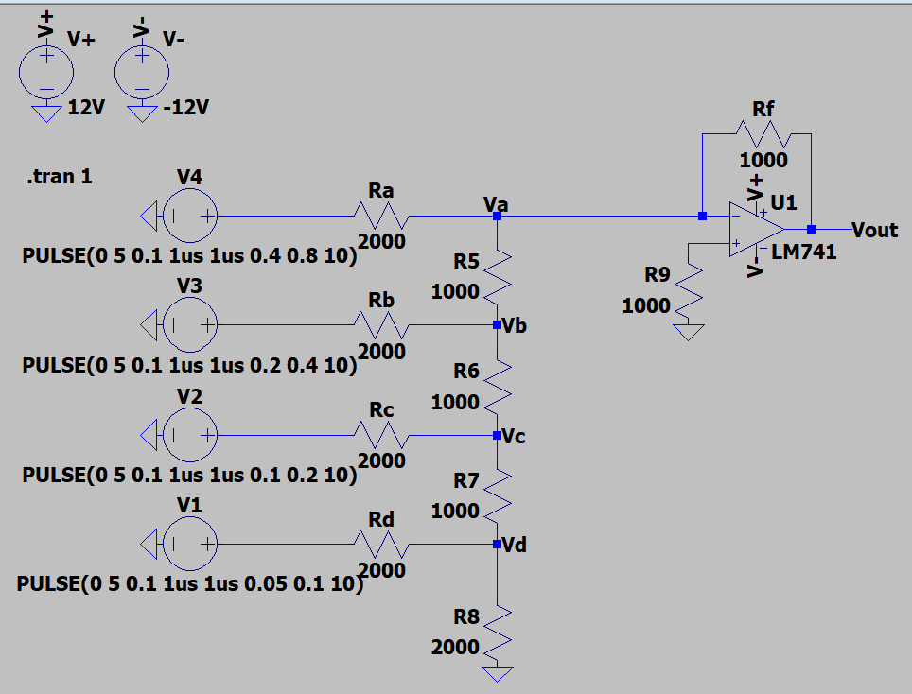
Figure #2: DAC Op-Amp Schematic (LTSpice)
The pulse commands for each voltage source systematically apply every possible combination of inputs, one after the other.
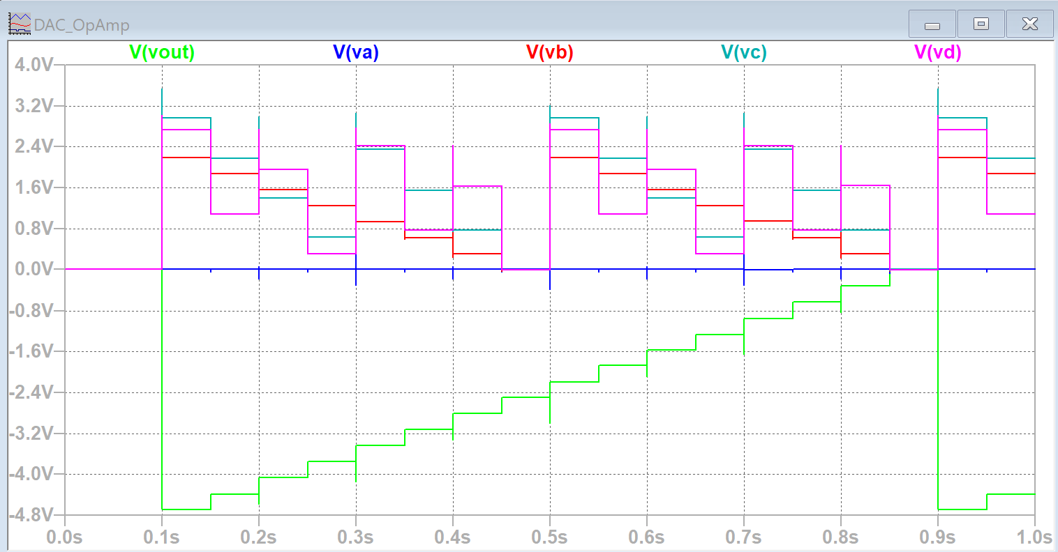
Figure #3: DAC Op-Amp Output (LTSpice)
Input |  |  |  |  | Simulation | Theoretical
 | V_{A} | V_{B} | V_{C} | V_{D} | V_{O} (V) | V_{O} (V)
0 | 0 | 0 | 0 | 0 | 0 V | 0 V
1 | 0 | 0 | 0 | 1 | -0.310V | -0.3125 V
2 | 0 | 0 | 1 | 0 | -0.623 V | -0.625 V
3 | 0 | 0 | 1 | 1 | -0.935 V | -0.9375 V
4 | 0 | 1 | 0 | 0 | -1.248 V | -1.25 V
5 | 0 | 1 | 0 | 1 | -1.561 V | -1.5625 V
6 | 0 | 1 | 1 | 0 | -1.873 V | -1.875 V
7 | 0 | 1 | 1 | 1 | -2.166 V | -2.1875 V
8 | 1 | 0 | 0 | 0 | -2.498 V | -2.5 V
9 | 1 | 0 | 0 | 1 | -2.810 V | -2.8125
10 | 1 | 0 | 1 | 0 | -3.123 V | -3.125 V
11 | 1 | 0 | 1 | 1 | -3.435 V | -3.4375 V
12 | 1 | 1 | 0 | 0 | -3.747 V | -3.75 V
13 | 1 | 1 | 0 | 1 | -4.066 V | -4.0625 V
14 | 1 | 1 | 1 | 0 | -4.373 V | -4.375 V
15 | 1 | 1 | 1 | 1 | -4.685 V | -4.6875 V
Table #2: Simulation and Theoretical Results
Experimental Setup and Results:
The DAC op-amp was constructed using a CN741 op-amp, 1k and 2k resistors, and a breadboard. A picture of the experimental setup can be found in Figure 4.
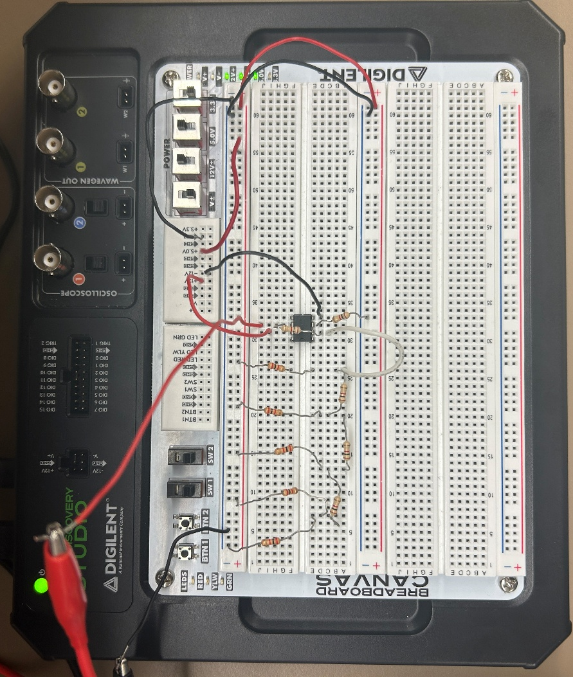
Figure #4: DAC Op-Amp Experimental Setup
Input |  |  |  |  | Simulation | Theoretical | Experimental
 | V_{A} | V_{B} | V_{C} | V_{D} | V_{O} (V) | V_{O} (V) | V_{O} (V)
0 | 0 | 0 | 0 | 0 | 0 V | 0 V | -0.001 V
1 | 0 | 0 | 0 | 1 | -0.310V | -0.3125 V | 0.318 V
2 | 0 | 0 | 1 | 0 | -0.623 V | -0.625 V | -0.632 V
3 | 0 | 0 | 1 | 1 | -0.935 V | -0.9375 V | -0.951 V
4 | 0 | 1 | 0 | 0 | -1.248 V | -1.25 V | -1.263 V
5 | 0 | 1 | 0 | 1 | -1.561 V | -1.5625 V | -1.574 V
6 | 0 | 1 | 1 | 0 | -1.873 V | -1.875 V | -1.891 V
7 | 0 | 1 | 1 | 1 | -2.166 V | -2.1875 V | -2.174 V
8 | 1 | 0 | 0 | 0 | -2.498 V | -2.5 V | -2.513 V
9 | 1 | 0 | 0 | 1 | -2.810 V | -2.8125 | -2.825 V
10 | 1 | 0 | 1 | 0 | -3.123 V | -3.125 V | -3.141 V
11 | 1 | 0 | 1 | 1 | -3.435 V | -3.4375 V | -3.452 V
12 | 1 | 1 | 0 | 0 | -3.747 V | -3.75 V | -3.764 V
13 | 1 | 1 | 0 | 1 | -4.066 V | -4.0625 V | -4.081 V
14 | 1 | 1 | 1 | 0 | -4.373 V | -4.375 V | -4.391 V
15 | 1 | 1 | 1 | 1 | -4.685 V | -4.6875 V | -4.702 V
Table #3: Simulation, Theoretical, and Experimental Results
Comparison and Discussion:
The simulation and experimental results matched closely with minor differences. The percent error for each measurement can be found in Table 4. The difference between the results can be explained by several factors including a non-ideal op-amp, imperfect supply voltages, and component tolerances. A graph of the simulation, theoretical, and experimental results can be found in Figure 5. Overall, the experimental results followed the same trend as the theoretical and simulation results, with the output voltage becoming more negative as the binary input increased. The small errors observed indicate that the DAC operated as expected despite the practical limitations of the circuit.
Input |  |  |  |  | Simulation | Experimental | Percent Error
 | V_{A} | V_{B} | V_{C} | V_{D} | V_{O} (V) | V_{O} (V) | Percent Error
0 | 0 | 0 | 0 | 0 | 0 V | -0.001 V | ---
1 | 0 | 0 | 0 | 1 | -0.310V | 0.318 V | 1.76%
2 | 0 | 0 | 1 | 0 | -0.623 V | -0.632 V | 1.12%
3 | 0 | 0 | 1 | 1 | -0.935 V | -0.951 V | 1.44%
4 | 0 | 1 | 0 | 0 | -1.248 V | -1.263 V | 1.04%
5 | 0 | 1 | 0 | 1 | -1.561 V | -1.574 V | 0.74%
6 | 0 | 1 | 1 | 0 | -1.873 V | -1.891 V | 0.85%
7 | 0 | 1 | 1 | 1 | -2.166 V | -2.174 V | 0.62%
8 | 1 | 0 | 0 | 0 | -2.498 V | -2.513 V | 0.52%
9 | 1 | 0 | 0 | 1 | -2.810 V | -2.825 V | 0.44%
10 | 1 | 0 | 1 | 0 | -3.123 V | -3.141 V | 0.51%
11 | 1 | 0 | 1 | 1 | -3.435 V | -3.452 V | 0.42%
12 | 1 | 1 | 0 | 0 | -3.747 V | -3.764 V | 0.37%
13 | 1 | 1 | 0 | 1 | -4.066 V | -4.081 V | 0.46%
14 | 1 | 1 | 1 | 0 | -4.373 V | -4.391 V | 0.37%
15 | 1 | 1 | 1 | 1 | -4.685 V | -4.702 V | 0.31%
Table #3: Percent Error
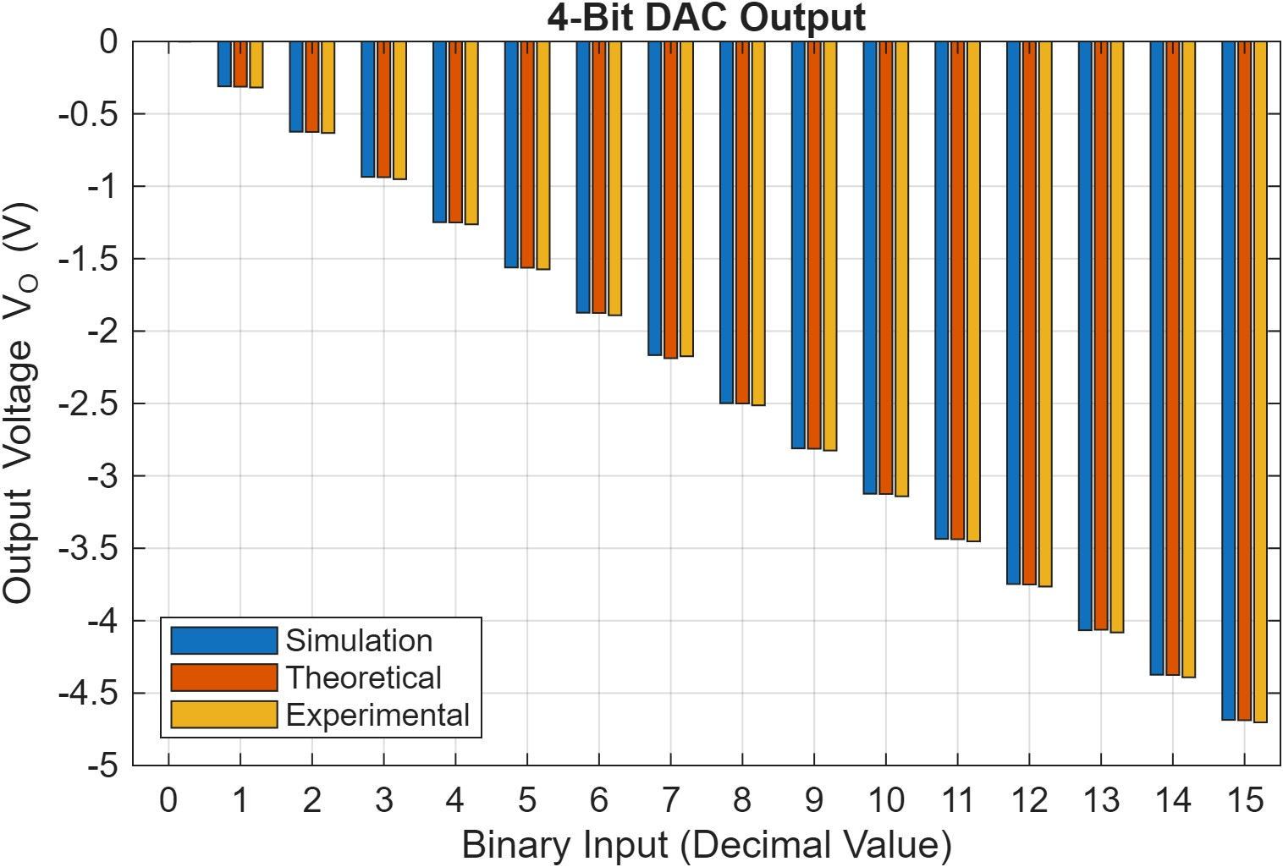
Figure #5: Simulation, Theoretical, and Experimental Results Plot
Conclusion:
The results demonstrated that the binary-weighted resistor network and op-amp successfully converted the digital inputs into corresponding analog output voltages. The experimental results closely followed the theoretical and simulation values, with small differences primarily caused by component tolerances, supply voltage variations, and non-ideal op-amp behavior. Overall, the DAC produced the expected step size and output range while maintaining relatively low measurement error.

