EE 316
Section 3
Lab 09
By: Hannah Kelley
Operating Characteristics of JFETs
Introduction:
This lab introduces the Junction Field-Effect Transistor (JFET), covering n-channel and p-channel constructions, channel symmetry, and key operational parameters such as pinch-off voltage and saturation current. By examining its voltage-controlled behavior, high input impedance, and low output noise, the experiment demonstrates why JFETs excel in small-signal amplification compared to BJTs. Ultimately, it teaches how to analyze JFET biasing and operating states, establishing the foundational concepts required to understand MOSFETs in future labs.
Simulations and Results:
The JFET circuit in Figure 1 was built and simulated in LTSpice to obtain its drain and transfer characteristic curves. Using the simulated circuit in Figure 2, I_{D} was measured across various V_{DS} values while maintaining V_{GS} at 0 V, -0.5 V, and -1 V by adjusting V₁ and V₂ independently. These I_{D} values are summarized in Table 1. The resulting data was plotted to create the drain characteristic curve in Figure 3, from which V_{P} and V_{TH} were estimated and annotated. Next, with V_{DS} fixed at 6 V, V_{GS} was incrementally decreased until I_{D} reached 0 mA to generate the transfer characteristic curve in Figure 4. Finally, V_{P} was estimated from the transfer plot and compared against the drain characteristic value.
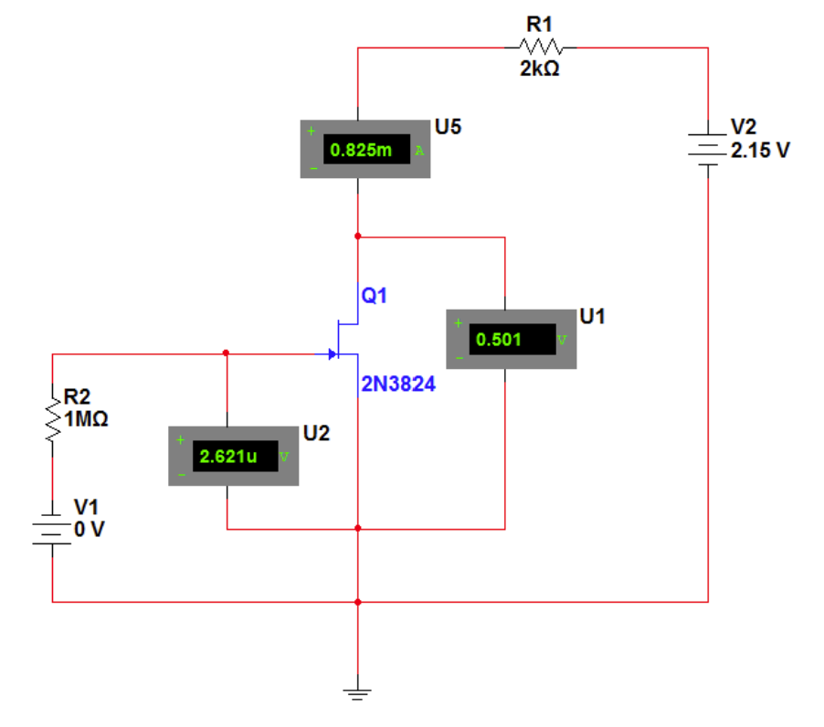
Figure #1: JFET Circuit (Lab Manual)
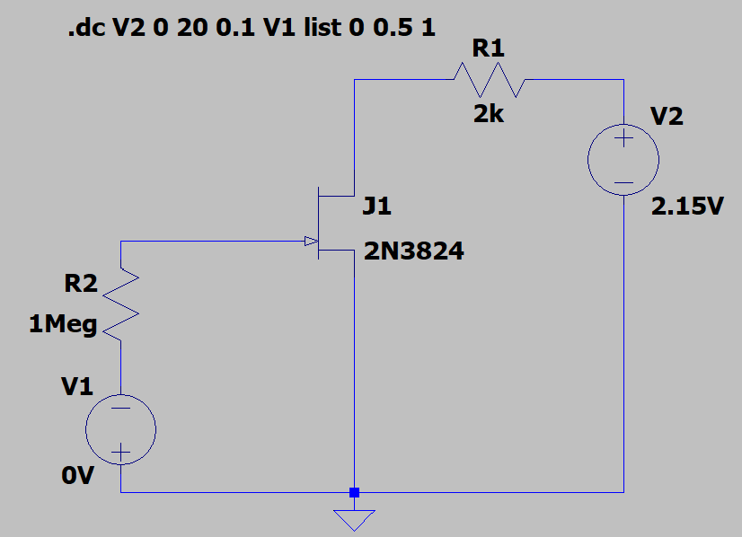
Figure #2: JFET Circuit (LTSpice)
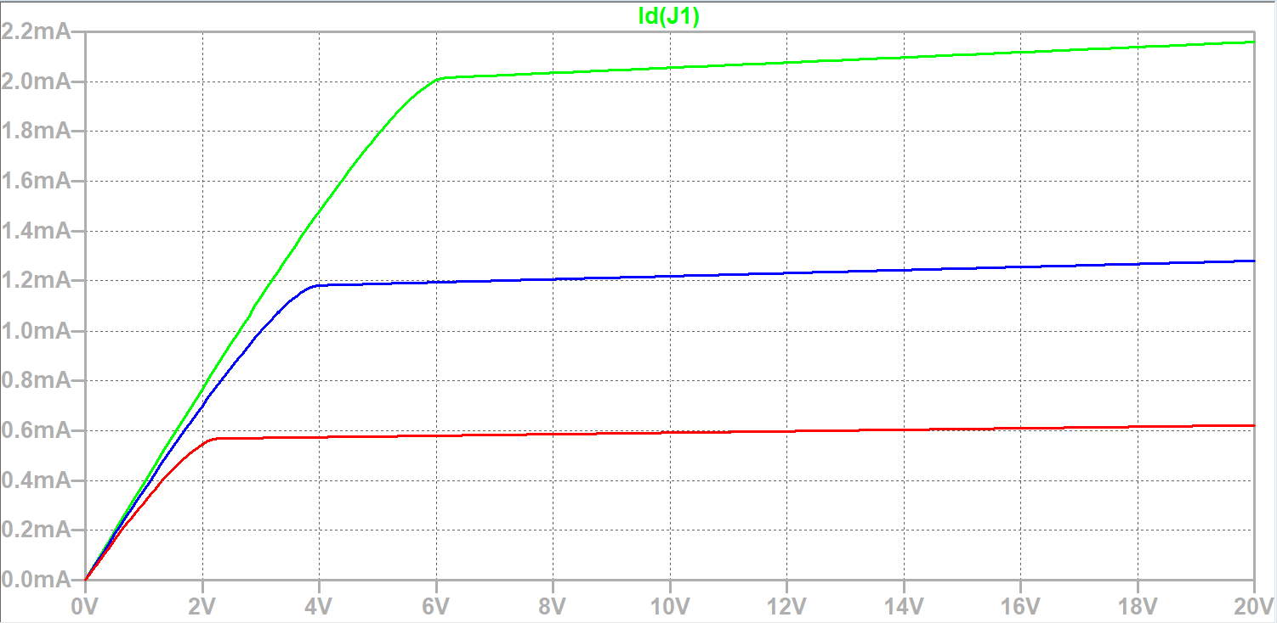Figure #3: JFET Drain Characteristic Curves (Simulation)

V_{P} = 3.8 V
V_{TH} = -2 V
 | V_{GS} = 0 V | V_{GS} = -0.5 V | V_{GS} = -1 V
V_{DS} (V) | I_{D} (mA) | I_{D} (mA) | I_{D} (mA)
0 | 0 | 0 | 0
0.5 | 0.19598597 | 0.18313265 | 0.16173965
1 | 0.38969575 | 0.36175252 | 0.31208465
2 | 0.76892186 | 0.70063752 | 0.54517260
4 | 1.4777967 | 1.1808369 | 0.57418324
8 | 2.0346143 | 1.2054729 | 0.58616768
12 | 2.076169 | 1.2301051 | 0.59815182
16 | 2.1177211 | 1.2547361 | 0.61013561
20 | 2.1592702 | 1.279366 | 0.62211906
Table #1: Drain Characteristics (Simulation)
 | V_{DS} = 6 V
V_{GS} (V) | I_{D} (mA)
0 | 2.0565675
-0.5 | 1.2080352
SS-1 | 0.58367301
-1.5 | 0.18379232
-2 | 0.008701697
Table #2: Transfer Characteristics (Simulation)
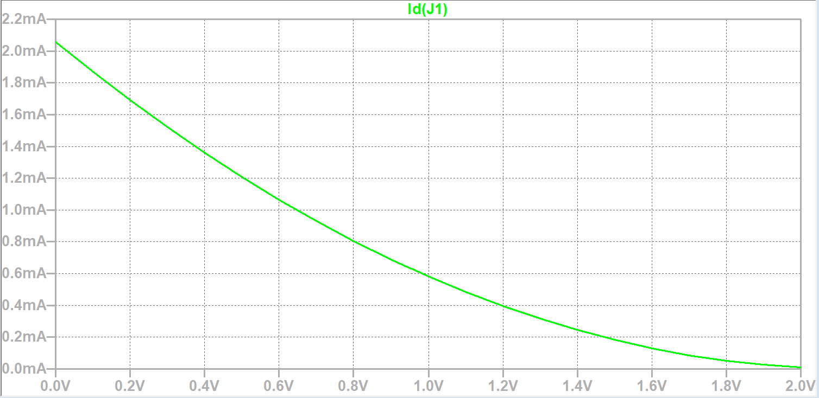
Figure #4: Transfer Characteristic Plot (Simulation)
V_{P} = 3.8 V
V_{TH} = -2 V
Experimental Setup and Results:
The JFET circuit in Figure 1 was built in the lab using a breadboard, JFET, and resistors. Figure 5 shows a picture of the experimental setup.
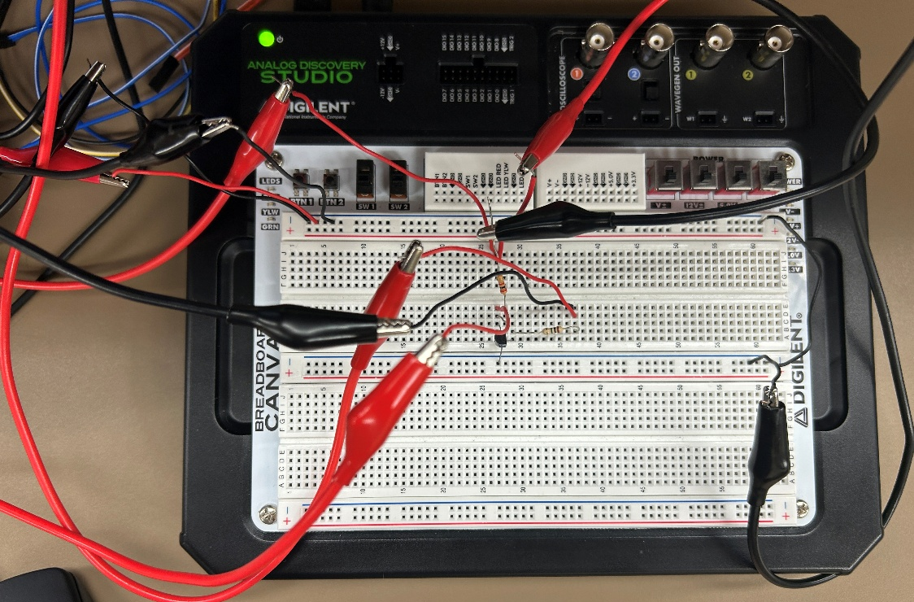
Figure #5: JFET Amplifier Experimental Setup
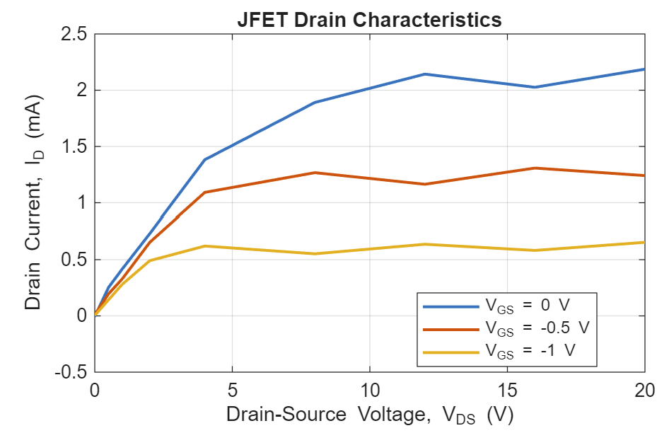
Figure #6: JFET Drain Characteristic Curves (Experimental)
V_{P} = 1.9 V
V_{TH} = 1.85 V
 | V_{GS} = 0 V | V_{GS} = -0.5 V | V_{GS} = -1 V
V_{DS} (V) | I_{D} (mA) | I_{D} (mA) | I_{D} (mA)
0 | 0.007 | 0.012 | 0.004
0.5 | 0.253 | 0.196 | 0.143
1 | 0.417 | 0.329 | 0.281
2 | 0.731 | 0.654 | 0.491
4 | 1.382 | 1.092 | 0.621
8 | 1.891 | 1.267 | 0.552
12 | 2.143 | 1.164 | 0.637
16 | 2.026 | 1.308 | 0.582
20 | 2.187 | 1.241 | 0.654
Table #3: Drain Characteristics (Experimental)
 | V_{DS} = 6 V
V_{GS} (V) | I_{D} (mA)
0 | 2.104
-0.5 | 1.165
SS-1 | 0.627
-1.5 | 0.156
-2 | 0.022
Table #4: Transfer Characteristics (Experimental)
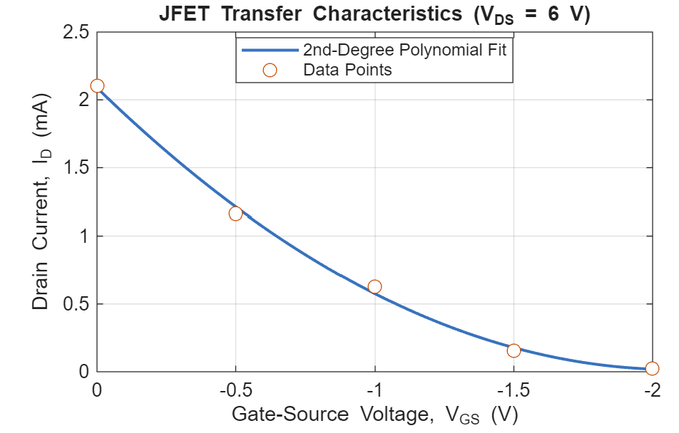
Figure #7: Transfer Characteristic Plot (Experimental)
V_{P} = 1.9 V
V_{TH} = 1.85 V
Discussion:
The simulation and experimental results matched well, with a few key differences. The drain characteristic curves were much smoother in the simulation, likely due to idealized component models and the lack of measurement noise. The transfer characteristic curves match closely, with only minor numerical differences for most values. Tables 5 and 6 show the percent errors between the drain characteristics and transfer characteristics, respectively. For the drain characteristics, the percent errors were generally below 12%, except for the 29.09% error at V_{DS} = 0.5 V and V_{GS} = 0 V. The transfer characteristics had errors ranging from 2.31% to 15.12% for most gate-source voltages, but the error increased to 152.82% at V_{GS} = -2 V. This large error occurred because the drain current was very close to zero, so a small absolute difference produced a large percentage error. Overall, the results show agreement between the simulation and experiment.
 | V_{GS} = 0 V | V_{GS} = -0.5 V | V_{GS} = -1 V
V_{DS} (V) | I_{D} Percent Error | I_{D} Percent Error | I_{D} Percent Error
0 | 29.09% | 7.03% | 11.59%
0.5 | 7.01% | 9.05% | 9.96%
1 | 4.93% | 6.66% | 9.94%
2 | 6.48% | 7.52% | 8.15%
4 | 7.06% | 5.10% | 5.83%
8 | 3.22% | 5.37% | 6.49%
12 | 4.33% | 4.25% | 4.61%
16 | 1.28% | 3.00% | 5.12%
20 | 29.09% | 7.03% | 11.59%
Table #5: Drain Characteristics Percent Error
 | V_{DS} = 6 V
V_{GS} (V) | I_{D} Percent Error
0 | 2.31%
-0.5 | 3.56%
SS-1 | 7.42%
-1.5 | 15.12%
-2 | 152.82%
Table #6: Transfer Characteristics Percent Error
Conclusion:
In conclusion, this lab demonstrated the voltage-controlled behavior of a JFET by examining its drain and transfer characteristics through simulation and experimental measurements. The results showed how drain current changes with drain-source and gate-source voltage, including the transition into saturation and the reduction in current as the gate-source voltage becomes more negative. The experimental results generally agreed with the simulations, with differences likely caused by component variations and measurement noise. Overall, the lab provided a better understanding of JFET operation, characteristic curves, and important parameters such as pinch-off voltage, which are useful for analyzing transistor circuits and preparing for future MOSFET experiments.

