EE 316
Section 3
Lab 10
By: Hannah Kelley
Small Signal Amplification with JFETs
Introduction:
This lab explores small-signal AC amplification, frequency response, and transistor dynamic behavior in field-effect transistor circuits. By evaluating a common-source JFET amplifier via simulation and hardware, the experiment demonstrates how external capacitors limit low-frequency performance while internal parasitic capacitances bound high-frequency bandwidth. The exercise teaches how to construct Bode magnitude plots to identify midband gain, cutoff frequencies, and bandwidth, while illustrating signal phase inversion. Additionally, it highlights the practical disparities between idealized simulation models and real-world hardware limits.
Simulations and Results:
The JFET amplifier circuit in Figure 1 was built and simulated in LTSpice. Figure 2 shows a screenshot of the JFET amplifier circuit in LTSpice. The circuit was simulated over a range of frequencies from 30 Hz to 16 MHz. Figure 3 shows the Bode plot for this simulation. The bandwidth and cutoff frequencies for the Bode plot in Figure 3 are noted in Table 1. Table 2 shows selected V_{out} and gain values from the Bode plot in Figure 3. The phase of the simulated circuit shifts from approximately 0° to −180° through the midrange and decreases further at high frequencies.
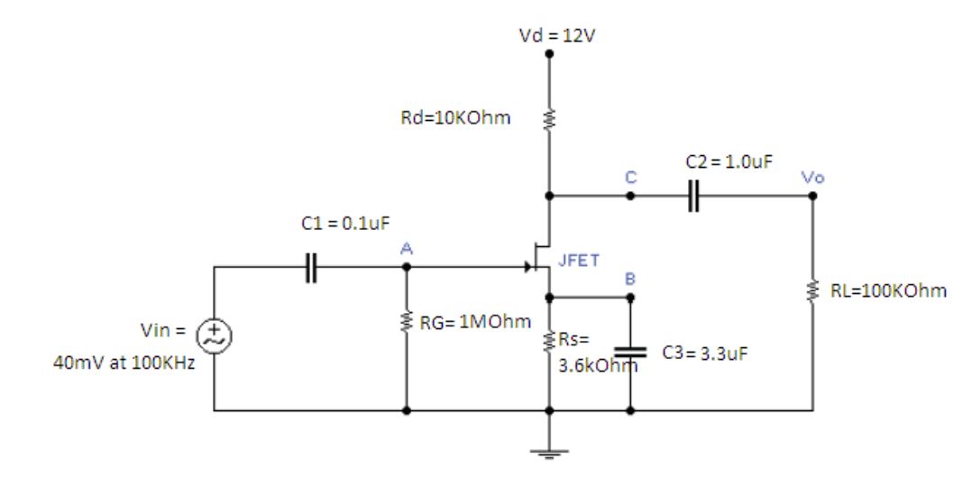
Figure #1: JFET Amplifier Schematic (Lab Manual)
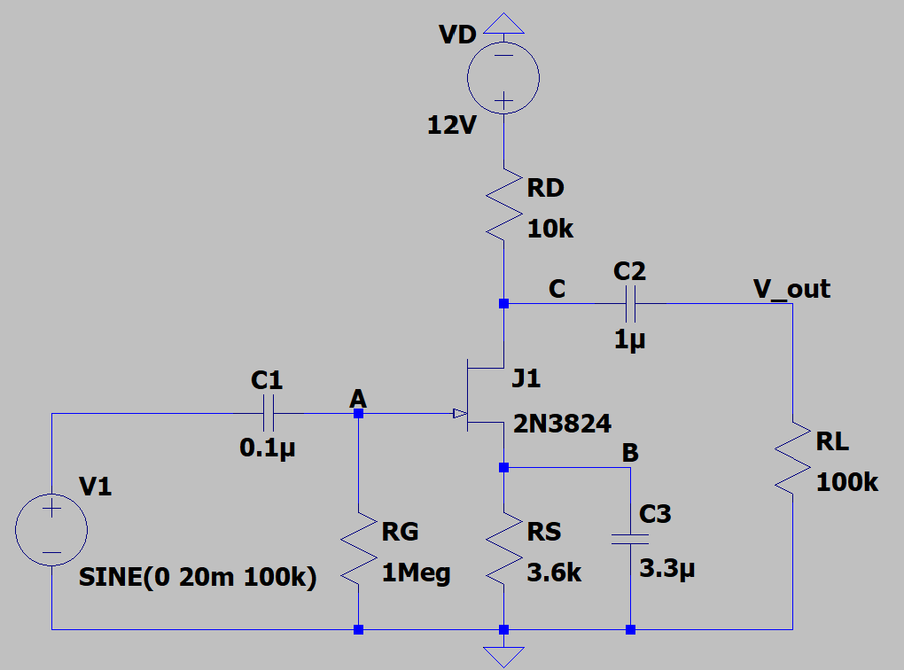
Figure #2: JFET Amplifier Circuit (LTSpice)
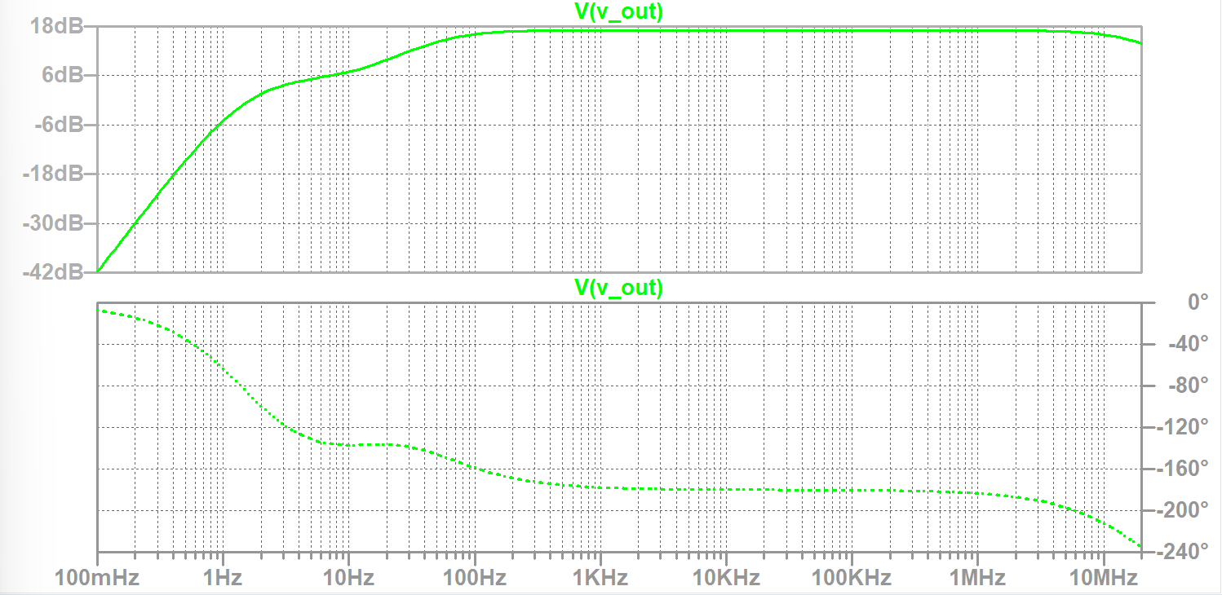
Figure #3: JFET Amplifier Bode Plot
 | Value
Bandwidth | 19.3 MHz
High Frequency Cutoff | 19.3 MHz
Low Frequency Cutoff | 46.9 Hz
Table #1: Important Bode Plot Values (Simulation)

Frequency (Hz) | V_{out} (mV) | Gain (dB)
30 | 154.94 | 11.76205
45 | 198.74 | 13.92439
60 | 219.48 | 14.78682
100 | 255.61 | 16.110466
200 | 276.4 | 16.789635
500 | 283.37 | 17.005928
1k | 284.4 | 17.03745
10k | 284.75 | 17.047975
100k | 284.75 | 17.047962
500k | 284.65 | 17.045081
1M | 284.36 | 17.036147
1.5M | 283.91 | 17.022409
2M | 283.2 | 17.000765
3M | 281.45 | 16.946799
4M | 278.74 | 16.862811
5M | 275.4 | 16.758145
7M | 268.18 | 16.527211
10M | 252.31 | 15.997369
11M | 247.95 | 15.846186
12M | 237.92 | 15.487421
15M | 226.11 | 15.045178
16M | 219.57 | 14.790256
Table #2: Simulations Results
Experimental Setup and Results:
The JFET amplifier circuit in Figure 1 was constructed in the lab using a breadboard, a JFET, capacitors, and resistors. Figure 4 shows the experimental setup of this circuit. After setting up the circuit, a range of frequencies from 1 Hz to 3 MHz was inputted into the system. The outputs were exported into a CSV file to be graphed in MATLAB. Figure 5 shows the resulting Bode plot. Table 3 shows the cutoff frequencies and bandwidth taken from the Bode plot. Table 4 summarizes select frequencies and their V_{out} and gain values.
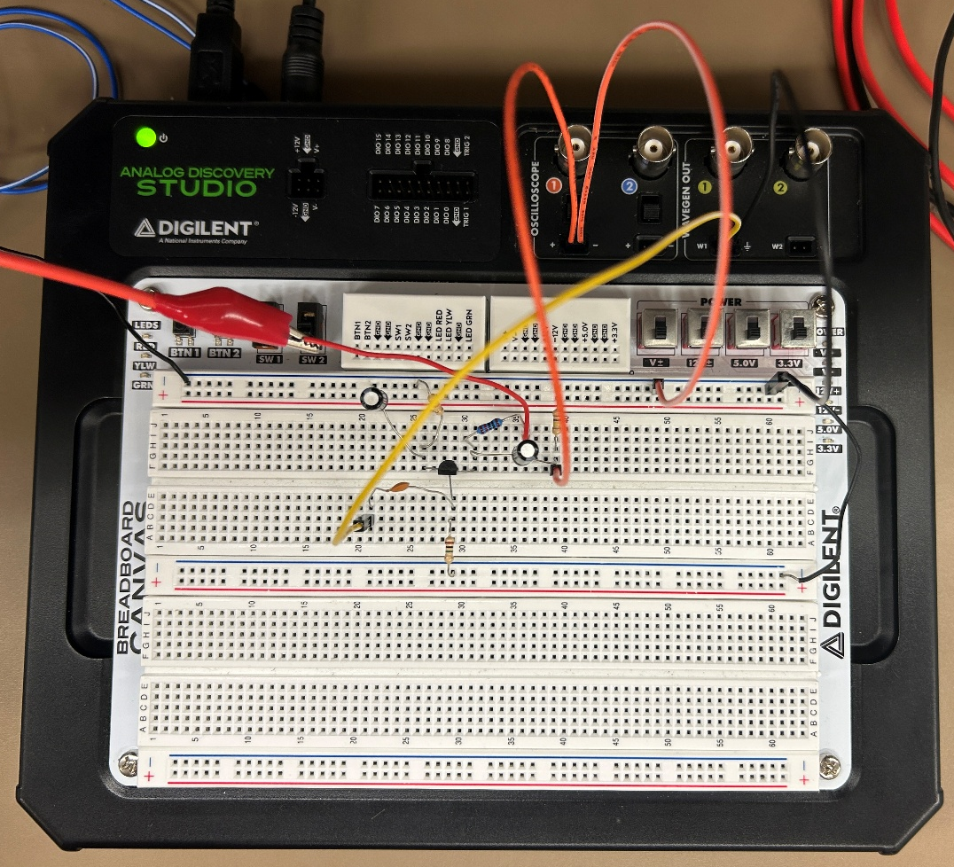
Figure #4: Experimental Setup of JFET Amplifier
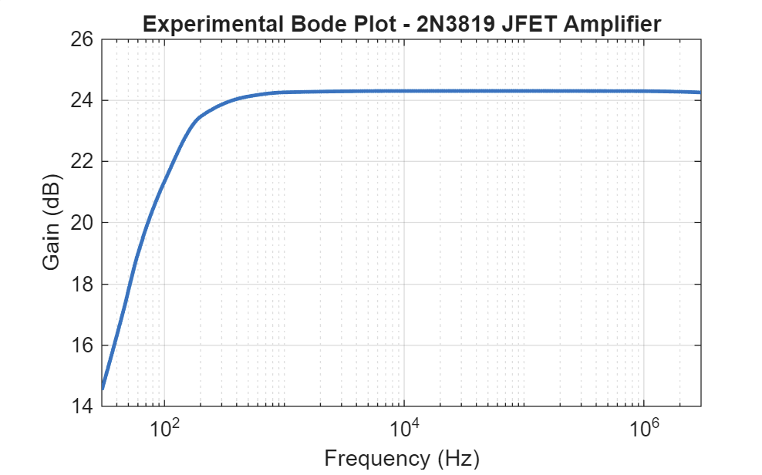
Figure #5: JFET Amplifier Experimental Bode Plot
 | Value
Bandwidth | 19.7 MHz
High Frequency Cutoff | 19.7 MHz
Low Frequency Cutoff | 92.61 Hz
Table #3: Important Bode Plot Values (Experimental)
Frequency (Hz) | V_{out} (mV) | Gain (dB)
30 | 106.62 | 14.545
45 | 142.77 | 17.082
60 | 178.13 | 19.004
100 | 233.44 | 21.351
200 | 298.09 | 23.466
500 | 321.72 | 24.129
1k | 326.72 | 24.263
10k | 328.42 | 24.308
100k | 328.46 | 24.309
500k | 328.31 | 24.305
1M | 328.2 | 24.302
1.5M | 327.86 | 24.293
2M | 327.45 | 24.282
3M | 326.58 | 24.259
Table #4: Experimental Results
Discussion:
The simulation and experimental results matched well. The Bode plots were very similar, though they had slight differences, most likely because the 2N3819 JFET used in the lab was not the same as the 2N3824 used in the simulation. The percent errors for the bandwidth and cutoff frequencies are shown in Table 5, while the percent errors for the Vout and gain values are shown in Table 6. Table 6 only includes the frequency values used in both the simulation and the experiment. The bandwidth and high-frequency cutoff had relatively low percent errors of 2.03%, while the low-frequency cutoff had a much larger error of 49.41%. This difference could be due to variations in the JFET characteristics and component tolerances, which affect the low-frequency response of the circuit. The Vout percent errors ranged from about 7% to 45%, with the largest errors occurring at lower frequencies. The gain percent errors ranged from about 18% to 30%, with the simulated gain consistently lower than the experimental gain. These differences may be caused by variations in the JFET's transconductance and capacitances, as well as resistor and capacitor tolerances and measurement inaccuracies. At lower frequencies, the coupling and bypass capacitors have a greater effect on the circuit's response, which can explain the larger differences in Vout. Overall, the results followed similar frequency-response trends, but differences in the transistor models and real-world component behavior caused noticeable variations in the measured values.
 | Percent Error
Bandwidth | 2.031%
High Frequency Cutoff | 2.031%
Low Frequency Cutoff | 49.412%
Table #5: Important Bode Plot Values Percent Error
Frequency (Hz) | V_{out} Percent Error (%) | Gain Percent Error (%)
30 | 45.32% | 19.13%
45 | 39.20% | 18.49%
60 | 23.21% | 22.19%
100 | 9.50% | 24.54%
200 | 7.28% | 28.45%
500 | 11.92% | 29.52%
1k | 12.95% | 29.78%
10k | 13.30% | 29.87%
100k | 13.31% | 29.87%
500k | 13.30% | 29.87%
1M | 13.36% | 29.90%
1.5M | 13.41% | 29.93%
2M | 13.51% | 29.99%
3M | 13.82% | 30.14%
Table #6: Results Percent Error
Conclusion:
In conclusion, this lab demonstrated the frequency response and amplification characteristics of a common-source JFET amplifier through simulation and experimental testing. The Bode plots showed that the gain increased at low frequencies before reaching a relatively stable midband region and gradually decreasing at higher frequencies. The simulation and experimental results followed similar trends, although differences in gain and cutoff frequencies occurred due to variations between the 2N3824 simulation model and the 2N3819 JFET used in the lab, as well as component tolerances and measurement inaccuracies. These results illustrated how coupling and bypass capacitors affect low-frequency performance, while parasitic capacitances limit high-frequency response. Overall, the experiment provided a better understanding of JFET amplification, bandwidth, and the differences between simulated and practical circuit behavior.

