EE 316
Section 3
Lab 11
By: Hannah Kelley
MOSFETs

Introduction:
This lab investigates the operating characteristics of an n-channel MOSFET by examining the relationship between drain current, drain-to-source voltage, and gate-to-source voltage. A MOSFET operates in the linear ohmic region, where it behaves like a voltage-controlled resistor, and the saturation region, where the drain current becomes relatively constant. The gate-to-source threshold voltage is the minimum voltage required to establish a conducting channel between the drain and source. Through circuit simulation in LTspice, the output and transfer characteristics of a 2N7000 MOSFET are analyzed to identify these operating regions and determine its threshold voltage.
Simulations and Results:
The MOSFET circuit shown in Figure 1 was constructed and simulated in LTspice, as shown in Figure 2. Two simulations were performed to examine the MOSFET's output and transfer characteristics.
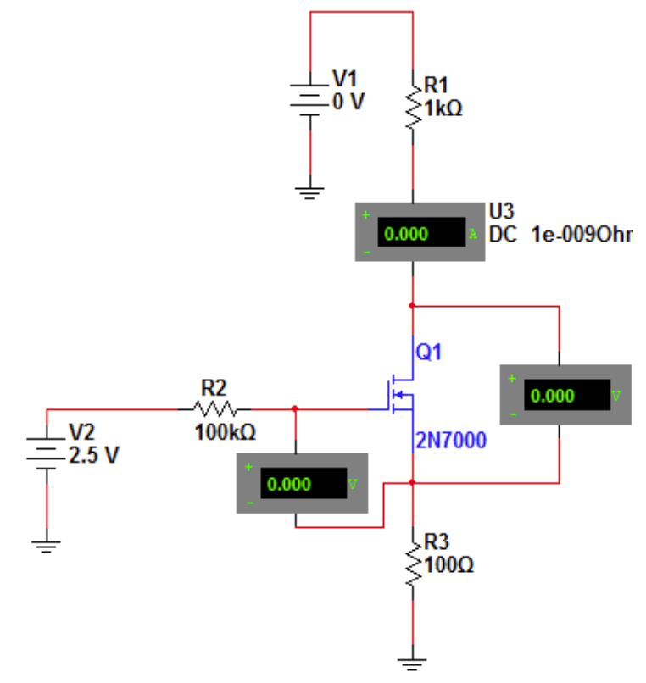
Figure #1: MOSFET Circuit Schematic (Lab Manual)
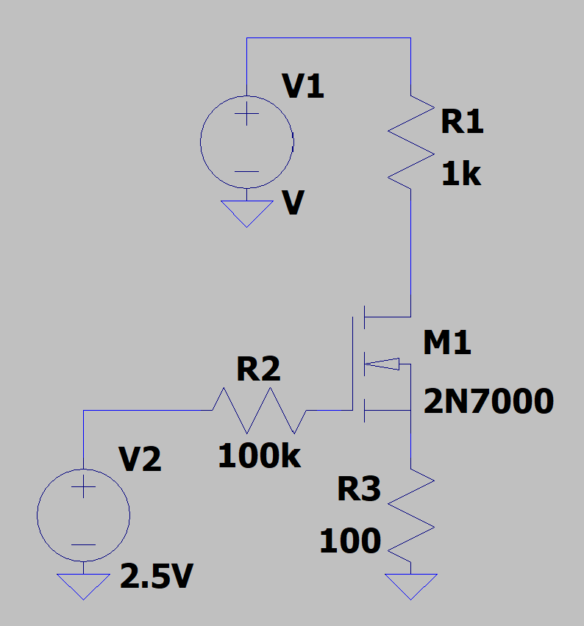
Figure #2: MOSFET Circuit (LTSpice)
For Part 1, V₂ was set to 2.5 V, and V₁ was increased from 0 V while measuring V_{GS}, V_{DS}, and I_{D}. The process was repeated with V₂ set to 3 V, 3.5 V, and 4 V. The results were recorded in Table 1 and plotted to show the relationship between drain current and drain-to-source voltage for each gate-to-source voltage. The plot in Figure 3 was used to identify the linear ohmic region, where the MOSFET behaves like a voltage-controlled resistor. The minimum V_{DS} required for saturation at each V_{GS} was also recorded based on the values in Figure 3.

V₂ = 2.5 V |  | V₂ = 3 V |  | V₂ = 3.5 V |  | V₂ = 4 V
V_{DS} | V_{GS} =  1.876 V | V_{DS} | V_{GS} =  1.958 V | V_{DS} | V_{GS} =  2.027 V | V_{DS} | V_{GS} =  2.089 V
(mV) | I_{D} (mA) | (mV) | I_{D} (mA) | (mV) | I_{D} (mA) | (mV) | I_{D} (mA)
0 | 0 | 0 | 0 | 0 | 0 | 0 | 0
5.956 | 0.903 | 5.785 | 1.296 | 3.493 | 1.036 | 4.949 | 1.727
13.316 | 1.806 | 33.984 | 5.358 | 38.428 | 7.678 | 30.568 | 8.136
22.760 | 2.707 | 62.184 | 7.421 | 73.362 | 10.758 | 64.192 | 12.666
35.549 | 3.604 | 90.383 | 8.593 | 149.054 | 13.468 | 101.019 | 15.290
54.334 | 4.496 | 137.383 | 9.631 | 189.811 | 14.077 | 152.256 | 17.194
86.479 | 5.376 | 165.182 | 9.872 | 207.278 | 14.252 | 198.690 | 18.104
115.481 | 5.804 | 184.382 | 10.122 | 230.568 | 14.428 | 233.916 | 18.523
181.184 | 6.194 | 259.581 | 10.392 | 259.680 | 14.577 | 297.962 | 18.940
632.641 | 6.243 | 334.780 | 10.421 | 376.128 | 14.721 | 344.396 | 19.066
1132.641 | 6.243 | 438.178 | 10.421 | 498.399 | 14.727 | 382.824 | 19.111
Table #1: MOSFET Output Characteristics (Simulation)
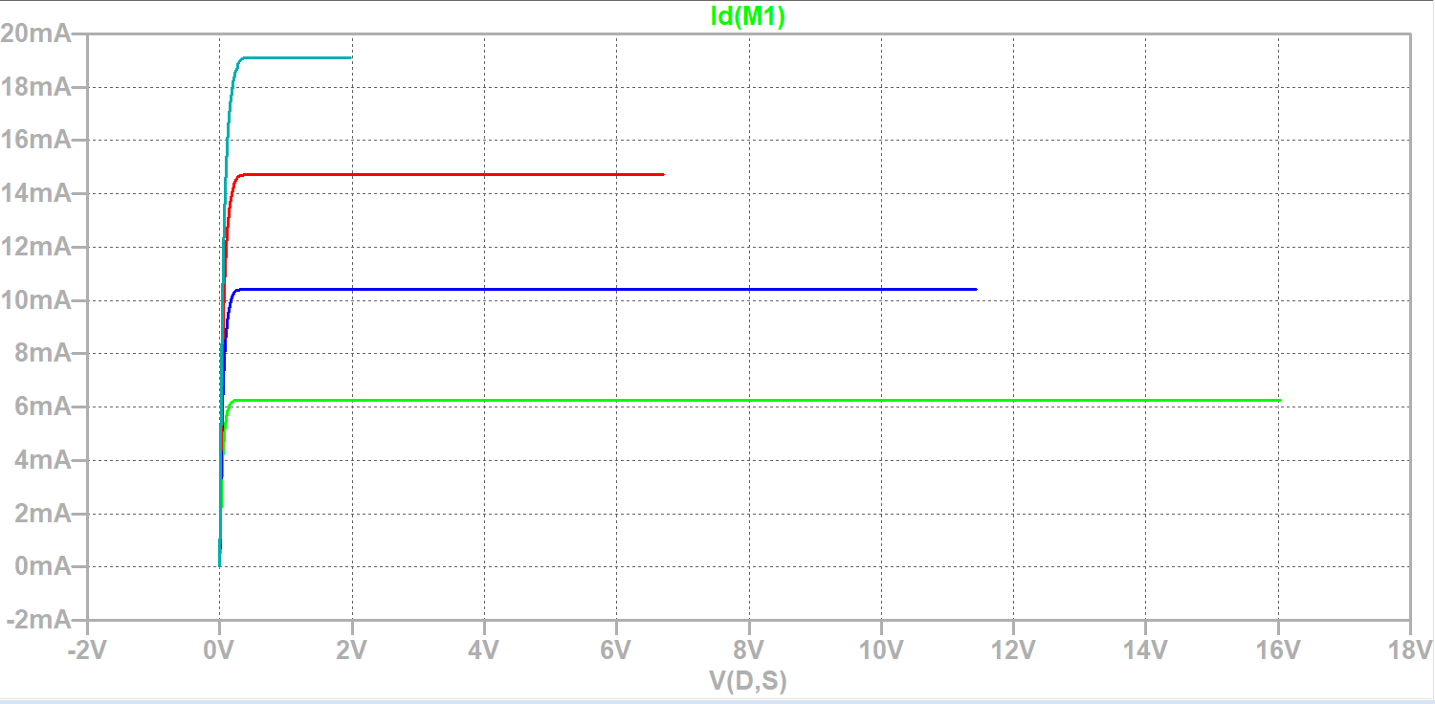
Figure #3: I_{D} vs. V_{DS} (Simulation)
For Part 2, V₁ was set to 22 V, and V₂ was varied from 0 V in 0.25 V increments until the drain current stopped increasing. The corresponding V_{GS} and I_{D} values were recorded in Table 2 and plotted in Figure 4 to examine the MOSFET's transfer characteristics. The threshold voltage was identified from Figure 4 as the minimum gate-to-source voltage required for the MOSFET to begin conducting.
V_{GS} (V) | I_{D} (mA)
0 | 0.022
1 | 0.022
1.5 | 0.022
1.75 | 2.018
2 | 12.960
2.25 | 19.766
2.5 | 19.876
3 | 19.910
Table #2: MOSFET Output Characteristics (Simulation)
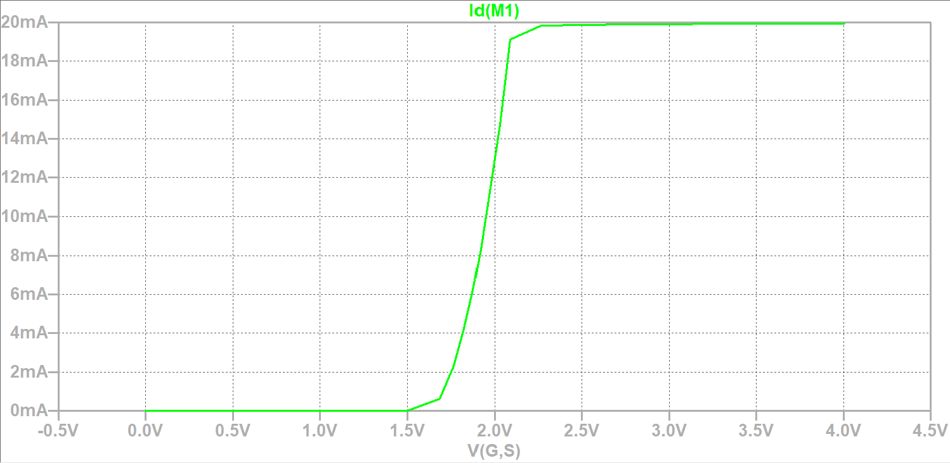
Figure #4: I_{D} vs. V_{GS}
Experimental Setup and Results:
For part one, the circuit in Figure 1 was constructed using a breadboard, resistors, DC voltage supplies, and a 2N7000 MOSFET. Figure 5 shows the experimental setup. The drain current I_{D} and voltages V_{GS} and V_{DS} were measured as V₁ was increased until the MOSFET reached saturation for V2 values of 2.5, 3, 3.5, and 4 V. The measured output characteristics are presented in Table 3 and Figure 6, which were used to identify the linear and saturation regions.
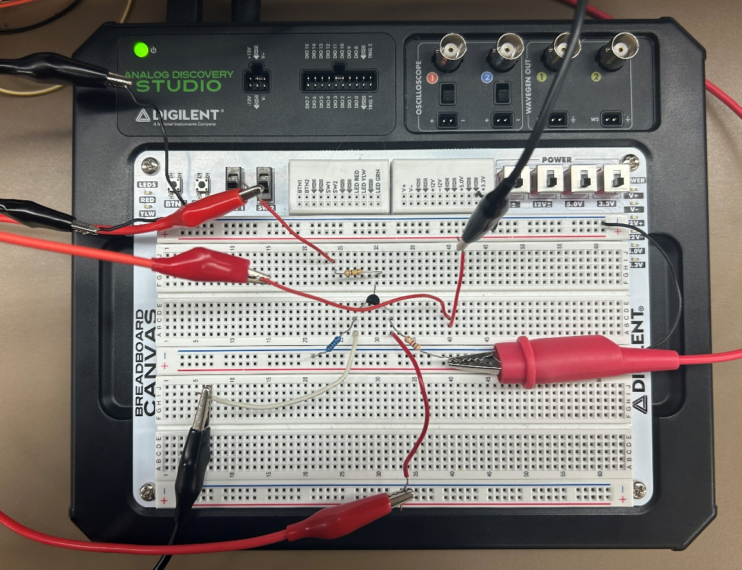
Figure #5: Experimental Setup

V₂ = 2.5 V |  | V₂ = 3 V |  | V₂ = 3.5 V |  | V₂ = 4 V
V_{DS} | V_{GS} =  1.983 V | V_{DS} | V_{GS} =  2.157 V | V_{DS} | V_{GS} =  2.409 V | V_{DS} | V_{GS} =  2.602 V
(V) | I_{D} (mA) | (V) | I_{D} (mA) | (V) | I_{D} (mA) | (V) | I_{D} (mA)
0.001 | 0.002 | 0.006 | 0.001 | 0.001 | 0.001 | 0.001 | 0.002
0.015 | 0.617 | 0.011 | 0.637 | 0.026 | 1.638 | 0.026 | 1.717
0.029 | 1.085 | 0.021 | 1.171 | 0.097 | 5.582 | 0.057 | 3.584
0.066 | 1.844 | 0.049 | 2.401 | 0.125 | 6.873 | 0.104 | 6.280
0.120 | 2.417 | 0.069 | 3.463 | 0.187 | 8.896 | 0.202 | 10.952
0.242 | 2.733 | 0.094 | 4.303 | 0.224 | 9.591 | 0.399 | 13.893
0.513 | 2.841 | 0.117 | 4.897 | 0.338 | 10.517 | 0.502 | 14.258
0.672 | 2.857 | 0.168 | 5.694 | 0.521 | 10.837 | 0.605 | 13.987
0.721 | 2.861 | 0.209 | 6.002 | 0.769 | 10.915 | 0.701 | 14.319
0.841 | 2.871 | 0.289 | 6.303 | 0.839 | 10.929 | 0.796 | 14.341
0.996 | 2.879 | 0.468 | 6.484 | 0.993 | 10.948 | 0.921 | 14.478
1.021 | 2.884 | 0.957 | 6.591 | 1.080 | 10.951 | 1.092 | 14.505
Table #3: MOSFET Output Characteristics (Experimental)
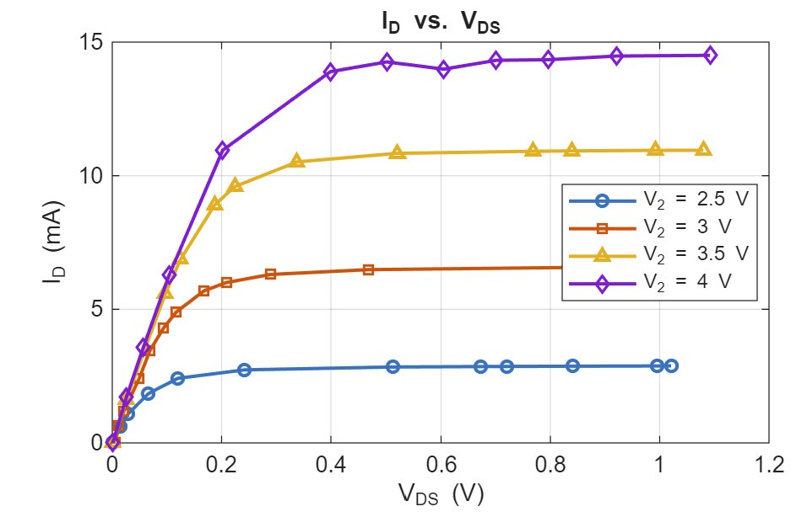
Figure #6: I_{D} vs. V_{DS} (Experimental)
For Part 2, the circuit used in Part 1 was modified by setting V1 to 22 V and varying V2 in 0.25 V increments to measure VGS and ID. The results were recorded in Table 4 and plotted in Figure 7 to determine the MOSFET threshold voltage.

V_{GS} (V) | I_{D} (mA)
0.005 | 0
1.557 | 0.002
1.957 | 0.261
2.148 | 1.557
2.292 | 4.534
2.378 | 7.474
2.447 | 10.598
2.631 | 19.268
2.924 | 20.204
3.017 | 20.204
Table #4: MOSFET Output Characteristics (Experimental)
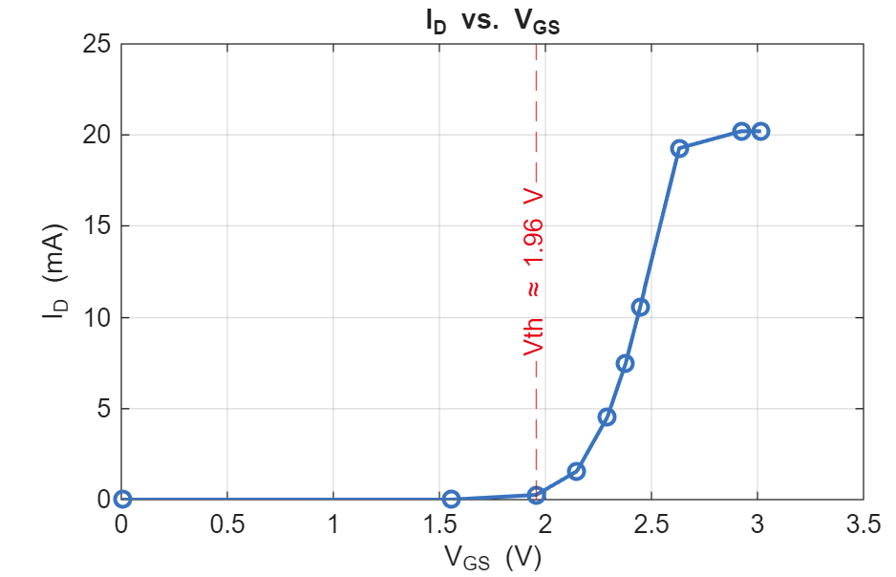
Figure #7: I_{D} vs. V_{GS}
Discussion:
The simulation and experimental results lined up pretty well overall. The Bode plots showed very similar trends, though there were some minor differences—mainly because the lab circuit used a 2N3819 JFET while the LTSpice simulation used a 2N3824. Looking at the numbers, the bandwidth and high-frequency cutoff had a small percent error of just 2.03%, but the low-frequency cutoff had a much larger error of 49.41%. The $V_{GS}$ threshold voltage was also noticeably higher in the experiment ($≈1.96\text{ V}$) compared to the simulation ($≈1.50\text{ V}-1.70\text{ V}$), which shifted where the transistor actually started conducting. Across the output curves, the experimental saturation currents ran about 24% to 54% lower than predicted for the same gate voltages, like at $V_{2}=2.5\text{ V}$, where $I_{D}$ leveled off at $2.88\text{ mA}$ experimentally versus $6.24\text{ mA}$ in LTSpice. On top of that, while the simulated curves stayed completely flat in saturation, the experimental plots showed a slight upward tilt. These low-frequency and saturation discrepancies mostly come down to differences in the JFET transconductance and parasitic capacitances, along with resistor/capacitor tolerances, channel-length modulation, and measurement loading in the physical setup. The coupling and bypass capacitors also play a bigger role at lower frequencies, which explains why V_{out} and cutoff errors spiked there. Overall, both sets of data followed the exact same core trends, but real-world component variations and model mismatches caused the measured values to pull away from the ideal simulation.
Conclusion:
This lab explored the operating characteristics of an n-channel MOSFET through circuit simulation and analysis of its output and transfer curves. The results demonstrated how changes in the applied voltages affect drain current and the operating region of the device. The experiment also provided a better understanding of MOSFET conduction and the role of threshold voltage in controlling current flow.

