EE 316
Section 3
Lab 12
By: Hannah Kelley
MOSFET Amplification (with Bonus)

Introduction:
This lab investigates the frequency response of a MOSFET amplifier using the 2N7000 transistor. By measuring voltage gain over a range of input frequencies, the amplifier’s low and high cutoff frequencies and approximate bandwidth can be determined. The experiment also examines the phase relationship between the input and output signals to demonstrate the phase inversion characteristic of a common-source MOSFET amplifier.
Simulations and Results:
The MOSFET amplifier circuit in Figure 1 was built and simulated in LTSpice using a 200 mV peak-to-peak input signal with frequencies varying from 10 Hz to 3 MHz. Figure 2 shows the simulated circuit. Figure 3 shows the Bode plot for the simulated circuit. Table 1 shows the high and low frequency cutoffs and the bandwidth, as seen in the Bode plot. Table 2 shows select frequencies and their V_{out} and gain values.
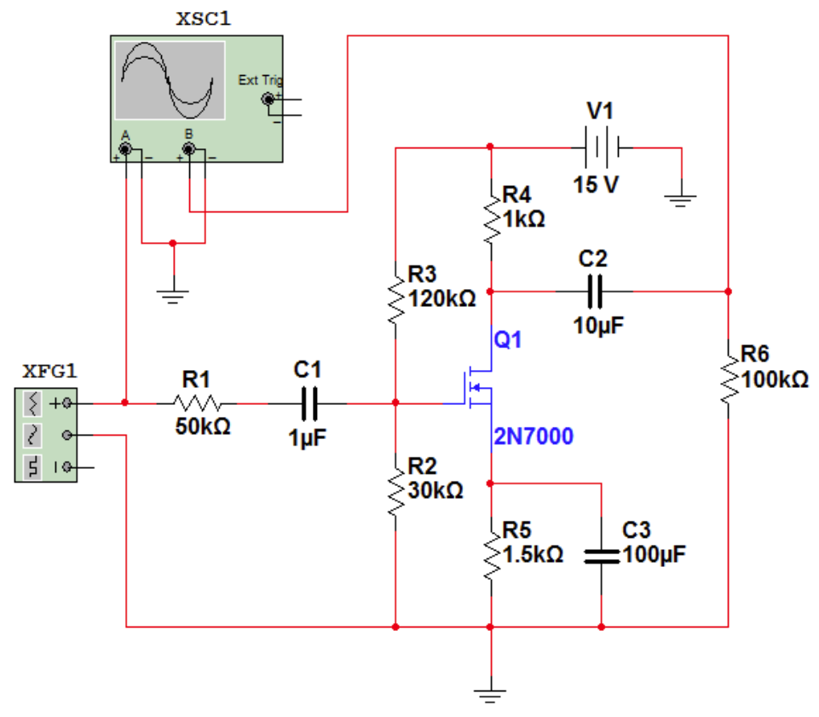
Figure #1: MOSFET Amplifier Schematic (Lab Manual)
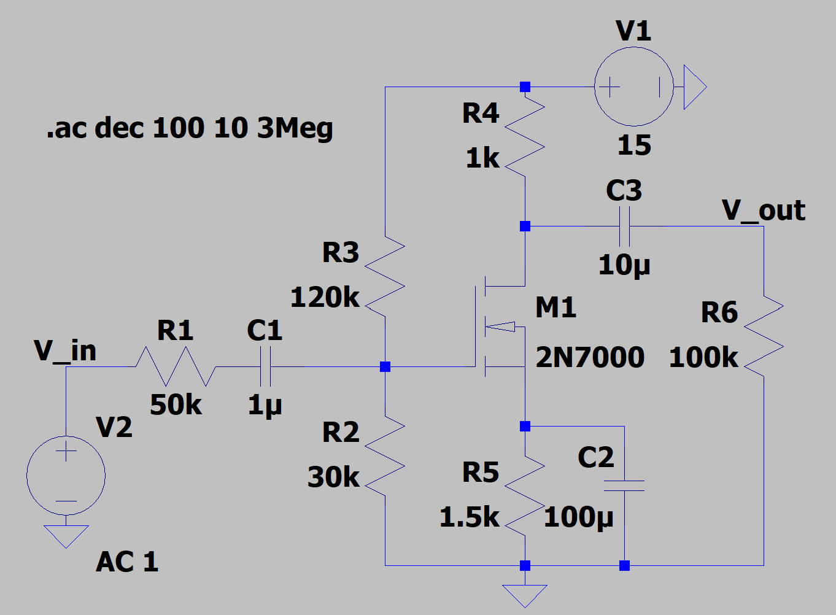
Figure #2: MOSFET Amplifier Circuit (LTSpice)
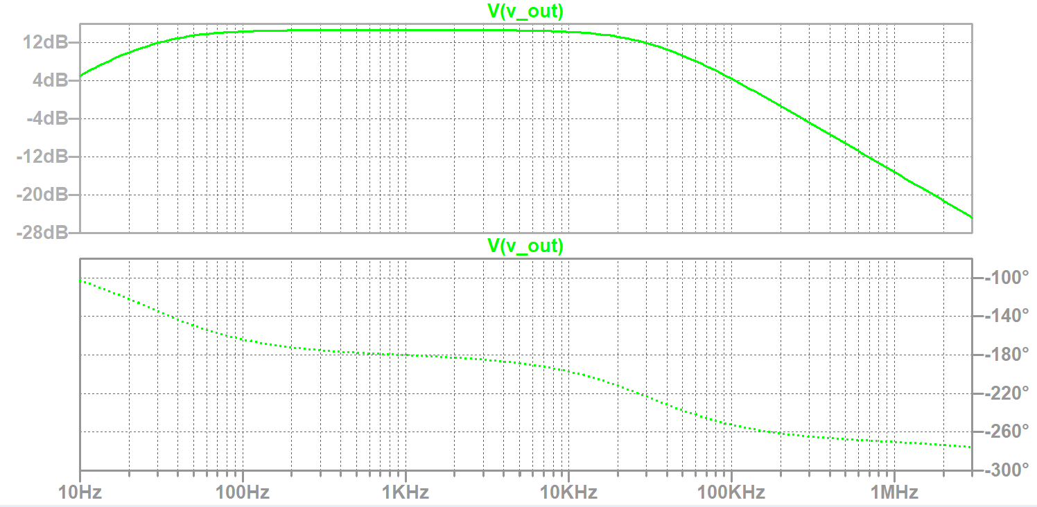
Figure #3: MOSFET Amplifier Bode Plot
 | Value
Low Frequency Cutoff | 28.8 Hz
High Frequency Cutoff | 33.7 kHz
Bandwidth | 33.67 kHz
Table #1: Important Frequencies (Simulation)
Frequency | V_{out} (V) | Voltage Gain (dB)
10 Hz | 0.17962 | 5.0926176
30 Hz | 0.398118 | 12.00017
60 Hz | 0.492983 | 13.861368
100 Hz | 0.523846 | 14.386605
200 Hz | 0.539604 | 14.631384
500 Hz | 0.543999 | 14.702174
1 kHz | 0.54444 | 14.709211
2 kHz | 0.543813 | 14.699192
5 kHz | 0.538357 | 14.611703
10 kHz | 0.519996 | 14.312978
15 kHz | 0.491868 | 13.841700
20 kHz | 0.461887 | 13.293075
50 kHz | 0.293064 | 9.3413204
75 kHz | 0.211748 | 6.5162771
100 kHz | 0.166314 | 4.4046672
150 kHz | 0.111264 | 1.0385469
200 kHz | 0.086358 | -1.2817469
500 kHz | 0.03472 | -9.1898298
750 kHz | 0.022947 | -12.781244
1 MHz | 0.017427 | -15.179768
1.5 MHz | 0.011491 | -18.782752
2.0 MHz | 0.008726 | -21.189108
3.0 MHz | 0.005782 | -24.752158
Table #2: Simulation Results
BONUS Simulation and Results:
The MOSFET amplifier circuit in Figure 1 was modified and simulated in LTspice to maximize its bandwidth while maintaining a passband gain above 10 dB. To achieve this, R₁ was reduced to 1 kΩ to extend high-frequency response, and capacitors C₁, C₂, and C₃ were set to 110 µF, 470 µF, and 100 µF respectively to push the low-frequency limit downward. To prevent output waveform clipping, supply voltage V₁ was increased to 20 V, and biasing resistors R₃ and R₂ were adjusted to 150 kΩ and 60 kΩ to center the DC operating point. Figure 4 shows the modified circuit in LTSpice. Figure 5 displays the resulting Bode plot. Table 3 summarizes the high and low cutoff frequencies along with the total bandwidth obtained from the simulation.
Additionally, transient analysis confirmed that the output signal remained clean and unclipped across the entire passband with a 200 mV peak-to-peak input signal. Figure 6 shows a plot of V_{out} during this transient analysis.
The modified circuit achieved a mid-band gain of 28.6 dB, easily exceeding the minimum 10 dB requirement. The lower cutoff frequency f_{low} was reduced to 12.3 Hz, while the upper cutoff frequency f_{high} increased significantly from 33.7 kHz to 515 kHz. Overall, this expanded the amplifier's total bandwidth from 33.67 kHz to 515 kHz, roughly a 15 times improvement over the original design.
This performance increase come down to how the components handle signal frequencies. Increasing the coupling and bypass capacitors allows low-frequency signals to pass straight through to the output instead of getting blocked, which pushes the lower cutoff frequency down to 12.3 Hz. At the same time, lowering input resistor R₁ from 50 kΩ to 1 kΩ removes a major bottleneck at the input gate. In the original circuit, a large R₁ reacted with the transistor's internal capacitance to choke off high-frequency signals. Shrinking R₁ lets those fast-changing signals pass freely, stretching the high-frequency cutoff out to 515 kHz. Furthermore, raising V₁ to 20 V provided the necessary DC headroom to support the higher mid-band gain without saturating or clipping the output waveform.
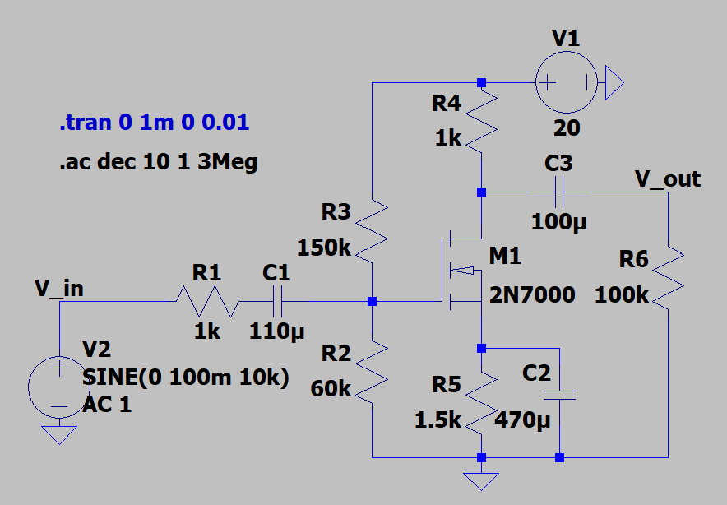
Figure #4: Modified MOSFET Amplifier Circuit (LTSpice)
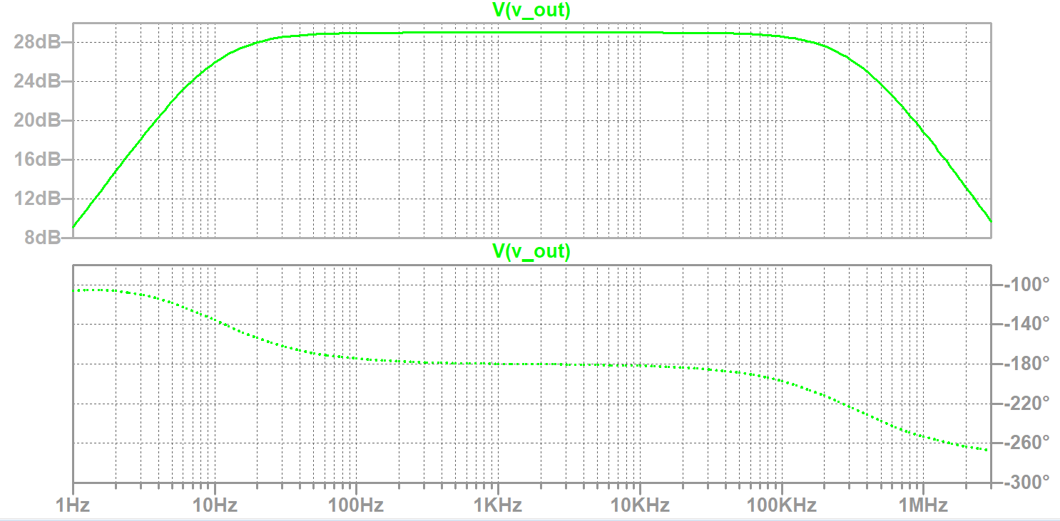
Figure #5: Modified MOSFET Amplifier Bode Plot
 | Value
Low Frequency Cutoff | <10 Hz
High Frequency Cutoff | 2.83 MHz
Bandwidth | 2.83 MHz
Table #3: Important Frequencies for Modified Circuit (Simulation)
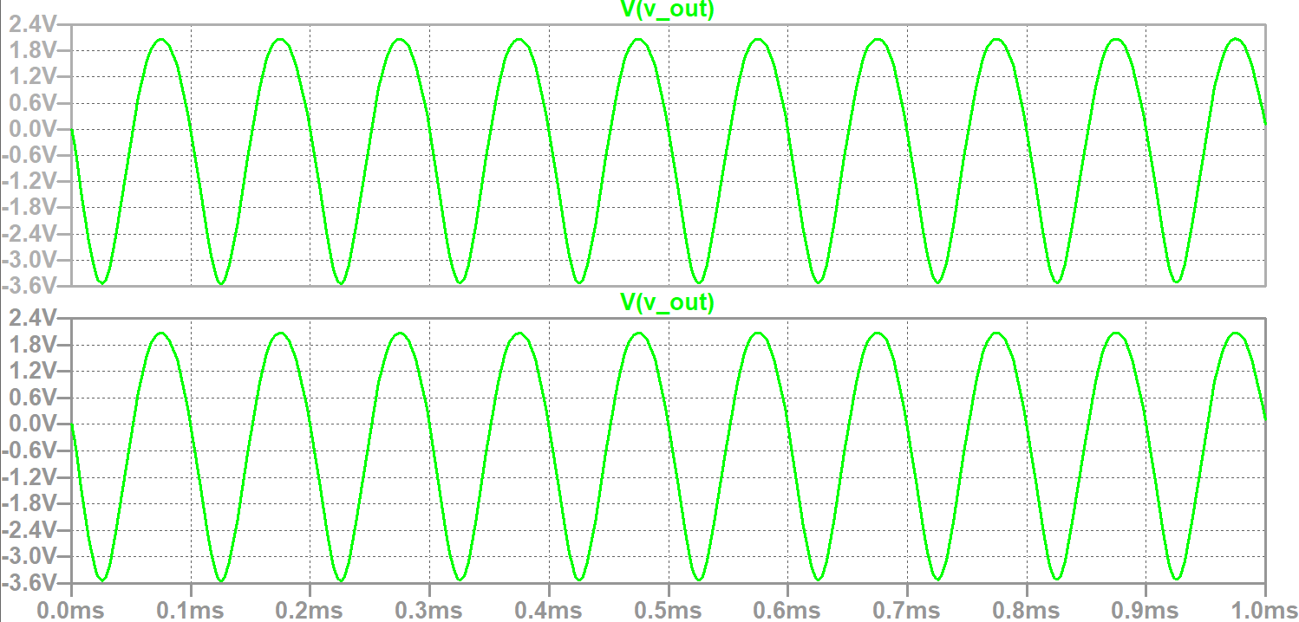
Figure #6: Modified MOSFET Transient Output Plot
Experimental Setup and Results:
The circuit in Figure 1 was built on a breadboard using capacitors, resistors, and a DC power supply.
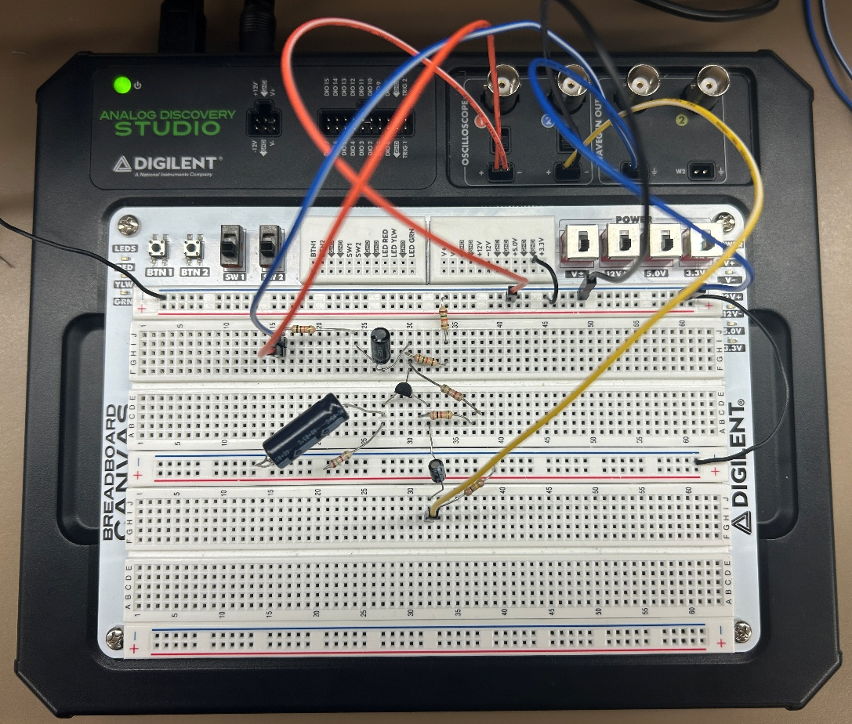
Figure #7: Experimental Setup
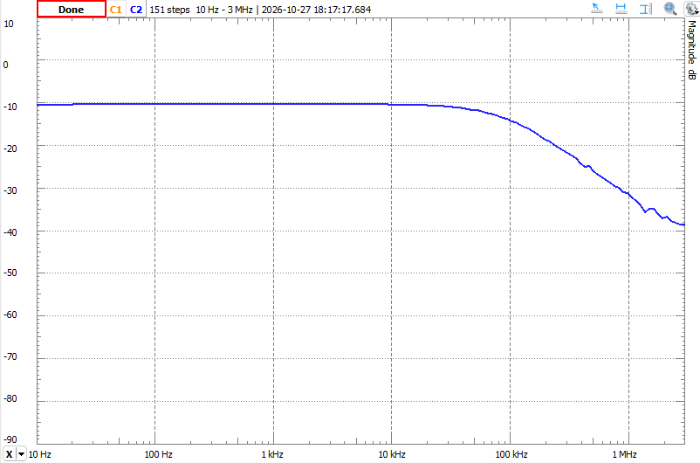
Figure #8: MOSFET Amplifier Bode Plot
 | Value
Low Frequency Cutoff | <10 Hz
High Frequency Cutoff | 56 kHz
Bandwidth | 56 kHz
Table #4: Important Frequencies (Experimental)

Frequency | V_{out} (V) | Voltage Gain (dB)
10 Hz | 0.316 | -10
30 Hz | 0.317 | -9.972
60 Hz | 0.318 | -9.945
100 Hz | 0.319 | -9.921
200 Hz | 0.32 | -9.897
500 Hz | 0.32 | -9.89
1 kHz | 0.32 | -9.89
2 kHz | 0.32 | -9.895
5 kHz | 0.319 | -9.924
10 kHz | 0.315 | -10.034
15 kHz | 0.309 | -10.201
20 kHz | 0.301 | -10.428
50 kHz | 0.239 | -12.432
75 kHz | 0.198 | -14.067
100 kHz | 0.166 | -15.598
150 kHz | 0.128 | -17.856
200 kHz | 0.102 | -19.827
500 kHz | 0.046 | -26.745
750 kHz | 0.03 | -30.458
1 MHz | 0.021 | -33.556
1.5 MHz | 0.017 | -35.391
2.0 MHz | 0.013 | -37.721
3.0 MHz | 0.012 | -38.416
Table #5: Experimental Results
Discussion:
The simulation and experimental Bode plots matched well, with both plots having a f_{low} less than 10 dB and an f_{high} in the 30-50 Hz range. The experimental Bode plot had a slightly higher f_{high} than the simulation (33 kHz vs 56kHz), though this is most likely due to the difference in transistors used. Table 6 shows the percent errors between the simulation and experiental V_{out} and gain values. The output voltage errors varied considerably with frequency, with the closest agreement occurring at 100 kHz. The gain errors were especially large because the experimental gains were negative while the simulated gains were positive across much of the measured range. This suggests a significant discrepancy between the simulated and experimental circuit behavior, potentially due to differences in transistor characteristics, circuit configuration, or measurement conditions.
Frequency | V_{out} (%) | Voltage Gain (%)
10 Hz | 75.61 | 296.34
30 Hz | 20.37 | 183.1
60 Hz | 35.5 | 171.74
100 Hz | 39.11 | 168.98
200 Hz | 40.7 | 167.65
500 Hz | 41.18 | 167.94
1 kHz | 41.22 | 167.22
2 kHz | 41.16 | 167.32
5 kHz | 40.76 | 167.91
10 kHz | 39.42 | 170.08
15 kHz | 37.18 | 171.09
20 kHz | 34.83 | 178.48
50 kHz | 18.44 | 233.17
75 kHz | 6.49 | 315.86
100 kHz | 0.19 | 454.14
150 kHz | 15.04 | 1817.33
200 kHz | 18.03 | 1447.1
500 kHz | 32.54 | 190.92
750 kHz | 30.68 | 138.34
1 MHz | 20.52 | 121.03
1.5 MHz | 47.96 | 88.22
2.0 MHz | 49.12 | 77.02
3.0 MHz | 107.55 | 55.12
Table #6: Percent Error
BONUS BJT, JFET, and MOSFET Comparison:
BJTs, JFETs, and MOSFETs are all types of transistors that work in different ways. Table 7 summarizes the pros and cons of each type of resistors.

BJT |  | JFET |  | MOSFET
Pros | Cons | Pros | Cons | Pros | Cons
High current gain. Good for amplification. | Requires continuous base current for operation. | Very high input impedance. Requires very little input current. | Conducts even the gate voltage is zero. | High input impedance. Requires very little input current. | Performance varies with temperature.
Provides high gain even at low currents. | Requires more drive current for switching than other transistors. | Low noise. Useful for analog circuits. | Less commonly available. | Can operate at high switching speeds. | Sensitive to electrostatic discharge.
Lower input impedance than other transistors. | Consumes more power than FETs. | Good thermal stability. | Difficult to use in digital switching applications. | Easy to integrate into circuits and ICs, making it the most common transistor. | Gate capacitance can limit switching speeds.
Table #7: Transistor Types Pros and Cons
BJTs, JFETs, and MOSFETs were all used for two labs. The first looked at their characteristics while the second looked at their small signal amplification applications. Table 8 summarizes the small signal amplification data for each transistor. Since each lab used slightly different frequency ranges and points to collect the data, only the frequencies at which all three transistors were measured are present in Table 8.
Frequency | BJT |  | JFET |  | MOSFET
Frequency | V_{out} (V) | Gain (dB) | V_{out} (V) | Gain (dB) | V_{out} (V) | Gain (dB)
30 Hz | 0.000216 | -67.295 | 0.10662 | 14.545 | 0.317 | -9.972
60 Hz | 0.000976 | -54.193 | 0.17813 | 19.004 | 0.318 | -9.945
100 Hz | 0.000675 | -57.394 | 0.23344 | 21.351 | 0.319 | -9.921
200 Hz | 0.001641 | -49.677 | 0.29809 | 23.466 | 0.32 | -9.897
500 Hz | 0.006919 | -37.179 | 0.32172 | 24.129 | 0.32 | -9.89
1 kHz | 0.021636 | -27.276 | 0.32672 | 24.263 | 0.32 | -9.89
10 kHz | 0.282957 | -4.945 | 0.32842 | 24.308 | 0.315 | -10.034
100 kHz | 1.680041 | 10.527 | 0.32846 | 24.309 | 0.166 | -15.598
500 kHz | 1.663106 | 10.439 | 0.32831 | 24.305 | 0.046 | -26.745
1.5 MHz | 1.669053 | 10.47 | 0.32786 | 24.293 | 0.017 | -35.391
2 MHz | 1.670782 | 10.479 | 0.32745 | 24.282 | 0.013 | -37.721
Table #8: Experimental Results for BJT, JFET, and MOSFET
The BJT amplifier demonstrated increasing voltage gain as frequency increased, starting with very low gain at lower frequencies and reaching a maximum of approximately 10.7 dB around 150 kHz. Beyond this point, the gain remained relatively constant through the higher frequencies tested. This suggests that the BJT amplifier has a relatively wide midband frequency range, with reduced performance primarily at lower frequencies.
The JFET amplifier maintained a relatively consistent gain across the entire frequency range. Its gain increased from approximately 14.5 dB at 30 Hz to a maximum of approximately 24.3 dB before remaining nearly constant at higher frequencies. Compared to the BJT, the JFET provided significantly higher overall gain and more consistent amplification across the measured frequencies.
The MOSFET amplifier exhibited nearly constant gain at lower frequencies, with a gradual decrease as frequency increased. Its gain started around -10 dB and decreased to approximately -38.4 dB at 3 MHz. Unlike the BJT and JFET amplifiers, the MOSFET showed a noticeable loss of gain at higher frequencies. Overall, the three amplifiers demonstrated different frequency responses, with the JFET providing the highest gain, the BJT showing increasing gain at lower-to-mid frequencies, and the MOSFET experiencing reduced gain at higher frequencies.
Overall, the three transistor amplifiers demonstrated different frequency response characteristics. The BJT and JFET amplifiers both showed increasing gain before reaching relatively stable midband regions, while the MOSFET amplifier showed decreasing gain as frequency increased. The JFET provided the highest overall voltage gain, followed by the BJT, while the MOSFET had the lowest gain. These differences demonstrate how transistor type and circuit configuration influence an amplifier's gain and frequency response.
Conclusion:
In conclusion, the frequency response of the MOSFET amplifier was examined by measuring its voltage gain across a range of frequencies. The low and high cutoff frequencies and bandwidth were determined from the Bode plots, and the phase inversion characteristic of the common-source amplifier was observed. Differences between the simulated and experimental results highlighted the effects of transistor characteristics and practical circuit variations on amplifier performance.

