EE 316
Section 3
Pre Lab 11
By: Hannah Kelley
MOSFETs

Introduction:
This lab investigates the operating characteristics of an n-channel MOSFET by examining the relationship between drain current, drain-to-source voltage, and gate-to-source voltage. A MOSFET operates in the linear ohmic region, where it behaves like a voltage-controlled resistor, and the saturation region, where the drain current becomes relatively constant. The gate-to-source threshold voltage is the minimum voltage required to establish a conducting channel between the drain and source. Through circuit simulation in LTspice, the output and transfer characteristics of a 2N7000 MOSFET are analyzed to identify these operating regions and determine its threshold voltage.
Simulations and Results:
The MOSFET circuit shown in Figure 1 was constructed and simulated in LTspice, as shown in Figure 2. Two simulations were performed to examine the MOSFET's output and transfer characteristics.
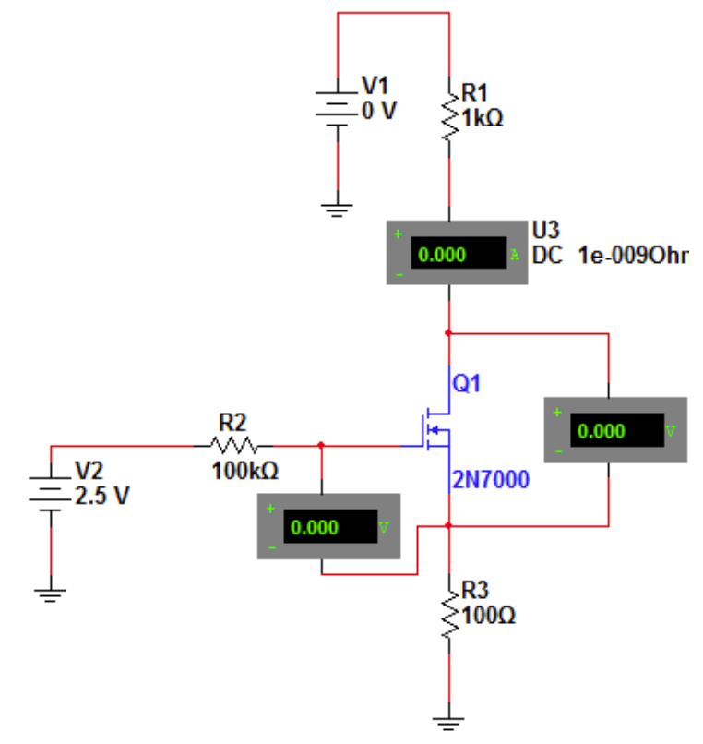
Figure #1: MOSFET Circuit Schematic (Lab Manual)
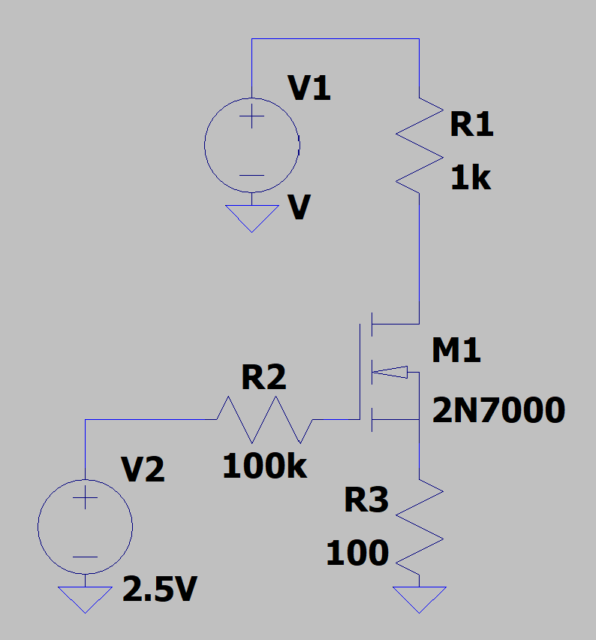
Figure #2: MOSFET Circuit (LTSpice)
For Part 1, V₂ was set to 2.5 V, and V₁ was increased from 0 V while measuring V_{GS}, V_{DS}, and I_{D}. The process was repeated with V₂ set to 3 V, 3.5 V, and 4 V. The results were recorded in Table 1 and plotted to show the relationship between drain current and drain-to-source voltage for each gate-to-source voltage. The plot in Figure 3 was used to identify the linear ohmic region, where the MOSFET behaves like a voltage-controlled resistor. The minimum V_{DS} required for saturation at each V_{GS} was also recorded based on the values in Figure 3.

V₂ = 2.5 V |  | V₂ = 3 V |  | V₂ = 3.5 V |  | V₂ = 4 V
V_{DS} | V_{GS} =  1.876 V | V_{DS} | V_{GS} =  1.958 V | V_{DS} | V_{GS} =  2.027 V | V_{DS} | V_{GS} =  2.089 V
(mV) | I_{D} (mA) | (mV) | I_{D} (mA) | (mV) | I_{D} (mA) | (mV) | I_{D} (mA)
0 | 0 | 0 | 0 | 0 | 0 | 0 | 0
5.956 | 0.903 | 5.785 | 1.296 | 3.493 | 1.036 | 4.949 | 1.727
13.316 | 1.806 | 33.984 | 5.358 | 38.428 | 7.678 | 30.568 | 8.136
22.760 | 2.707 | 62.184 | 7.421 | 73.362 | 10.758 | 64.192 | 12.666
35.549 | 3.604 | 90.383 | 8.593 | 149.054 | 13.468 | 101.019 | 15.290
54.334 | 4.496 | 137.383 | 9.631 | 189.811 | 14.077 | 152.256 | 17.194
86.479 | 5.376 | 165.182 | 9.872 | 207.278 | 14.252 | 198.690 | 18.104
115.481 | 5.804 | 184.382 | 10.122 | 230.568 | 14.428 | 233.916 | 18.523
181.184 | 6.194 | 259.581 | 10.392 | 259.680 | 14.577 | 297.962 | 18.940
632.641 | 6.243 | 334.780 | 10.421 | 376.128 | 14.721 | 344.396 | 19.066
1132.641 | 6.243 | 438.178 | 10.421 | 498.399 | 14.727 | 382.824 | 19.111
Table #1: MOSFET Output Characteristics
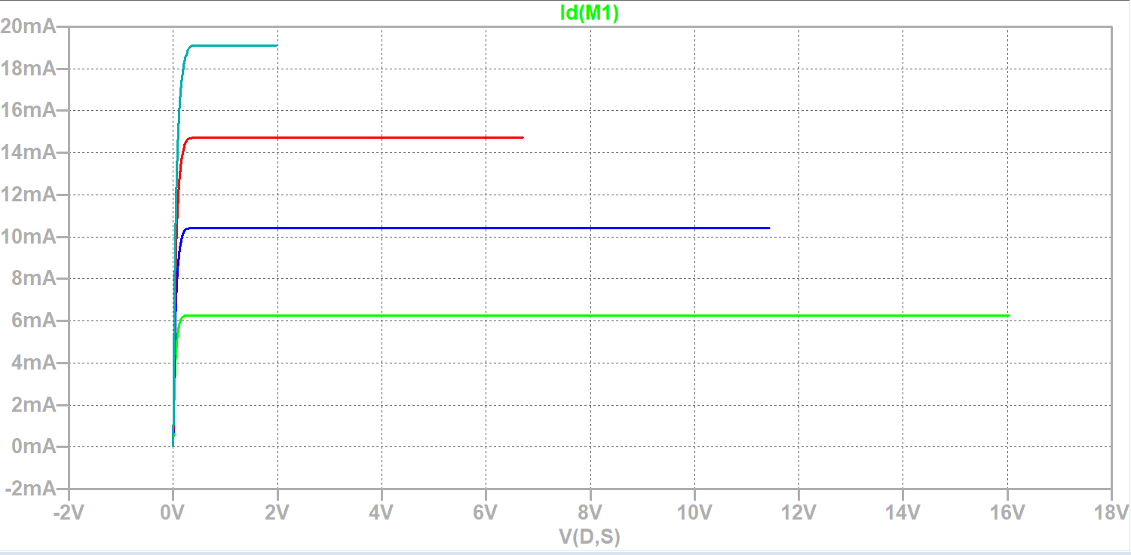
Figure #3: I_{D} vs. V_{DS} at
For Part 2, V₁ was set to 22 V, and V₂ was varied from 0 V in 0.25 V increments until the drain current stopped increasing. The corresponding V_{GS} and I_{D} values were recorded in Table 2 and plotted in Figure 4 to examine the MOSFET's transfer characteristics. The threshold voltage was identified from Figure 4 as the minimum gate-to-source voltage required for the MOSFET to begin conducting.
V_{GS} (V) | I_{D} (mA)
0 | 0.022
1 | 0.022
1.5 | 0.022
1.75 | 2.018
2 | 12.960
2.25 | 19.766
2.5 | 19.876
3 | 19.910
Table #2: MOSFET Output Characteristics
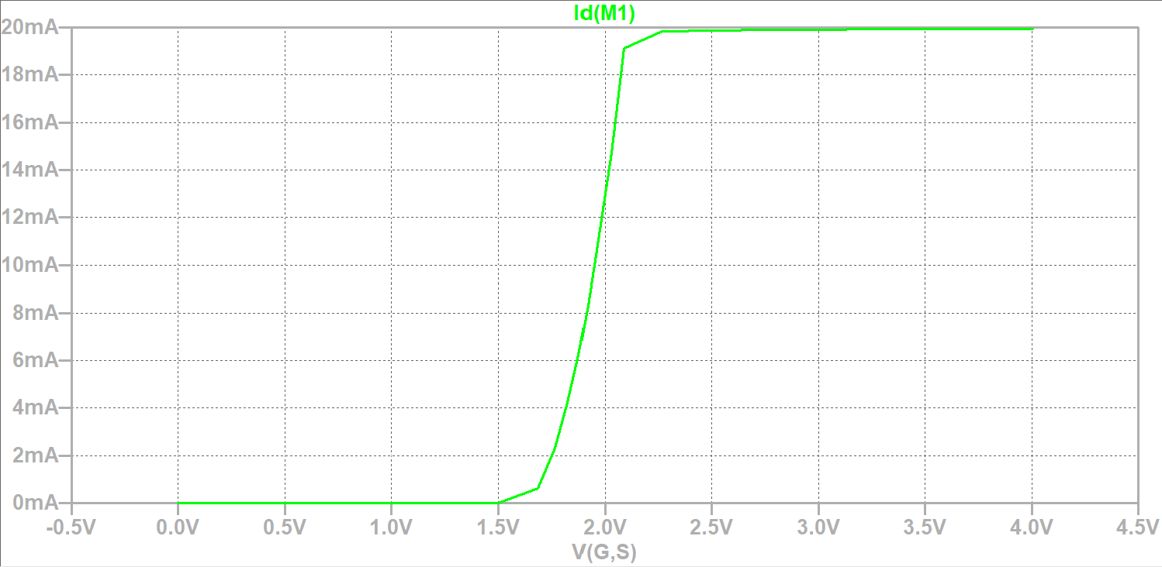
Figure #3: I_{D} vs. V_{DS}

