EE 316
Section 3
Pre Lab 12
By: Hannah Kelley
MOSFET Amplification (with Bonus)

Introduction:
This lab investigates the frequency response of a MOSFET amplifier using the 2N7000 transistor. By measuring voltage gain over a range of input frequencies, the amplifier’s low and high cutoff frequencies and approximate bandwidth can be determined. The experiment also examines the phase relationship between the input and output signals to demonstrate the phase inversion characteristic of a common-source MOSFET amplifier.
Simulations and Results:
The MOSFET amplifier circuit in Figure 1 was built and simulated in LTSpice using a 200 mV peak-to-peak input signal with frequencies varying from 10 Hz to 3 MHz. Figure 2 shows the simulated circuit. Figure 3 shows the Bode plot for the simulated circuit. Table 1 shows the high and low frequency cutoffs and the bandwidth, as seen in the Bode plot. Table 2 shows select frequencies and their V_{out} and gain values.
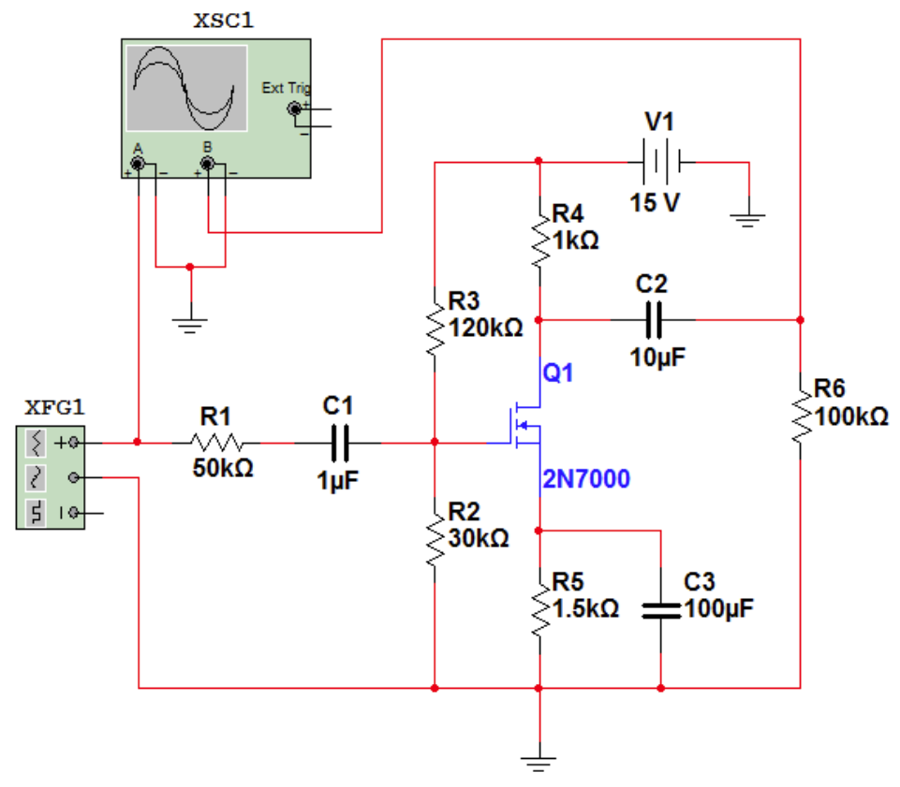
Figure #1: MOSFET Amplifier Schematic (Lab Manual)
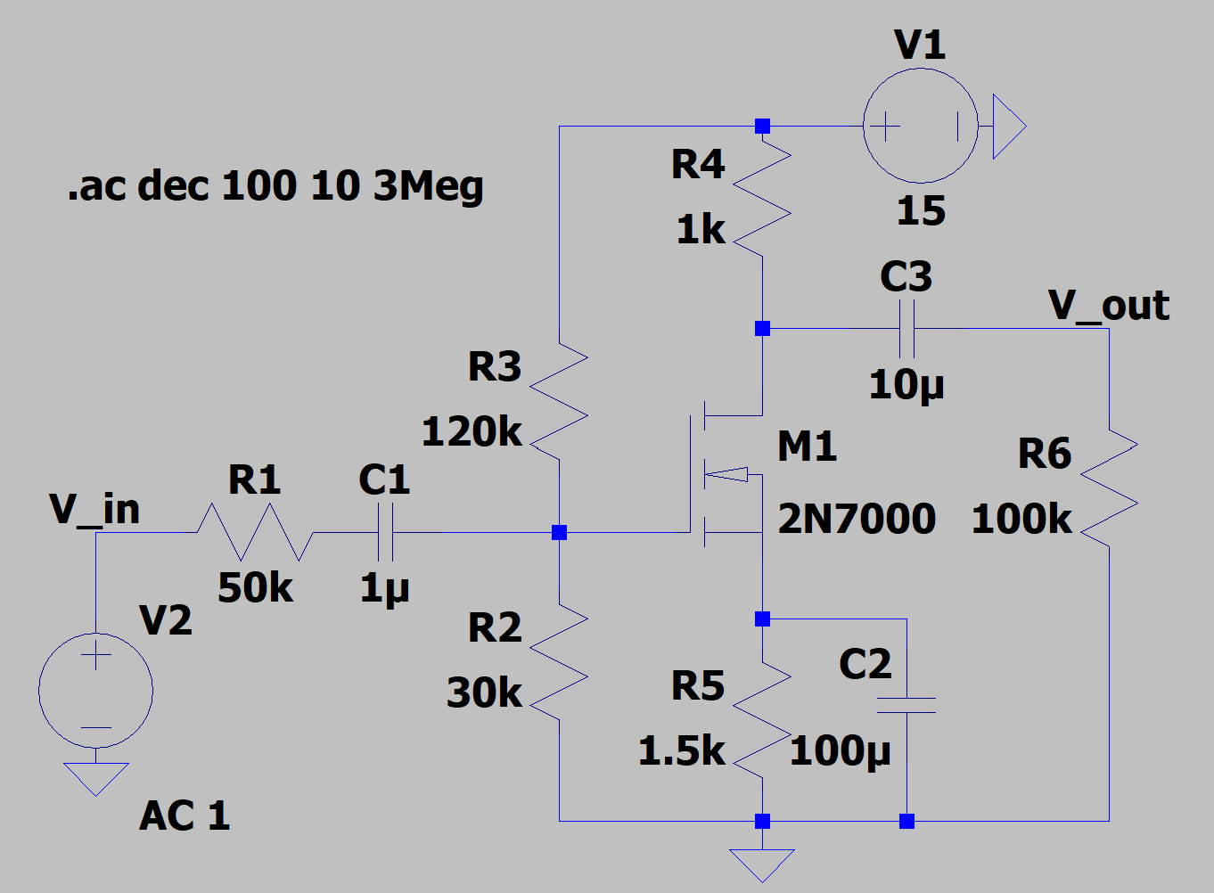
Figure #2: MOSFET Amplifier Circuit (LTSpice)
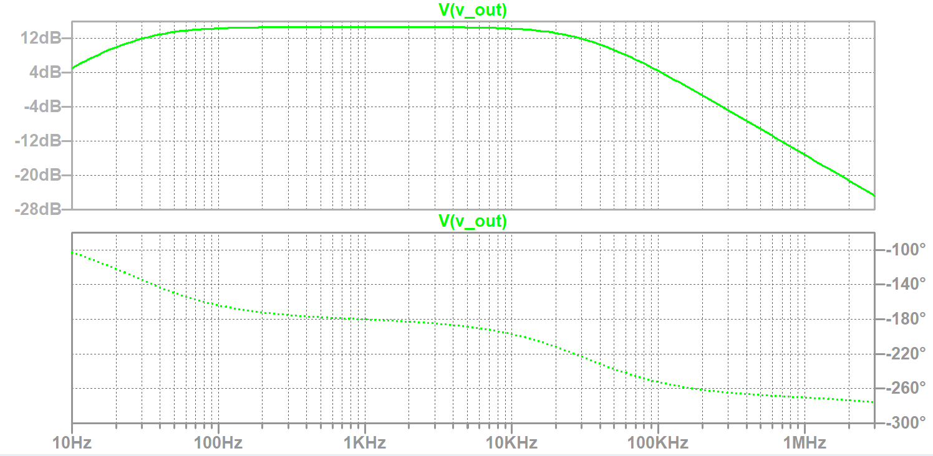
Figure #3: MOSFET Amplifier Bode Plot
 | Value
Low Frequency Cutoff | 28.8 Hz
High Frequency Cutoff | 33.7 kHz
Bandwidth | 33.67 kHz
Table #1: Important Frequencies (Simulation)
Frequency | V_{out} (V) | Voltage Gain (dB)
10 Hz | 0.17962 | 5.0926176
30 Hz | 0.398118 | 12.00017
60 Hz | 0.492983 | 13.861368
100 Hz | 0.523846 | 14.386605
200 Hz | 0.539604 | 14.631384
500 Hz | 0.543999 | 14.702174
1 kHz | 0.54444 | 14.709211
2 kHz | 0.543813 | 14.699192
5 kHz | 0.538357 | 14.611703
10 kHz | 0.519996 | 14.312978
15 kHz | 0.491868 | 13.841700
20 kHz | 0.461887 | 13.293075
50 kHz | 0.293064 | 9.3413204
75 kHz | 0.211748 | 6.5162771
100 kHz | 0.166314 | 4.4046672
150 kHz | 0.111264 | 1.0385469
200 kHz | 0.086358 | -1.2817469
500 kHz | 0.03472 | -9.1898298
750 kHz | 0.022947 | -12.781244
1 MHz | 0.017427 | -15.179768
1.5 MHz | 0.011491 | -18.782752
2.0 MHz | 0.008726 | -21.189108
3.0 MHz | 0.005782 | -24.752158
Table #2: Simulation Results
BONUS Simulation and Results:
The MOSFET amplifier circuit in Figure 1 was modified and simulated in LTspice to maximize its bandwidth while maintaining a passband gain above 10 dB. To achieve this, R₁ was reduced to 1 kΩ to extend high-frequency response, and capacitors C₁, C₂, and C₃ were set to 110 µF, 470 µF, and 100 µF respectively to push the low-frequency limit downward. To prevent output waveform clipping, supply voltage V₁ was increased to 20 V, and biasing resistors R₃ and R₂ were adjusted to 150 kΩ and 60 kΩ to center the DC operating point. Figure 4 shows the modified circuit in LTSpice. Figure 5 displays the resulting Bode plot. Table 3 summarizes the high and low cutoff frequencies along with the total bandwidth obtained from the simulation.
Additionally, transient analysis confirmed that the output signal remained clean and unclipped across the entire passband with a 200 mV peak-to-peak input signal. Figure 6 shows a plot of V_{out} during this transient analysis.
The modified circuit achieved a mid-band gain of 28.6 dB, easily exceeding the minimum 10 dB requirement. The lower cutoff frequency f_{low} was reduced to 12.3 Hz, while the upper cutoff frequency f_{high} increased significantly from 33.7 kHz to 515 kHz. Overall, this expanded the amplifier's total bandwidth from 33.67 kHz to 515 kHz, roughly a 15 times improvement over the original design.
This performance increase come down to how the components handle signal frequencies. Increasing the coupling and bypass capacitors allows low-frequency signals to pass straight through to the output instead of getting blocked, which pushes the lower cutoff frequency down to 12.3 Hz. At the same time, lowering input resistor R₁ from 50 kΩ to 1 kΩ removes a major bottleneck at the input gate. In the original circuit, a large R₁ reacted with the transistor's internal capacitance to choke off high-frequency signals. Shrinking R₁ lets those fast-changing signals pass freely, stretching the high-frequency cutoff out to 515 kHz. Furthermore, raising V₁ to 20 V provided the necessary DC headroom to support the higher mid-band gain without saturating or clipping the output waveform.
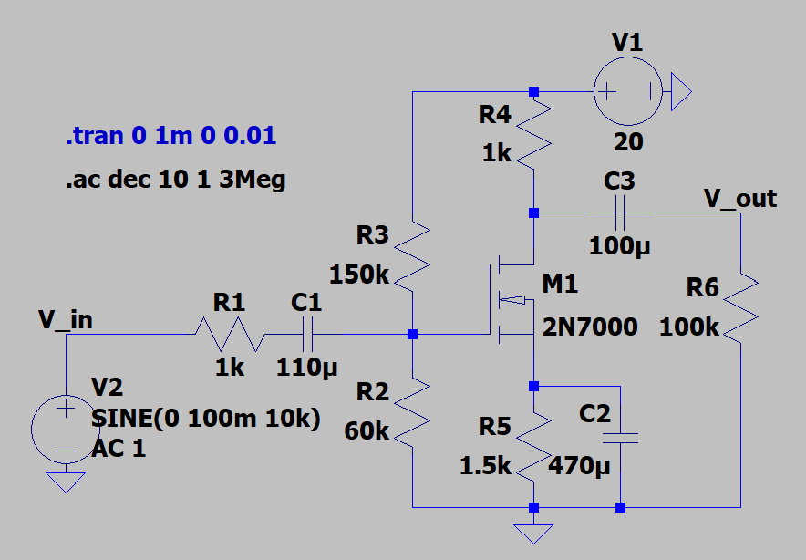
Figure #4: Modified MOSFET Amplifier Circuit (LTSpice)
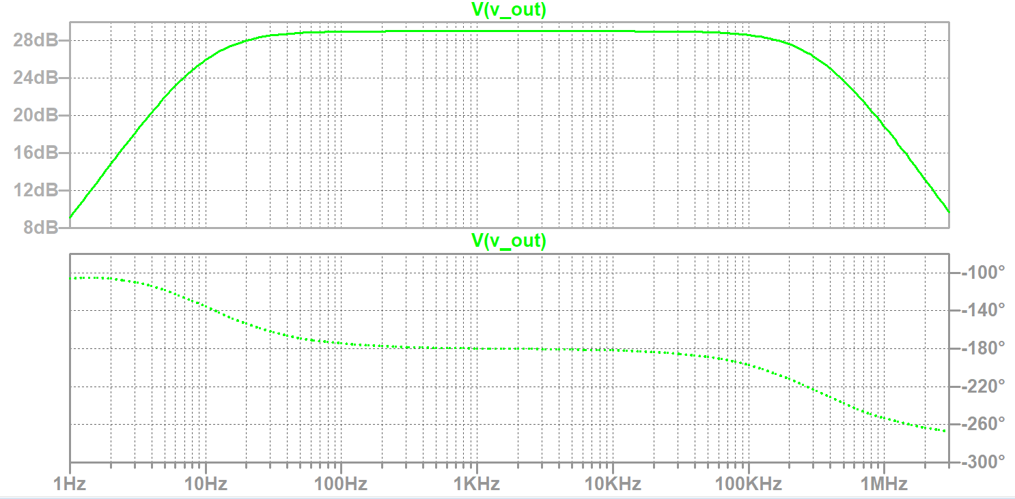
Figure #5: Modified MOSFET Amplifier Bode Plot
 | Value
Low Frequency Cutoff | <10 Hz
High Frequency Cutoff | 2.83 MHz
Bandwidth | 2.83 MHz
Table #3: Important Frequencies for Modified Circuit (Simulation)
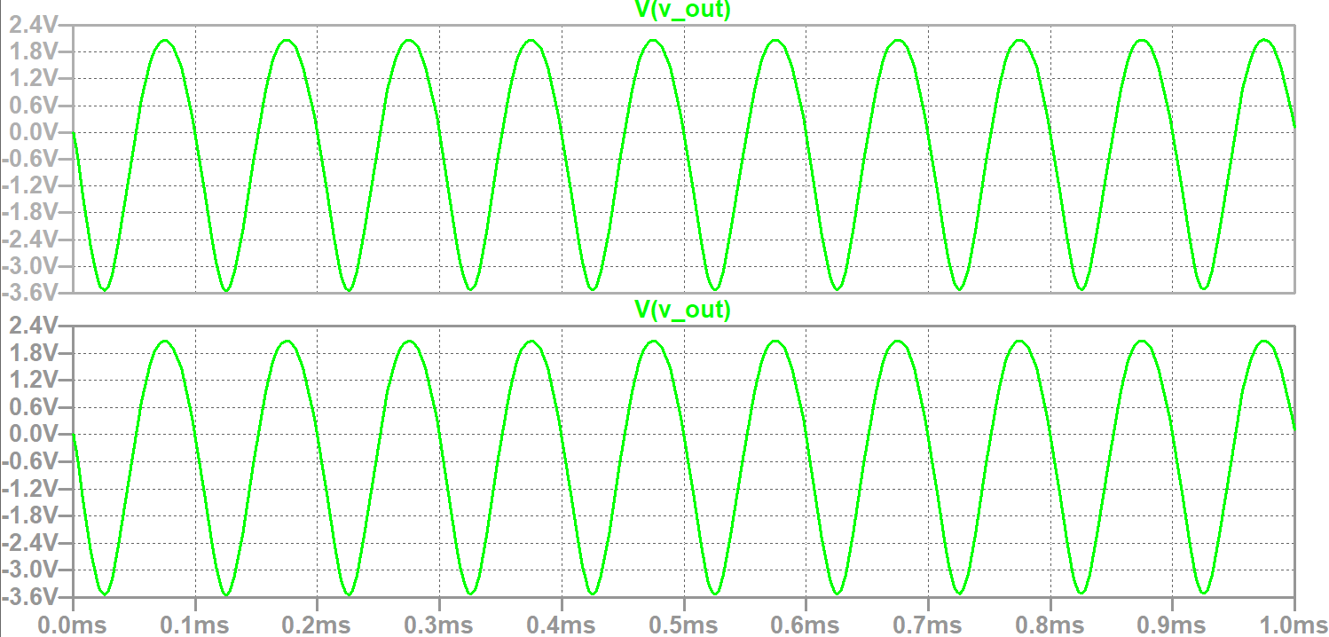
Figure #6: Modified MOSFET Transient Output Plot

