EE 316
Section 3
Pre Lab 09
By: Hannah Kelley
Operating Characteristics of JFETs
Introduction:
This lab introduces the Junction Field-Effect Transistor (JFET), covering n-channel and p-channel constructions, channel symmetry, and key operational parameters such as pinch-off voltage and saturation current. By examining its voltage-controlled behavior, high input impedance, and low output noise, the experiment demonstrates why JFETs excel in small-signal amplification compared to BJTs. Ultimately, it teaches how to analyze JFET biasing and operating states, establishing the foundational concepts required to understand MOSFETs in future labs.
Simulations and Results:
The JFET circuit in Figure 1 was built and simulated in LTSpice to obtain its drain and transfer characteristic curves. Using the simulated circuit in Figure 2, I_{D} was measured across various V_{DS} values while maintaining V_{GS} at 0 V, -0.5 V, and -1 V by adjusting V₁ and V₂ independently. These I_{D} values are summarized in Table 1. The resulting data was plotted to create the drain characteristic curve in Figure 3, from which V_{P} and V_{TH} were estimated and annotated. Next, with V_{DS} fixed at 6 V, V_{GS} was incrementally decreased until I_{D} reached 0 mA to generate the transfer characteristic curve in Figure 4. Finally, V_{P} was estimated from the transfer plot and compared against the drain characteristic value.
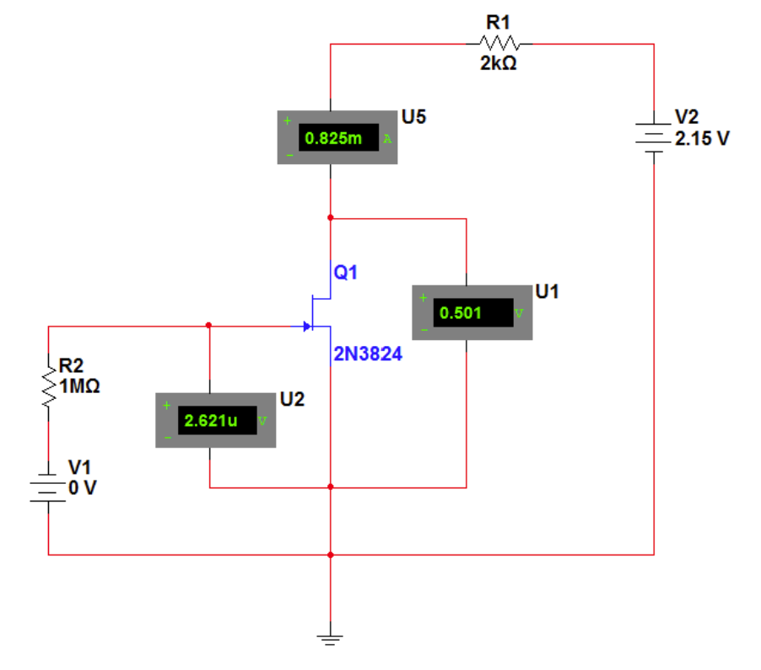
Figure #1: JFET Circuit (Lab Manual)
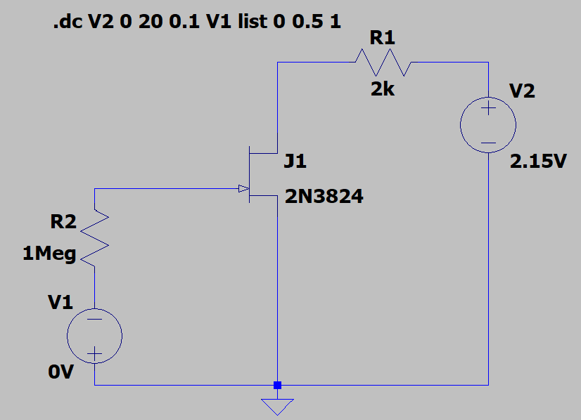
Figure #2: JFET Circuit (LTSpice)
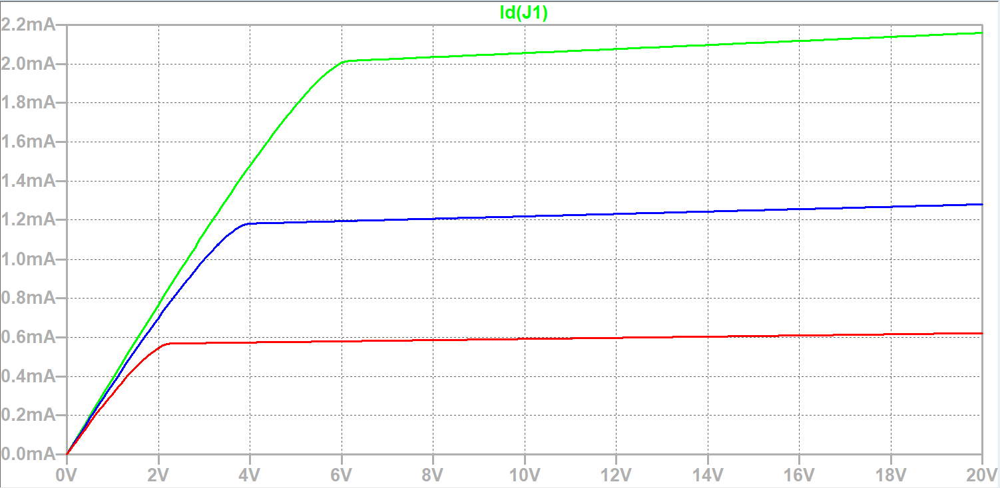Figure #3: JFET Drain Characteristic Curves

V_{P} = 3.8 V
V_{TH} = -2 V
 | V_{GS} = 0 V | V_{GS} = -0.5 V | V_{GS} = -1 V
V_{DS} (V) | I_{D} (mA) | I_{D} (mA) | I_{D} (mA)
0 | 0 | 0 | 0
0.5 | 0.19598597 | 0.18313265 | 0.16173965
1 | 0.38969575 | 0.36175252 | 0.31208465
2 | 0.76892186 | 0.70063752 | 0.54517260
4 | 1.4777967 | 1.1808369 | 0.57418324
8 | 2.0346143 | 1.2054729 | 0.58616768
12 | 2.076169 | 1.2301051 | 0.59815182
16 | 2.1177211 | 1.2547361 | 0.61013561
20 | 2.1592702 | 1.279366 | 0.62211906
Table #1: Drain Characteristics
 | V_{DS} = 6 V
V_{GS} (V) | I_{D} (mA)
0 | 2.0565675
-0.5 | 1.2080352
SS-1 | 0.58367301
-1.5 | 0.18379232
-2 | 0.008701697
Table #2: Transfer Characteristics
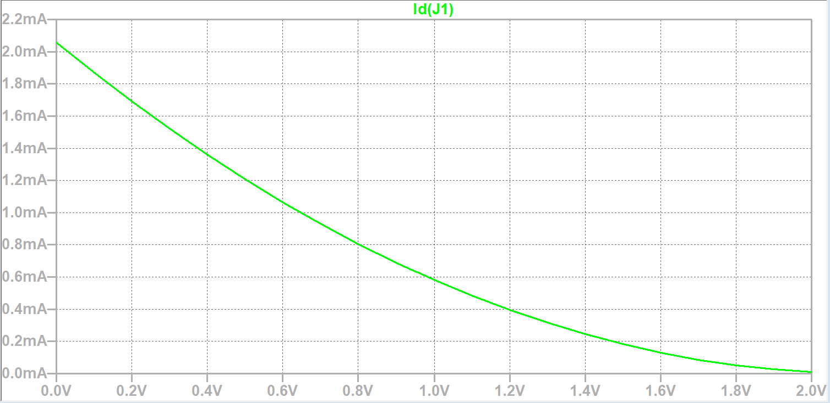
Figure #4: Transfer Characteristic Plot
V_{P} = 3.8 V
V_{TH} = -2 V

