EE 316
Section 3
Pre Lab 10
By: Hannah Kelley
Small Signal Amplification with JFETs
Introduction:
This lab explores small-signal AC amplification, frequency response, and transistor dynamic behavior in field-effect transistor circuits. By evaluating a common-source JFET amplifier via simulation and hardware, the experiment demonstrates how external capacitors limit low-frequency performance while internal parasitic capacitances bound high-frequency bandwidth. The exercise teaches how to construct Bode magnitude plots to identify midband gain, cutoff frequencies, and bandwidth, while illustrating signal phase inversion. Additionally, it highlights the practical disparities between idealized simulation models and real-world hardware limits.
Simulations and Results:
The JFET amplifier circuit in Figure 1 was built and simulated in LTSpice. Figure 2 shows a screenshot of the JFET amplifier circuit in LTSpice. The circuit was simulated over a range of frequencies from 30 Hz to 16 MHz. Figure 3 shows the Bode plot for this simulation. The bandwidth and cutoff frequencies for the Bode plot in Figure 3 are noted in Table 1. Table 2 shows selected V_{out} and gain values from the Bode plot in Figure 3.
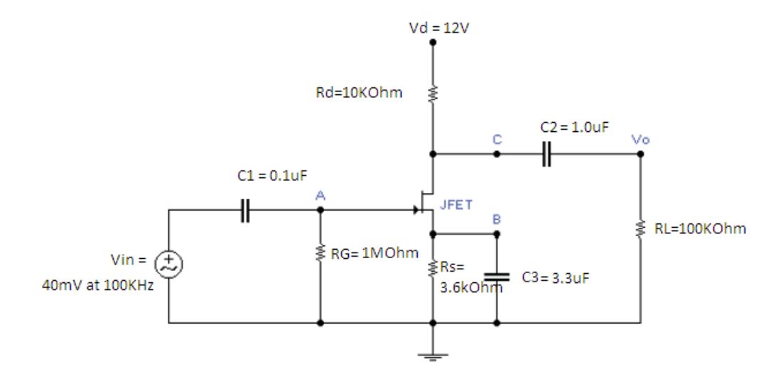
Figure #1: JFET Amplifier Schematic (Lab Manual)
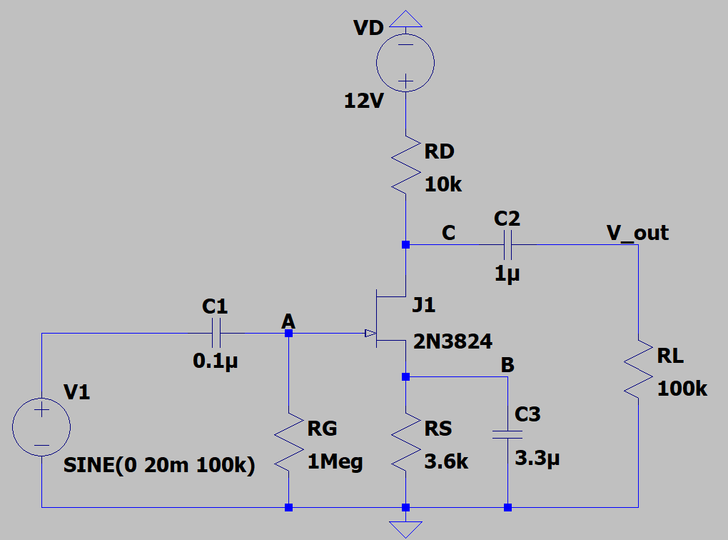
Figure #2: JFET Amplifier Circuit (LTSpice)
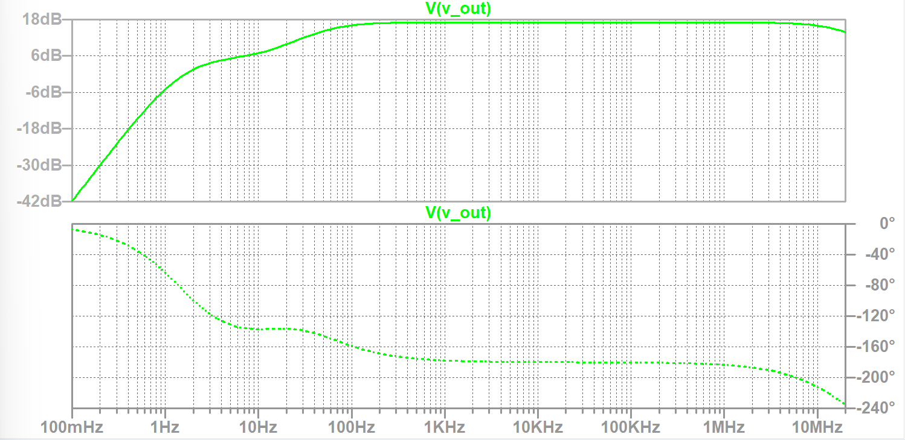
Figure #3: JFET Amplifier Bode Plot

 | Value
Bandwidth | 19.3 MHz
High Frequency Cutoff | 19.3 MHz
Low Frequency Cutoff | 46.9 Hz
Table #1: Important Bode Plot Values
Frequency (Hz) | V_{out} (mV) | Gain (dB)
30 | 154.94 | 11.76205
45 | 198.74 | 13.92439
60 | 219.48 | 14.78682
100 | 255.61 | 16.110466
200 | 276.4 | 16.789635
500 | 283.37 | 17.005928
1k | 284.4 | 17.03745
10k | 284.75 | 17.047975
100k | 284.75 | 17.047962
500k | 284.65 | 17.045081
1M | 284.36 | 17.036147
1.5M | 283.91 | 17.022409
2M | 283.2 | 17.000765
3M | 281.45 | 16.946799
4M | 278.74 | 16.862811
5M | 275.4 | 16.758145
7M | 268.18 | 16.527211
10M | 252.31 | 15.997369
11M | 247.95 | 15.846186
12M | 237.92 | 15.487421
15M | 226.11 | 15.045178
16M | 219.57 | 14.790256
Table #1: Simulations Results

