EE 316
Section 3
Lab 03
By: Hannah Kelley
Op-Amp Integrator and Differentiator Circuits
Introduction:
This lab investigates the behavior of operational amplifier differentiator circuits by examining the relationship between the input and output waveforms. The effects of different input waveforms and frequencies are observed using LTSpice simulations and an oscilloscope, with particular attention given to output gain, phase relationship, and high-frequency noise.
Simulation and Results:
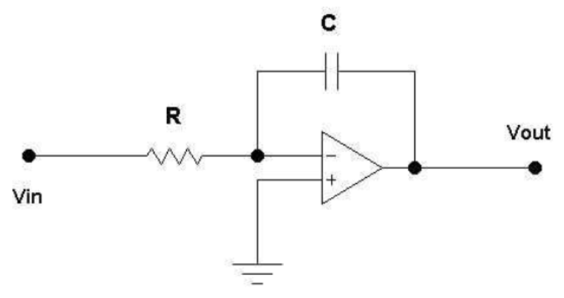
Figure #1: Op-Amp Integrator Schematic from Lab Manual
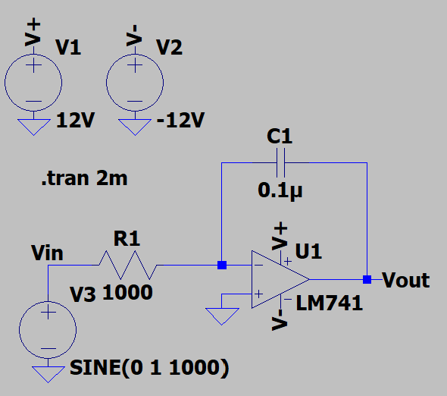
Figure #2: Op-Amp Integrator with $C=0.1 μF$ and Sinusoidal Input (LTSpice)
The following input voltage commands were used to generate a sinusoidal, triangular, and square wave respectively: SINE(0 1 1000), PWL REPEAT FOREVER (0 -1 0.5m 1 1m -1) ENDREPEAT, and PULSE(-1 1 0 1n 1n 0.5m 1m). The same commands were later used for the differentiating amplifier.
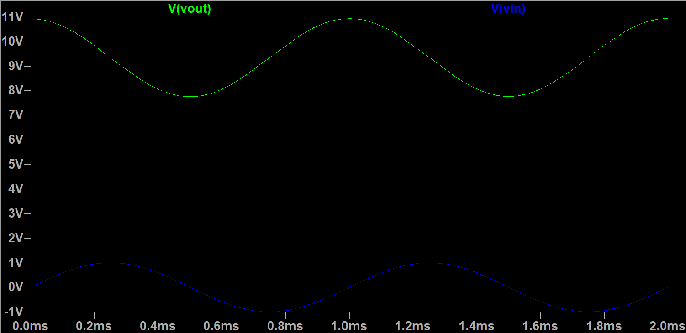
Figure #3: Integrator Oscilloscope Output for $C=0.1 μF$ with Sinusoidal Input
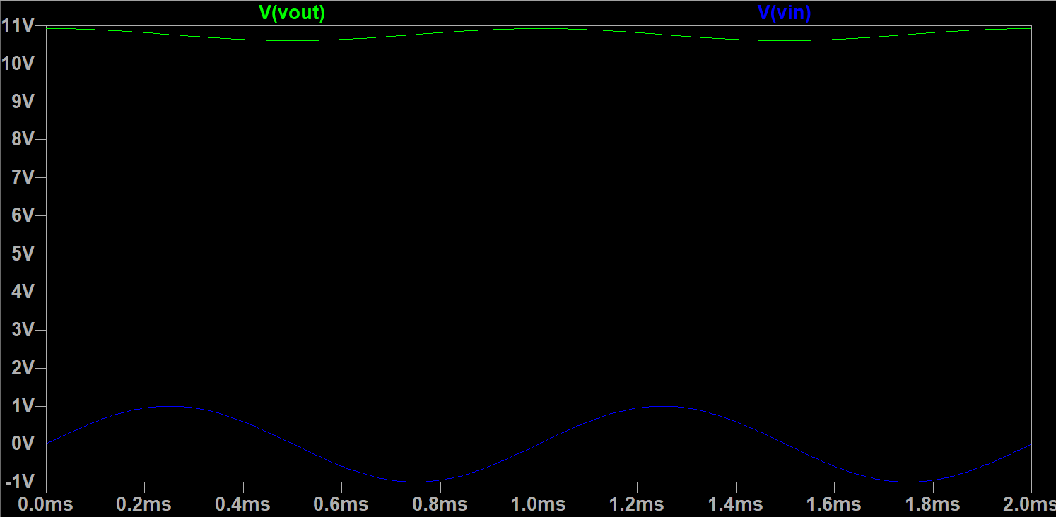
Figure #4: Integrator Oscilloscope Output for $C=1 μF$ with Sinusoidal Input
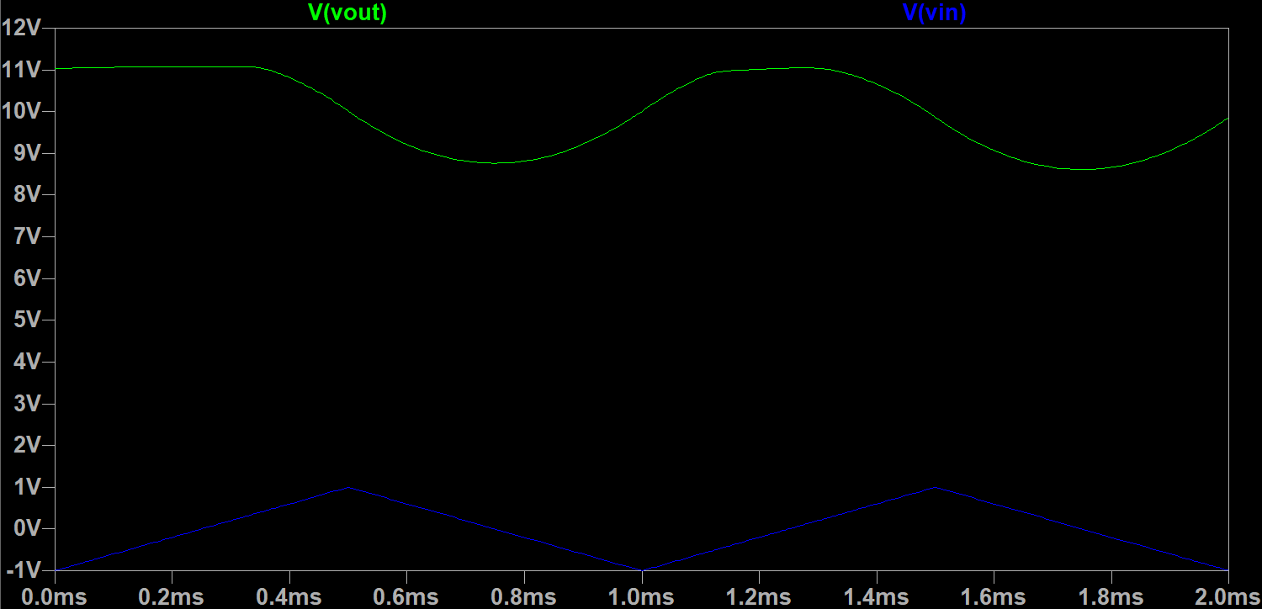
Figure #5: Integrator Oscilloscope Output for $C=0.1 μF$ with Triangular Input
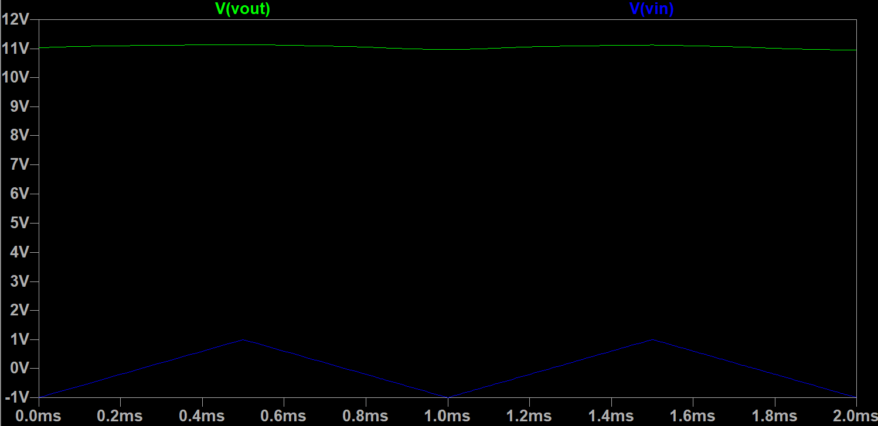
Figure #6: Integrator Oscilloscope Output for $C=1 μF$ with Triangular Input
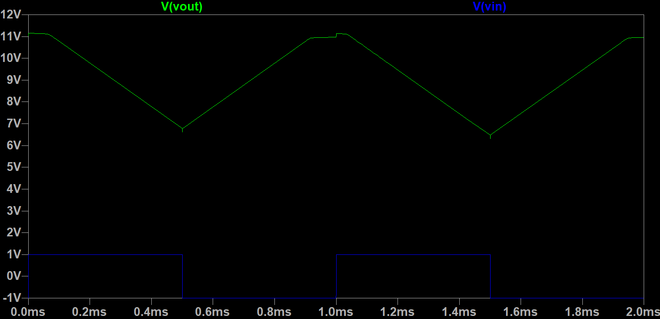
Figure #7: Integrator Oscilloscope Output for $C=0.1 μF$ with Square Input
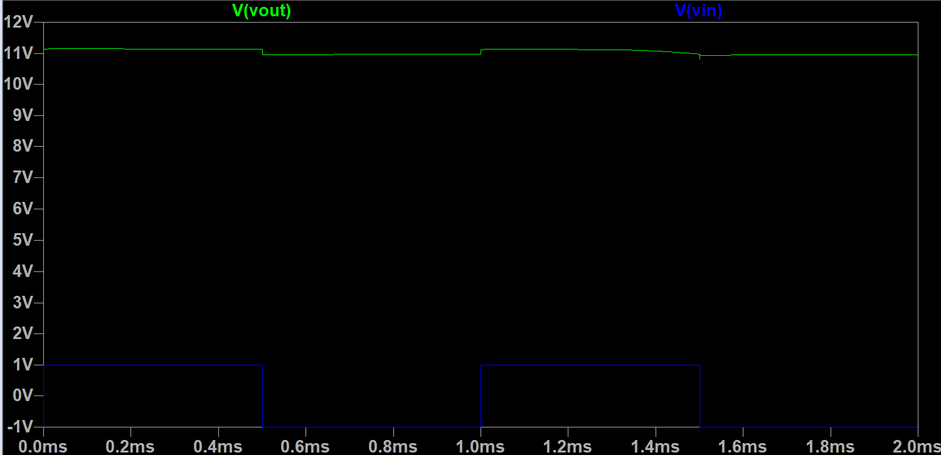
Figure #8: Integrator Oscilloscope Output for $C=1 μF$ with Square Input
The output waveform demonstrates the expected integrating behavior of the inverting integrator. Because the gain is frequency-dependent, the output magnitude depends on R, C, and the input frequency rather than remaining constant. The output also has the expected phase relationship with the input, with a sinusoidal input producing an approximately 90° phase-shifted cosine waveform. The square-wave input produces a triangular output, while the triangular input produces a curved, parabolic output. In some cases, the output also approaches the upper power rail, as the capacitor can initially act similarly to a short circuit and cause a large output response before the capacitor charges. Overall, the results demonstrate the expected relationships of an integrator, with sine, triangular, and square inputs producing cosine, parabolic, and triangle outputs respectively.
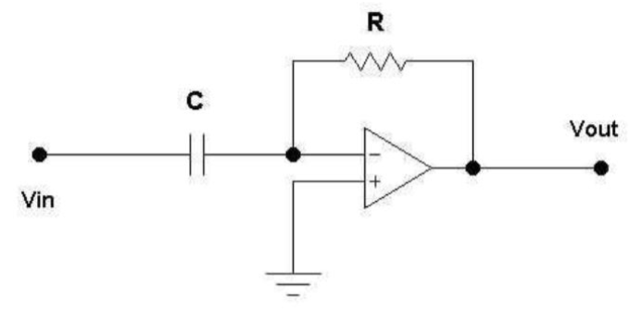
Figure #9: Op-Amp Differentiator Schematic from Lab Manual
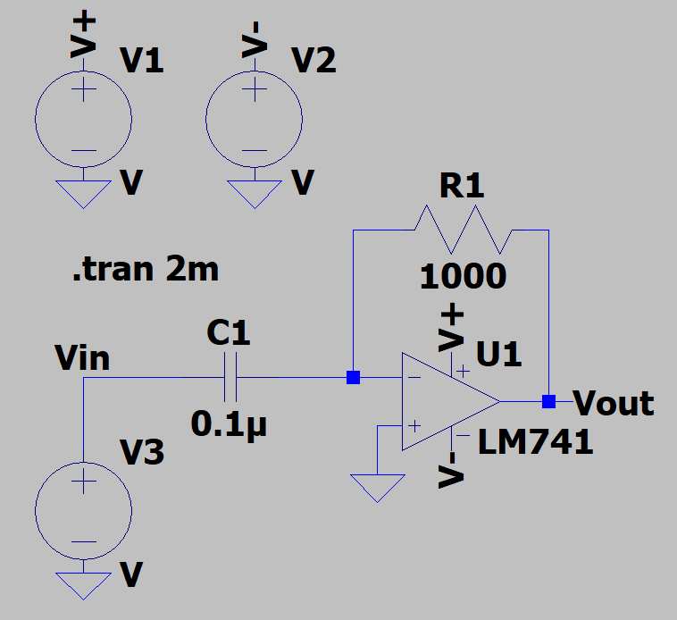
Figure #10: Op-Amp Differentiator with $C=0.1 μF$ and Sinusoidal Input (LTSpice)
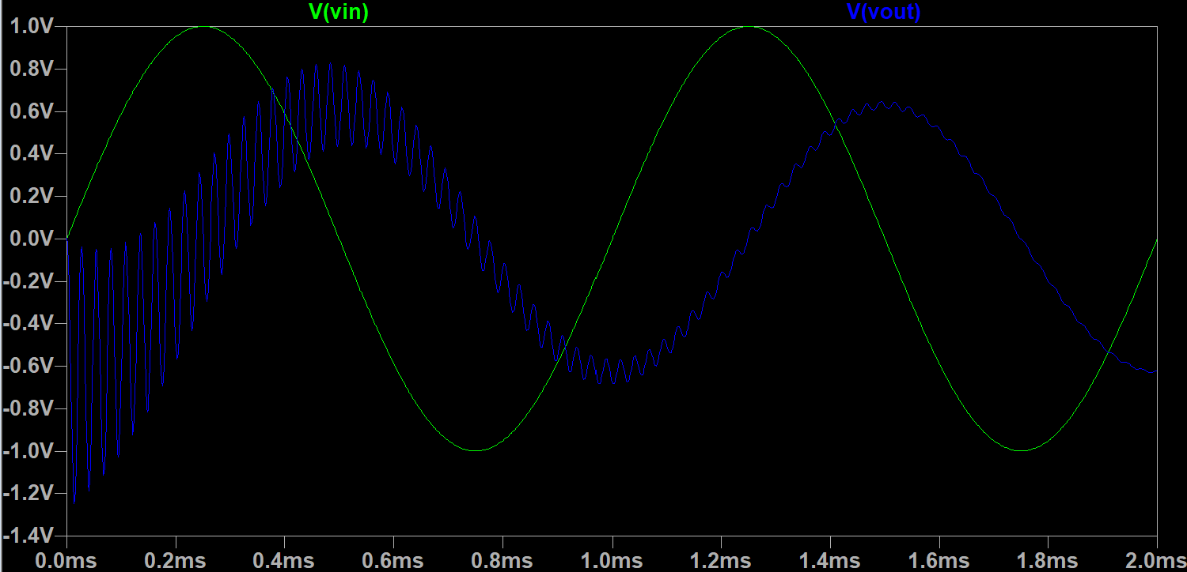
Figure #11: Differentiator Oscilloscope Output for $C=0.1 μF$ with Sinusoidal Input
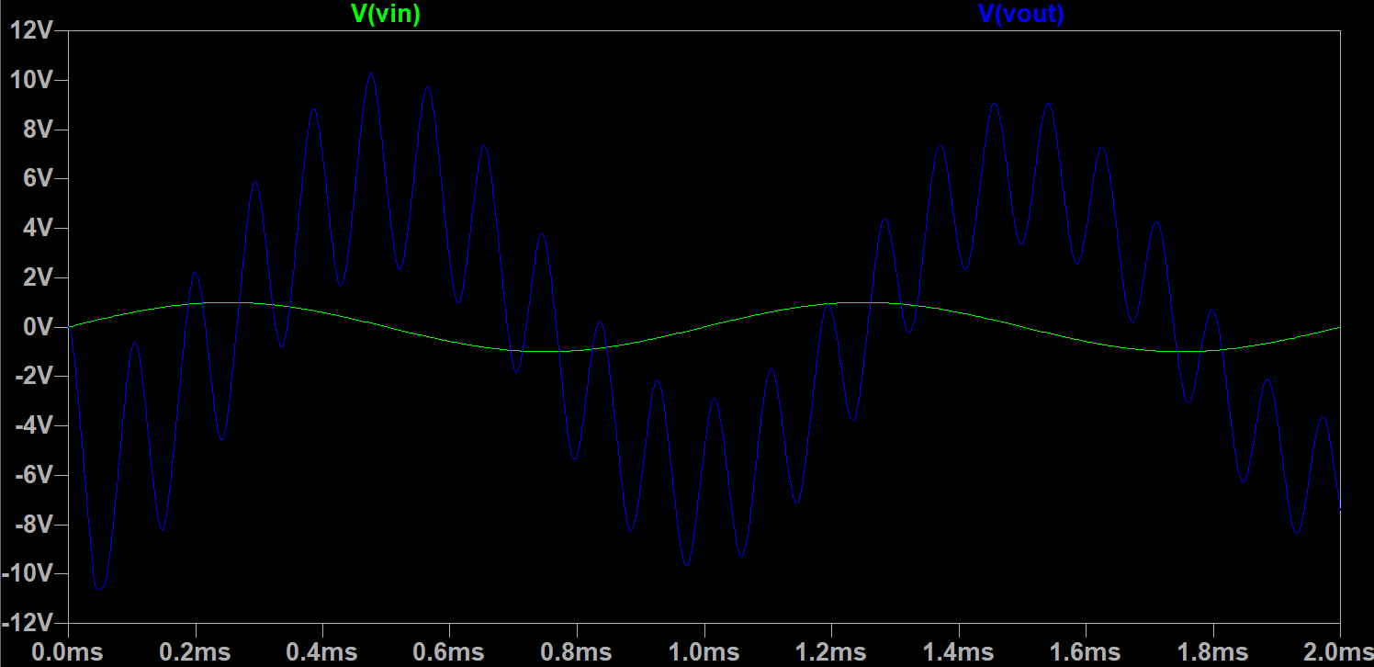
Figure #12: Differentiator Oscilloscope Output for $C=1 μF$ with Sinusoidal Input
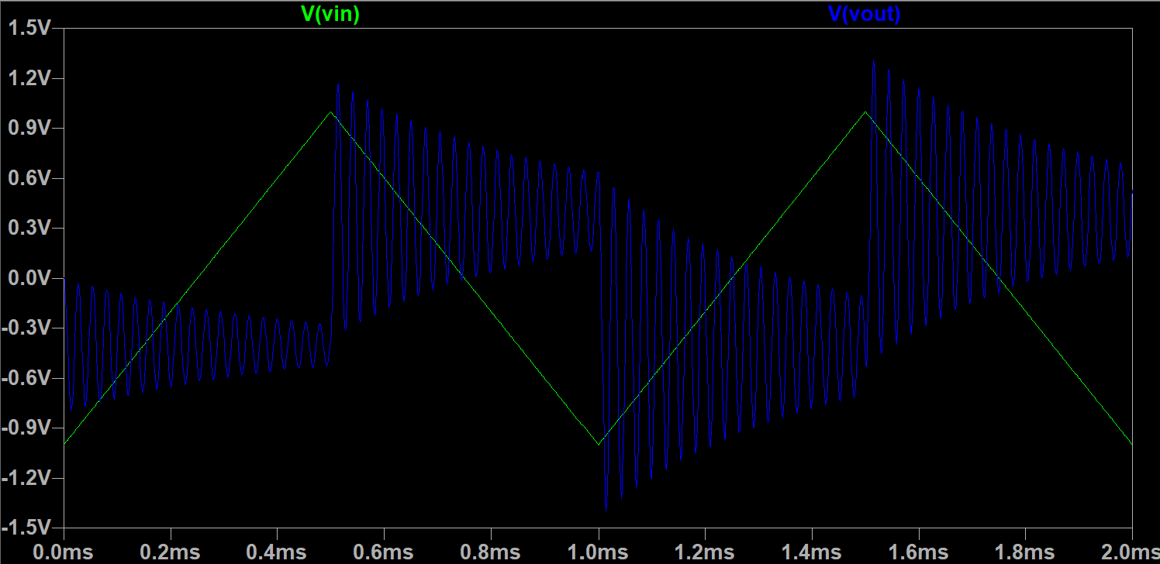
Figure #13: Differentiator Oscilloscope Output for $C=0.1 μF$ with Triangular Input
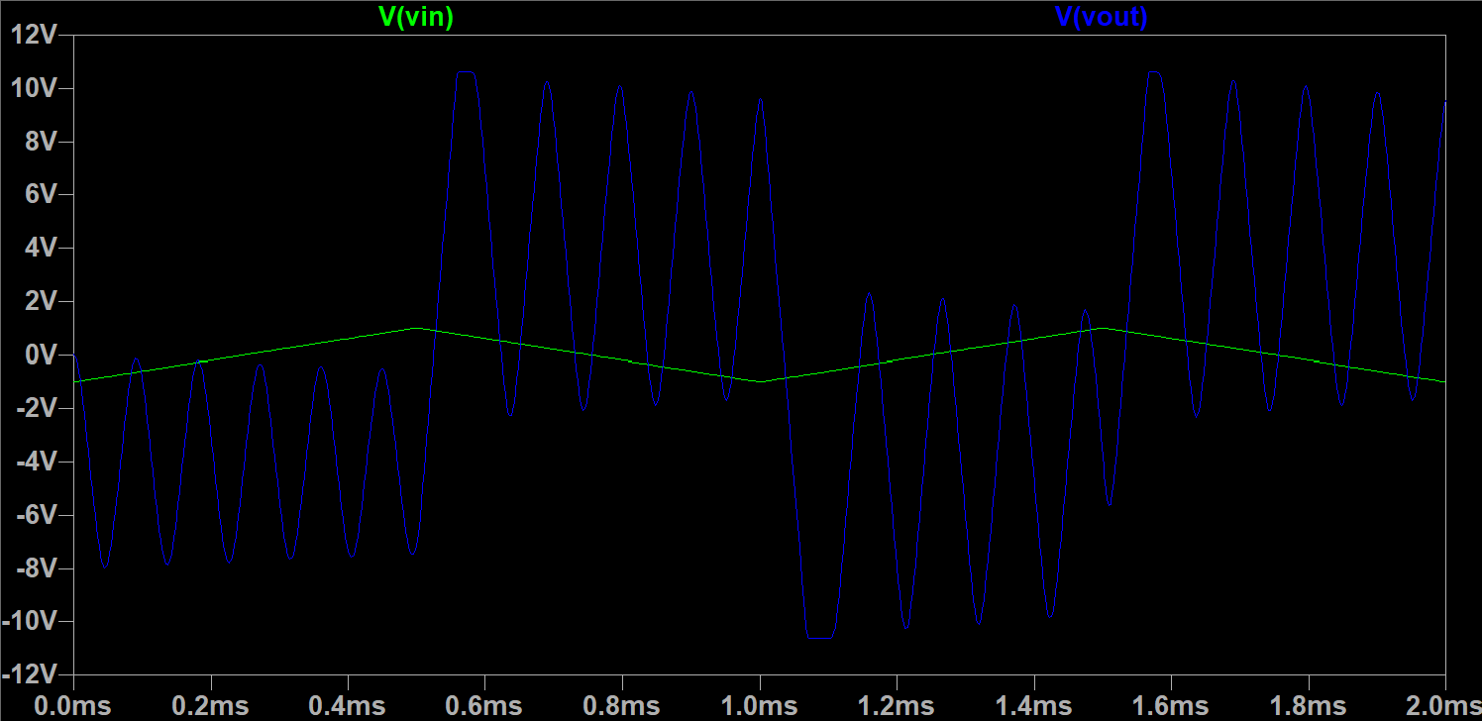
Figure #14: Differentiator Oscilloscope Output for $C=1 μF$ with Triangular Input
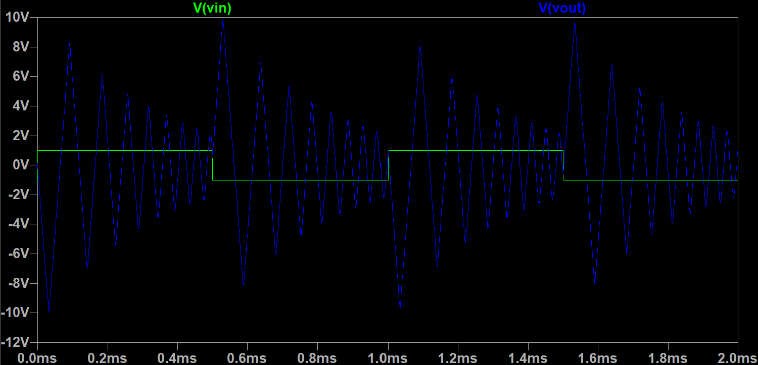
Figure #15: Differentiator Oscilloscope Output for $C=0.1 μF$ with Square Input
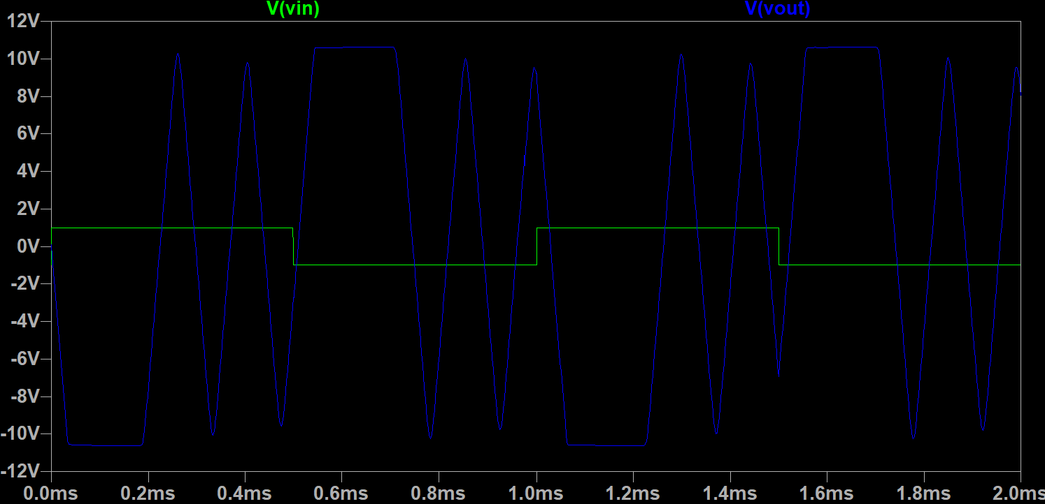
Figure #16: Differentiator Oscilloscope Output for $C=1 μF$ with Square Input
The op-amp differentiator demonstrates the expected differentiating behavior, where the output voltage is proportional to the rate of change of the input signal. As the frequency of the input increases, the magnitude of the output also increases, resulting in a higher gain at higher frequencies. On the oscilloscope, the input and output waveforms show the expected phase relationship for an inverting differentiator, with the output responding to changes in the input waveform rather than its overall magnitude. High-frequency noise is also visible in the output waveform because the differentiator inherently amplifies high-frequency components, including unwanted noise present in the circuit. As seen in Figures 11 and 12, this noise can taper off and become less noticeable with time. Conversely, as seen in Figures 13-16, this noise may persist throughout the simulation. Therefore, the output may appear less smooth at higher frequencies even though the overall waveform follows the expected differentiator behavior.
Experimental Setup and Results:
Op-Amp Integrator:
The op-amp integrator circuit as seen in Figure 1 was built using 0.1$μF$ and 1 $μF$ resistors and a 741CN op-amp. A picture of the experimental setup can be found in Figure 18. The output voltage and gain were measured for varying capacitor values and input voltage waveforms using an oscilloscope. Screenshots of the various oscilloscope outputs (V_{out} vs. V_{in}) can be found in Figures 18-23.
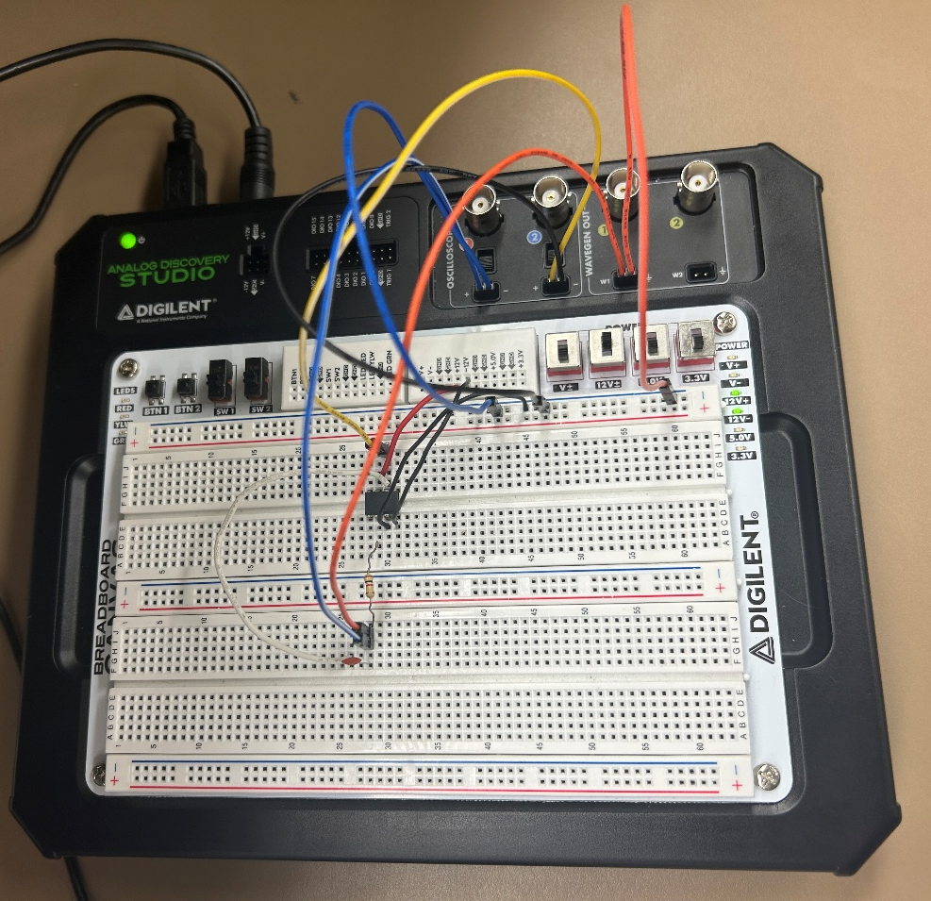
Figure #17: Op-Amp Integrator Experimental Setup
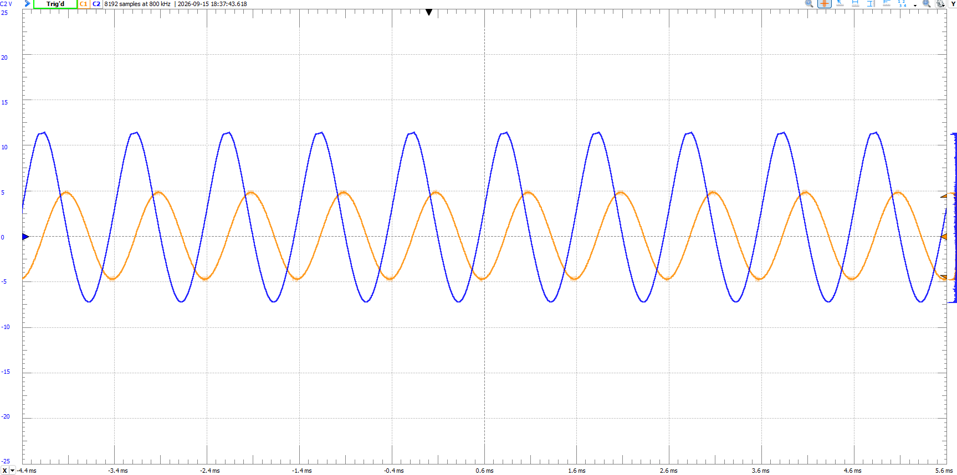
Figure #18: Integrator Oscilloscope Output for $C=0.1 μF$ with Sinusoidal Input
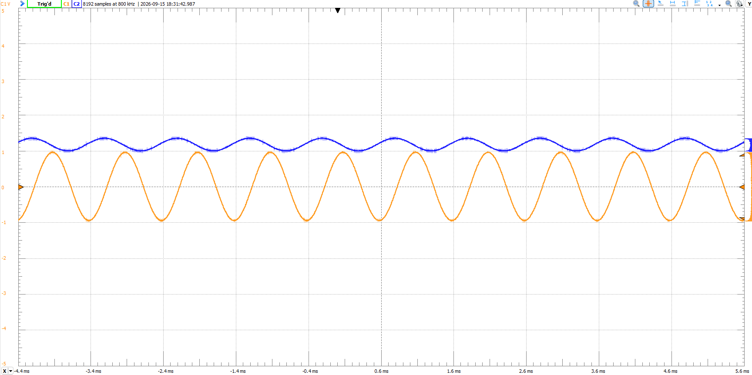
Figure #19: Integrator Oscilloscope Output for $C=1 μF$ with Sinusoidal Input
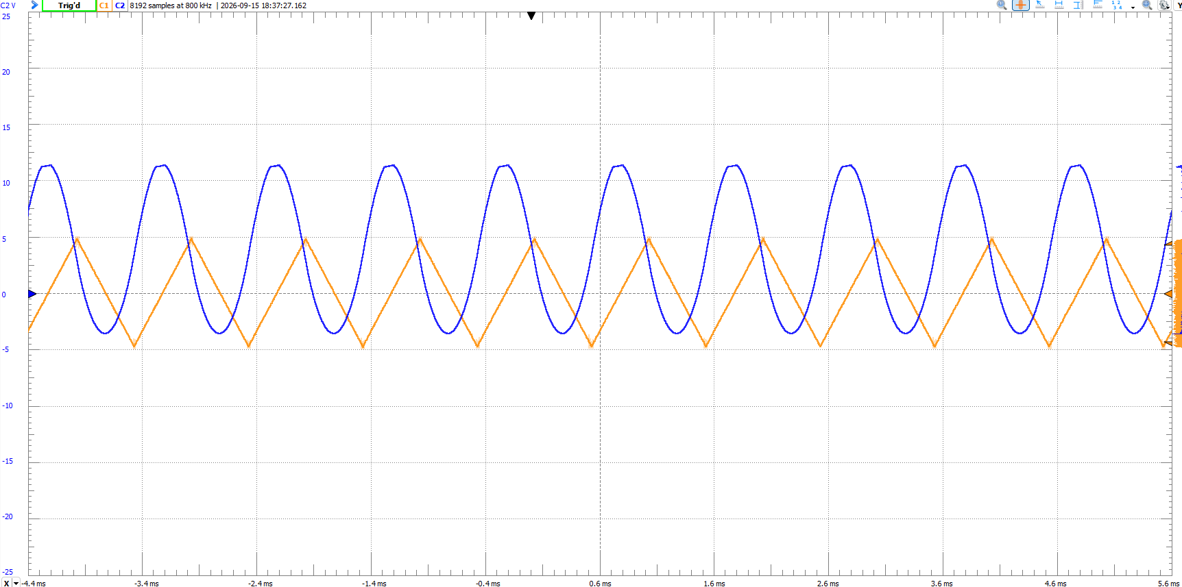
Figure #20: Integrator Oscilloscope Output for $C=0.1 μF$ with Triangular Input
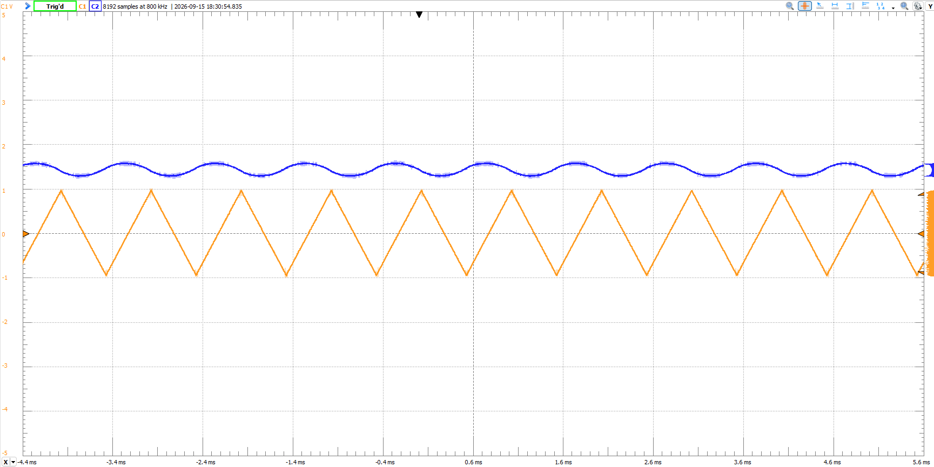
Figure #21: Integrator Oscilloscope Output for $C=1 μF$ with Triangular Input
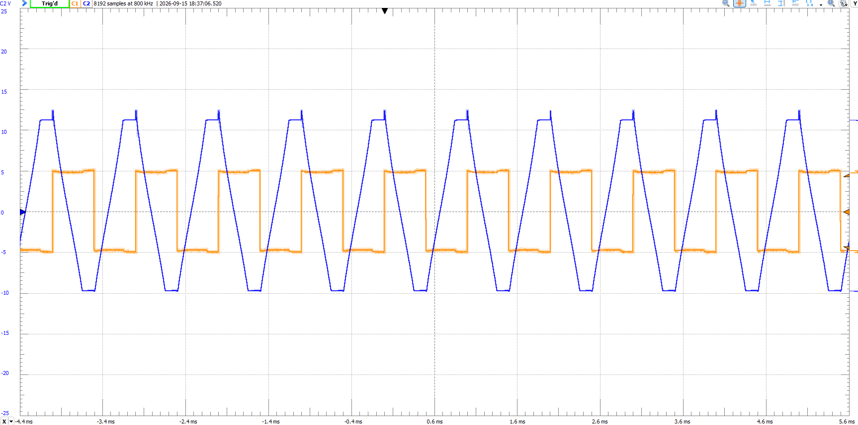
Figure #22: Integrator Oscilloscope Output for $C=0.1 μF$ with Square Input
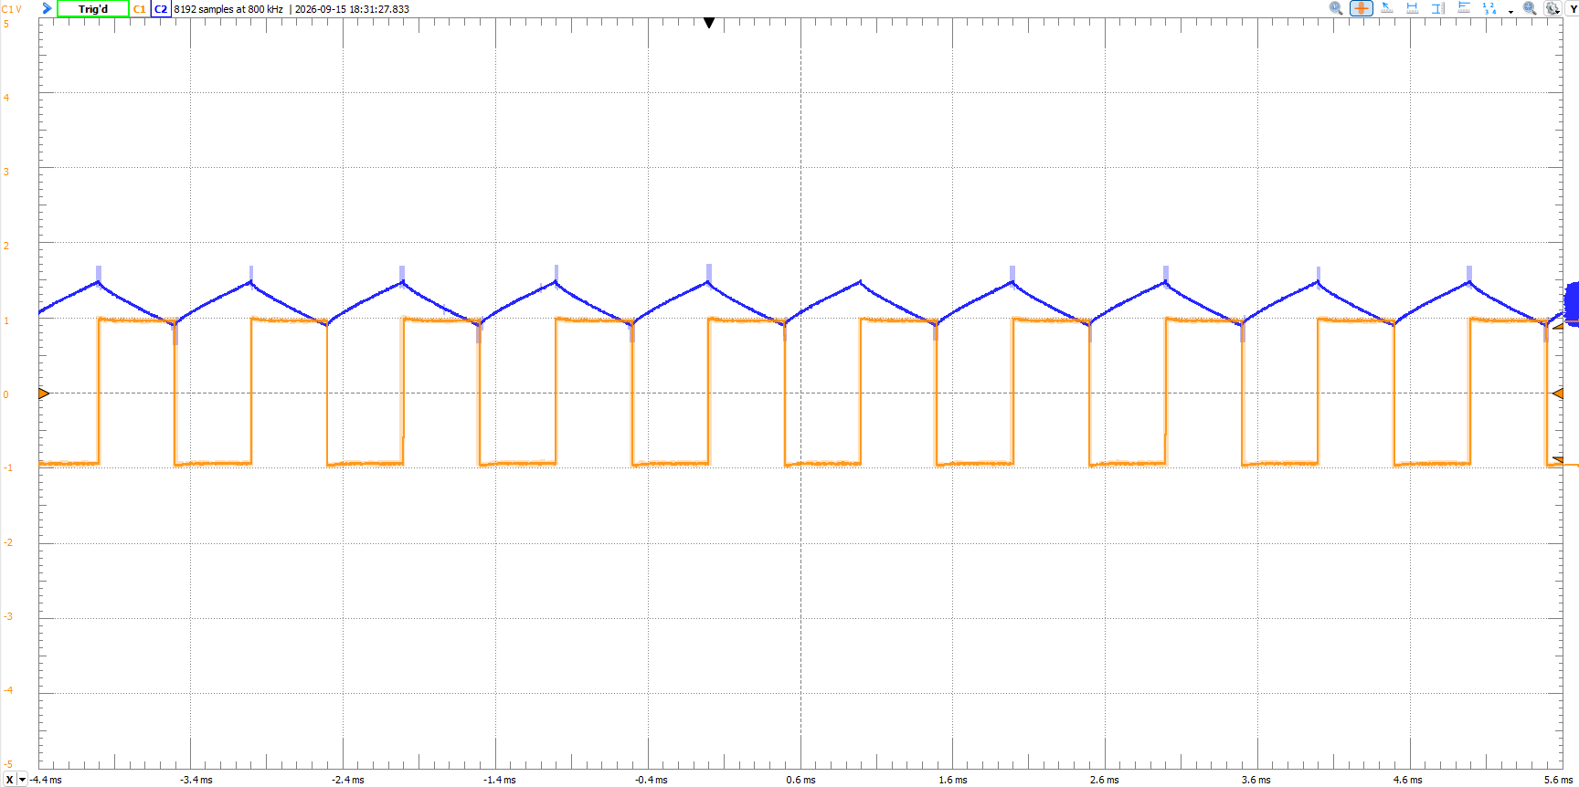
Figure #23: Integrator Oscilloscope Output for $C=1 μF$ with Square Input
Op-Amp Differentiator
The op-amp differentiator circuit as seen in Figure 9 was built using a _____ and a 741CN op-amp. A picture of the experimental setup can be found in Figure 24. The output voltage and gain were measured for varying capacitor values and input voltage waveforms using an oscilloscope. Screenshots of the various oscilloscope outputs (V_{out} vs. V_{in}) can be found in Figures 25-30.
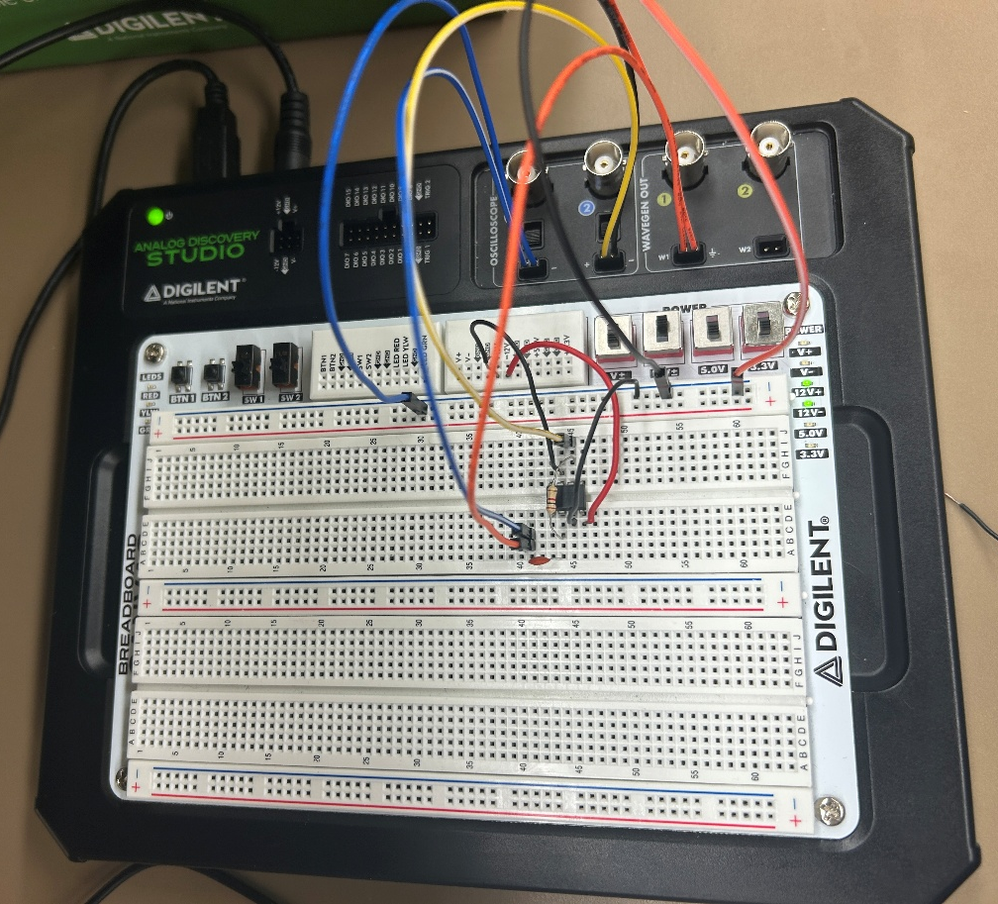
Figure #24: Op-Amp Differentiator Experimental Setup
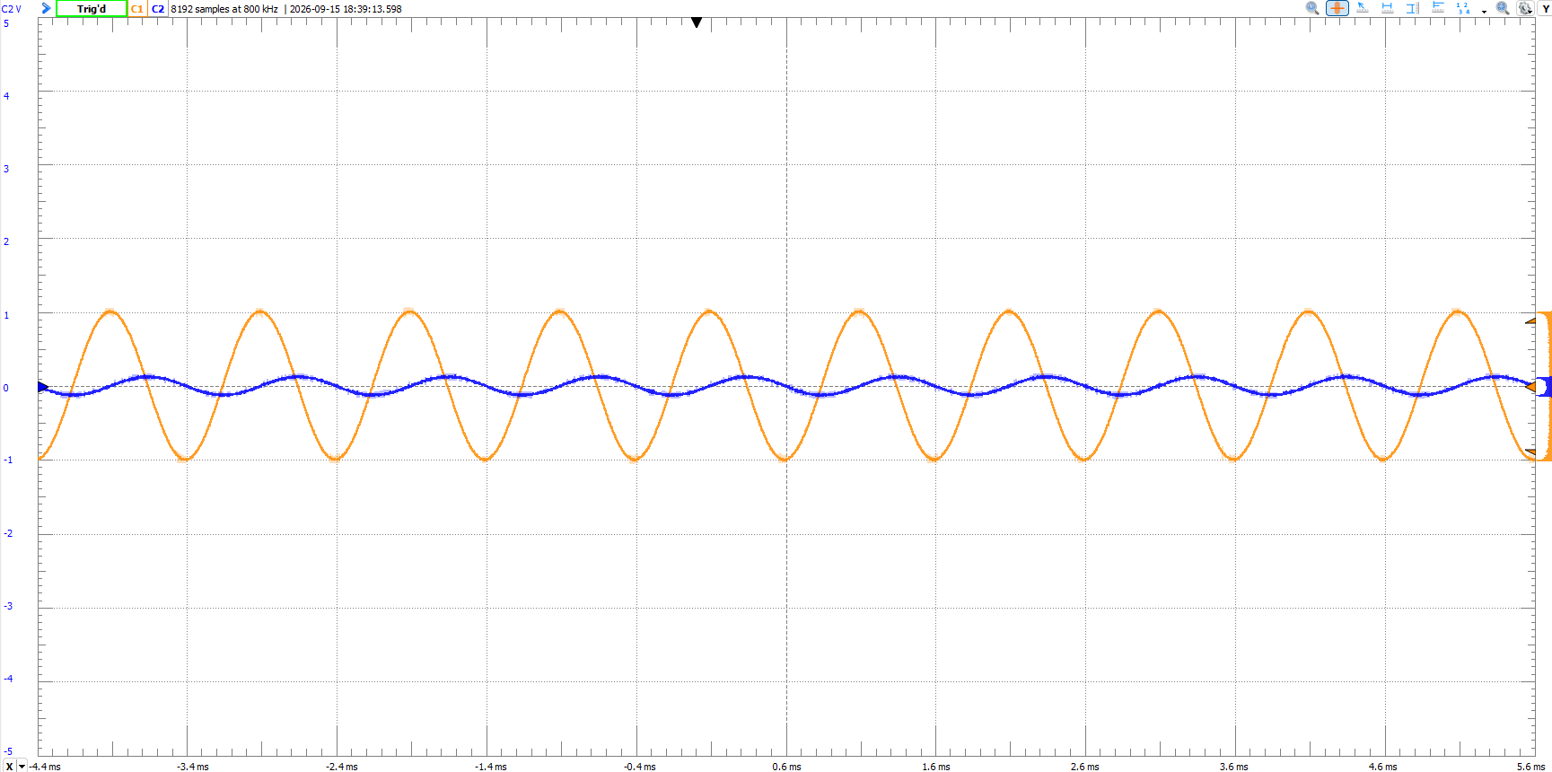
Figure #25: Differentiator Oscilloscope Output for $C=0.1 μF$ with Sinusoidal Input
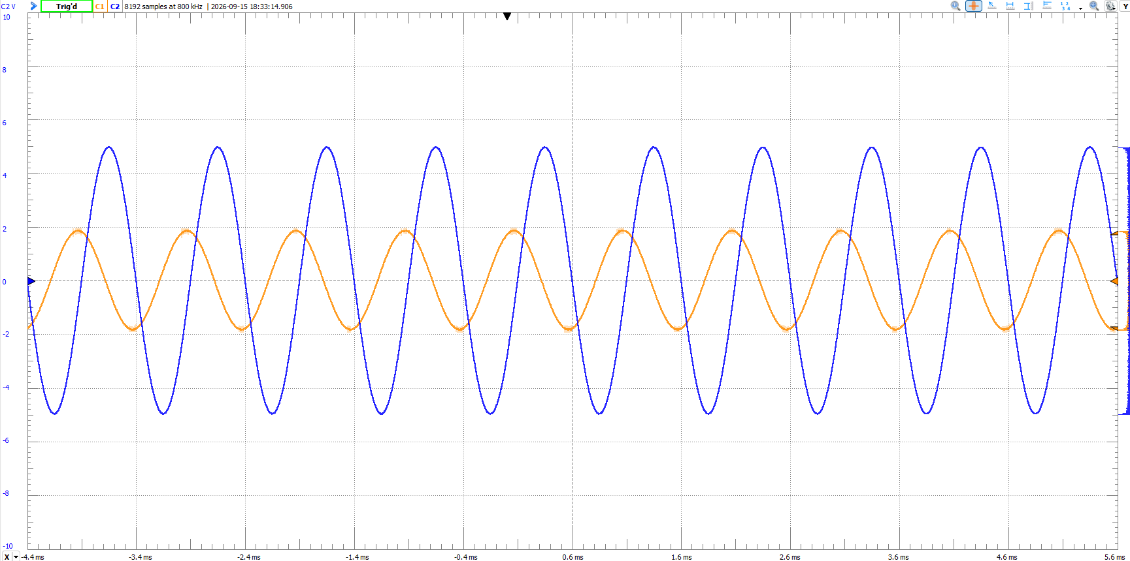
Figure #26: Differentiator Oscilloscope Output for $C=1 μF$ with Sinusoidal Input
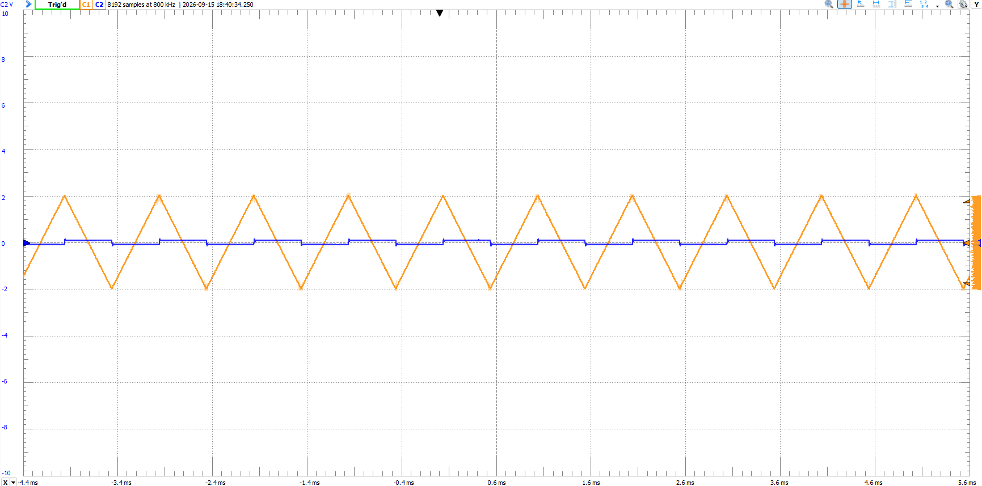
Figure #27: Differentiator Oscilloscope Output for $C=0.1 μF$ with Triangular Input
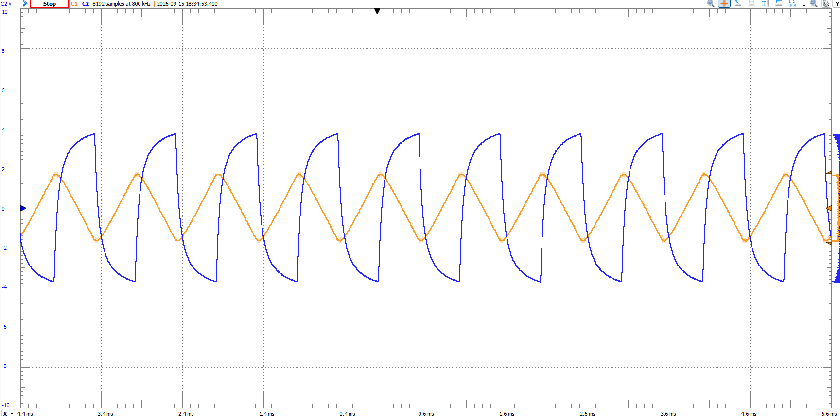
Figure #28: Differentiator Oscilloscope Output for $C=1 μF$ with Triangular Input
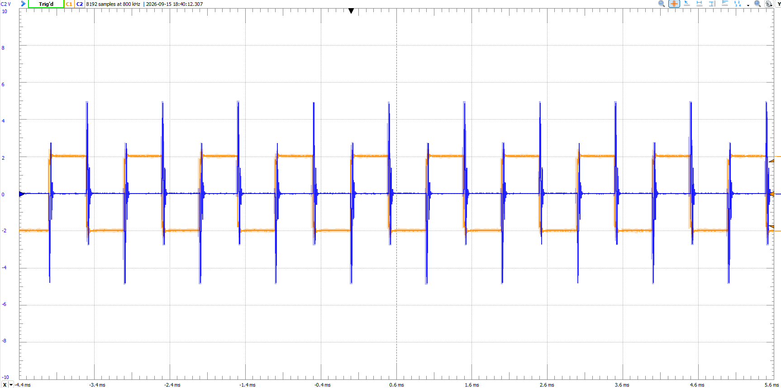
Figure #29: Differentiator Oscilloscope Output for $C=0.1 μF$ with Square Input
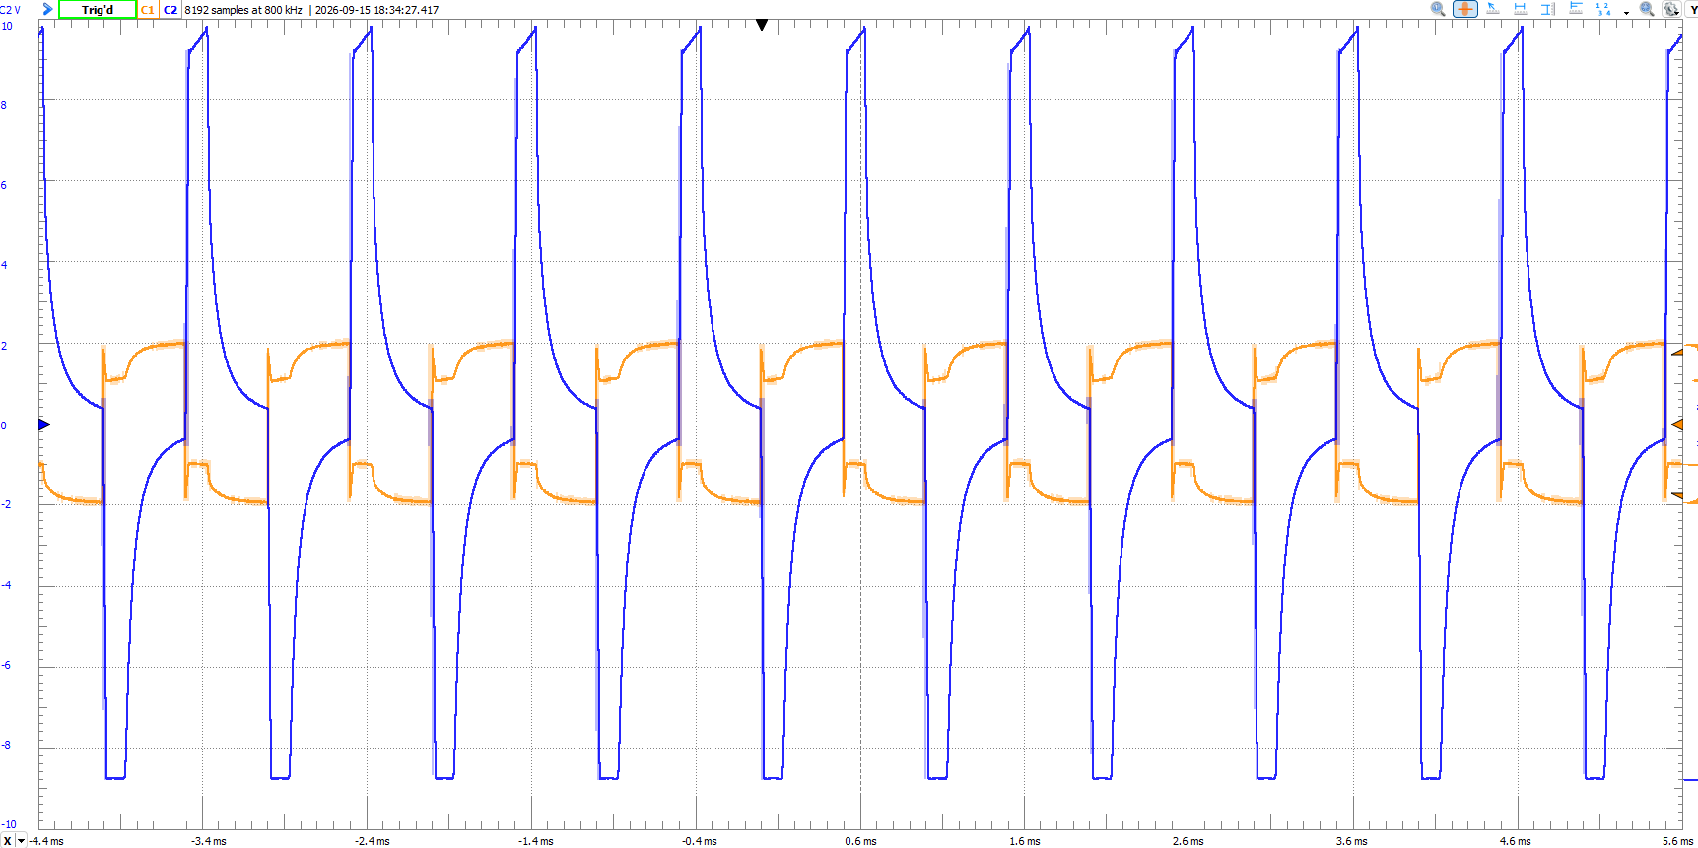
Figure #30: Differentiator Oscilloscope Output for $C=1 μF$ with Square Input
Comparison and Discussion:
Op-Amp Integrator:
The op-amp integrator demonstrates results consistent with the simulation. In both the experimental and simulation results, the output voltage is proportional to the integral of the input signal. For the square wave input, the output waveform behaves generally as expected, producing a linear change in voltage when the input is at a constant positive or negative level. Some noise is observed at the rising and falling edges of the waveform, most likely due to the abrupt changes in the input signal. In a practical circuit, a resistor can be added in parallel with the feedback capacitor to provide a DC feedback path and prevent the capacitor from continuously charging, which can help reduce output drift and clipping. However, this modification also changes the frequency response and reduces the circuit's gain at lower frequencies.
Op-Amp Differentiator:
The op-amp differentiator demonstrates results consistent with the simulation. The output voltage is proportional to the rate of change of the input signal in both the experiment and the simulation. For the square wave input, the output contains noticeable high-frequency noise, particularly around the rising and falling edges of the waveform. This occurs because the square wave has very rapid changes in voltage, which contain many high-frequency components. Since the differentiator amplifies higher-frequency components, it also amplifies these components of the square wave as well as unwanted high-frequency noise in the signal. In an actual circuit, the noise and distortion can be reduced by adding a resistor in series with the input capacitor. This limits the high-frequency gain of the differentiator, reducing the amplification of unwanted high-frequency components and producing a smoother output. However, this modification also reduces the circuit's gain at higher frequencies.
Conclusion:
This lab investigated the behavior of op-amp integrator and differentiator circuits using both LTSpice simulations and experimental measurements. The results demonstrated how the input waveform and frequency affect the output waveform, gain, and phase relationship of each circuit. I also learned how to troubleshoot op-amp circuits and identify potential causes of noise and distortion. Although troubleshooting the circuits was challenging, it helped reinforce the differences between simulated and experimental results and provided a better understanding of how practical circuit modifications can improve circuit performance.

