EE 316
Section 3
Pre Lab 03
By: Hannah Kelley
Op-Amp Integrator and Differentiator Circuits
Introduction:
This lab investigates the behavior of operational amplifier differentiator circuits by examining the relationship between the input and output waveforms. The effects of different input waveforms and frequencies are observed using LTspice simulations and an oscilloscope, with particular attention given to output gain, phase relationship, and high-frequency noise.
Simulations and Results:
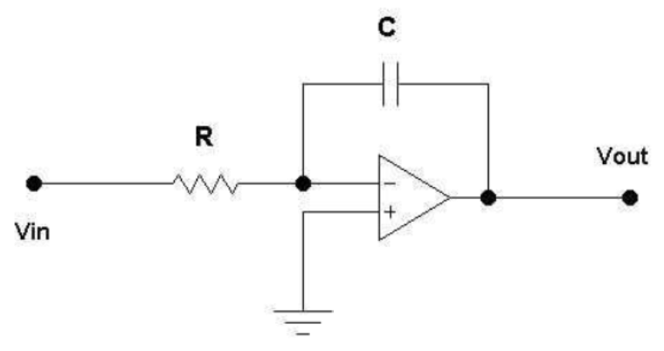
Figure #1: Op-Amp Integrator Schematic from Lab Manual
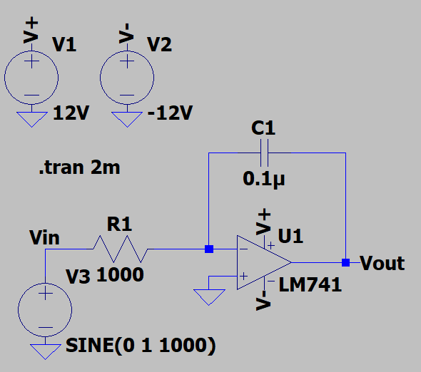
Figure #2: Op-Amp Integrator with $C=0.1 μF$ and Sinusoidal Input (LTSpice)
The following input voltage commands were used to generate a sinusoidal, triangular, and square wave respectively: SINE(0 1 1000), PWL REPEAT FOREVER (0 -1 0.5m 1 1m -1) ENDREPEAT, and PULSE(-1 1 0 1n 1n 0.5m 1m). The same commands were later used for the differentiating amplifier.
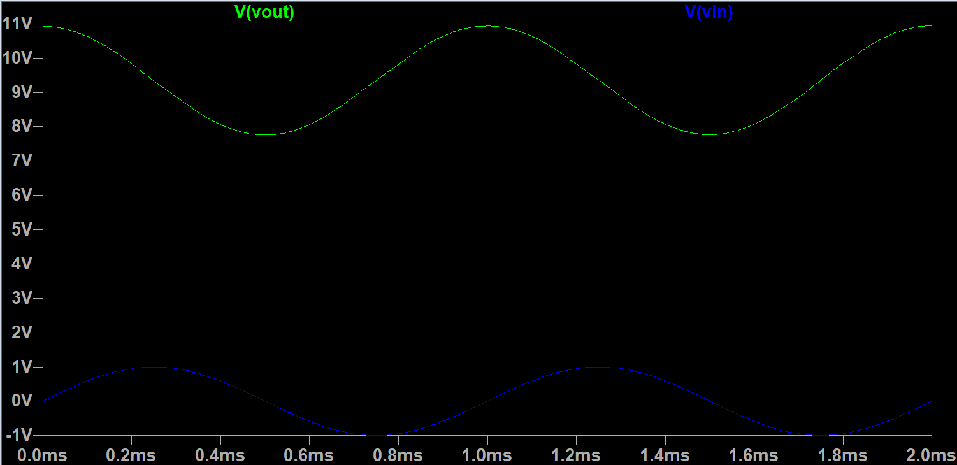
Figure #3: Integrator Oscilloscope Output for $C=0.1 μF$ with Sinusoidal Input
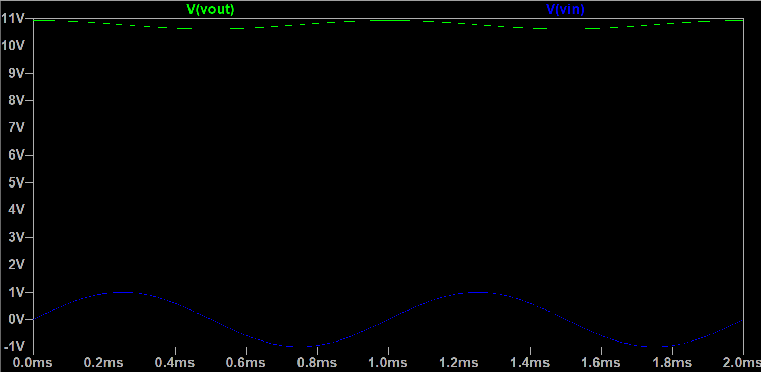
Figure #4: Integrator Oscilloscope Output for $C=1 μF$ with Sinusoidal Input
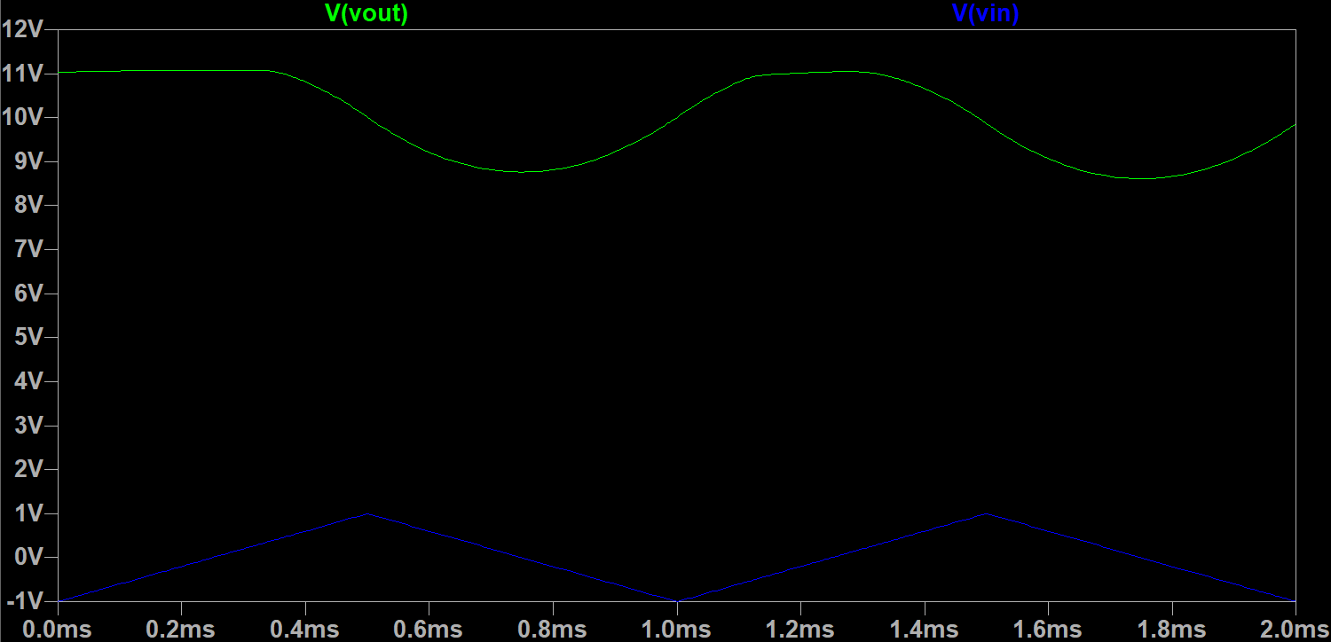
Figure #5: Integrator Oscilloscope Output for $C=0.1 μF$ with Triangular Input
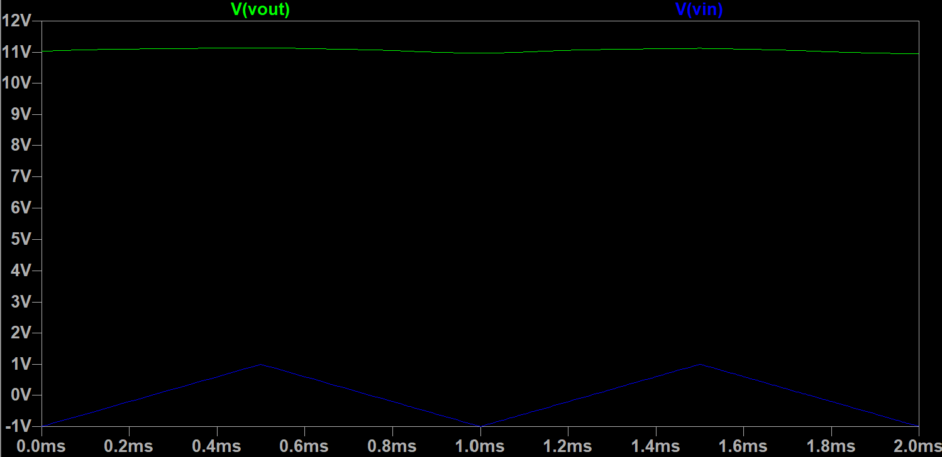
Figure #6: Integrator Oscilloscope Output for $C=1 μF$ with Triangular Input
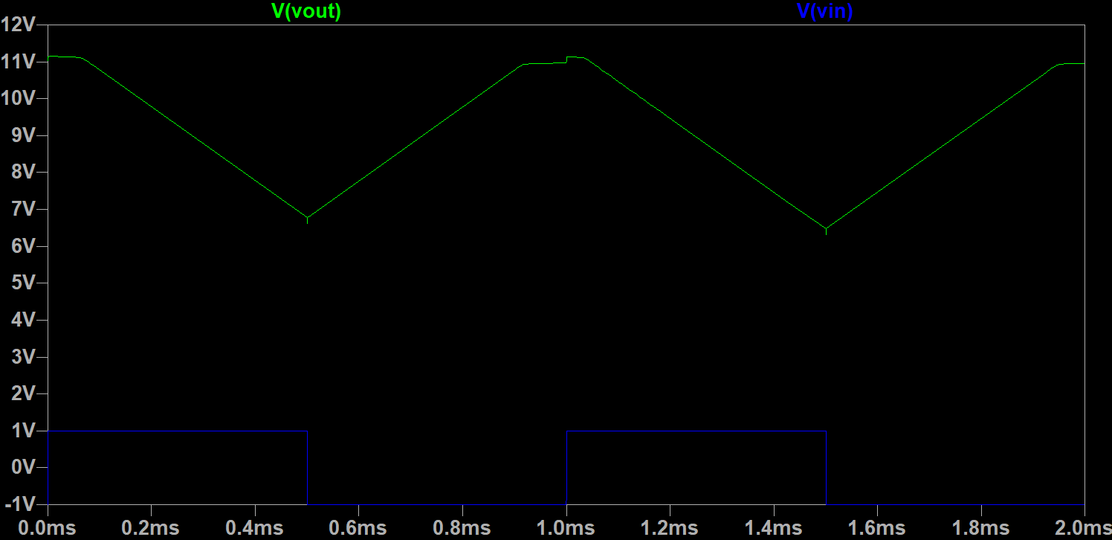
Figure #7: Integrator Oscilloscope Output for $C=0.1 μF$ with Square Input
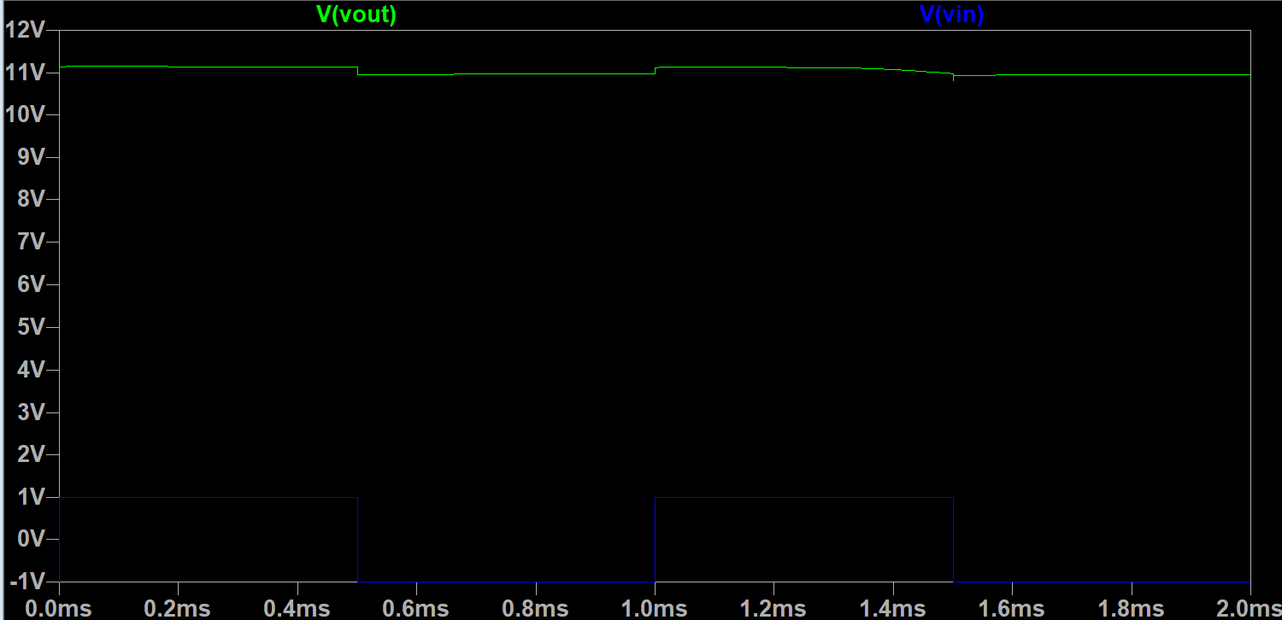
Figure #8: Integrator Oscilloscope Output for $C=1 μF$ with Square Input
The output waveform demonstrates the expected integrating behavior of the inverting integrator. Because the gain is frequency-dependent, the output magnitude depends on R, C, and the input frequency rather than remaining constant. The output also has the expected phase relationship with the input, with a sinusoidal input producing an approximately 90° phase-shifted cosine waveform. The square-wave input produces a triangular output, while the triangular input produces a curved, parabolic output. In some cases, the output also approaches the upper power rail, as the capacitor can initially act similarly to a short circuit and cause a large output response before the capacitor charges. Overall, the results demonstrate the expected relationships of an integrator, with sine, triangular, and square inputs producing cosine, parabolic, and triangle outputs respectively.
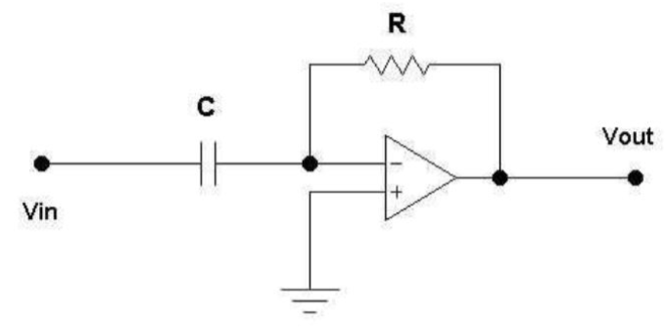
Figure #9: Op-Amp Differentiator Schematic from Lab Manual
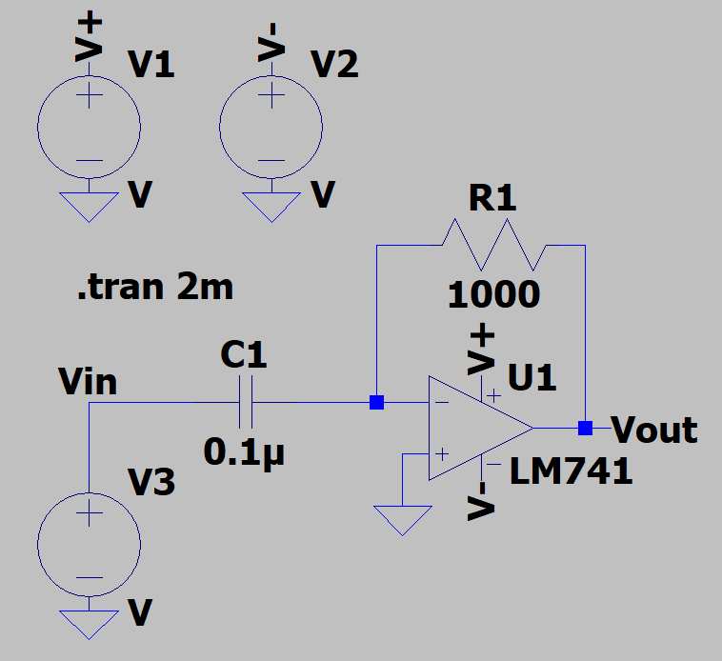
Figure #10: Op-Amp Differentiator with $C=0.1 μF$ and Sinusoidal Input (LTSpice)
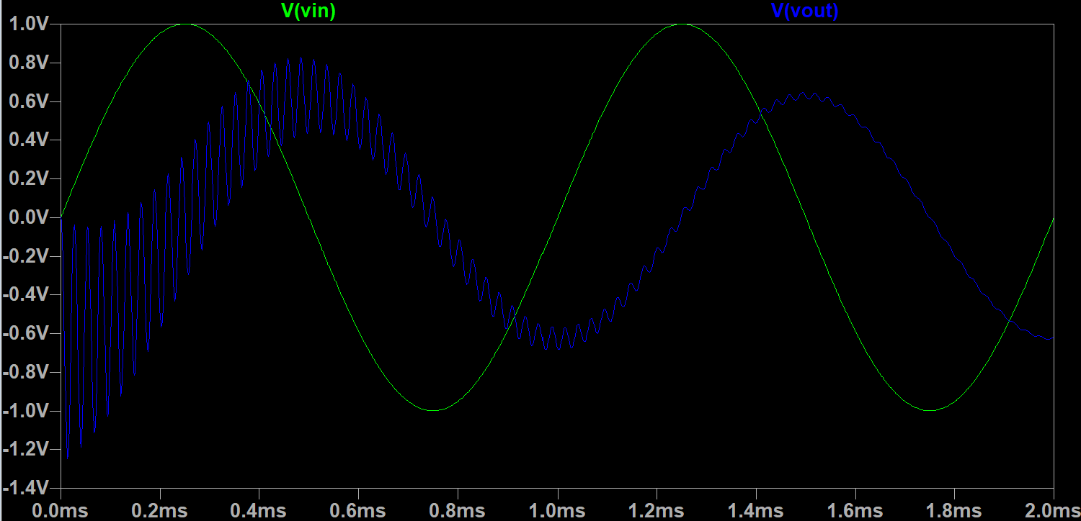
Figure #11: Differentiator Oscilloscope Output for $C=0.1 μF$ with Sinusoidal Input
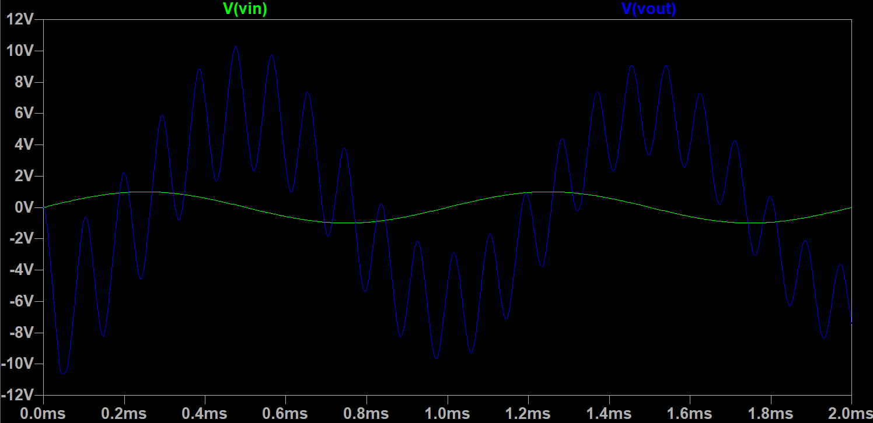
Figure #12: Differentiator Oscilloscope Output for $C=1 μF$ with Sinusoidal Input
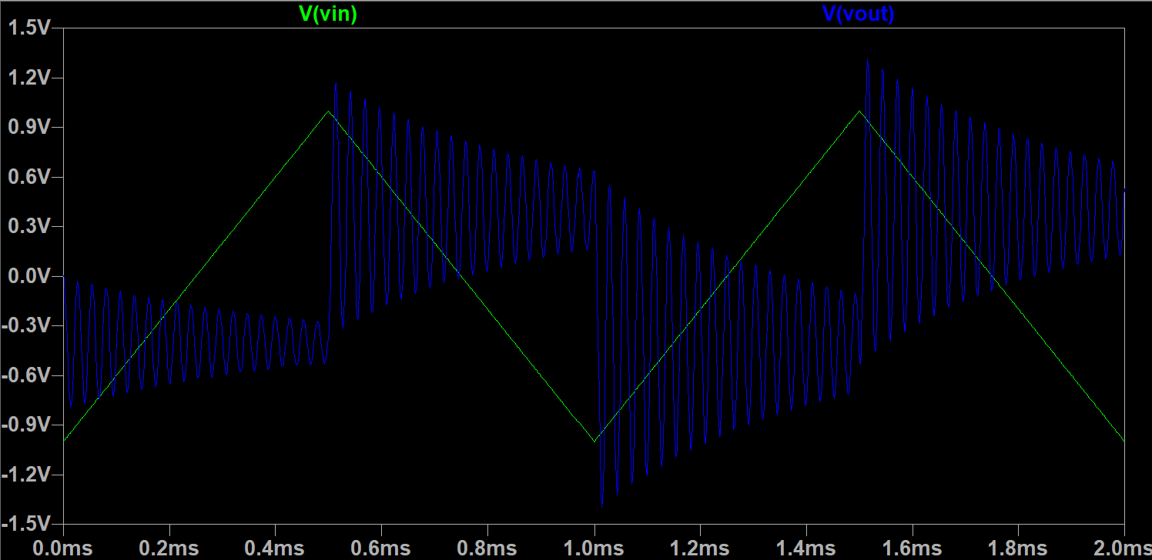
Figure #13: Differentiator Oscilloscope Output for $C=0.1 μF$ with Triangular Input
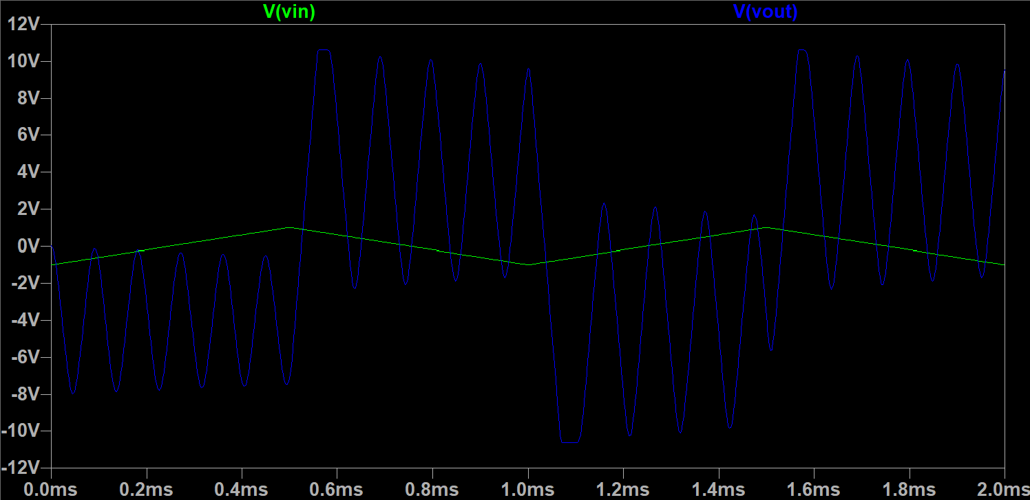
Figure #14: Differentiator Oscilloscope Output for $C=1 μF$ with Triangular Input
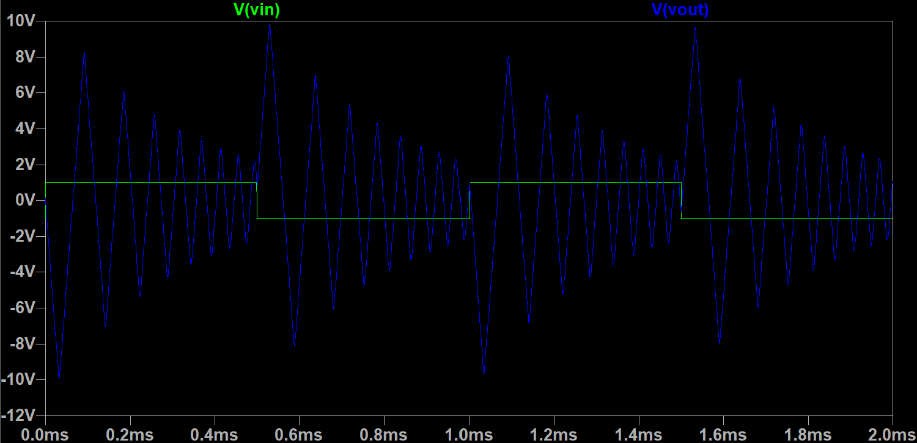
Figure #15: Differentiator Oscilloscope Output for $C=0.1 μF$ with Square Input
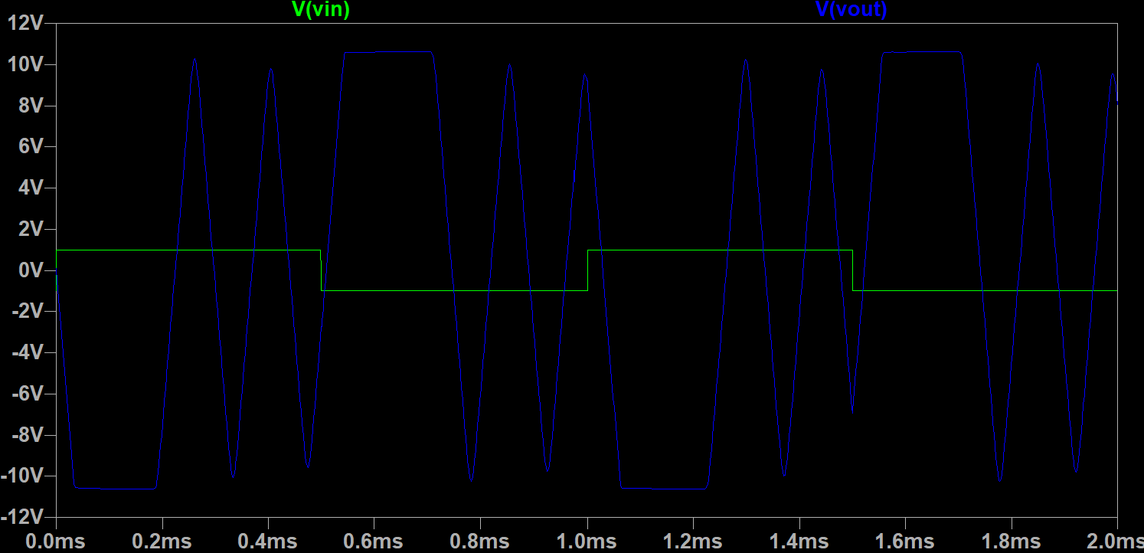
Figure #16: Differentiator Oscilloscope Output for $C=1 μF$ with Square Input
The op-amp differentiator demonstrates the expected differentiating behavior, where the output voltage is proportional to the rate of change of the input signal. As the frequency of the input increases, the magnitude of the output also increases, resulting in a higher gain at higher frequencies. On the oscilloscope, the input and output waveforms show the expected phase relationship for an inverting differentiator, with the output responding to changes in the input waveform rather than its overall magnitude. High-frequency noise is also visible in the output waveform because the differentiator inherently amplifies high-frequency components, including unwanted noise present in the circuit. As seen in Figures 11 and 12, this noise can taper off and become less noticeable with time. Conversely, as seen in Figures 13-16, this noise may persist throughout the simulation. Therefore, the output may appear less smooth at higher frequencies even though the overall waveform follows the expected differentiator behavior.

