EE 316
Section 3
Lab 01
By: Hannah Kelley
Circuits Review

Introduction:
The purpose of this lab is to review concepts used to analyze basic circuits such as mesh current analysis, nodal analysis, and Thevenin and Norton equivalent circuits while introducing lab tools such as LT Spice and the lab breadboarding and measurement tools. This lab also serves as a hands-on way to validate basic circuit laws such as Ohm’s Law and Kirchoff’s Current and Voltage Laws.
Theoretical Analysis:
Part 1A
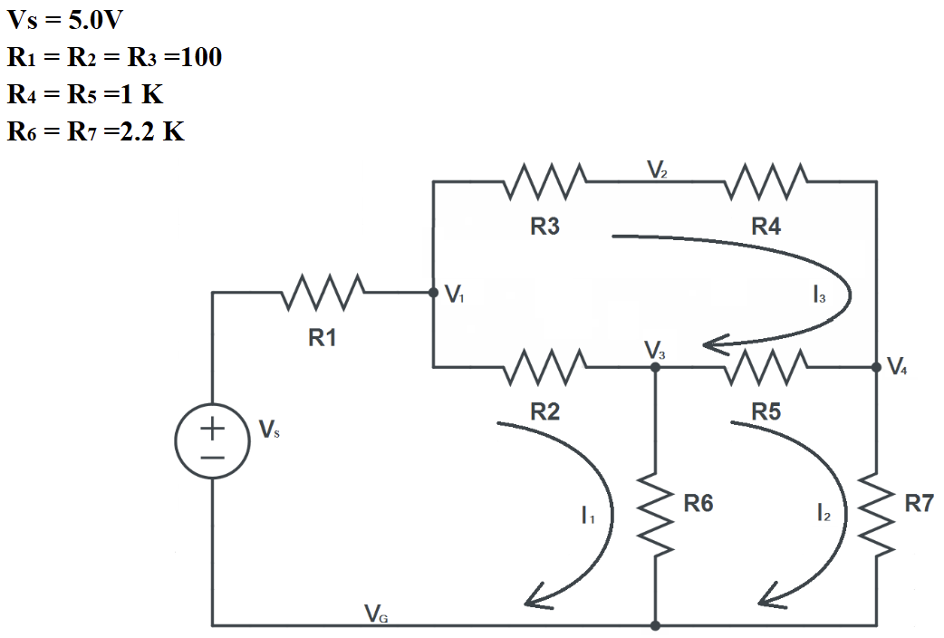
Figure #1: Circuit Schematic from Lab Manual (Part A)
Based on Figure 1, mesh analysis (as seen in Figure 2) was used to obtain the following general equations.
$$\begin{aligned} I_{1}\left(R_{1}+R_{2}+R_{6}\right)-I_{2}R_{6}-I_{3}R_{2}=5V\#(1)\end{aligned}$$
$$\begin{aligned}-I_{1}R_{6}+I_{2}\left(R_{5}+R_{6}+R_{7}\right)-I_{3}R_{5}=0V\#(2)\end{aligned}$$
$$\begin{aligned}-{I_{1}R}_{2}-I_{2}R_{5}+I_{3}\left({R_{2}+R}_{3}+R_{4}+R_{5}\right)=0V\#\left(3\right)\end{aligned}$$
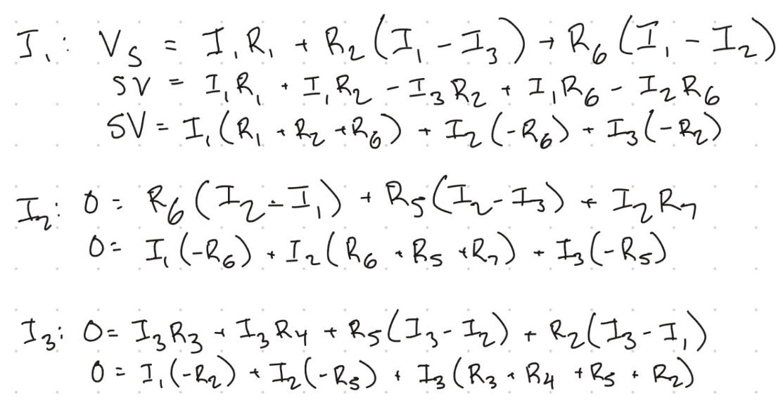
Figure #2: Mesh Analysis for Part A
Equations 1-3 were then used to find the mesh currents, branch currents, node voltages, and branch currents for all elements, branches, and meshes in Figure 1. This process was repeated three times with resistor values at 90%, 100%, and 110% of the given values as seen in Table 1.
Resistor Values | Resistor | Value (Ohms)
90% | R₁, R₂, R₃ | 90
90% | R₄, R₅ | 900
90% | R₆, R₇ | 1980
100% | R₁, R₂, R₃ | 100
100% | R₄, R₅ | 1000
100% | R₆, R₇ | 2200
110% | R₁, R₂, R₃ | 110
110% | R₄, R₅ | 1100
110% | R₆, R₇ | 2420
Table #1: Resistor Values for Part 1A
Using these resistor values, the mesh current values were found using matrix multiplication and equation 4
$$\begin{aligned}m=R^{-1}V\#\left(4\right)\end{aligned}$$
Where m is the matrix containing the mesh current values, $R^{-1}$ is the inverse of the resistance matrix, and $V$ is the matrix containing the voltage source values. Using the mesh current and resistor values, the node voltages, branch currents, and branch voltages were calculated using equations 5- 8, 9- 15, and Ohm’s Law $\left(V_{n}=I_{n}R_{n}\right)$, respectively.

Node Voltages
$$\begin{aligned}V_{1}=V_{S}-V_{R1}\#\left(5\right)\end{aligned}$$
$$\begin{aligned}V_{2}=V_{1}-V_{R3}\#\left(6\right)\end{aligned}$$
$$\begin{aligned}V_{3}=V_{R6}\#\left(7\right)\end{aligned}$$
$$\begin{aligned}V_{4}=V_{R7}\#\left(8\right)\end{aligned}$$

Branch Currents
$$\begin{aligned}i_{R1}=I_{1}\#\left(9\right)\end{aligned}$$
$$\begin{aligned}i_{R2}=I_{1}-I_{3}\#\left(10\right)\end{aligned}$$
$$\begin{aligned}i_{R3}=I_{3}\#\left(11\right)\end{aligned}$$
$$\begin{aligned}i_{R4}=I_{3}\#\left(12\right)\end{aligned}$$
$$\begin{aligned}i_{R5}=I_{3}-I_{2}\#\left(13\right)\end{aligned}$$
$$\begin{aligned}i_{R6}=I_{1}-I_{2}\#\left(14\right)\end{aligned}$$
$$\begin{aligned}i_{R7}=I_{2}\#\left(15\right)\end{aligned}$$

The mesh current, branch current, node voltage, and branch current values are summarized in Tables 2-4.
Branch Voltages | Branch Currents | Node Voltages | Loop Currents
V_{R1} = 363.42 mV | i_{R1} = 4.038 mA | V₁ = 4.637 V | I₁ = 4.038 mA
V_{R2} = 271.89 mV | i_{R2} = 3.021 mA | V₂ = 4.544 V | I₂ = 1.833 mA
V_{R3} = 91.53 mV | i_{R3} = 1.017 mA | V₃ = 4.366 V | I₃ = 1.017 mA
V_{R4} = 915.3 mV | i_{R4} = 1.017 mA | V₄ = 3.629 V
V_{R5} = 734.4 mV | i_{R5} = 0.816 mA
V_{R6} = 4.366 V | i_{R6} = 2.205 mA
V_{R7} = 3.629 V | i_{R7} =1.833 mA
Table #2: Theoretical Data for Part A (90% Resistor Values)
Branch Voltages | Branch Currents | Node Voltages | Loop Currents
V_{R1} = 403.8 mV | i_{R1} = 3.634 mA | V₁ = 4.637 V | I₁ = 3.634 mA
V_{R2} = 302.2 mV | i_{R2} = 2.719 mA | V₂ = 4.545 V | I₂ = 1.650 mA
V_{R3} = 101.7 mV | i_{R3} = 0.915 mA | V₃ = 4.365 V | I₃ = 0.915 mA
V_{R4} = 1.017 V | i_{R4} = 0.915 mA | V₄ = 3.630 V
V_{R5} = 0.816 V | i_{R5} = 0.735 mA
V_{R6} = 4.366 V | i_{R6} = 1.984 mA
V_{R7} = 3.629 V | i_{R7} =1.650 mA
Table #3: Theoretical Data for Part A (100% Resistor Values)

Branch Voltages | Branch Currents | Node Voltages | Loop Currents
V_{R1} = 363.44 mV | i_{R1} = 3.304 mA | V₁ = 4.637 V | I₁ = 3.304 mA
V_{R2} = 271.92 mV | i_{R2} = 2.472 mA | V₂ =4.545 V | I₂ = 1.500 mA
V_{R3} = 91.52 mV | i_{R3} = 0.832 mA | V₃ = 4.366 V | I₃ = 0.832 mA
V_{R4} = 1.025 V | i_{R4} = 0.932 mA | V₄ = 3.630 V
V_{R5} = 734.8 mV | i_{R5} = 0.668 mA
V_{R6} = 4.366 V | i_{R6} = 1.804 mA
V_{R7} = 3.63 V | i_{R7} = 1.500 mA
Table #4: Theoretical Data for Part A (110% Resistor Values)
Part 2
Using Figure 3, the open circuit voltage $V_{OC}$ and short circuit current $I_{SC}$ across terminals A and B were calculated using a voltage divider and mesh current analysis found in Figures 3 and 4, respectively.
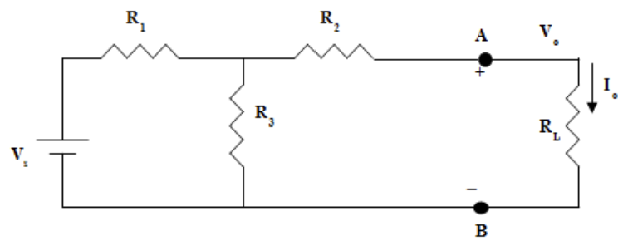
Figure #3: Circuit Schematic from Lab Manual (Part 2)
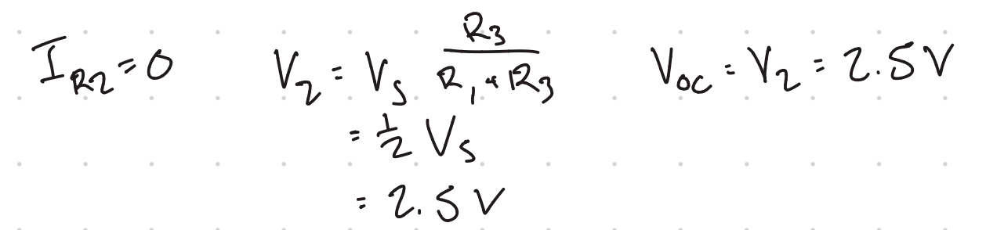
Figure #4: $V_{OC}$ Calculations using Node Voltage Analysis
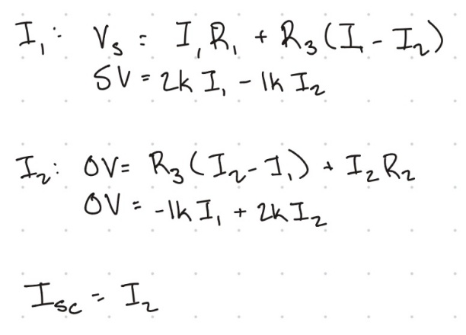
Figure #5: $I_{SC}$ Calculations using Mesh Current Analysis
Next, the Thevenin equivalent resistance $R_{TH}$ and Norton equivalent resistance R_{N} was calculated using equation 16.
$$\begin{aligned}R_{TH}=R_{N}=\frac{V_{OC}}{I_{SC}}\#\left(14\right)\end{aligned}$$
A summary of these analytical values—V_{OC}, I_{SC}, and R_{TH}, R_{N}, and I_{N}—can be found in Table 5.
 | Value
V_{OC} | 2.5 V
I_{SC} | 1.667 mA
R_{TH} | 4.168 Ohms
R_{N} | 4.168 Ohms
I_{N} | 1.667 mA
Table #5: Thevenin and Norton Analytical Values (Part 1B)
The Thevenin and Norton equivalent circuits of Figure 3can be found in Figures 6 and 7.

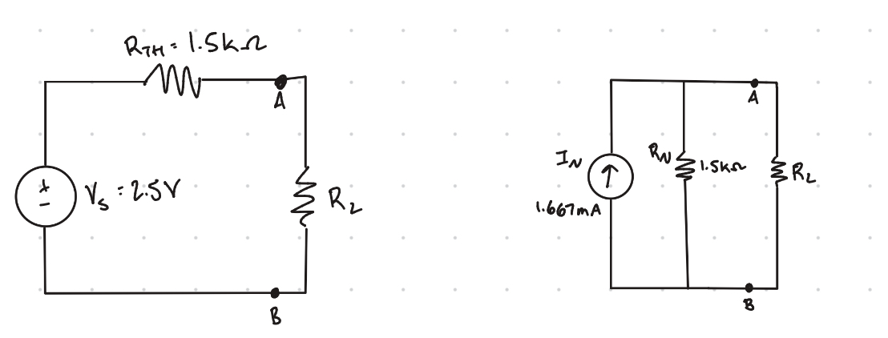
Figure #6: Thevenin Equivalent Circuit
Figure #7: Norton Equivalent Circuit
Simulation Results:
Part 1A
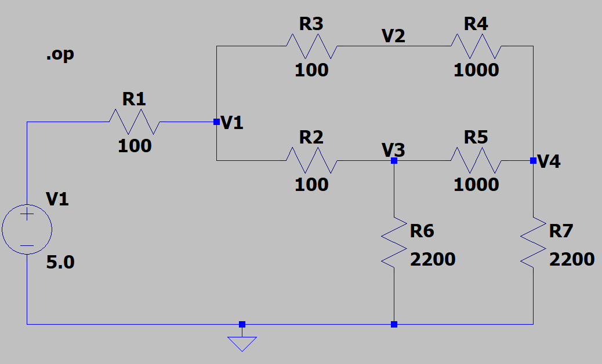
Figure #8: Simulation in LT Spice (Part A)
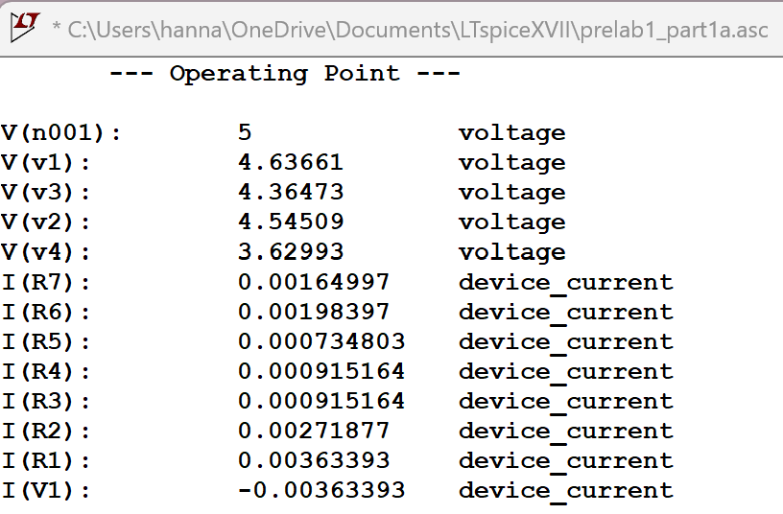
Figure #9: Simulation Output from LT Spice (Part A)
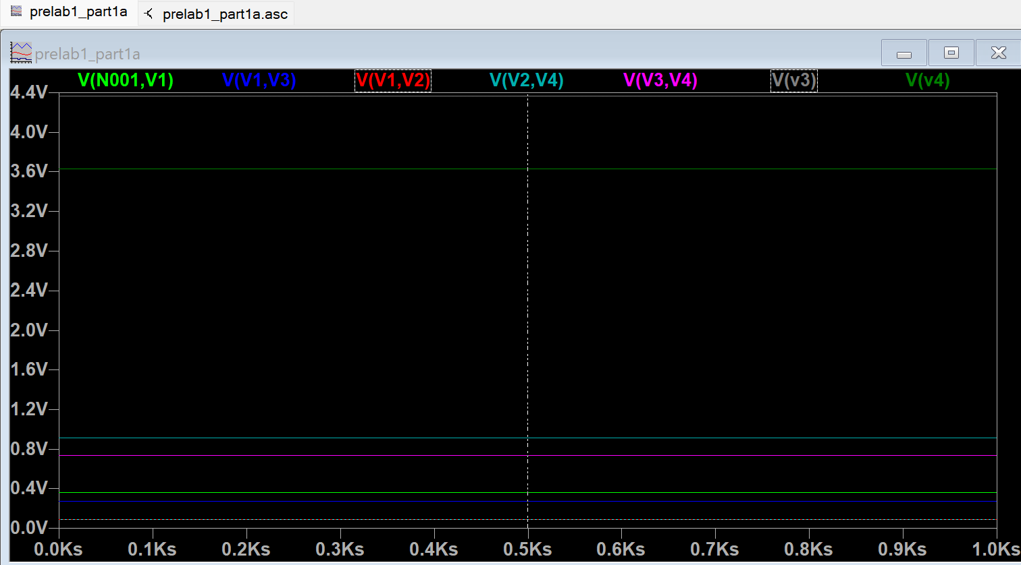
Figure #10: Branch Voltage Data from LT Spice Simulation (Part A)
Branch Voltages | Branch Currents | Node Voltages | Loop Currents
V_{R1} = 363.39331 mV | i_{R1} = 3.63393 mA | V₁ = 4.63661 V | I₁ = 3.63393 mA
V_{R2} = 271.87729 mV | i_{R2} = 2.71877 mA | V₂ = 4.54509 V | I₂ = 1.64997 mA
V_{R3} = 91.516495 mV | i_{R3} = 0.915164 mA | V₃ = 4.36473 V | I₃ = 0.915164 mA
V_{R4} = 915.16376 mV | i_{R4} = 0.915164 mA | V₄ = 3.62993 V
V_{R5} = 734.80296 mV | i_{R5} = 0.734803 mA
V_{R6} = 4.3647294 V | i_{R6} = 1.98397 mA
V_{R7} = 3.6299264 V | i_{R7} = 1.64997 mA
Table #6: Simulation Data for Part A
Part 1B
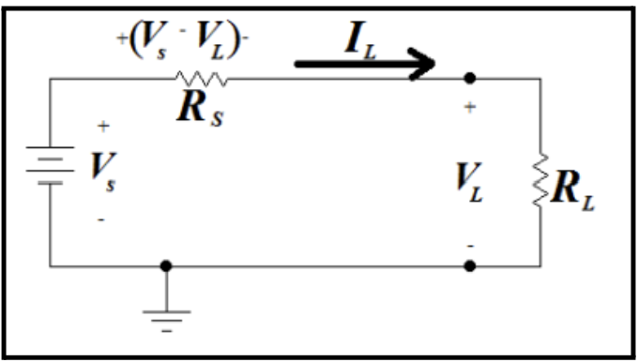
Figure #11: Circuit from Lab Manual (Part B)
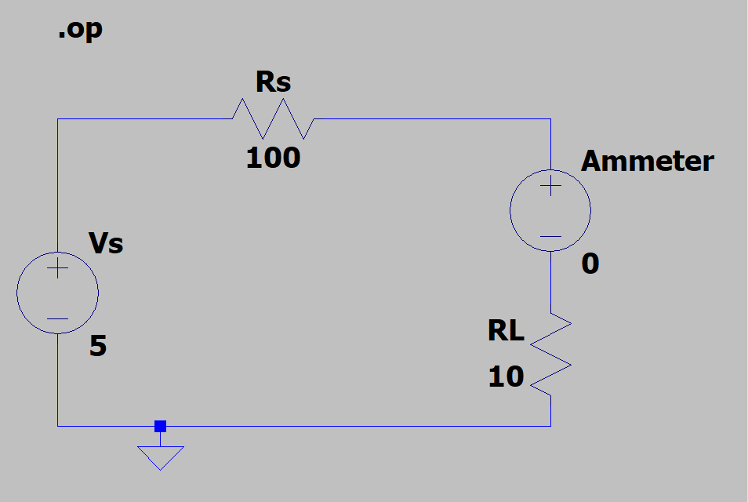
Figure #12: Simulation in LT Spice at R_{L} = 10 Ohms (Part B)
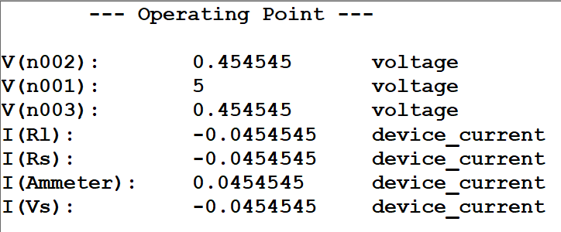
Figure #13: Output of Part B Simulation at R_{L} = 10 Ohms

R_{L} (Ohms) | V_{L} (V) | I_{L} (mA)
10 | 454.54547 mV | 45.454547 mA
20 | 833.33331 mV | 41.666668 mA
40 | 1.4285715 V | 35.714287mA
70 | 2.0588236 V | 29.411765mA
100 | 2.5 V | 25 mA
150 | 3 V | 20 mA
200 | 3.3333333 V | 16.666668 mA
300 | 3.75 V | 12.5 mA
500 | 4.1666665 V | 8.3333338 mA
1000 | 4.5454545 V | 4.5454544 mA
Table #7: Simulation Data for Part B
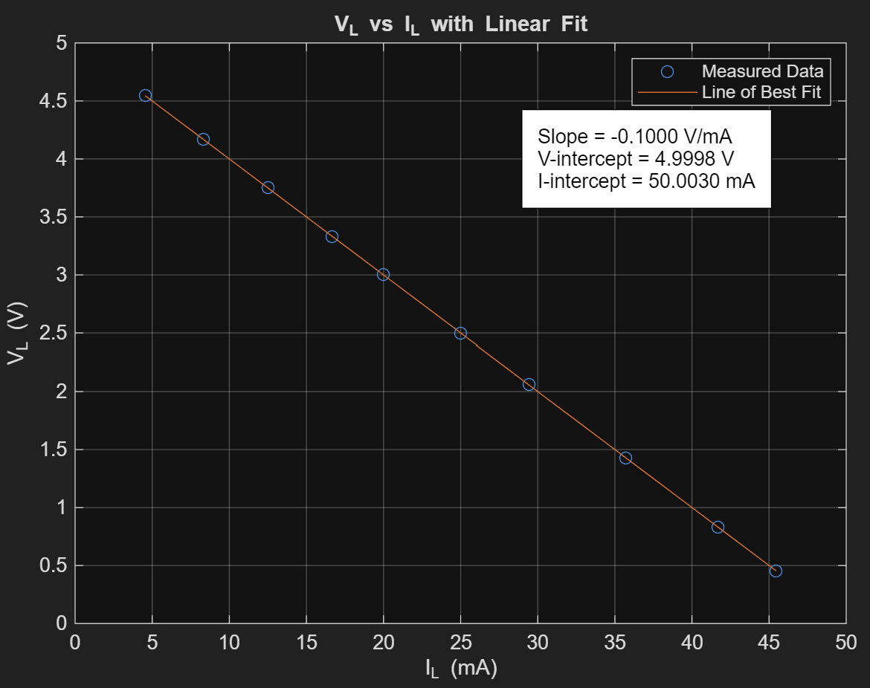
Figure #14: Load Voltage vs. Load Current (MATLAB)

IL = [45.455 41.667 35.714 29.412 25 20 16.667 12.5 8.333 4.545]; % in Amps
VL = [0.455 0.833 1.429 2.059 2.5 3 3.333 3.75 4.167 4.545]; % in Volts

p = polyfit(IL, VL, 1); % eq for line of best fit
VL_fit = polyval(p, IL);
slope = p(1);
y_intercept = p(2);
x_intercept = -y_intercept / slope;

plot (IL, VL, ‘o’)
hold on
plot(IL, VL_fit)
hold off

xlabel(‘I_L (mA)’);
ylabel(‘V_L (V)’);
title(‘V_L vs I_L with Linear Fit’);
legend(‘Measured Data’, ‘Line of Best Fit’, ‘Location’, ‘northeast’);
grid on;

text(30, 4.0, print([‘Slope = %.4f V/mA\n’ ...
‘V-intercept = %.4f V\n’ ...
‘I-intercept = %.4f mA’], ...
slope, y_intercept, x_intercept), ...
‘Color’, ‘black’, ...
‘BackgroundColor’, ‘white’, ...
‘EdgeColor’, ‘black’, ...
‘Margin’, 8);
Table #8: MATLAB Code Used to Produce Figure 8

Part 2
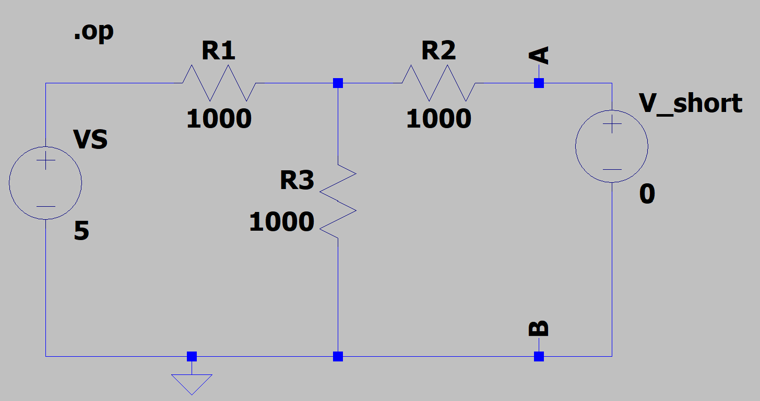
Figure #15: Simulated Circuit for Part 2 (V_short)
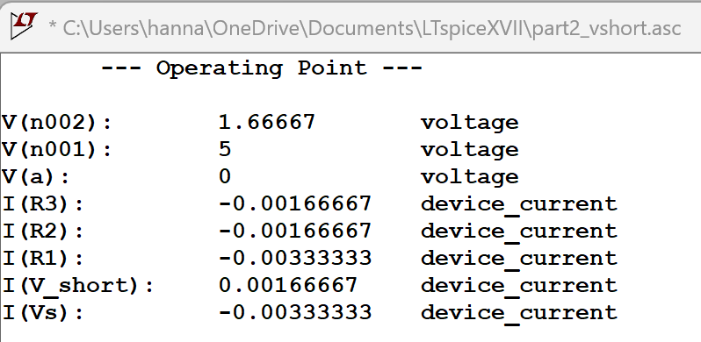
Figure #16: Simulated Outputs of V_short
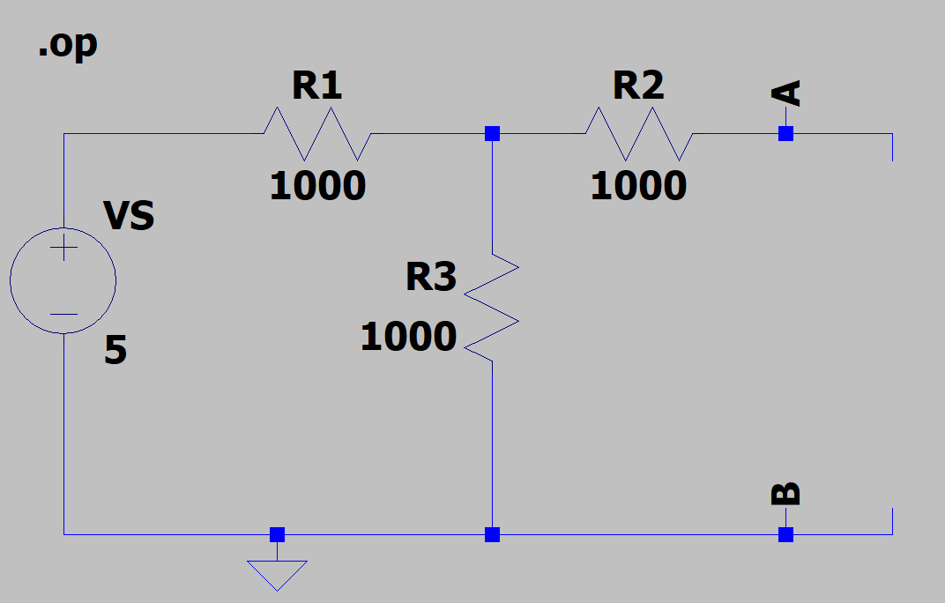
Figure #17: Simulated Circuit for Part 2 (I_oc)
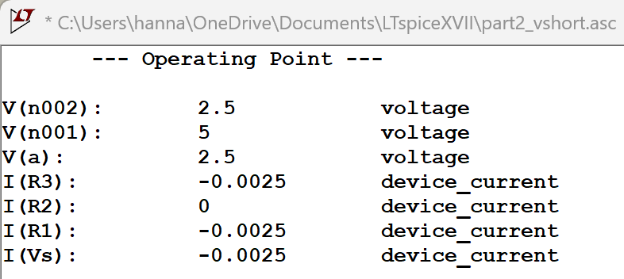
Figure #18: Simulated Outputs of I_oc
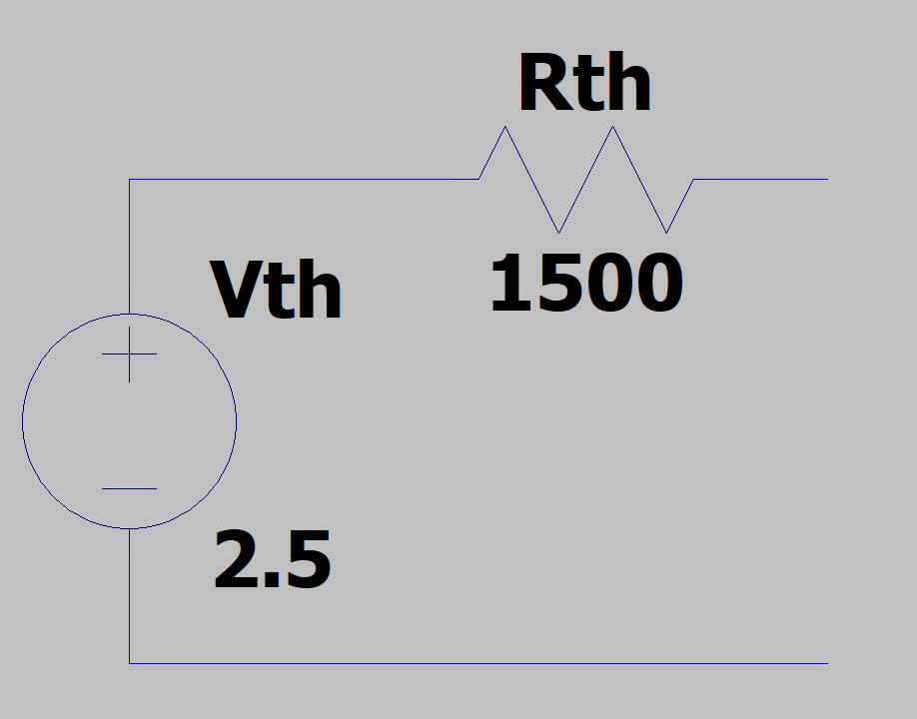
Figure #19: Thevenin Equivalent Circuit
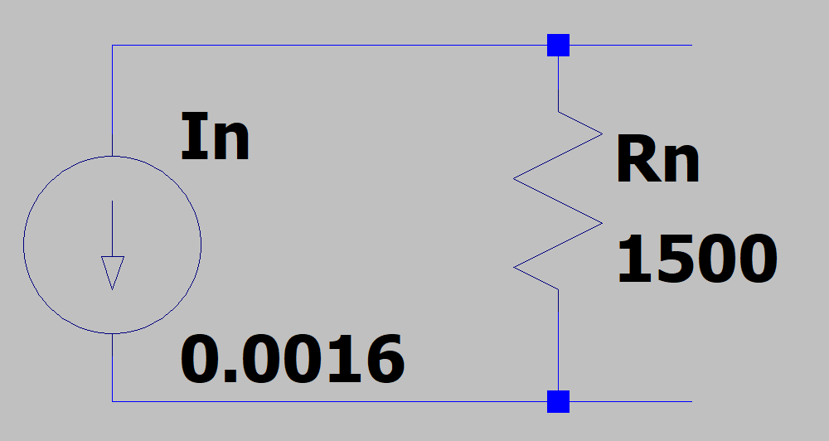
Figure #20: Norton Equivalent Circuit

Circuit | R_{L} (Ohms) | P_{max}
Thevenin | 1500 | $$P_{max}=\frac{V_{th}^{2}R_{L}}{2R_{TH}}=1.042 mW$$
Norton | 1500 | $$P_{max}=\frac{I_{N}^{2}R_{N}^{2}R_{L}}{{\left(R_{N}+R_{L}\right)}^{2}}=0.960 mW$$
Table #9: Power Calculations of Thevenin and Norton Circuits
Experimental Setup and Results:
Part 1A
The circuit diagram found in Figure 1 was built using the Analog/Digital Trainer in the electronic laboratory. A picture of the breadboarded circuit can be found in Figure 21. Using this circuit and a digital multimeter, the branch voltages, branch currents, node voltages, and loop currents were measured and recorded in Table 10.
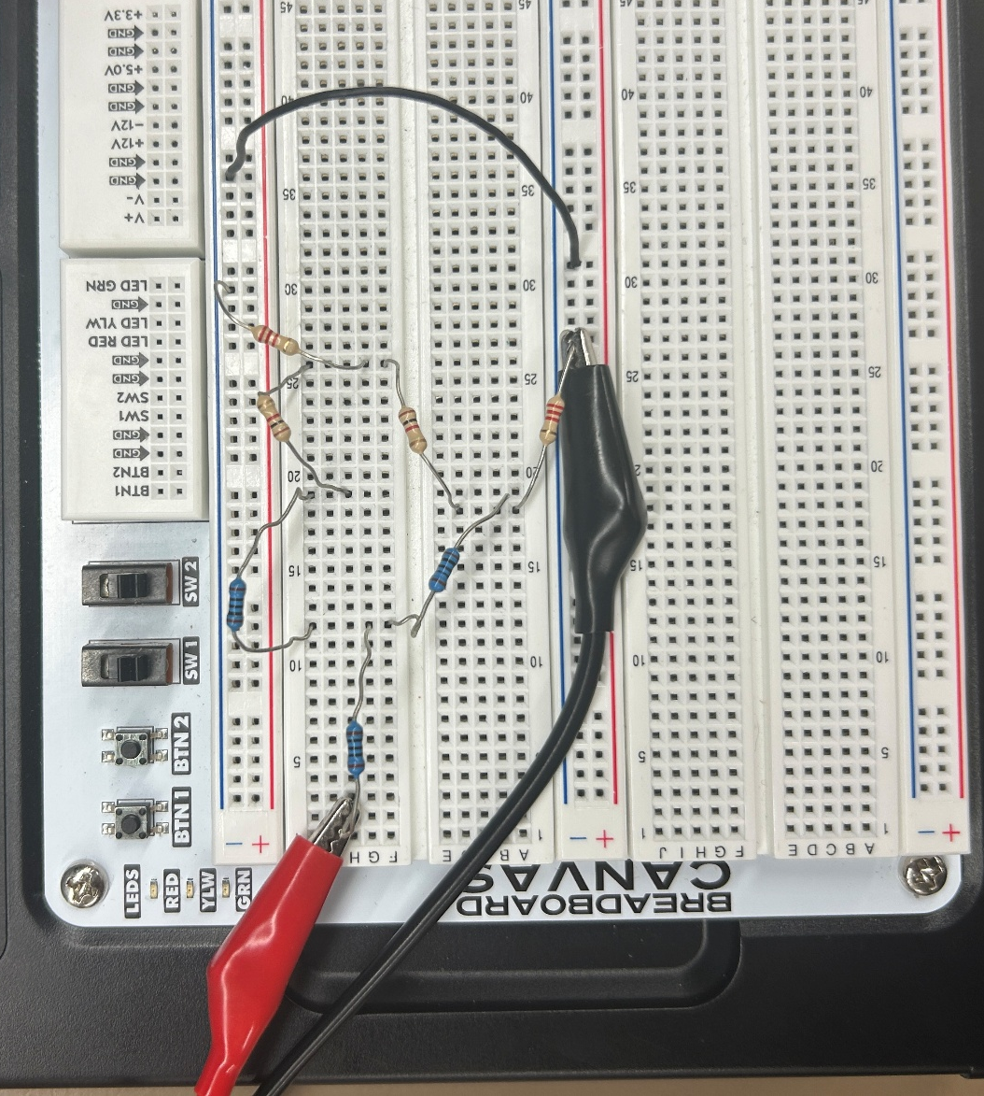
Figure #21: Experimental Setup (Part 1A)
Branch Voltages | Branch Currents | Node Voltages | Loop Currents
V_{R1} = 368.5 mV | i_{R1} = 3.44 mA | V₁ = 4.632 V | I₁ = 3.44 mA
V_{R2} = 276.8 mV | i_{R2} = 2.70 mA | V₂ = 4.538 V | I₂ = 1.669 mA
V_{R3} = 93.6 mV | i_{R3} = 0.8 mA | V₃ = 4.408 V | I₃ = 0.924 mA
V_{R4} = 925.4 mV | i_{R4} = 0.924 mA | V₄ = 3.666 V
V_{R5} = 742.3 mV | i_{R5} = 0.737 mA
V_{R6} = 4.408 V | i_{R6} = 2.00 mA
V_{R7} = 3.666 V | i_{R7} =1.669 mA
Table #10: Experimental Results (Part A)
Part 1B
The circuit in Figure 11 was built using a variable resistor. A picture of the experimental setup can be found in Figure 22. The current and voltage across the load resistor was then measured for each resistor value and recorded in Table 11. The results were then plotted in MATLAB and the line of best fit, x-intercept, and y-intercept were obtained using the code found in Table 8. This plot can be found in Figure 23.
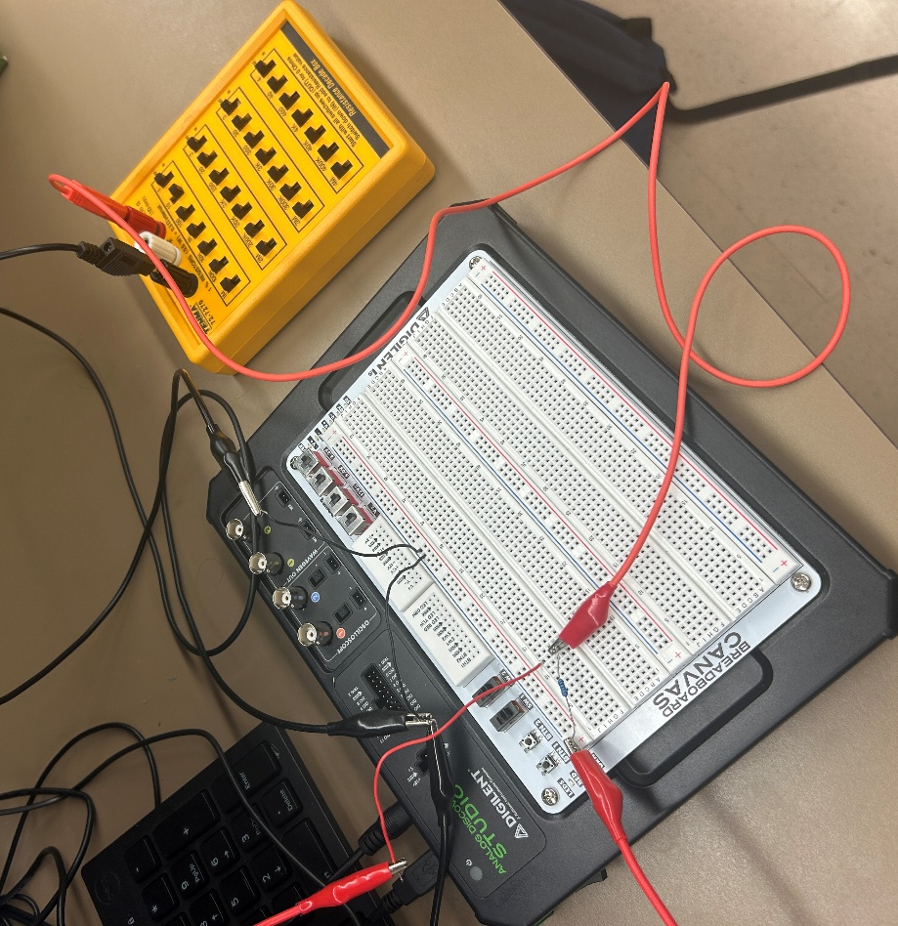
Figure #22: Experimental Setup with Variable Resistor (Part 1B)
R_{L} (Ohms) | V_{L} (V) | I_{L} (mA)
10 | 482.1 mV | 40.25 mA
20 | 859.1 mV | 37.349 mA
40 | 1.454 V | 32.687 mA
70 | 2.087 V | 27.490 mA
100 | 2.533 V | 23.612 mA
150 | 3.036 V | 19.152 mA
200 | 3.373 V | 15.393 mA
300 | 3.789 V | 12.277 mA
500 | 4.211 V | 8.262 mA
1000 | 4.595 V | 4.539 mA
Table #11: Experimental Results (Part 1B)
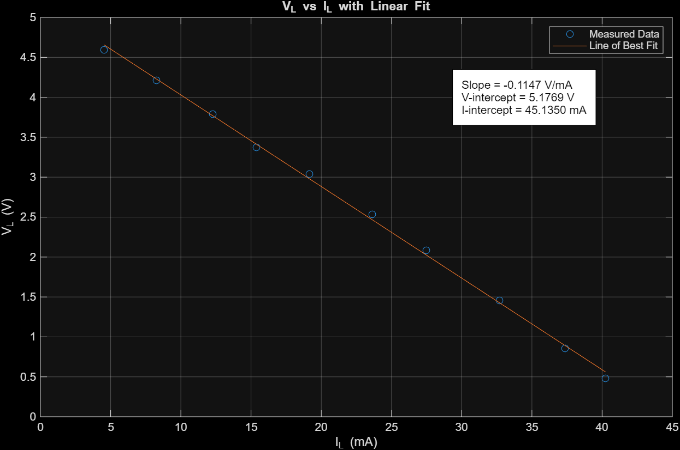
Figure #23: MATLAB Plot of Experimental Results (Part 1B)
Comparison and Discussion:
Part 1A
The experimental results found in Table 6 differ from the analytical results found in Tables 2-4, however, the experimental results have a percent error of about 1-2%, depending on the specific measurement. This relatively small difference indicates that the circuit components are operating within their device tolerances, and the experimental voltage and current values fall within the expected operational ranges. The close agreement between the analytical and experimental results also demonstrates that the analytical analysis accurately represents the behavior of the circuit. The differences between the analytical and experimental results can be attributed to several factors, including component tolerances, measurement inaccuracies, and variations in the voltage supplied to the circuit compared to its nominal value. Overall, the small percent errors indicate that the experimental results are consistent with the theoretical analysis and that the circuit performed as expected.
Part 1B
The experimental results found in Table 11 differ from the analytical results in Table 7. The experimental results have percent errors ranging from 1-3.1%, again indicating that the devices are operating within operational ranges. While the experimental results vary from the analytical ones, they are within a normal range. All the components in the circuit are operating correctly.
Additionally, the graphs of V_{L} vs. I_{L} for the analytical and experimental results found in Figures 14 and 23 are remarkably similar. The slope has a percent error of 14.7% while the voltage and current intercepts have percent errors of 3.54% and 9.7% respectively. While this circuit has higher percent errors overall when compared to Part 1, the circuit is still operating within expected ranges. Like in the first circuit, the discrepancies between the analytical and experimental results can be a result of many factors including imperfect components, measurement inaccuracies, and an imperfect voltage source.
Conclusion:
This lab provided an opportunity to apply several fundamental circuit analysis techniques, including mesh current analysis, nodal analysis, and Thevenin and Norton Equivalent circuits. The circuits were analyzed using analytical methods, simulated using LT Spice, and constructed and measured using a digital multimeter. This allowed the theoretical concepts discussed in class to be applied to physical circuits and provided practical experience with the tools used to analyze and measure electrical systems.
The results of this lab demonstrated the usefulness of these circuit analysis techniques for determining circuit behavior and simplifying complex circuits. Additionally, the lab reinforced fundamental electrical principles such as Ohm’s Law and Kirchoff’s Current and Voltage Laws. Overall, the lab connected theoretical circuit analysis with hands-on experimentation, providing a practical understanding of how these methods can be used to analyze real-world circuits.

