EE 316
Section 3
Lab 05
By: Hannah Kelley
Basic Filters and Frequency Response
Introduction:
The goal of this laboratory is to study the frequency characteristics of low-pass and high-pass filters. The effects of input frequency on signal amplitude and phase angle are examined through theoretical calculations and experimental measurements. The theoretical gain and phase angle are calculated for a range of frequencies, and the cutoff frequency is determined and used to identify the point where the filter gain is approximately −3 dB.
Theoretical Analysis:
Equations 1 and 2, given in the lab manual, were used to find the gain and phase angle for a low pass filter with $V_{in}=4V$, $R=1kΩ$, and $C=1μF$. Equation 3 was used to find the cutoff frequency.
$$\begin{aligned}\left|\frac{V_{out}}{V_{in}}\right|=\frac{1}{\sqrt{1+{\left(2πfRC\right)}^{2}}}⟹G=20\log\left(\frac{1}{\sqrt{1+{\left(2πfRC\right)}^{2}}}\right)dB\#\left(1\right)\end{aligned}$$
$$\begin{aligned}θ=\tan^{-1}\left(-2πfRC\right)\#\left(2\right)\end{aligned}$$
$$\begin{aligned}f_{c}=\frac{1}{2πRC}\#\left(3\right)\end{aligned}$$
Equations 4 and 5 show equations 1 and 2 evaluated at $f=25Hz$. These calculations were then repeated for varying values of f and used to complete Table 1. Equation 6 shows the cutoff frequency calculation. Figures 1 and 2 show the plots of gain and phase angle versus frequency.
$$\begin{aligned}G=20\log\left(\frac{1}{\sqrt{1+{\left(2π*25*1000*{10}^{-6}\right)}^{2}}}\right)dB=-0.1059 dB\#\left(4\right)\end{aligned}$$
$$\begin{aligned}θ=\tan^{-1}\left(-2π*25*1000*{10}^{-6}\right)=-8.9271°\#\left(5\right)\end{aligned}$$
$$\begin{aligned}f_{c}=\frac{1}{2π*1000*{10}^{-6}}=159.1594 Hz\#\left(6\right)\end{aligned}$$

 | Theoretical
f (Hz) | Gain (dB) | Phase Angles (degrees)
25 | -0.1059 | -8.9271
50 | -0.4088 | -17.4406
75 | -0.8709 | -25.2316
100 | -1.4451 | -32.1419
150 | -2.7606 | -43.3038
200 | -4.1147 | -51.4881
300 | -6.5830 | -62.0533
500 | -10.3621 | -72.3432
600 | -11.8219 | -75.1439
700 | -13.0845 | -77.1908
800 | -14.1940 | -78.7483
900 | -15.1822 | -79.9716
1000 | -16.0722 | -80.9570
Table #1: Low Pass Filter Theoretical Results
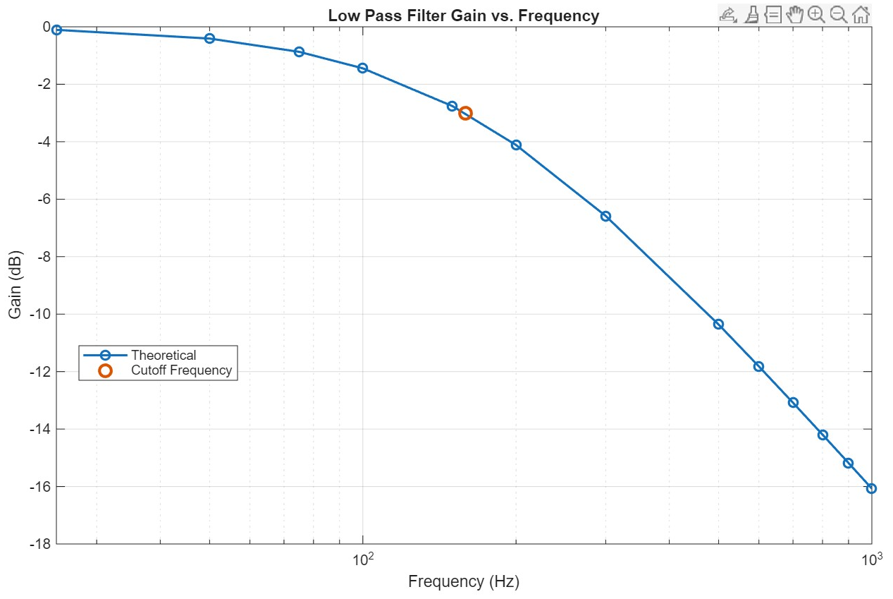
Figure #1: Gain vs. Frequency (LPF)
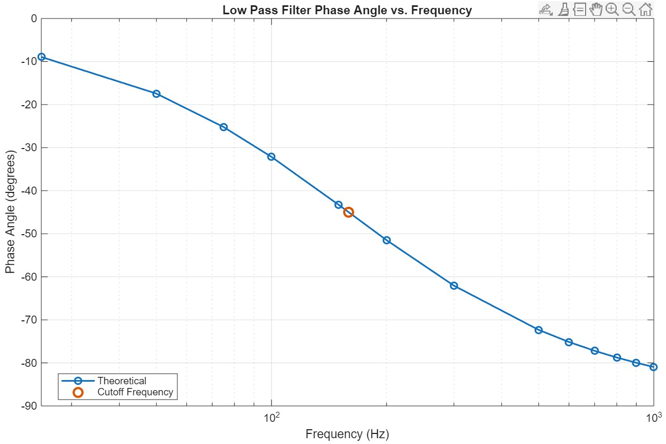
Figure #2: Phase Angle vs. Frequency (LPF)
Equations 7 and 8, given in the lab manual, were used to find the gain and phase angle for a high pass filter with $V_{in}=4V$, $R=1kΩ$, and $C=1μF$. Equation 9 was used to find the cutoff frequency. It is important to note that Equation 9 matches Equation 3, which was used to find the cutoff frequency of the low pass filter.
$$\begin{aligned}\left|\frac{V_{out}}{V_{in}}\right|=\frac{2πfRC}{\sqrt{1+{\left(2πfRC\right)}^{2}}}⟹G=20\log\left(\frac{2πfRC}{\sqrt{1+{\left(2πfRC\right)}^{2}}}\right)dB\#\left(7\right)\end{aligned}$$
$$\begin{aligned}θ=\tan^{-1}\left(\frac{1}{2πfRC}\right)\#\left(8\right)\end{aligned}$$
$$\begin{aligned}f_{c}=\frac{1}{2πRC}\#\left(9\right)\end{aligned}$$
Equations 10 and 11 show equations 7 and 8 evaluated at $f=25Hz$. These calculations were then repeated for varying values of f and used to complete Table 2. Equation 12 shows the cutoff frequency calculation. Figures 3 and 4 show the plots of gain and phase angle versus frequency.
$$\begin{aligned}G=20\log\left(\frac{2π*25*1000*{10}^{-6}}{\sqrt{1+{\left(2π*25*1000*{10}^{-6}\right)}^{2}}}\right)dB=-16.1835\#\left(10\right)\end{aligned}$$
$$\begin{aligned}θ=\tan^{-1}\left(\frac{1}{2π*25*1000*{10}^{-6}}\right)=81.0730\#\left(11\right)\end{aligned}$$
$$\begin{aligned}f_{c}=\frac{1}{2π*1000*{10}^{-6}}=159.1594 Hz\#\left(6\right)\end{aligned}$$
 | Theoretical
f (Hz) | Gain (dB) | Phase Angles (degrees)
25 | -16.1835 | 81.0730
50 | -10.4658 | 72.5594
75 | -7.4061 | 64.7684
100 | -5.4815 | 57.8581
150 | -3.2752 | 46.6962
200 | -2.1305 | 38.5119
300 | -1.0770 | 27.9467
500 | -0.4191 | 17.6568
600 | -0.2953 | 14.8561
700 | -0.2189 | 12.8092
800 | -0.1686 | 11.2517
900 | -0.1337 | 10.0284
1000 | -0.1086 | 9.0431
Table #2: High Pass Filter Theoretical Results
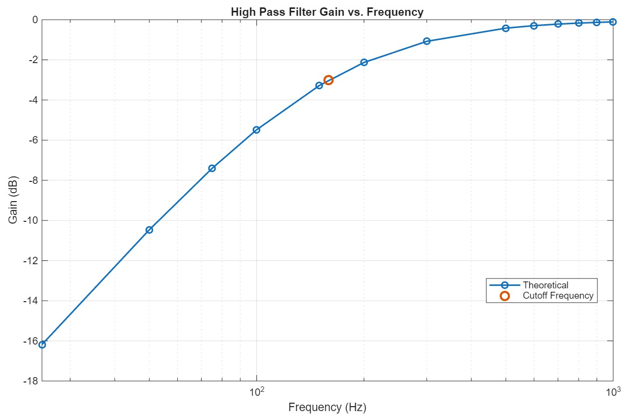
Figure #3: Gain vs. Frequency (HPF)
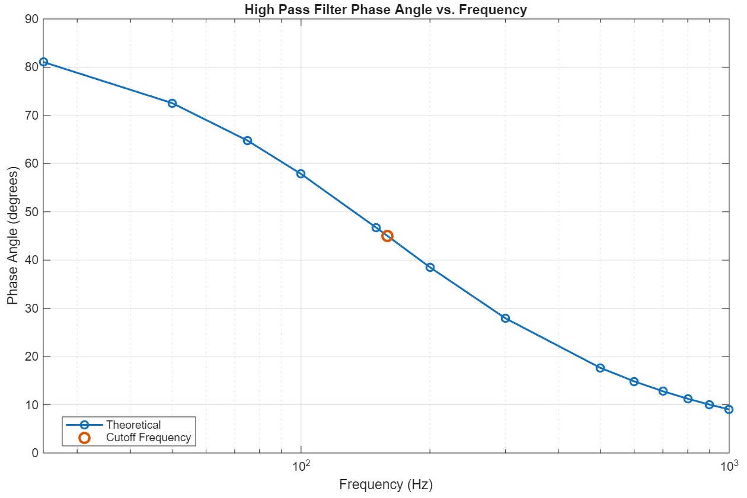
Figure #4: Phase Angle vs. Frequency (HPF)

Simulations and Results:
LTSpice was used to simulate both a low pass and high pass filter with $V_{in}=4V_{pk-pk}$, $R=1kΩ$, and $C=1μF$. Figures 5 and 6 show the schematics given in the lab manual for the LPF and HPF. Figure 7 shows the LTSpice schematic used to simulate both filters simultaneously. Figure 8 shows the Bode plot for both simulated filters with the simulated -3dB point marked. Tables 3 and 4 show the simulation results for the LPF and HPF respectively.
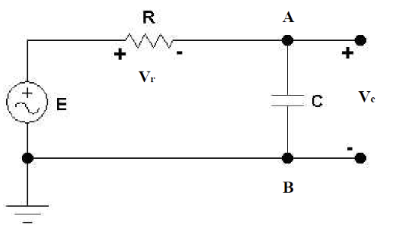
Figure #5: Low Pass Filter Schematic (Lab Manual)
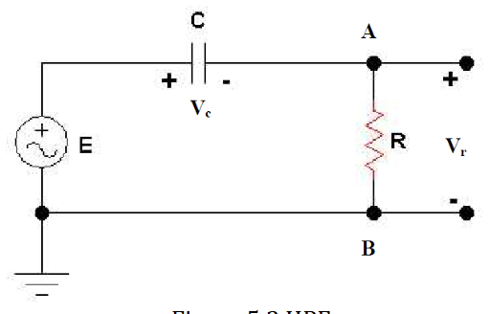
Figure #6: Low Pass Filter Schematic (Lab Manual)
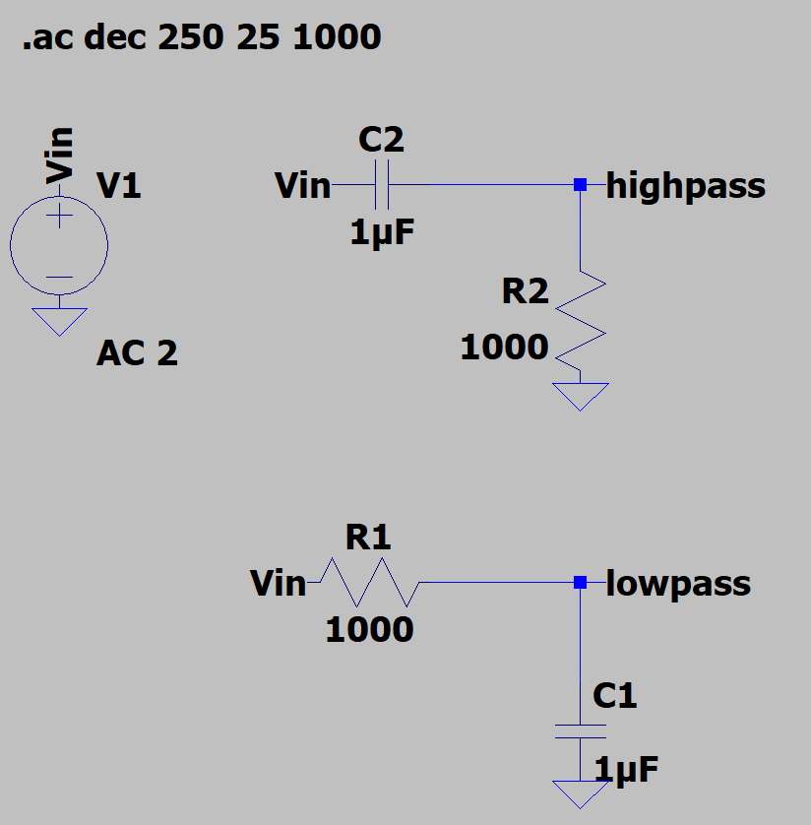
Figure #7: LTSpice Schematic (LPF and HPF)
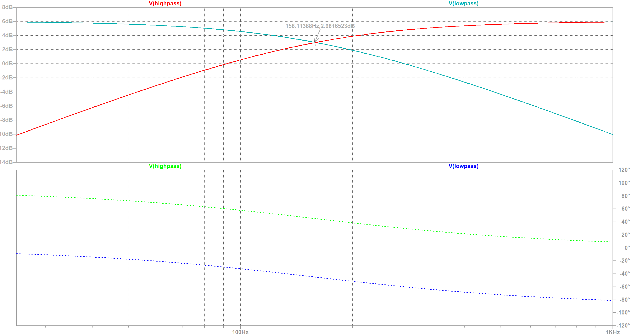
Figure #8: LTSpice Bode Plot (LPF and HPF)
 | Simulation
f (Hz) | Gain (dB) | Phase Angles (degrees)
25 | -0.10586154 | -8.9271434
50 | -0.4087871 | -17.440703
75 | -0.8709666 | -25.231744
100 | -1.4450701 | -32.141908
150 | -2.7606321 | -43.303809
200 | -4.114777 | -51.488062
300 | -6.5830569 | -62.053199
500 | -10.362149 | -72.343103
600 | -11.82194 | -75.143819
700 | -13.084461 | -77.190656
800 | -14.193975 | -78.748199
900 | -15.182185 | -79.971464
1000 | -16.072235 | -80.956939
Table #3: Low Pass Filter Simulation Results
 | Simulation
f (Hz) | Gain (dB) | Phase Angles (degrees)
25 | -16.183464 | 81.072857
50 | -10.46579 | 72.559297
75 | -7.406144 | 64.768256
100 | -5.4814727 | 57.858092
150 | -3.2752096 | 46.696191
200 | -2.1305798 | 38.511938
300 | -1.0770344 | 27.946801
500 | -0.41915173 | 17.656897
600 | -0.29531781 | 14.856181
700 | -0.21890279 | 12.809344
800 | -0.16857801 | 11.251801
900 | -0.13373748 | 10.028536
1000 | -0.1086379 | 9.0430611
Table #4: High Pass Filter Simulation Results

