EE 316
Section 3
Lab 02
By: Hannah Kelley
Inverting and Non-Inverting Op Amps

Introduction:
This laboratory investigates inverting and non-inverting operational amplifier (op-amp) configurations using both DC and AC inputs. The lab provides experience analyzing and simulating op-amp circuits while examining closed-loop voltage gain and the effects of load resistance on output voltage. Additionally, this lab provided experience using WaveForms to generate input waveforms and operate an oscilloscope.
Theoretical Analysis:
Based on the circuit schematic in Figure 1, the ideal theoretical gain and output voltage values were obtained according to the calculations in Figure 2. A summary of these results can be found in Table 1.
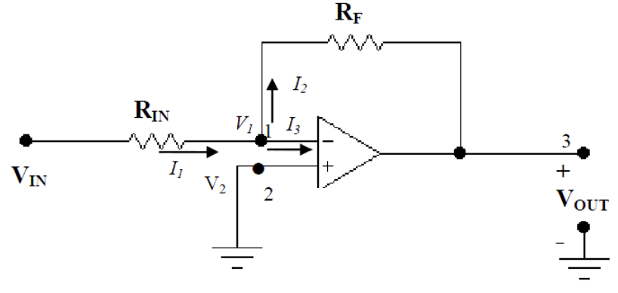
Figure #1: Inverting Op-Amp Schematic (from Lab Manual)
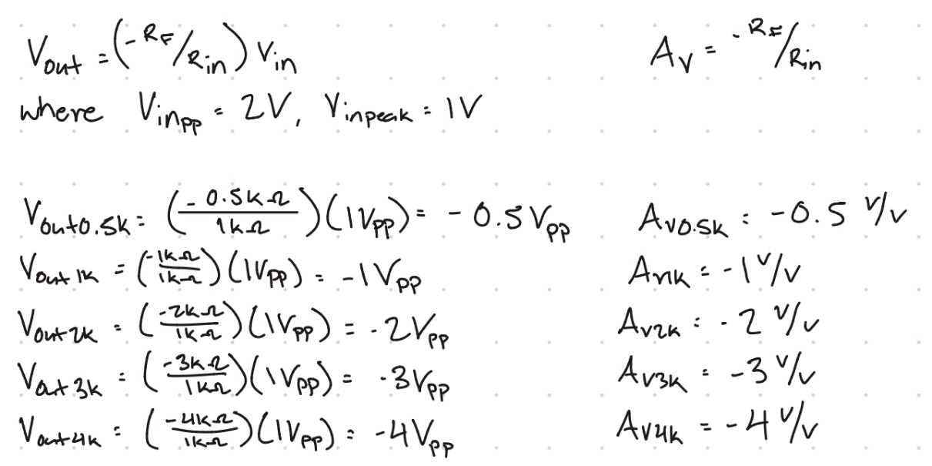
Figure #2: Inverting Op-Amp Calculations
$V_{in_{PP}}$ (V) | $R_{IN}$ ($kΩ$) | $R_{F}$ ($kΩ$) | $V_{{out}_{PP}}$ (V) | Gain (V/V) | $V_{out_{PP}}$ (V) RMS
2 | 1 | 0.5 | 1 | -0.5 | 0.354
2 | 1 | 1 | 2 | -1 | 0.707
2 | 1 | 2 | 4 | -2 | 1.414
2 | 1 | 3 | 6 | -3 | 2.122
2 | 1 | 4 | 8 | -4 | 2.829
Table #2: Inverting Op-Amp Theoretical Analysis Results
The same process was repeated for the non-inverting op-amp schematic in Figure 3. The ideal theoretical gain and output voltage values were obtained according to the calculations in Figure 4 and summarized in Table 2.
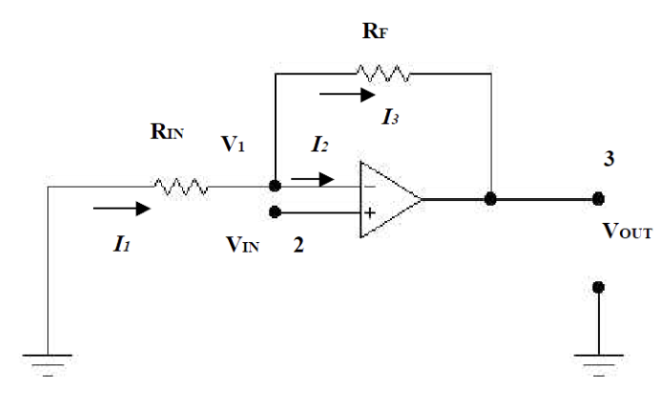
Figure #3: Non-Inverting Op-Amp Schematic (from Lab Manual)
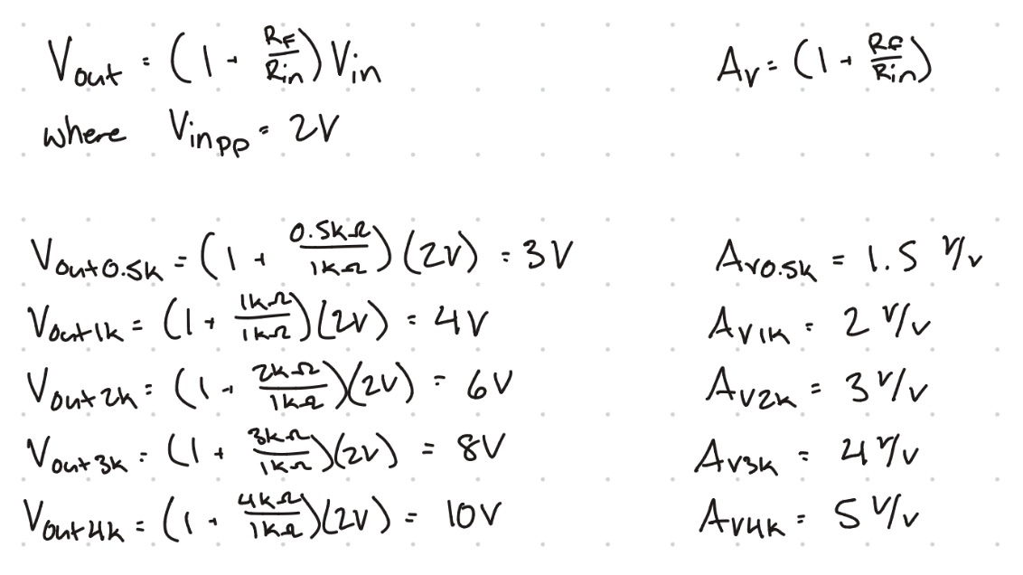
Figure #4: Non-Inverting Op-Amp Calculations
$V_{in_{PP}}$ (V) | $R_{IN}$ ($kΩ$) | $R_{F}$ ($kΩ$) | $V_{{out}_{PP}}$ (V) O-scope | Gain (V/V) | $V_{out_{PP}}$ (V) RMS
2 | 1 | 0.5 | 3 | 1.5 | 2.121
2 | 1 | 1 | 4 | 2 | 2.828
2 | 1 | 2 | 6 | 3 | 4.242
2 | 1 | 3 | 8 | 4 | 5.657
2 | 1 | 4 | 10 | 5 | 7.071
Table #2: Non-Inverting Op-Amp Theoretical Analysis Results
Simulation and Results:
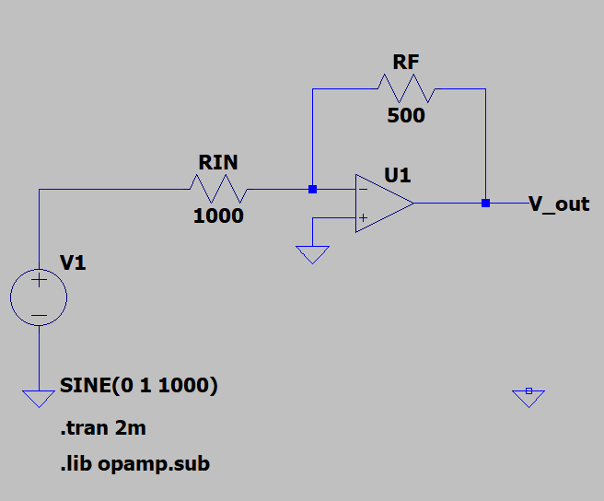
Figure #5: Inverting Op-Amp with $R_{F}=500$ Ohms (LTSpice)
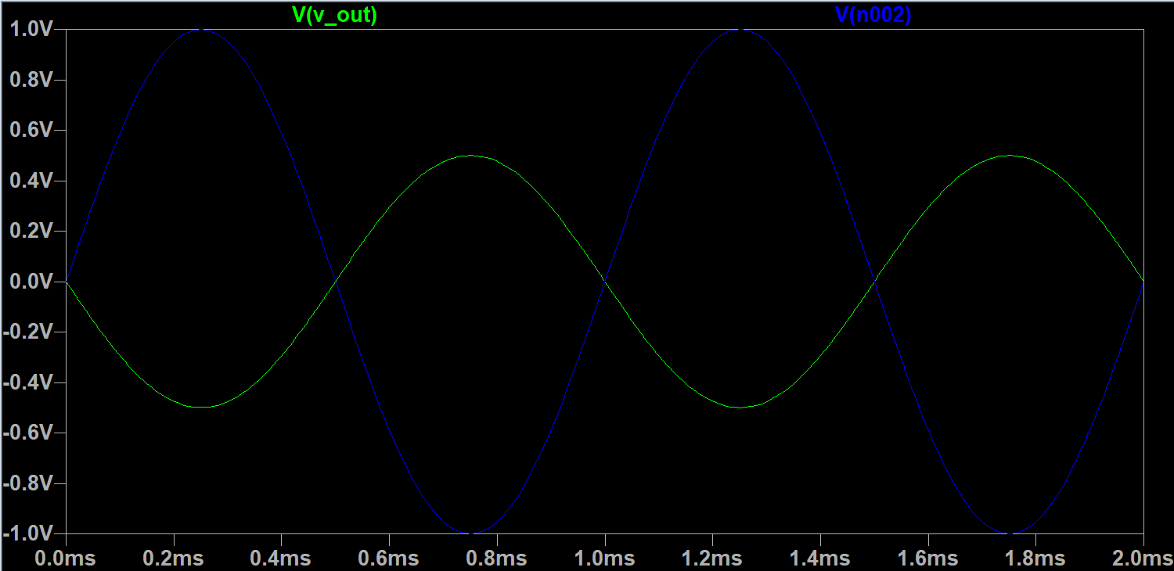
Figure #6: Inverting Op-Amp Oscilloscope Output at $R_{F}=500$ Ohms ($V_{out}$ and $V_{in}$)
$V_{in_{PP}}$ (V) | $R_{IN}$ ($kΩ$) | $R_{F}$ ($kΩ$) | $V_{{out}_{PP}}$ (V) O-scope | Gain (V/V) | $V_{out_{PP}}$ (V) DMM
2 | 1 | 0.5 | 1 | -0.5 | 0.354
2 | 1 | 1 | 2 | -1 | 0.707
2 | 1 | 2 | 4 | -2 | 1.414
2 | 1 | 3 | 6 | -3 | 2.122
2 | 1 | 4 | 8 | -4 | 2.829
Table #3: Inverting Op-Amp Simulation Results
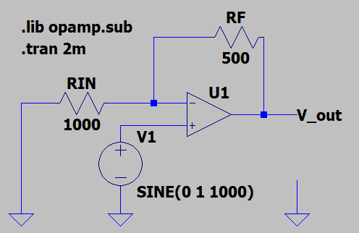
Figure #7: Non-Inverting Op-Amp with $R_{F}=500$ Ohms (LTSpice)
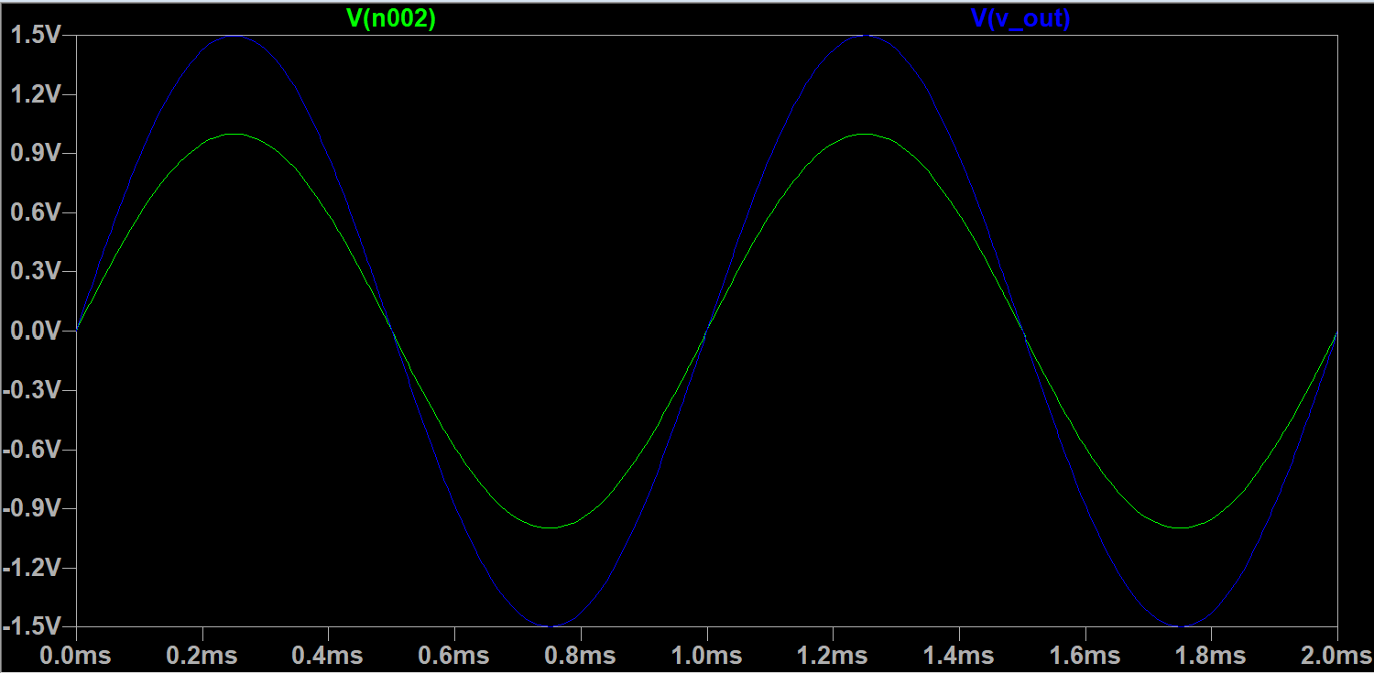
Figure #8: Non-Inverting Op-Amp Oscilloscope Output at $R_{F}=500$ Ohms ($V_{out}$ and $V_{in}$)
$V_{in_{PP}}$ (V) | $R_{IN}$ ($kΩ$) | $R_{F}$ ($kΩ$) | $V_{{out}_{PP}}$ (V) O-scope | Gain (V/V) | $V_{out_{PP}}$ (V) DMM
2 | 1 | 0.5 | 3 | 1.5 | 2.121
2 | 1 | 1 | 4 | 2 | 2.828
2 | 1 | 2 | 6 | 3 | 4.242
2 | 1 | 3 | 8 | 4 | 5.657
2 | 1 | 4 | 10 | 5 | 7.071
Table #4: Non-Inverting Op-Amp Simulation Results
Experimental Setup and Results:

Inverting Op-Amp
The inverting op-amp circuit as seen in Figure 1 was built using a variable resistor and a 741CN op-amp. A picture of the experimental setup can be found in Figure 9. The output voltage and gain were measured using a digital multimeter and oscilloscope and recorded in Table 5. A screenshot of the oscilloscope outputs of V_{in} and V_{out} can be found in Figure 10.
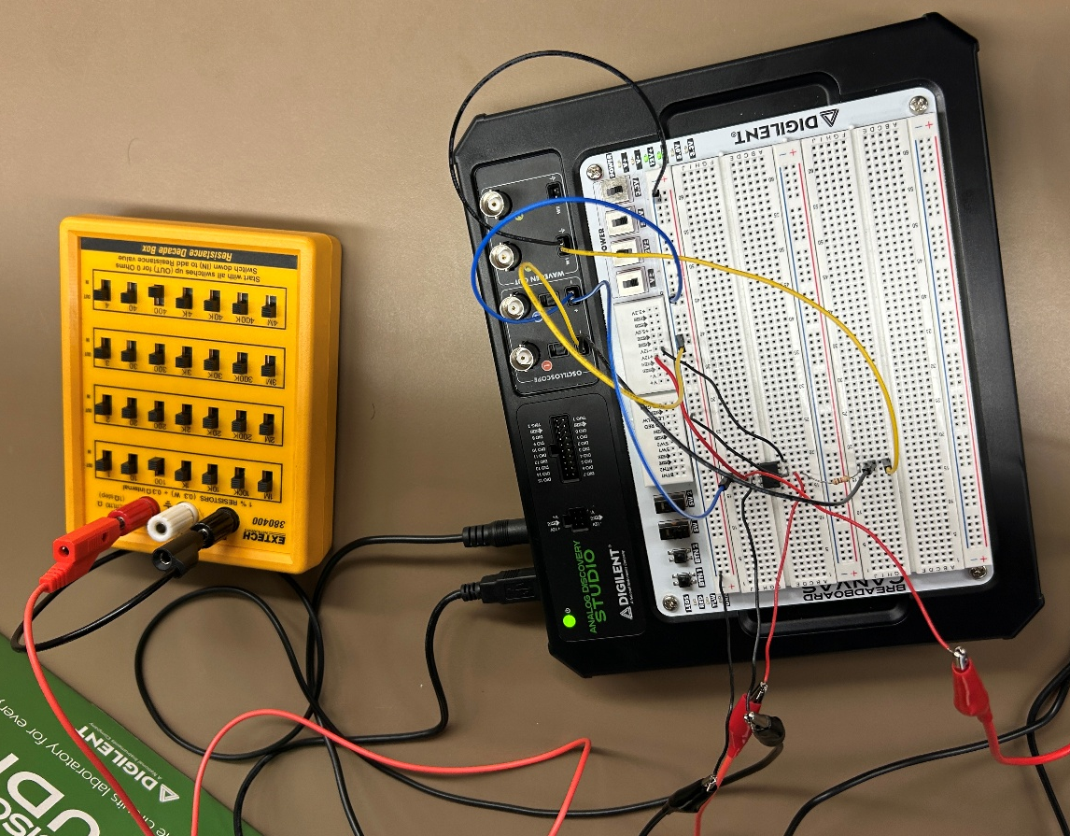
Figure #9: Inverting Op-Amp Experimental Setup
$V_{in_{PP}}$ (V) | $R_{IN}$ ($kΩ$) | $R_{F}$ ($kΩ$) | $V_{{out}_{PP}}$ (V) O-scope | Gain (V/V) | $V_{out_{PP}}$ (V) DMM
2 | 1 | 0.5 | 0.966 | 0.483 | 0.704
2 | 1 | 1 | 1.927 | 0.964 | 1.363
2 | 1 | 2 | 3.866 | 1.933 | 2.734
2 | 1 | 3 | 5.758 | 2.879 | 4.072
2 | 1 | 4 | 7.684 | 3.842 | 5.433
Table #5: Inverting Op-Amp Experimental Results
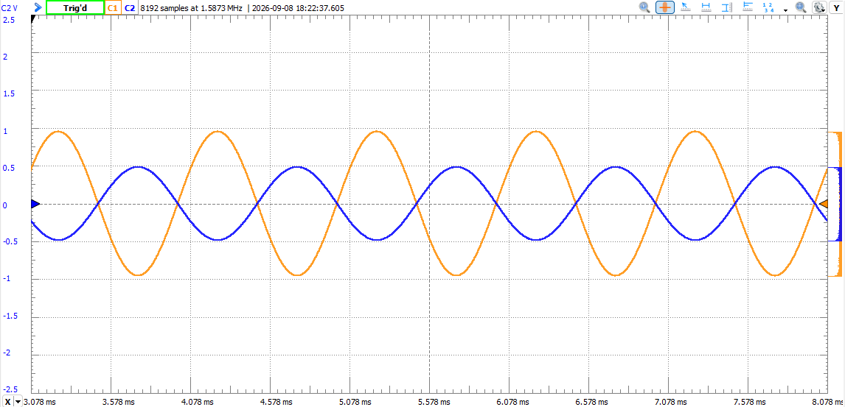
Figure #10: Inverting V_{out} vs V_{in} Oscilloscope Output (R_{F}=500 ohms)
Non-Inverting Op-Amp
The non-inverting op-amp circuit as seen in Figure 3 was built using a variable resistor and a 741CN op-amp. A picture of the experimental setup can be found in Figure 11. The output voltage and gain were measured using a digital multimeter and oscilloscope and recorded in Table 6. A screenshot of the oscilloscope outputs for V_{in} and V_{out} can be found in Figure 12.
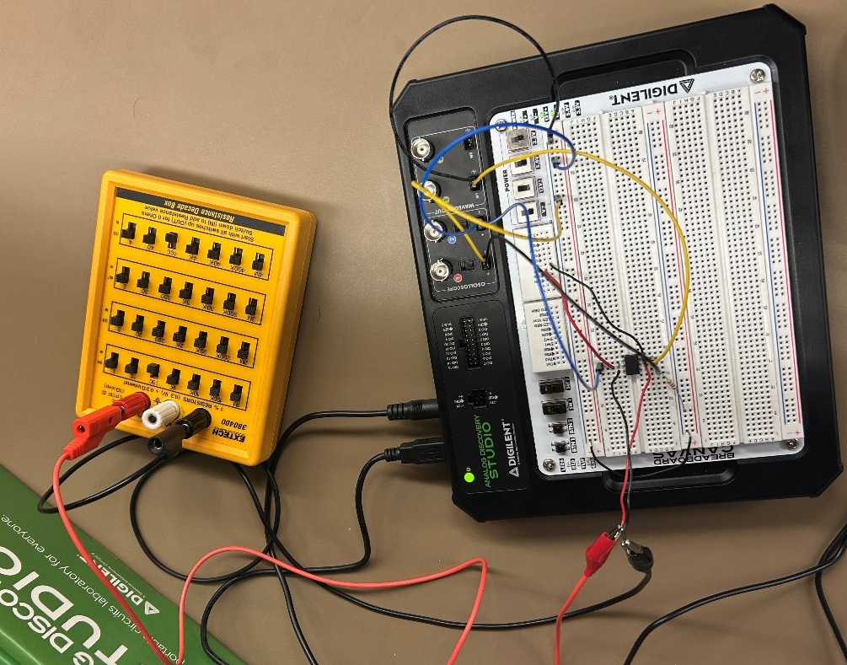
Figure #11: Non-Inverting Op-Amp Experimental Setup
$V_{in_{PP}}$ (V) | $R_{IN}$ ($kΩ$) | $R_{F}$ ($kΩ$) | $V_{{out}_{PP}}$ (V) O-scope | Gain (V/V) | $V_{out_{PP}}$ (V) DMM
2 | 1 | 0.5 | 2.998 V | 1.499 V/V | 2.120 V
2 | 1 | 1 | 4.002 V | 2.001 V/V | 2.830 V
2 | 1 | 2 | 6.036 V | 3.018 V/V | 4.268 V
2 | 1 | 3 | 8.046 V | 4.023 V/V | 5.689 V
2 | 1 | 4 | 10.030 V | 5.015 V/V | 7.092 V
Table #6: Non-Inverting Op-Amp Experimental Results
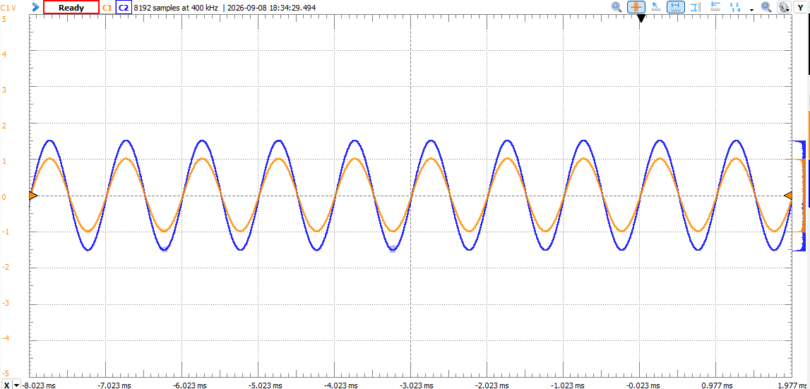
Figure #12: Non-Inverting V_{out} vs V_{in} Oscilloscope Output (R_{F}=500 ohms)
Comparison and Discussion:
Inverting Op-Amp
The theoretical and simulation results for the inverting op-amp matched. Since the op-amp used in the simulation was an ideal op amp, these results are expected. The experimental results, however, deviate from the ideal and simulation conditions by 3.95% at maximum. This deviation is likely due to the non-ideal characteristics of the physical op amp, resistor tolerances, and measurement inaccuracies from the laboratory equipment. Despite these differences, the experimental results closely agree with the theoretical and simulation results, demonstrating the expected behavior of the inverting op-amp configuration.
Non-Inverting Op-Amp
Like the inverting op-amp, the theoretical and simulation results for the non-inverting op-amp matched. These results are, again, expected as the op-amp used in the simulations was an ideal op-amp. The experimental results vary from the theoretical and simulation results with a maximum deviation of 5.75%. Similarly to the inverting op-amp, the differences between theoretical and experimental results are likely due to the non-ideal op-amp, resistor tolerances, and measurement inaccuracies.
Conclusion:
Overall, this laboratory demonstrated the behavior of inverting and non-inverting op-amp configurations with both DC and AC inputs. The theoretical, simulation, and experimental results showed that both configurations operate as expected, with minor differences between the ideal and practical results. These differences highlight the effects of non-ideal components and measurement equipment in practical circuits. The lab also provided valuable experience analyzing op-amp circuits and using WaveForms and an oscilloscope to generate and measure waveforms.

