EE 316
Section 3
Pre Lab 03
By: Hannah Kelley
Op-Amp Integrator and Differentiator Circuits
Introduction:
This experiment investigates the operation of a basic digital-to-analog converter using an op-amp and a binary-weighted resistor network. The circuit’s output behavior is examined to evaluate its step size, range, resolution, and accuracy using both theoretical calculations and simulations.
Theoretical Analysis:
The theoretical results for the R-2R DAC op-amp found in Table 1 were calculated using the following formula given in the lab manual:
$$\begin{aligned}V_{O}\left(V_{A}, V_{B},V_{C},V_{D}\right)=-\left(\frac{V_{A}}{2}+\frac{V_{B}}{4}+\frac{V_{C}}{8}+\frac{V_{D}}{16}\right)\#\left(1\right)\end{aligned}$$
Equation 2 shows an example of this formula for the input sequence (0, 5, 5, 0). It is important to know that 5V is used here instead of 1V. The “1” in the input column of Table 1 simply refers to that input being active high at 5V.
$$\begin{aligned}V_{O}\left(V_{A}, V_{B},V_{C},V_{D}\right)=-\left(\frac{0}{2}+\frac{5}{4}+\frac{5}{8}+\frac{0}{16}\right)=-1.875 V\#\left(2\right)\end{aligned}$$
Input |  |  |  |  | Theoretical
 | V_{A} | V_{B} | V_{C} | V_{D} | V_{O}
0 | 0 | 0 | 0 | 0 | 0 V
1 | 0 | 0 | 0 | 1 | -0.3125 V
2 | 0 | 0 | 1 | 0 | -0.625 V
3 | 0 | 0 | 1 | 1 | -0.9375 V
4 | 0 | 1 | 0 | 0 | -1.25 V
5 | 0 | 1 | 0 | 1 | -1.5625 V
6 | 0 | 1 | 1 | 0 | -1.875 V
7 | 0 | 1 | 1 | 1 | -2.1875 V
8 | 1 | 0 | 0 | 0 | -2.5 V
9 | 1 | 0 | 0 | 1 | -2.8125
10 | 1 | 0 | 1 | 0 | -3.125 V
11 | 1 | 0 | 1 | 1 | -3.4375 V
12 | 1 | 1 | 0 | 0 | -3.75 V
13 | 1 | 1 | 0 | 1 | -4.0625 V
14 | 1 | 1 | 1 | 0 | -4.375 V
15 | 1 | 1 | 1 | 1 | -4.6875 V
Table #1: Theoretical Results
Simulations and Results:
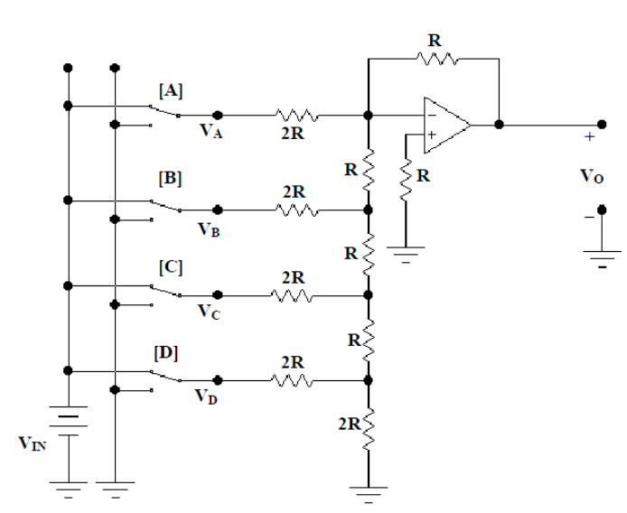
Figure #1: DAC Op-Amp Schematic from Lab Manual
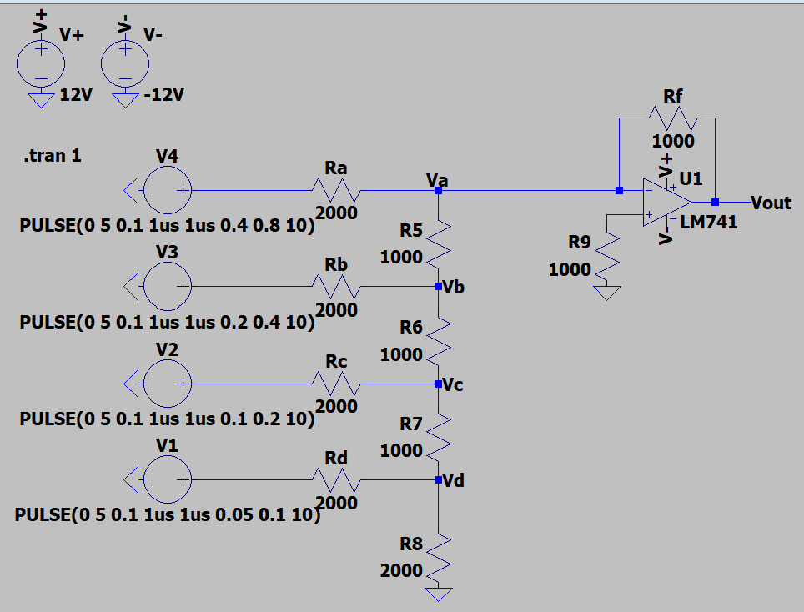
Figure #2: DAC Op-Amp Schematic (LTSpice)
The pulse commands for each voltage source systematically apply every possible combination of inputs, one after the other.
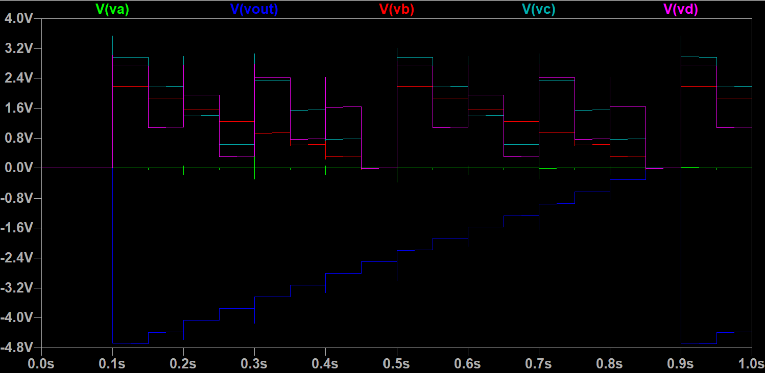
Figure #3: DAC Op-Amp Output (LTSpice)
Input |  |  |  |  | Simulation | Theoretical
 | V_{A} | V_{B} | V_{C} | V_{D} | V_{O} (V) | V_{O} (V)
0 | 0 | 0 | 0 | 0 | 0 V | 0 V
1 | 0 | 0 | 0 | 1 | -0.310V | -0.3125 V
2 | 0 | 0 | 1 | 0 | -0.623 V | -0.625 V
3 | 0 | 0 | 1 | 1 | -0.935 V | -0.9375 V
4 | 0 | 1 | 0 | 0 | -1.248 V | -1.25 V
5 | 0 | 1 | 0 | 1 | -1.561 V | -1.5625 V
6 | 0 | 1 | 1 | 0 | -1.873 V | -1.875 V
7 | 0 | 1 | 1 | 1 | -2.166 V | -2.1875 V
8 | 1 | 0 | 0 | 0 | -2.498 V | -2.5 V
9 | 1 | 0 | 0 | 1 | -2.810 V | -2.8125
10 | 1 | 0 | 1 | 0 | -3.123 V | -3.125 V
11 | 1 | 0 | 1 | 1 | -3.435 V | -3.4375 V
12 | 1 | 1 | 0 | 0 | -3.747 V | -3.75 V
13 | 1 | 1 | 0 | 1 | -4.066 V | -4.0625 V
14 | 1 | 1 | 1 | 0 | -4.373 V | -4.375 V
15 | 1 | 1 | 1 | 1 | -4.685 V | -4.6875 V
Table #2: Simulation Results

