EE 316
Section 3
Pre Lab 06
By: Hannah Kelley
AC Signals, Transformers, and Bridge Rectifiers

Introduction:
The goal of this laboratory is to explore AC signals, transformers, and diodes through theoretical calculations and circuit simulations. Different methods of representing and reporting AC voltages will be examined, including peak, peak-to-peak, and RMS values. The operation of transformers will also be analyzed using their turns ratios and voltage relationships. Finally, diode circuits will be simulated to investigate how sinusoidal AC signals can be rectified into DC signals.
Theoretical Analysis:
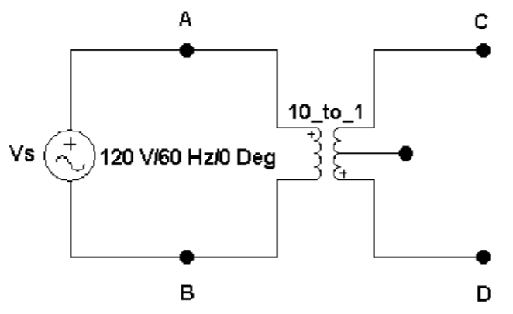
Figure #1: Basic Transformer Circuit (Lab Manual)
The basic transformer in Figure 1 has a peak voltage is approximately $120V*\sqrt{2}=169.71V$. This results in a peak-to-peak voltage of approximately $2*V_{peak}=339.41$. Using these voltages and a frequency of 60 Hz, the sinusoidal equation representing the input voltage at node A is:
$$\begin{aligned}V_{A}\left(t\right)=169.71\sin\left(2π60t\right)V\#\left(1\right)\end{aligned}$$
Since the primary and secondary coils have a ratio of 10 to 1, the secondary voltage will have a peak value of $\frac{120}{10}=12V_{rms}$ or $V_{peak}=12*\sqrt{2}=16.97V$. Since the coils are perfectly coupled, node C will be in phase with node A while node D will be 180º out of phase with nodes A and C. This results in the following equations for nodes C and D.
$$\begin{aligned}V_{C}\left(t\right)=16.97\sin\left(2π60t\right)V\#\left(2\right)\end{aligned}$$
$$\begin{aligned}V_{D}\left(t\right)=-16.97\sin\left(2π60t\right)=16.97\sin\left(2π60t+{180}^{o}\right)V\#\left(3\right)\end{aligned}$$
Figures 2 shows Equations 1, 2, and 3 each graphed over two cycles.
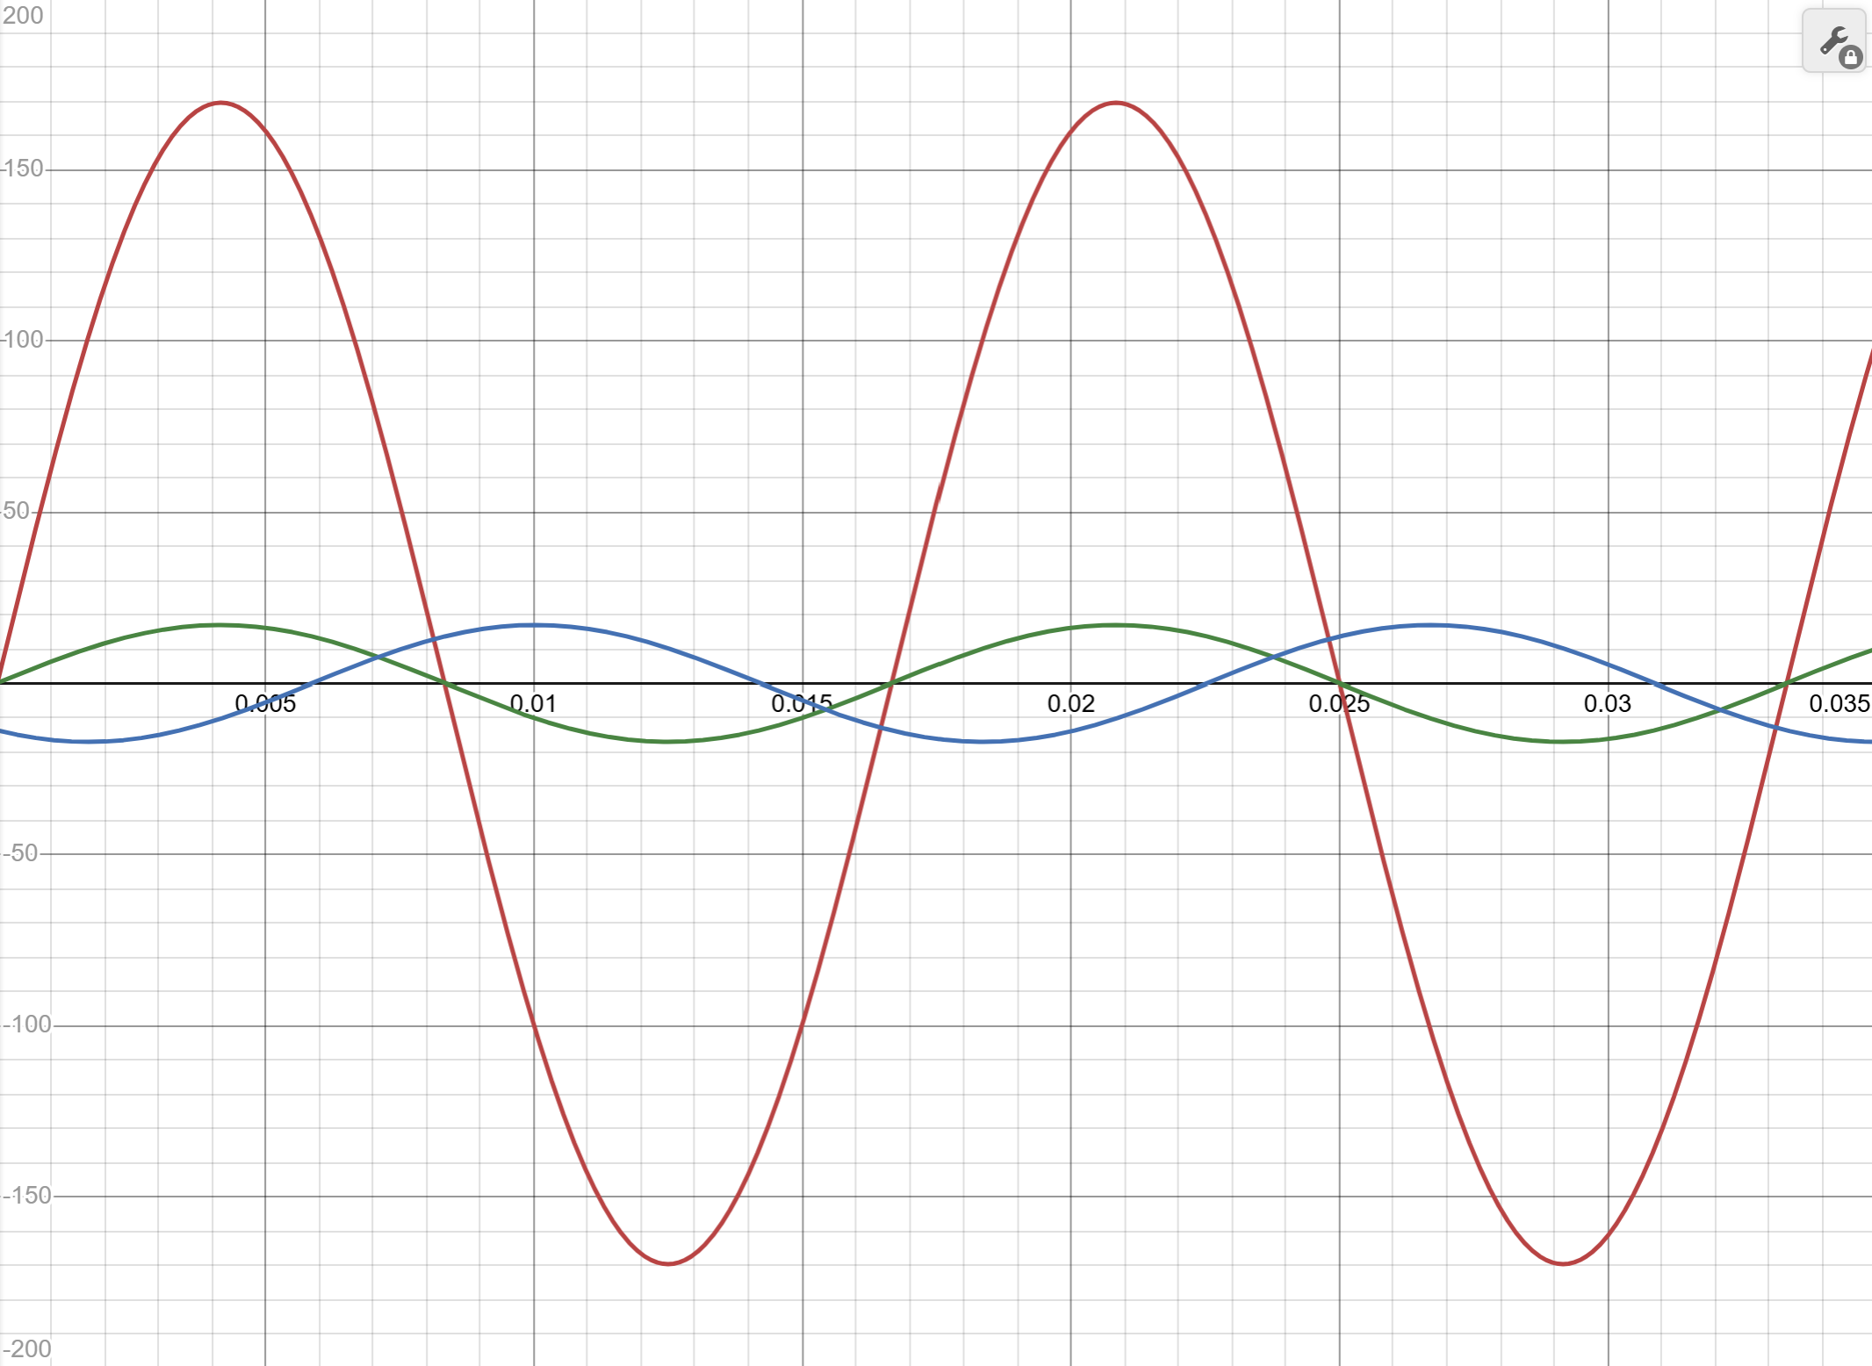
Figure #2: V_{A}(t), V_{B}(t), and V_{C}(t) Spanning Two Cycles
Figure 3 shows the bridge rectifier circuit schematic used for this lab.
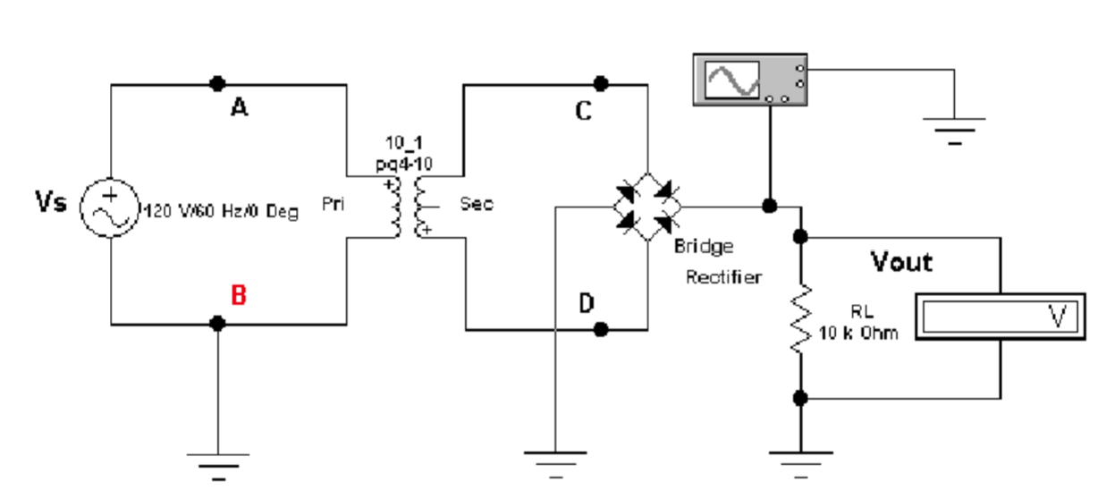
Figure #3: Bridge Rectifier Schematic (Lab Manual)
The ideal peak output voltage for the bridge rectifier circuit is approximately $V_{out,pk}=16.97V$. Using this peak output voltage, the DC value is roughly $V_{DC}=\frac{2V_{outpk}}{π}=10.8V$. Using these values and the frequency, the following equation is formed:
$$\begin{aligned}V_{out}\left(t\right)=\left|16.97sin⁡(2π60t)\right| V\#\left(4\right)\end{aligned}$$
A graph of Equation 4 spanning two cycles can be found in Figure 4. Node C contributes the odd number pulses while node D contributes the even number pulses.
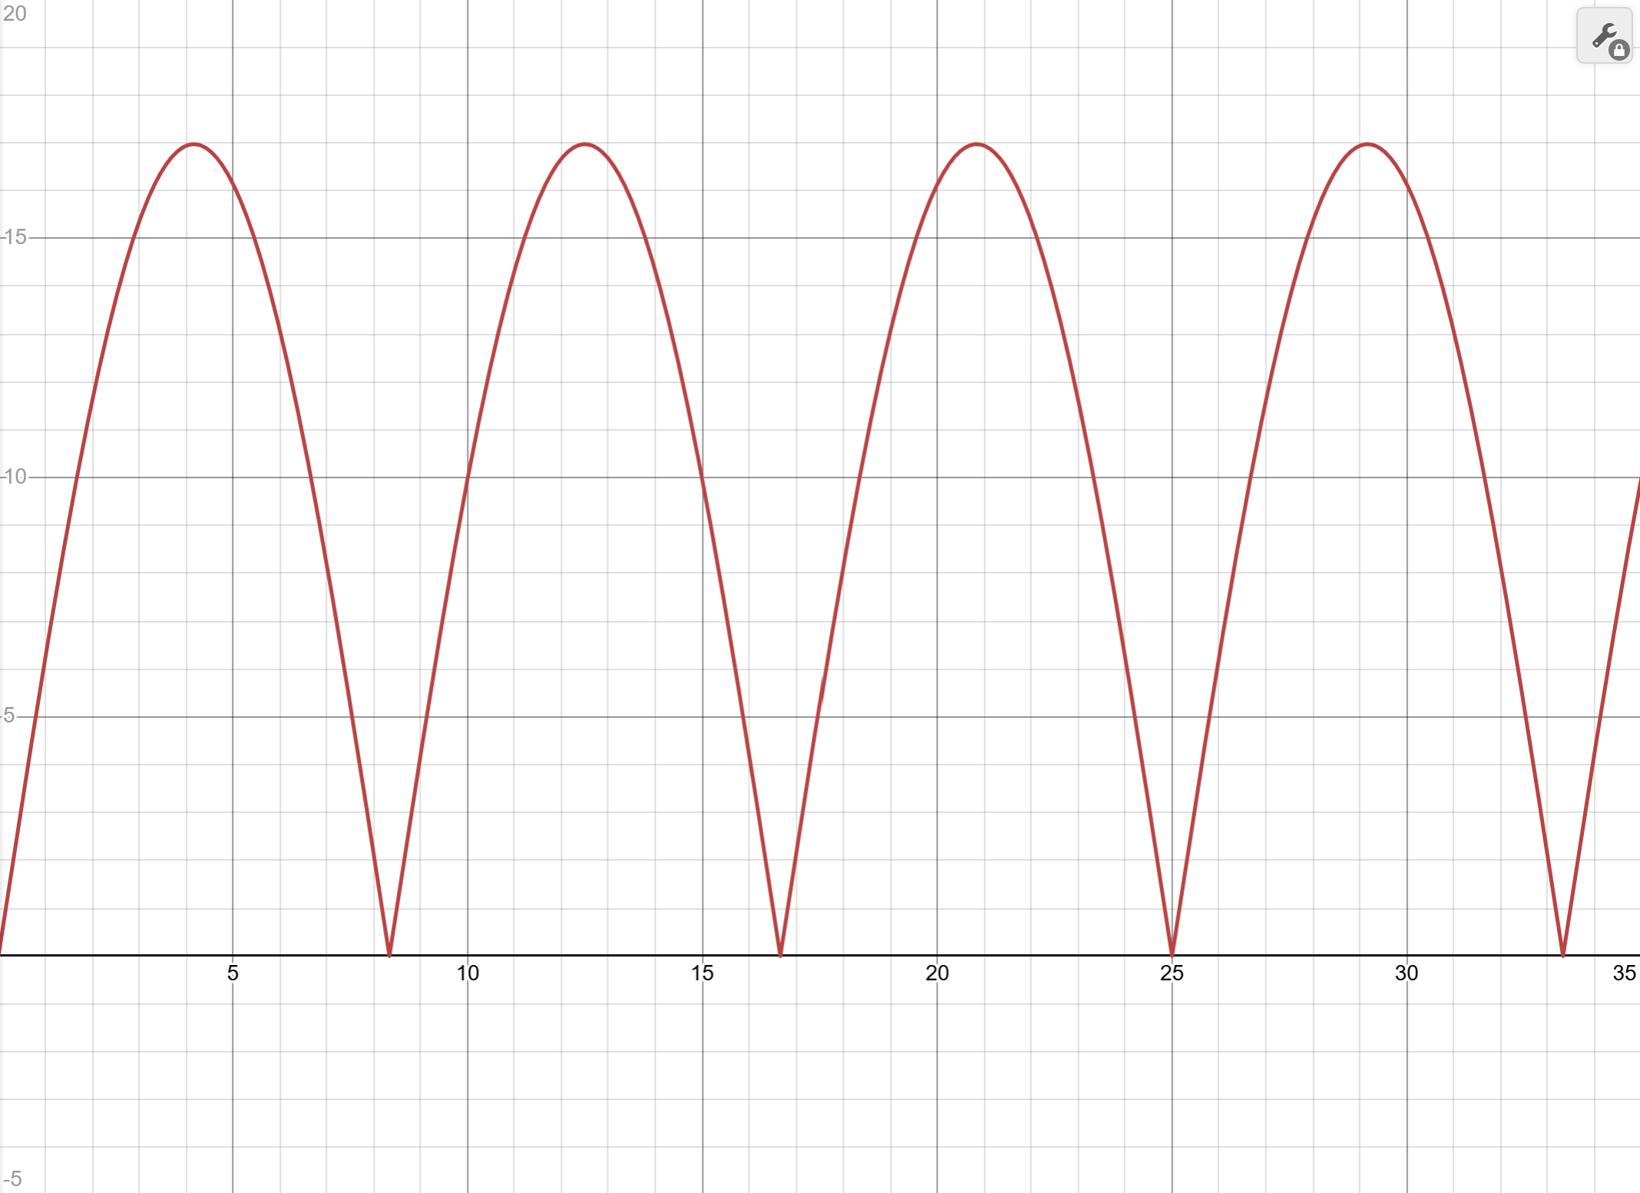
Figure #4: V_{out}(t) Spanning Two Cycles
The ripple frequency $f_{ripple}$ can be calculated using the input period $T_{in}=\frac{1}{60 Hz}=16.67ms$ and the output frequency $T_{out}=\frac{T_{in}}{2}=8.33ms$.
$$f_{ripple}=\frac{1}{T_{out}}=120 Hz$$
If the circuit was a half rectifier instead of a full rectifier, the ripple frequency would be the same as the input frequency. In this case, the ripple frequency of the half rectifier would be 60 Hz.
Simulations and Results:
LTSpice was used to simulate two different transformer circuits, shown in Figures 1 and 3.
Figure 5 shows the basic transformer circuit in LTSpice. The Spice directive “K1 L1 L2 1” was used to show that the inductors L1 and L2 are perfectly coupled. A small input resistance was used to make the simulation non-ideal. Figure 6 shows the oscilloscope output of the primary and secondary voltages. The input sine wave has a peak voltage of 169.7V and the secondary output voltage has a peak of around 16.9V. The ratio between the inputs is roughly 0.01. Since the secondary voltage is expected to be around 10 times less than the input voltage, the simulation matches the expected results. The signals are also 180º out of phase with the maximum input voltage and minimum secondary voltages occurring at the same time. The frequency of the secondary coil was measured at 59.89 Hz, closely matching the input frequency of 60 Hz. Figure 7 shows the voltage differences between nodes A and D versus the differences between node C and ground. The results are the same as the first graph in Figure 6, with the two traces being 180º out of phase and the secondary voltage being 10 times less than the primary. In this second scenario, nodes A and C are producing the voltage while nodes B and D are acting as a common ground.
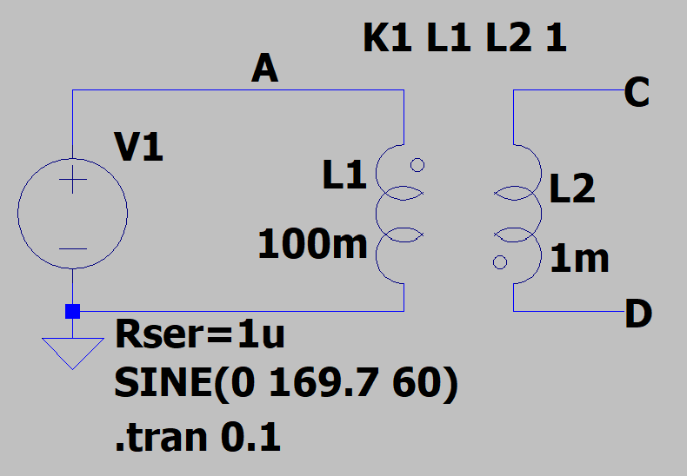
Figure #5: LTSpice Schematic (Basic Transformer)
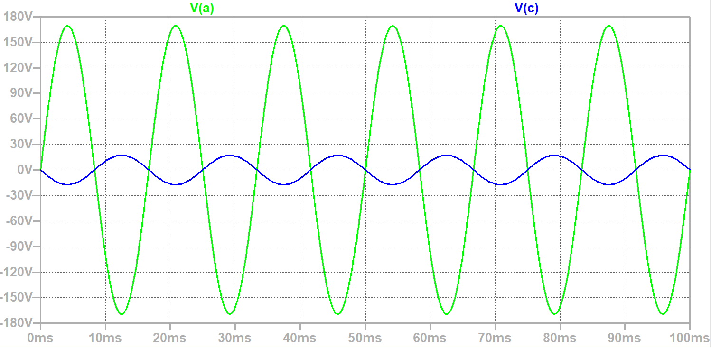
Figure #6: LTSpice Primary vs. Secondary Coil Voltage (Basic Transformer)
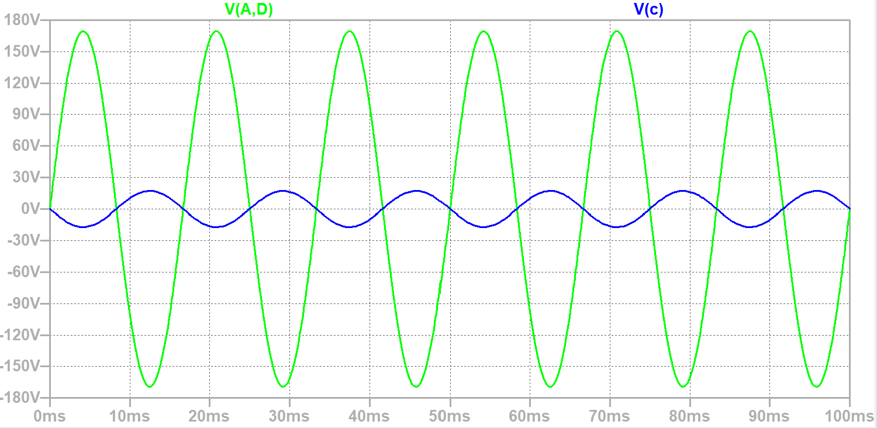
Figure #7: LTSpice Primary vs. Secondary Coil Voltage (Basic Transformer)
Figure 8 shows the bridge rectifier circuit in LTSpice. Figure 9 shows the oscilloscope output of the primary coil and rectified voltages. The rectified signal has a peak voltage of 15.629 V, or 11.051 V in DC. The period of the rectified voltage is about 8.325 ms, resulting in a frequency of 120 Hz.
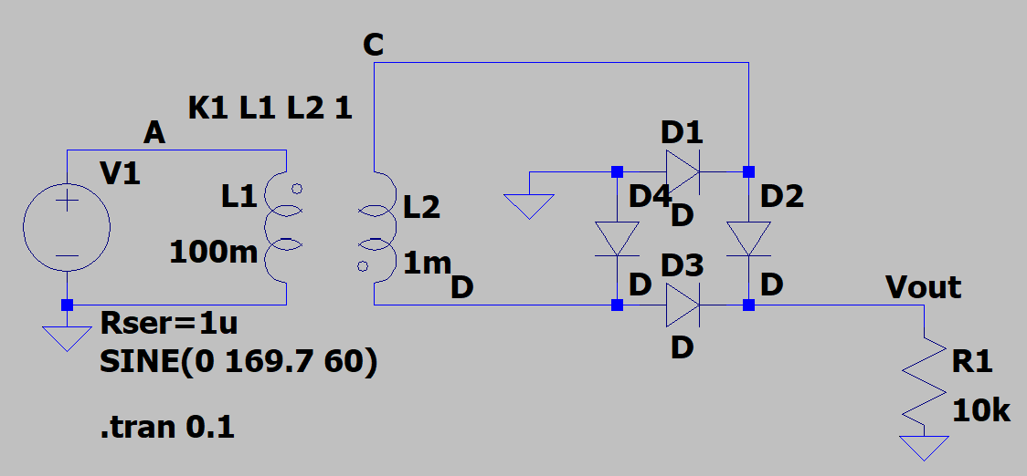
Figure #8: LTSpice Schematic (Bridge Rectifier)
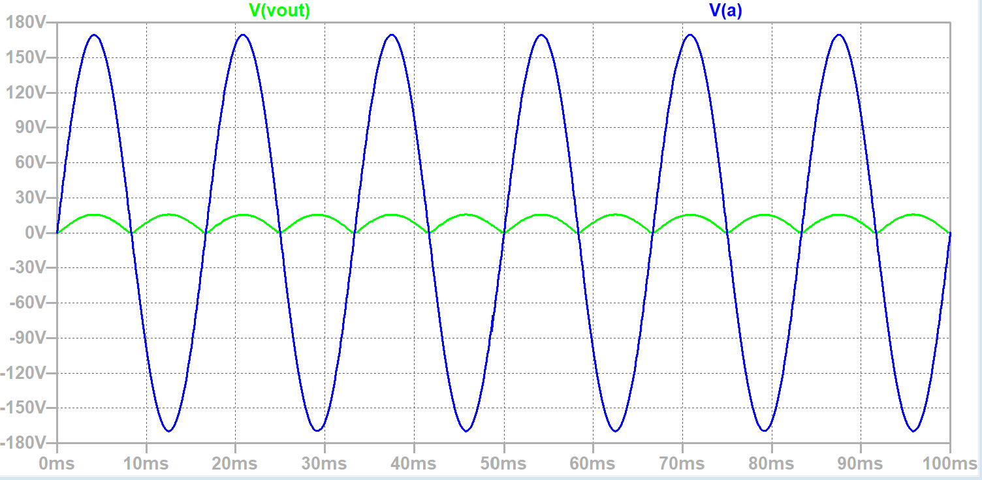
Figure #9: LTSpice Primary Coil vs. Rectified Voltages (Bridge Rectifier)
Experimental Setup and Results:
The basic transformer circuit in Figure 1 was built using a breadboard and a UAH transformer. A picture of the experimental setup can be found in Figure 10. The voltage waveforms of nodes C and D were measured using an oscilloscope. A screenshot of these outputs can be found in Figure 11. The peak and peak-to-peak voltages, frequencies, and RMS voltages of the output were measured and summarized in Table 1. A digital multimeter was used to measure the AC voltage at node C. The value was 7.54 V. This is an RMS type measurement.
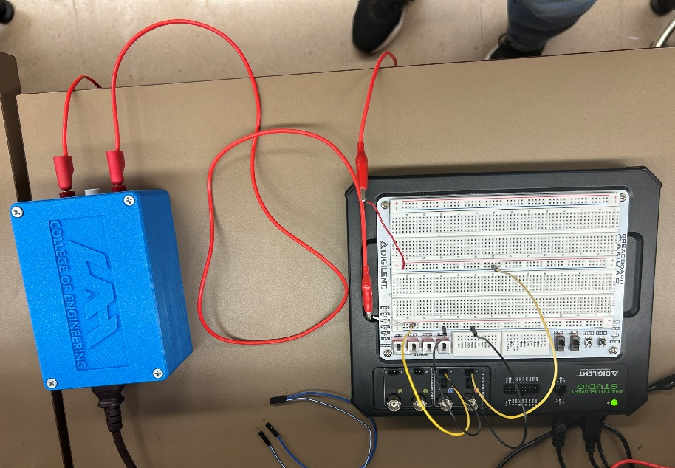
Figure #10: Basic Transformer Experimental Setup
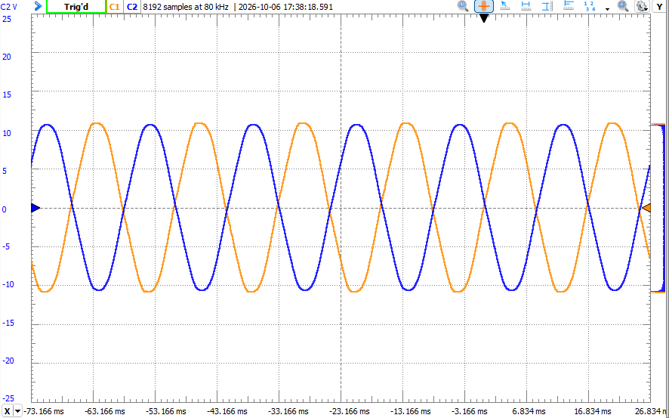
Figure #11: V_{C} and V_{D} Oscilloscope Output (Basic Transformer)
Measurement | Value
V_{pp} | 21.7 V
Frequency | 59.98 Hz
Peak Voltage | 10.66 V
V_{RMS} | 7.5378 V
Phase (input to output) | 180º
Table #1: Basic Transformer Measured Values
The bridge rectifier circuit in Figure 3 was built using a breadboard, diodes, a resistor, and the UAH lab transformer. A picture of the experimental setup can be found in Figure 12. The input and output waveforms were measured using an oscilloscope. The oscilloscope output for the bridge rectifier can be found in Figure 13. The output peak and DC voltages, period, and frequency were measured using the oscilloscope output. A summary of these values can be found in Table 2. The DC voltage was also measured using a digital multimeter and recorded in Table 2. The DC voltage measured using the digital multimeter was 12.62 V, while the DC voltage calculated from the oscilloscope measurement was 10.16 V. The difference between these measurements may be due to the different methods used by the oscilloscope and digital multimeter to determine the DC voltage.
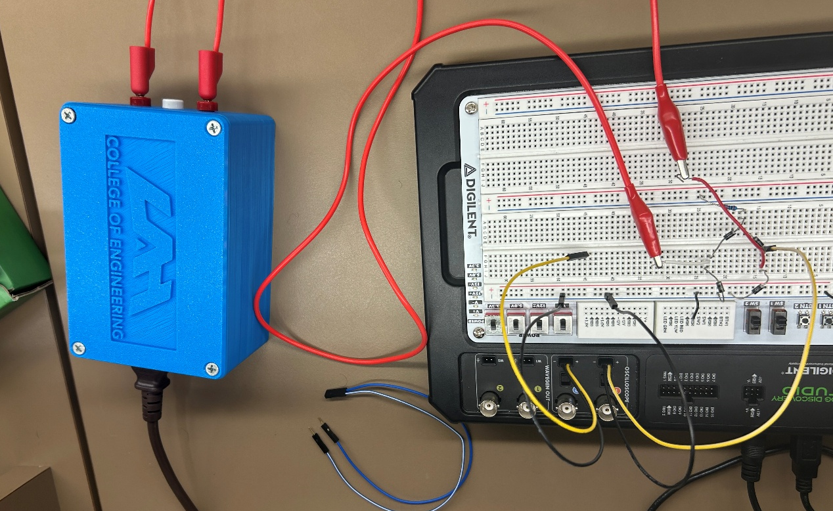
Figure #12: Bridge Rectifier Experimental Setup
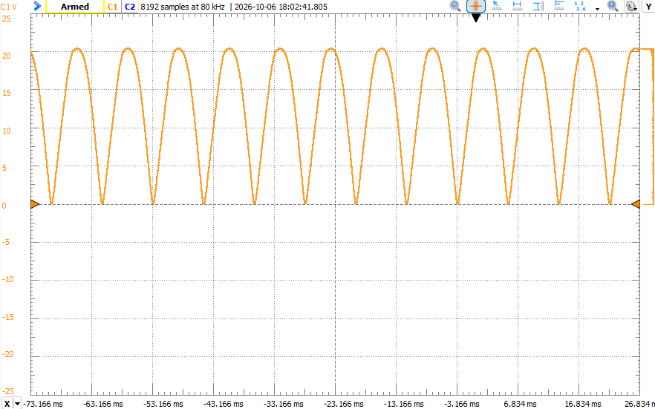
Figure #13: V_{C} and V_{D} Oscilloscope Output (Bridge Rectifier)
Measurement | Value
Peak Voltage | 14.32 V
Peak Voltage (DC) | 10.84 V
Period | 8.331 ms
Ripple frequency | 120.03 Hz
DC Voltage (DMM) | 12.62 V
Table #2: Bridge Rectifier Measured Values
Comparison and Discussion:
The basic transformer results generally followed the expected behavior. The theoretical secondary peak voltage was 16.97 V, compared to 16.9 V in simulation (0.41% error) and 10.66 V experimentally (37.18% error). The experimental RMS voltage was 7.5378 V, which had a 37.19% error compared to the theoretical 12 V RMS. In contrast, the frequency measurements closely matched the theoretical 60 Hz, with errors of 0.18% for the simulation and 0.03% experimentally. The measured 180° phase difference also agreed with the expected phase relationship.
For the bridge rectifier, the theoretical, simulated, and experimental ripple frequencies were all approximately 120 Hz. The experimental value of 120.03 Hz had only 0.03% error. The simulated and experimental peak voltages were 15.629 V and 14.32 V, corresponding to errors of 7.91% and 15.61%, respectively, compared to the theoretical 16.97 V. The theoretical DC output was 10.8 V, compared to 11.051 V in simulation (2.32% error) and 10.16 V experimentally (5.93% error). Overall, the frequency and phase measurements closely matched the expected results, while the voltage measurements showed greater differences between the theoretical, simulated, and experimental circuits.
Conclusion:
The purpose of this lab was to investigate AC signals, transformer operation, and diode rectification. The basic transformer circuit demonstrated the expected 180° phase relationship between the secondary waveforms and produced an output frequency close to the 60 Hz input. The bridge rectifier successfully converted the AC signal into a full-wave rectified signal with a ripple frequency of approximately 120 Hz. The theoretical, simulated, and experimental results were generally consistent, with the smallest differences occurring in frequency measurements and larger differences occurring in voltage measurements. Overall, the lab demonstrated how transformers and bridge rectifiers can be used to modify and rectify AC signals and showed the differences between ideal, simulated, and practical circuit behavior.

